

# ANALOG ELECTRONIC CIRCUITS

**COURSE CODE:ECE 2002**

FACULTY: PROF-BRINTHA THERESE

DONE BY:

D.SRIDAR -18BEC1348

**ACKNOWLEDGEMENT**

The success and final outcome of this project required a lot of guidance and assistance from many people and we are extremely fortunate to have got this all along the completion of our project work. Whatever we have done is only due to such guidance and assistance and we would not forget to thank them.

We would like to thank Prof. BINDHU for providing us with the required ideas and support for completing the project.

We are extremely grateful to **Dr. A. Sivasubramanian,** Dean of the School of Electronics Engineering, VIT Chennai, for extending the facilities of the School towards our project and for her unstinting support.

We express our thanks to our Programme Chair **Dr. Vetrivelan.P** and Co-Chair **Dr. D. Thiripurasundari** for their support throughout the course of this project.

We would like to thank VIT UNIVERSITY for providing us with the opportunity of learning through projects. We have learned many new concepts through this project which has in turn helped us in gaining the practical knowledge of this subject.

## INDEX:

### TITLE

1. ABSTRACT
2. PRINCIPLE AND LOGIC
3. CIRCUIT DIAGRAM
4. SIMULATION OF THIS CIRUCIT
5. WORKING
6. COMPONENTS AND SPECIFICATION
7. ADVANTAGES
8. CONCLUSION
9. PROJECT PHOTO

#### PROJECT TITLE: LIE DETECTOR

##### ABSTRACT:

The concept behind this **Lie Detector Circuit** is that, we assume when a person lie he kind of pumps up his anxiety level which makes him sweat and develop moisture on his skin. We then use this piece of circuit to detect if there is moisture on his skin and based on the result we glow and LED, a green one for truth and red for lie.

##### PRINCIPLE AND LOGIC:

PRINCIPLE:

The device detects true or false by detecting the change in resistance of the subject.

LOGIC:

Dry fingers have resistance up to 1000KΩ and wet fingers have a, relatively lower resistance than the previous one.

##### 2.CIRCUIT DIAGRAM:

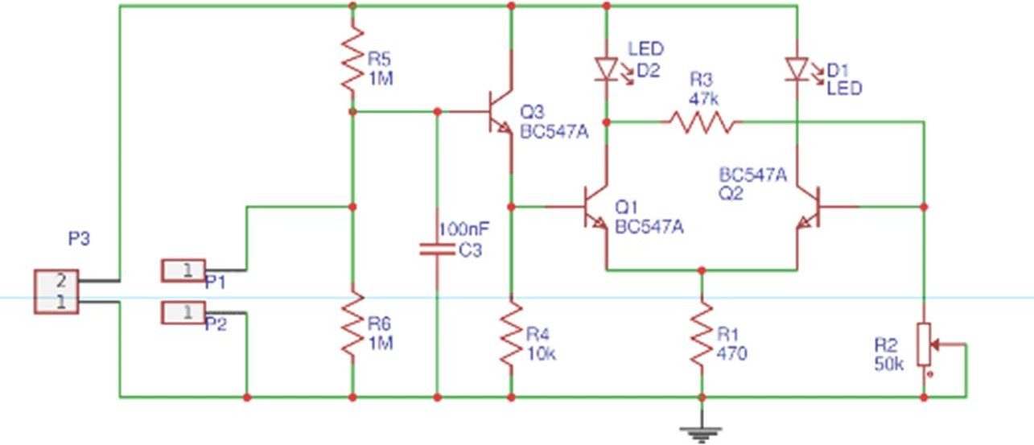

1. **SIMULATION OF THIS CIRCUIT: Truth circuit:**

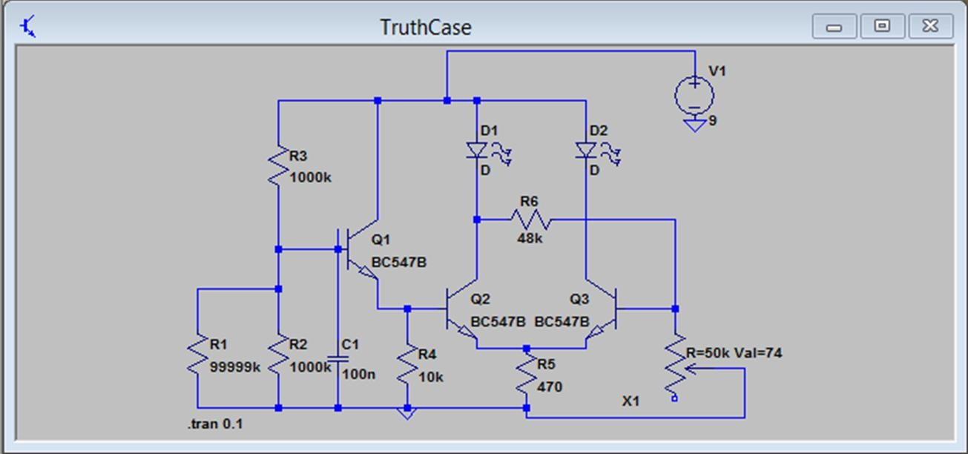

**LIE CIRCUIT:**

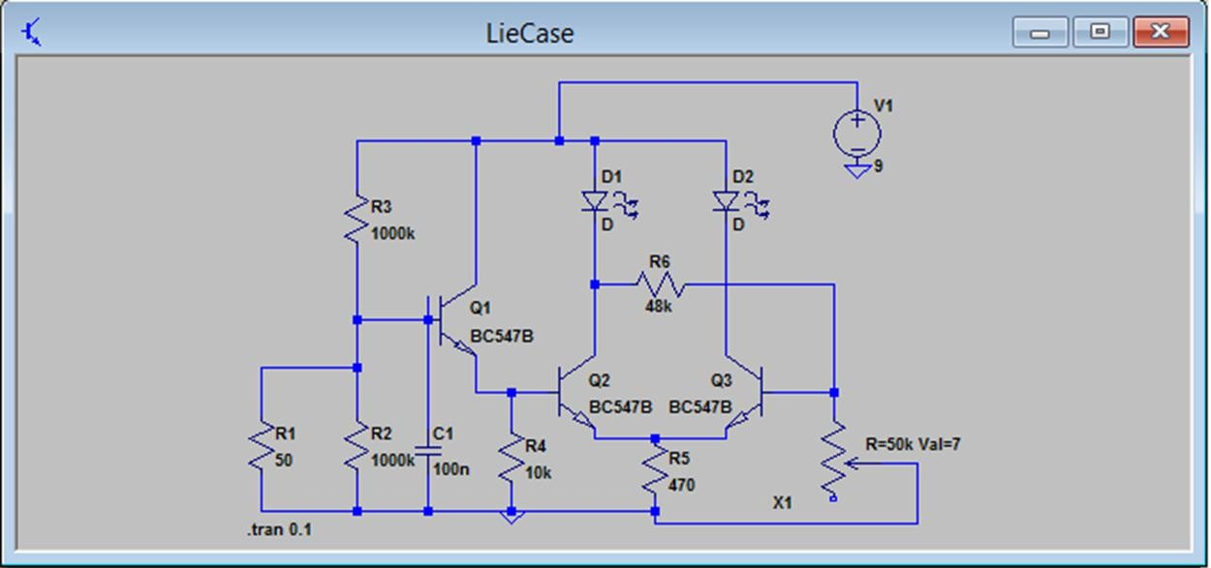

##### Knime circuit

##### 

##### Properties

##### 

##### SIMULATION: Truth- Waveform=>

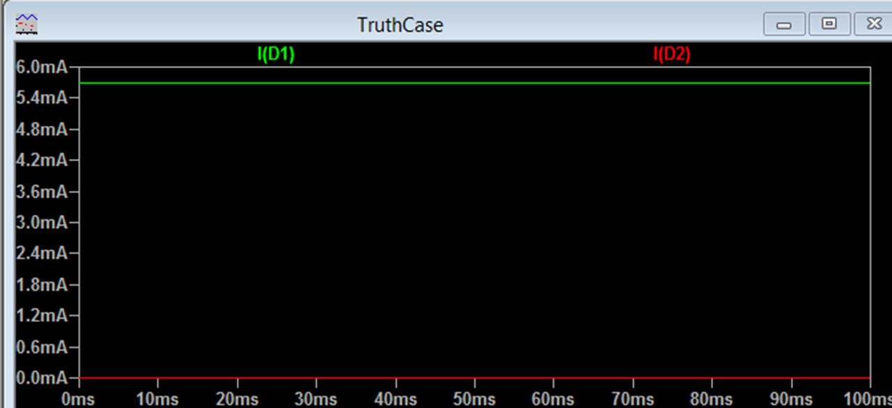

**SIMULATION: Lie- Waveform=>**

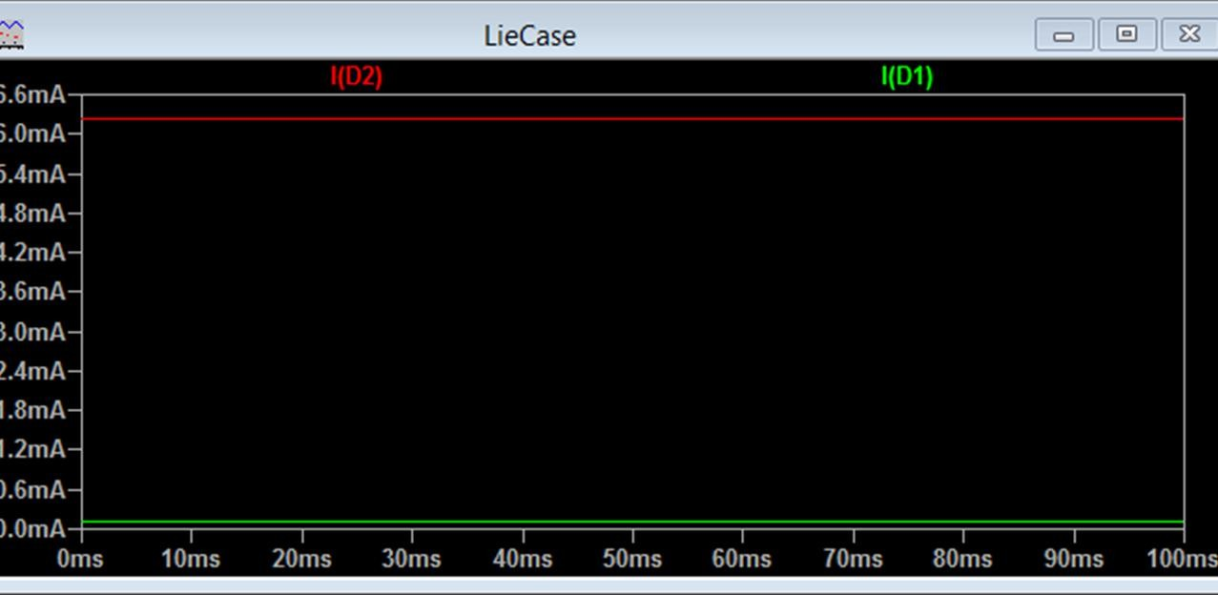

Output from knime

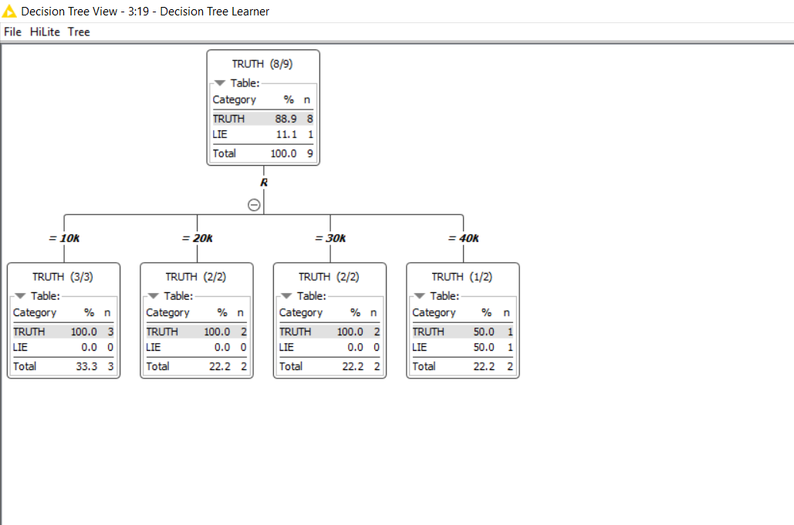

1. **WORKING:**

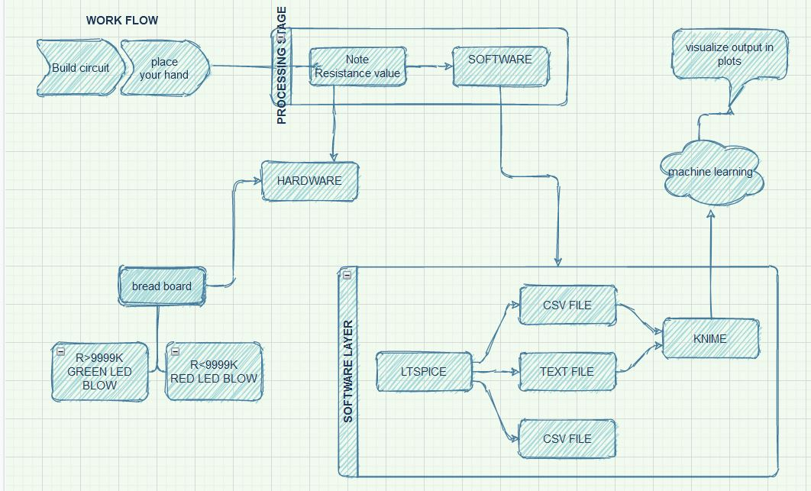

In the simulation the resistor R6 is assumed to be the resistance of the finger. When no finger is placed the value of resistor is infinity. So simulate that condition I have just mentioned the value to be 99999K.

The green LED has turned on when no finger is laced because, the base voltage of Q1 and Q2 is around 3.2 voltage and

hence the transistor is on making the Green LED to glow. At the same time since the Transistor Q2 is turned on, the base voltage across the transistor Q3 drops to be around 1.4V which will keep the transistor Q3 in off and hence the Red LED is turned off.

Now let’s assume we have placed our finger across the resistor R4 and hence the value of R6 falls to 50 ohms. This will affect the value of resistor R4 and hence the red LED

glows as shown below. The voltage drop across resistor R4 is less and hence the base voltage of Transistor Q1 and Q2 is almost 0V as shown above.

This will keep them turned off and thus the Green LED will not glow. But since the transistor Q2 is off the entire supply voltage gets divided between the resistor R1 and base of Q3. This makes the base voltage of Q3 to be 3V

which is enough to turn it on. You can fine tune the base voltage a bit more by using the potentiometer also. If the transistor Q3 is turned on the Red LED will also glow.

#### COMPONENTS AND SPECIFICATIONS:

* Bread board
* BC547 Transistor (3Nos)
* LED (2 Nos)
* Capacitor (100nF)
* Resistors (1000K, 10K, 470, 47K)
* Potentiometer (50K or 100K)
* Connecting wires.

#### ADVANTAGES:

* + It is easy in construction
  + It is light in weight.
  + Low circuit cost.
  + Low power requirement

#### CONCLUSION:

The green LED has turned on when no finger is placed because, the base voltage of Q1 and Q2 is around 3.2 voltage and hence the transistor is on making the Green LED to glow. At the same time since the Transistor Q2 is turned on, the base voltage across the transistor Q3 drops to be around 1.4V which will keep the transistor Q3 in off and hence the Red LED is turned off. We have placed our finger across the resistor R4 and hence the value of R6 falls to 50 ohms. This will affect the value of resistor R4 and hence the red LED glows.

W USE KNIME allows users to visually create data flows (or pipelines), selectively execute some or all analysis steps, and later inspect the results, models, using interactive widgets and views. KNIME is written in Java and based on Eclipse. Drag & drop this workflow right into the Explorer of KNIME Analytics Platform (4. x or higher). Or copy & paste the workflow URL there! After the data is partitioned into train and test set, a decision tree model is trained and applied

Drag and drop the . csv file from the file system explorer to the workspace. The CSV Reader node will be created on the workspace automatically and it will be configured to read the dropped file. To read the file properly, the appropriate column delimiter must be chosen in the configuration dialog.

##### PROJECT PHOTO:

