Database

==================================================================================

In database we have different types of connectors like

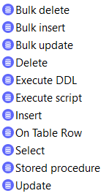

On Table Row:-

If any record created in database immediately trigger the flow, the only connector we can drag in source system remaining all connectors we have to use only in process system

Difference between bulk insert and insert

🡪While inserting large number of records in single time .In bulk insert single time it generates

The query mapping. So that it increase the Data base performance

Database configuration:-

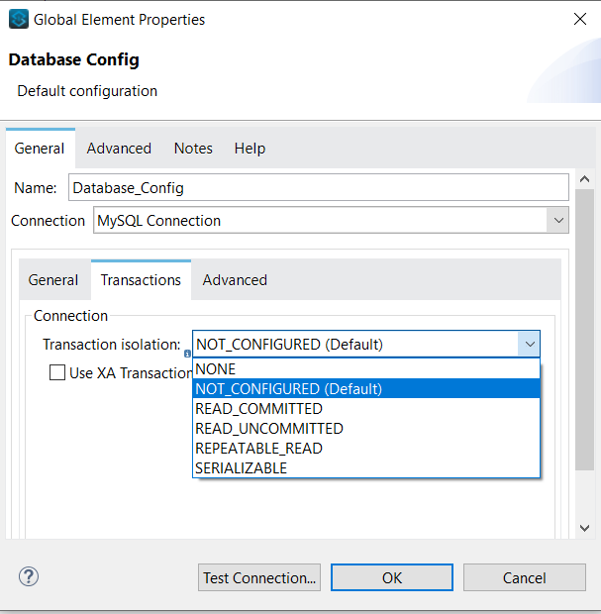

**General-Transactions** :-

NOT_CONFIGURED:= now configuration we can set committed and none committed

READ_COMMITTED:=while we fetching data from database it only take the committed records

READ_UNCOMMITTED:= while we fetching data from database it only take the uncommitted records

REPEATABLE_READ:=?

SERIALIZABLE:=?

**General-Advanced**:-

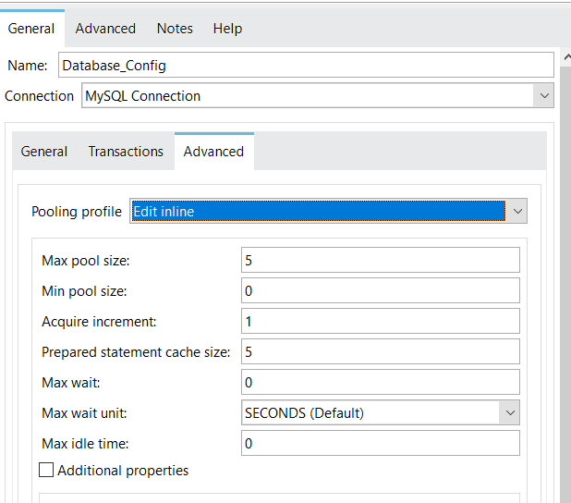

Polling profile:- Every database it create any number of connections .if increase the connection it reduced the performance

If existing connection not in service it allocated the resources

**Advanced**:-

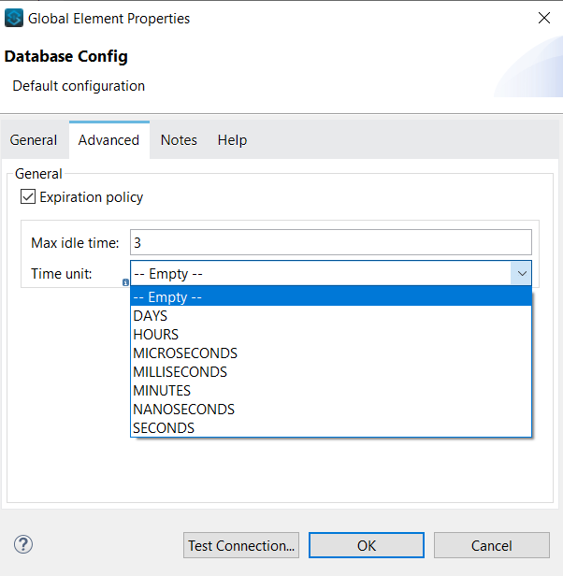

Max idle time:- here we have to give the time interval , if the response not received in particulate interval time it raise the error

Time Unit:- Time frequency

Note:-

* To download the JDBC driver :- <https://www.ibm.com/support/pages/db2-jdbc-driver-versions-and-downloads>
* :First_name:- sql injection