Salesforce

Step1:- create salesforce account

Step2:- switch to classic mode

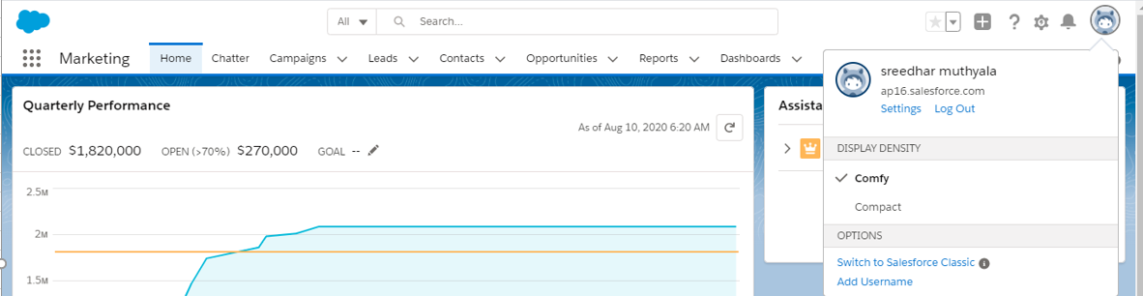

Step 3:- go to setup

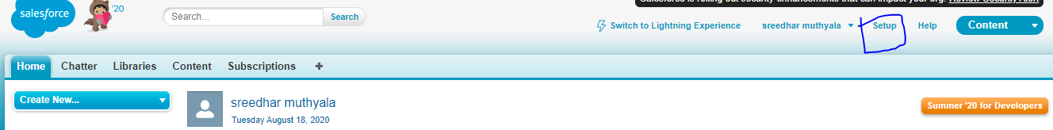

Step 4:- now create a new custom Object

🡪 Build🡪Create🡪Object 🡪New custom Object

Step 5:- To Create Object fields go to Fields & Relationship 🡪New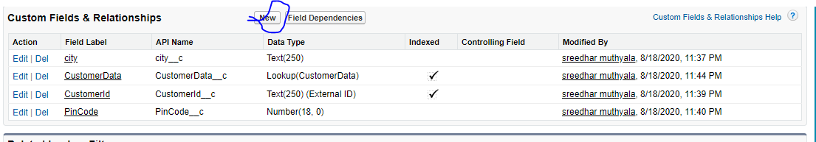

Step 6:- Taps🡪 customObject tabs🡪 select the Object name 🡪

Step7:- Create New view

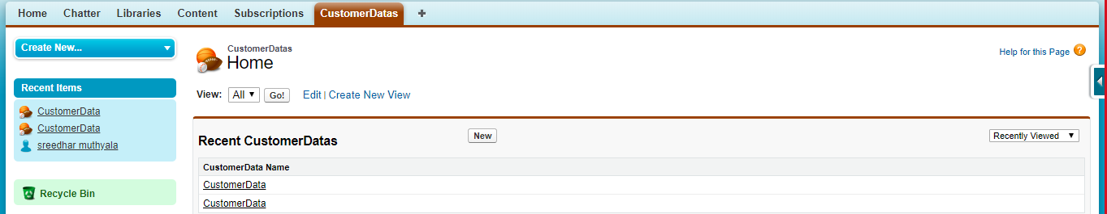

How to create look up

Step1:- go to Fields & Relationship 🡪New

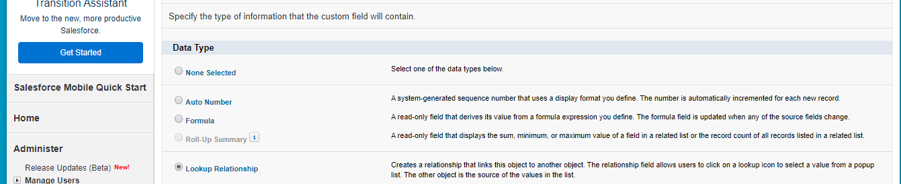

Step2:- select the object name we need to create lookup

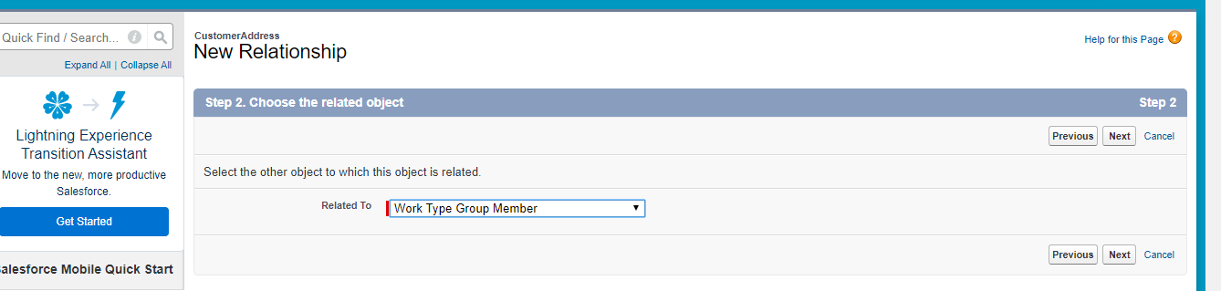

How to create query:

User name🡪 Developer Console 🡪

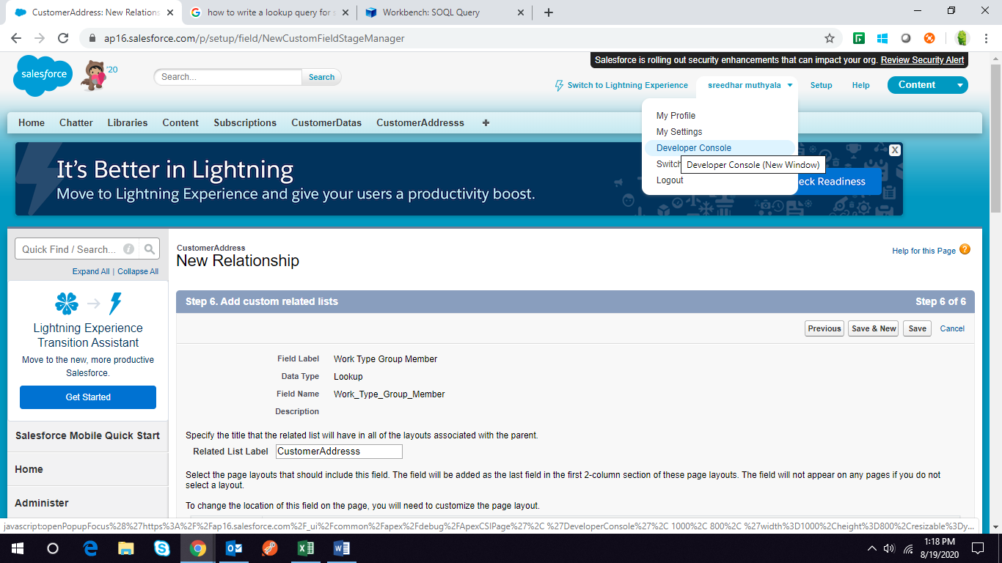

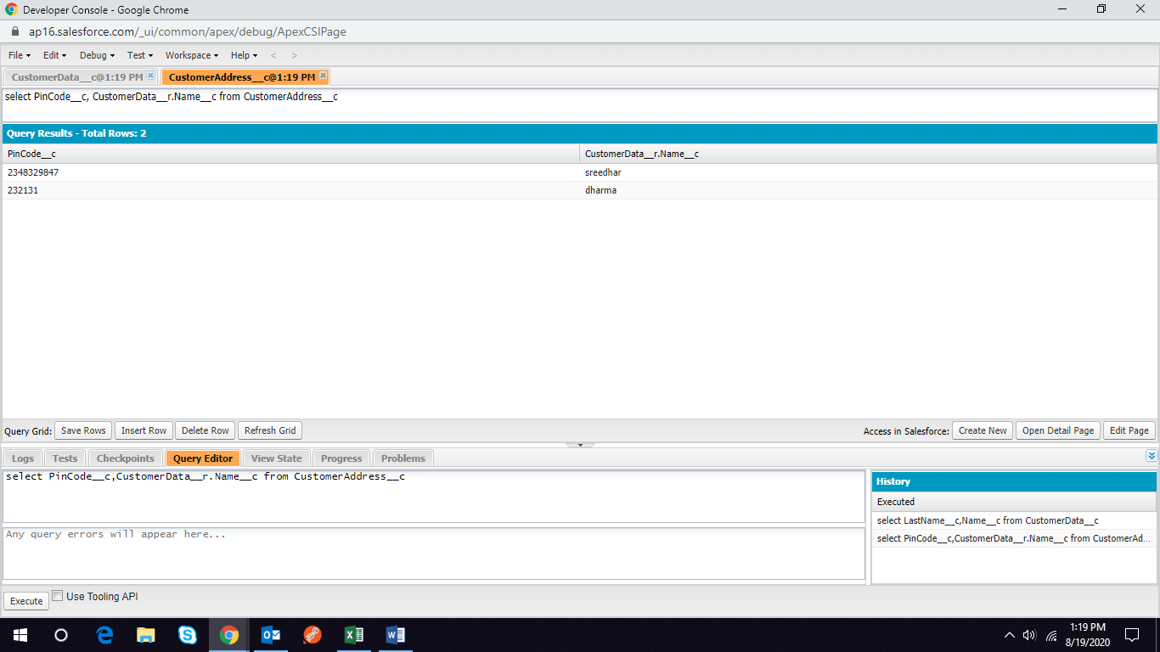

Example Query:-

select PinCode__c,CustomerData__r.Name__c from CustomerAddress__c

How to reset a access-token

Step1:- 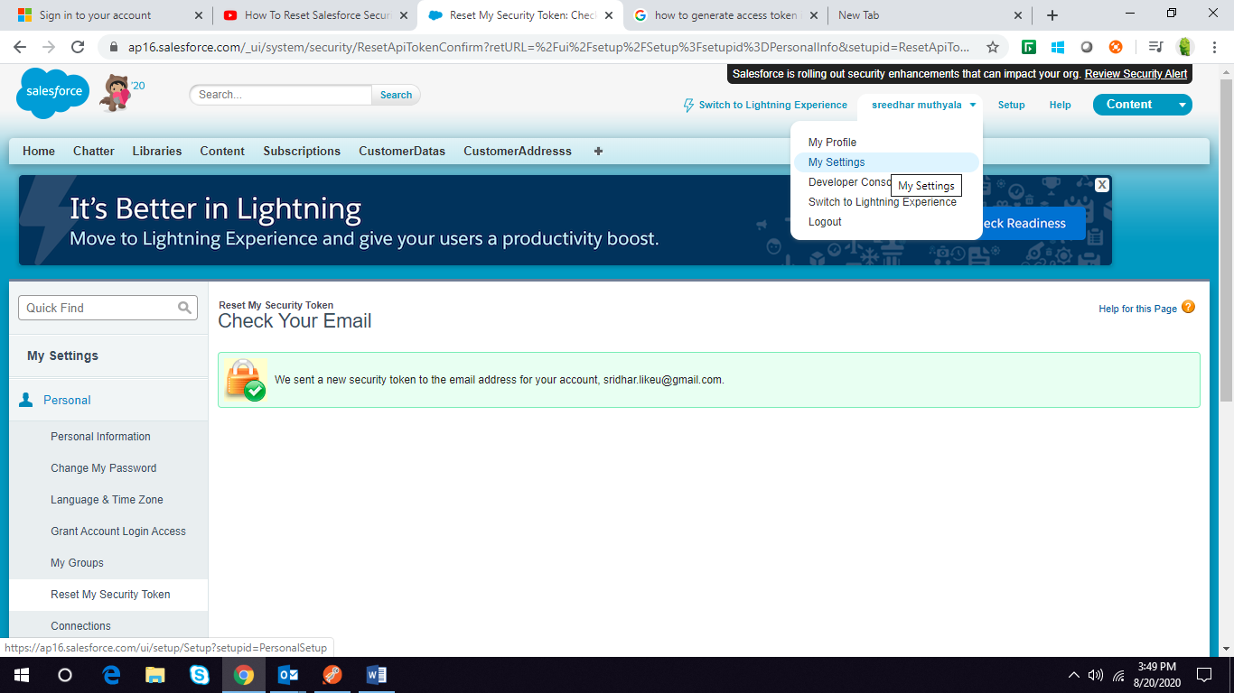

Step2:- personal🡪 Reset My Security Token

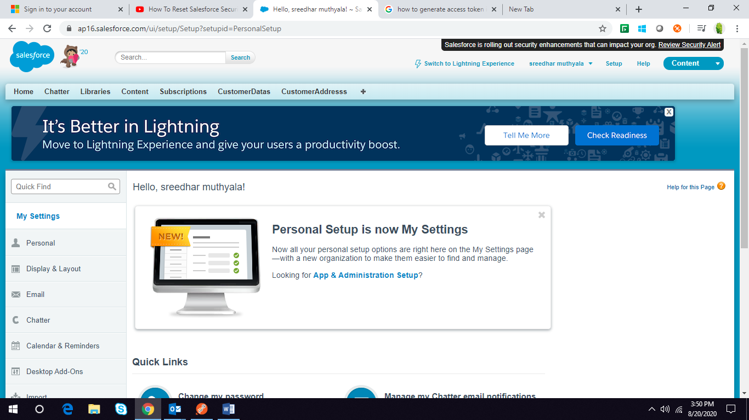

Step3:- check your Email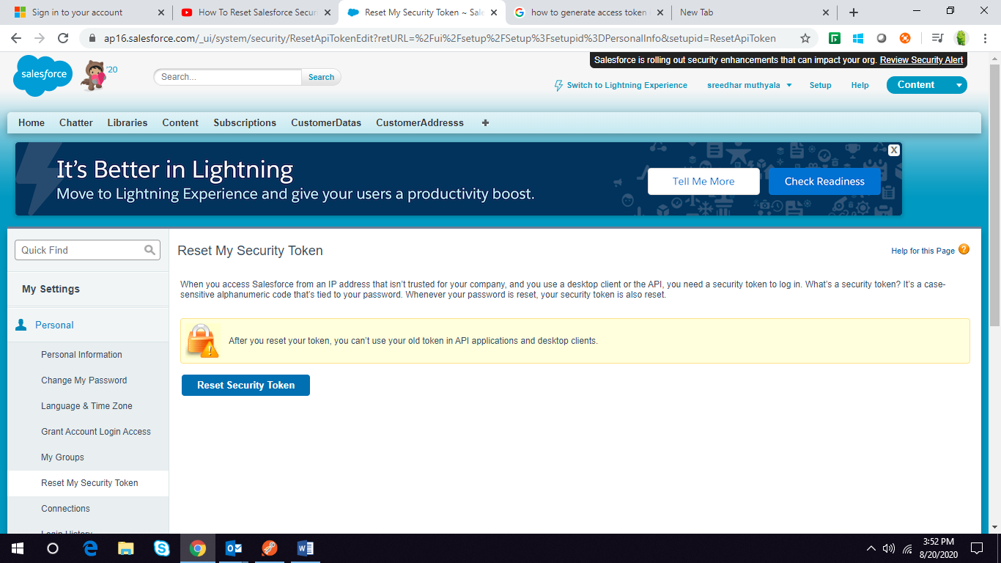

WorkBench:-

https://workbench.developerforce.com