Basic

=========

Example:-1

Logic:- %dw 2.0

output application/json

var abc={one:1,two:2}

---

Abc

Output:- {"one": 1,"two": 2}

Screen shot:- 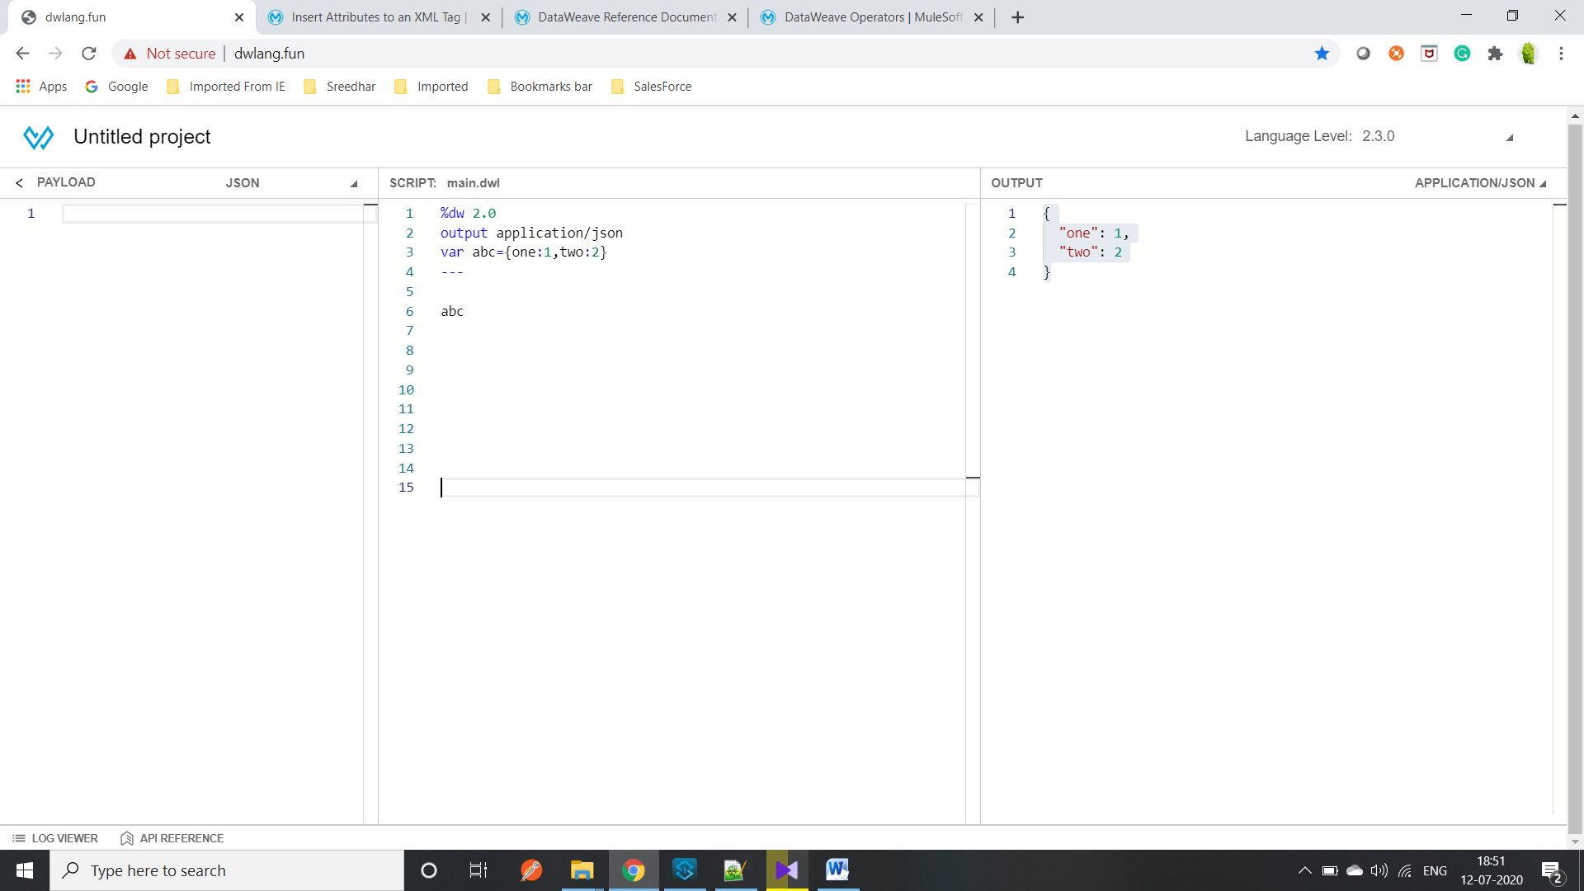

Example 2:-

Input:- %dw 2.0

output application/json

var abc={one:1,two:2}

---

{(abc)}

OutPut:- Output:- {"one": 1,"two": 2}

Note:-whenever we rapped an object inside a parentheses() that object will evaluated