Group By

Example:-

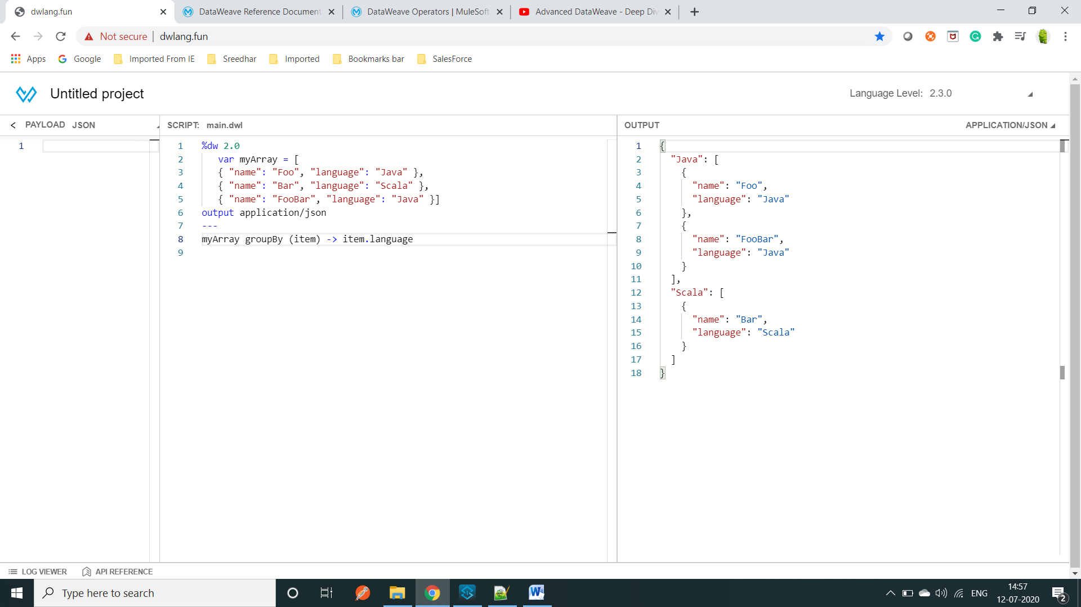

==============================================================================

Example

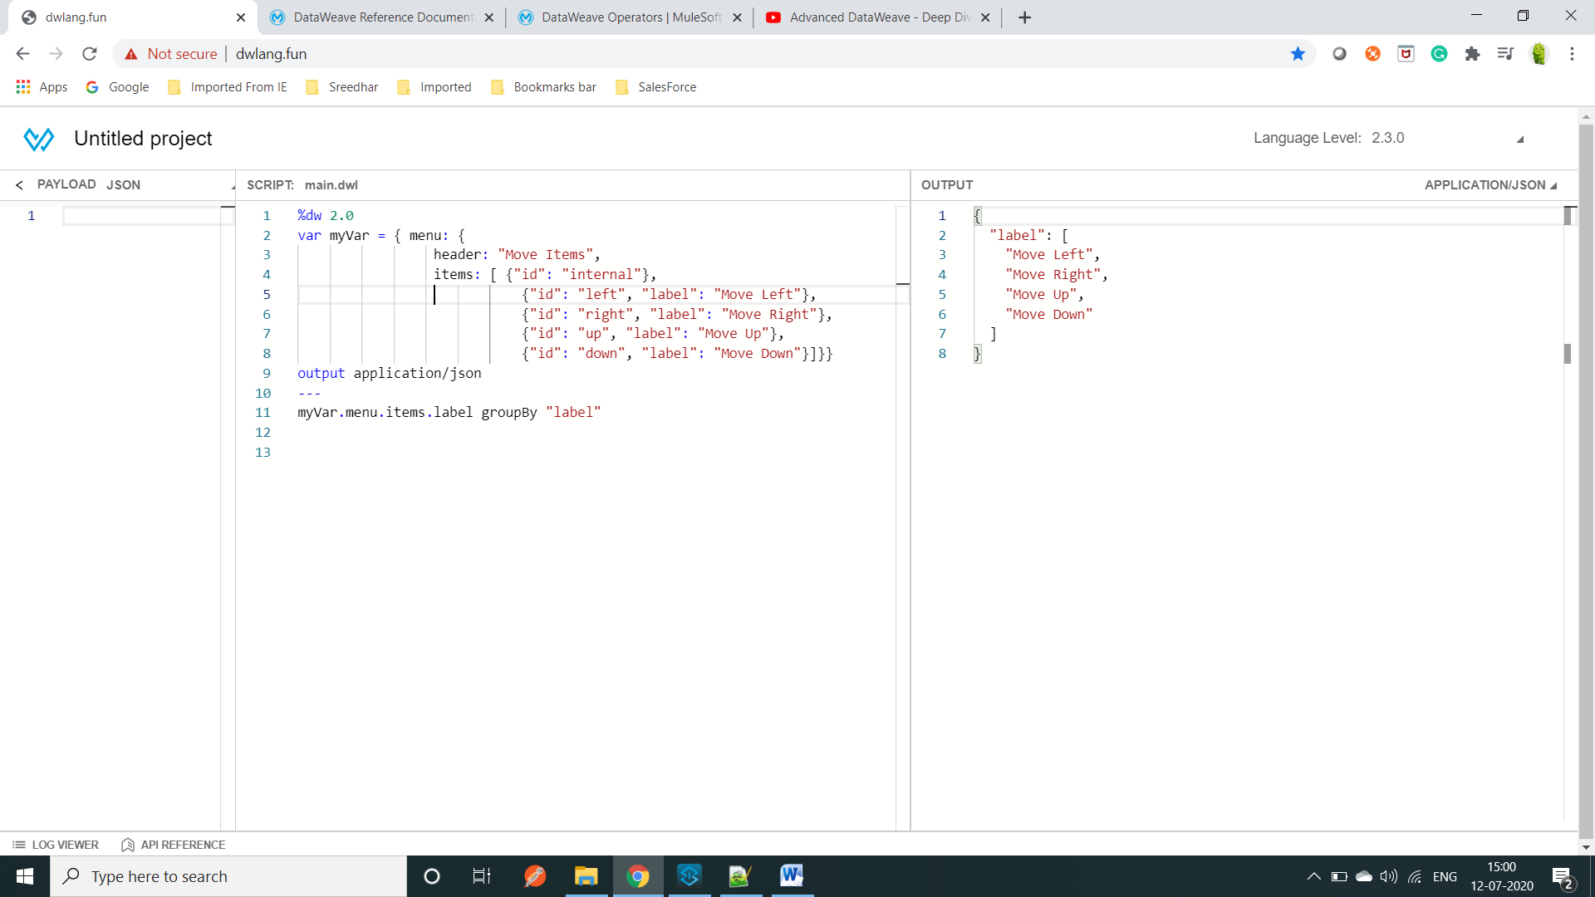==============================================================================

Example: separate the payload base on the value

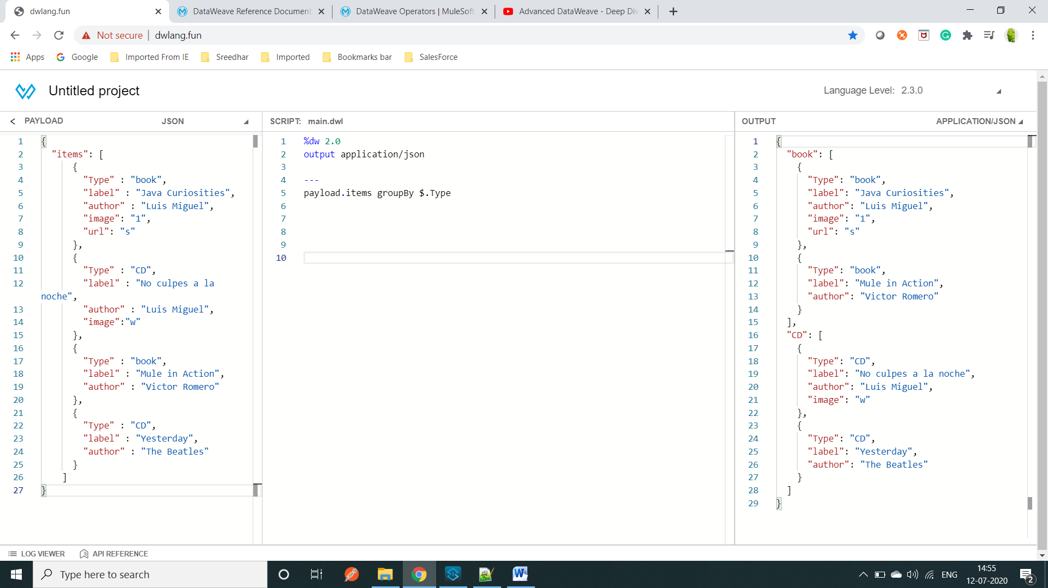

==============================================================================

Example:Out put give true and false

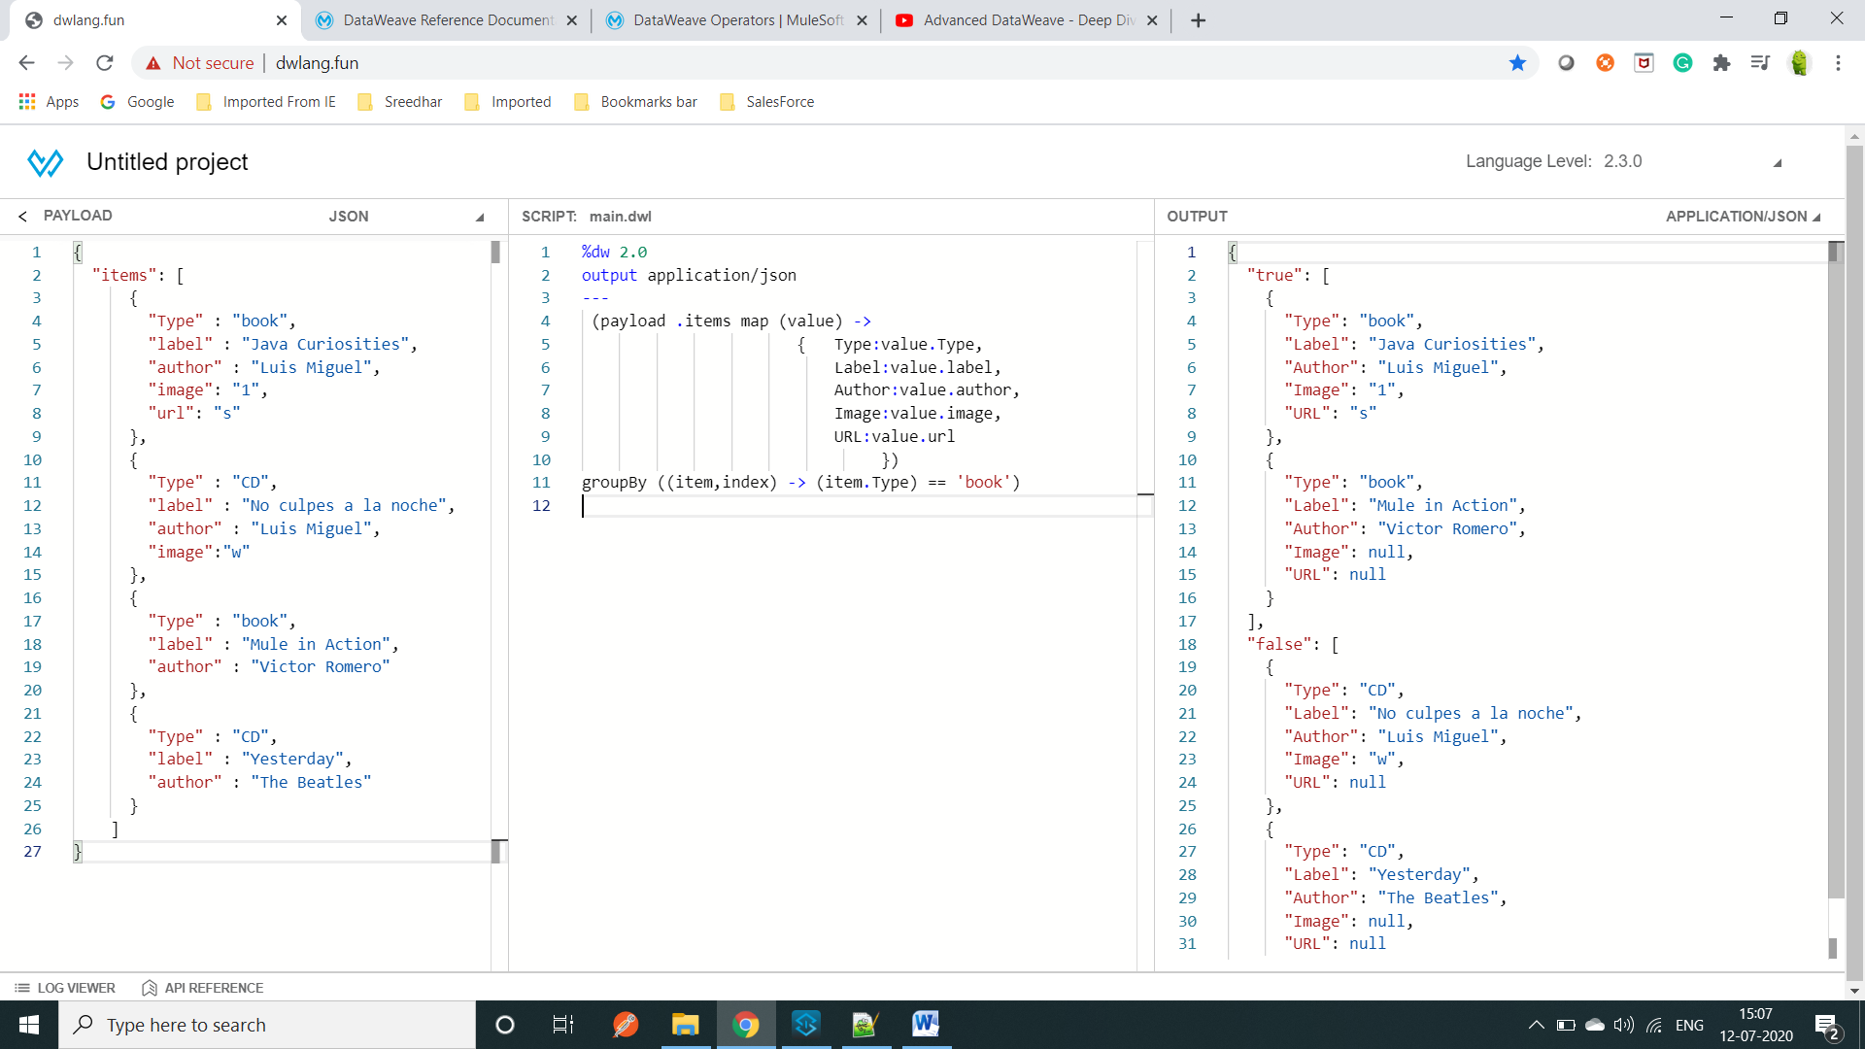

==============================================================================

Example:-

Input:- [ { "merchantName": "HelloFresh" }, { "merchantName": "Amazon" }, { "merchantName": "Walmart" },

{ "merchantName": "Guitar Center" }]

Logic:- payload groupBy (if(sizeOf($.merchantName)>=10)"size greater than or equal to" else "size less than ")

Output: {

"size greater than or equal to": [

{"merchantName": "HelloFresh" }, {"merchantName": "Guitar Center" } ],

"size less than ": [ {"merchantName": "Amazon"},{"merchantName": "Walmart"}]}