Splitter

Example:-

Input:- Abc=abc:DEF=def:GHI=ghi:JKL=jkl:MNO=mno:PQR=pqr

Logic:- payload splitBy ":"

Log1:- payload splitBy ":" map((item,index) -> item splitBy "=")

Log2:- payload splitBy ":" map((item,index) -> item )

Output:- [

"Abc=abc",

"DEF=def",

"GHI=ghi",

"JKL=jkl",

"MNO=mno",

"PQR=pqr"

]

Pic:- 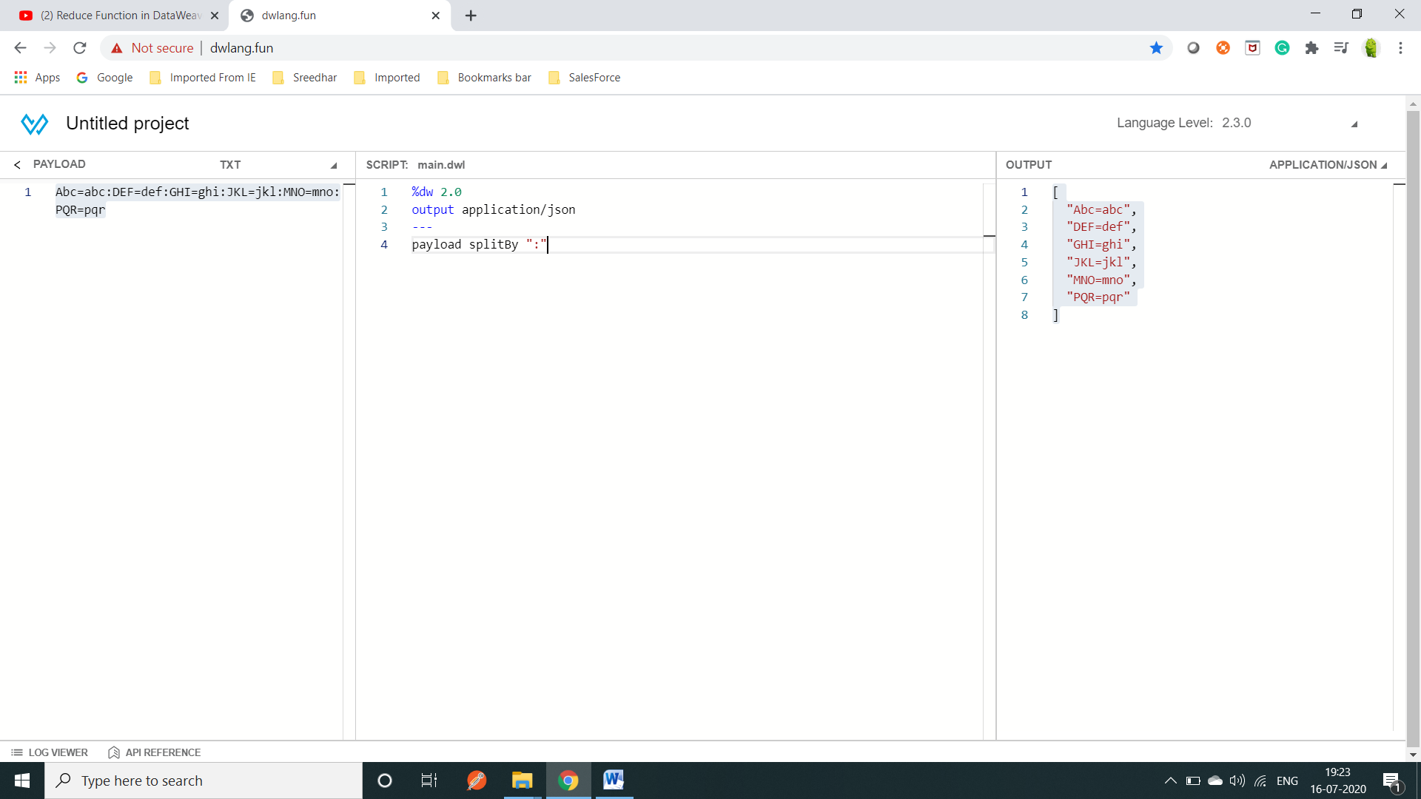

Example:2