Logic

1. Calculating Average Precipitation Value of Every Month
2. Output Objects in which a specific field is present()
3. Output fields depending on conditions
4. Date converting format

Example1:-

[

{

"date": "2018-01-01",

"temperature": 8,"temperature_min": 6.6,"temperature_max": 11.2,"precipitation": 12.1, "snowfall": null, "snowdepth": null,

"winddirection": 203, "windspeed": 25.8, "peakgust": null,"sunshine": null, "pressure": 1003.5},

{

"date": "2018-02-01",

"temperature": 8,"temperature_min": 6.6,"temperature_max": 11.2,"precipitation": 1.1, "snowfall": null, "snowdepth": null,

"winddirection": 203, "windspeed": 25.8, "peakgust": null,"sunshine": null, "pressure": 1003.5},

{

"date": "2018-03-01",

"temperature": 8,"temperature_min": 6.6,"temperature_max": 11.2,"precipitation": 10.1, "snowfall": null, "snowdepth": null,

"winddirection": 203, "windspeed": 25.8, "peakgust": null,"sunshine": null, "pressure": 1003.5},

{

"date": "2018-04-01",

"temperature": 8,"temperature_min": 6.6,"temperature_max": 11.2,"precipitation": 16.1, "snowfall": null, "snowdepth": null,

"winddirection": 203, "windspeed": 25.8, "peakgust": null,"sunshine": null, "pressure": 1003.5},

{

"date": "2018-05-01",

"temperature": 8,"temperature_min": 6.6,"temperature_max": 11.2,"precipitation": 1.1, "snowfall": null, "snowdepth": null,

"winddirection": 203, "windspeed": 25.8, "peakgust": null,"sunshine": null, "pressure": 1003.5},

{

"date": "2018-06-01",

"temperature": 8,"temperature_min": 6.6,"temperature_max": 11.2,"precipitation": 19.1, "snowfall": null, "snowdepth": null,

"winddirection": 203, "windspeed": 25.8, "peakgust": null,"sunshine": null, "pressure": 1003.5}]

Logic:-

%dw 2.0

output application/json

var month = payload groupBy ((item,index1) -> (item.date.month))

fun replacenull(abc)=abc.precipitation map ((value,index) ->if (value !=null) value else 0)

---

month mapObject ((value, key, index) -> {(key):avg(replacenull(value))})

output:-{"1": 12.1,"2": 1.1,"3": 10.1,"4": 16.1,"5": 1.1,"6": 19.1}

Video:-<https://www.youtube.com/watch?v=L2evcDQMu_0&t=6s>

Example3:-

Input:-[

{"id":120,"Name":"Name1","lastName":"lastname1","city":"nellore","pin":"1231","age":30},

{"id":121,"Name":"rakesh","lastName":null,"city":"nellore","pin":"123213","age":5},

{"id":122,"Name":"name3","lastName":"lastnam2","city":"nellore","pin":"524002","age":23},

{"id":120,"Name":null,"lastName":null,"city":"nellore","pin":"","age":7}]

LOGIC:-payload map ((item, index) -> {

ID:item.id,

(Name:item.Name) if(item.Name != null),

(LastName:item.lastName) if(!isBlank(item.lastName)),

(pin:item.pin) if !isBlank(item.pin)})

OUTPUT:-[

{

"ID": 120,"Name": "Name1", "LastName": "lastname1", "pin": "1231" },

{

"ID": 121,"Name": "rakesh", "pin": "123213" },

{

"ID": 122, "Name": "name3", "LastName": "lastnam2", "pin": "524002"

},

{

"ID": 120

}]

PIC:-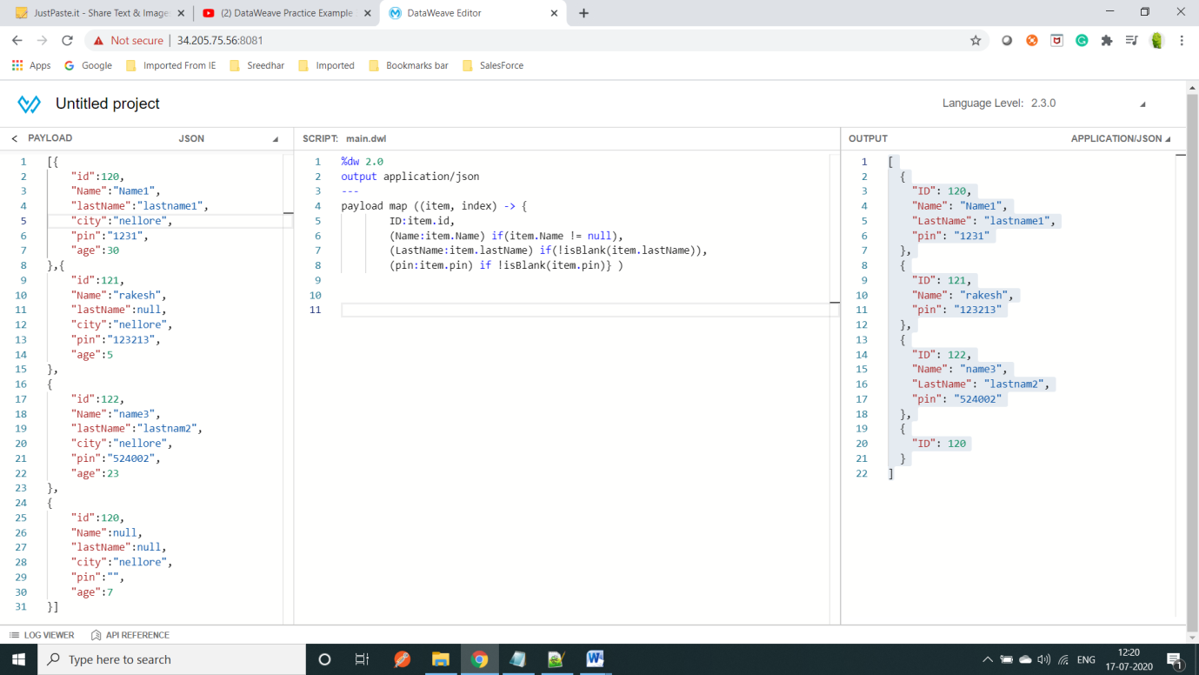VIDEO:-<https://www.youtube.com/watch?v=V-d6JtQdK6o>

=====================================================================================================

Input:-

%dw 2.0

output application/json

var dt='29-01-2018'

var dt1='29-jan-2018'

---

{a:dt as Date {format: 'dd-MM-yyyy'} as String {format: 'yyyyMMMdd'},

b:dt1 as Date {format: 'dd-MMM-yyyy'} as String {format: 'yyyyMMdd'}}

OutPut:-

{

"a": "2018Jan29",

"b": "20180129"

}