**Indicator**:-

Moving Average Weighted (MVW)length -50

Case1:-

BUY:- once candle cross the MVW-50, wait for the candle low greater than MVW-50 line

Example:-

MVW-50 = 1.08422

Candle Lower=1.08424

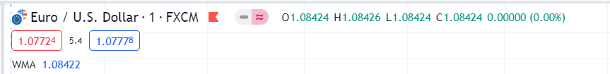

Buy entry As per the screen shot

* Once candle was break upside the MVW-50
* And the candle lower greater than MVW-50 line
* Now take the buy entry above the 2 candle as per the below screen shot.

2nd candle Higher was 1.08426

Buy entry level was 1.08427

STOP LOSS As per the Below Diagram

* Once candle was break upside the MVW-50
* Below the MVW-50 line refer the 3rd candle in the below Screen Shot

Candle high was lesser than MVW-50,and The same candle greater than lower was the SL.

Example:-

MVW-50 = 1.08422

Candle High=1.08421

Candle Lower=1.08417

SL=1.08416

**Take Profit :- 1:2 -> value should de dynamic.**

**Example:-**

**Buy entry =** 1.08427

**Stop Loss =** 1.08416

**Difference Between Buy entry and Stop Loss was 0.00011.**

**Take Profit = 1.08449 (0.00022)**

Case2:

* As per the below screenshot if we taken the buy order and it got success profit,
* After some time, candles breaking below the MVW-50 (Candle 4 in the below Screenshot) and the next new candle heigh create lesser than MVW-50 line (Candle 5 in the below Screenshot)
* After the 5th candle the next candle was not break the 5th candle low
* If take reverse direction of upside again break the MVW-50 line, And the next candle (6th candle as per the below screenshot) candle lower greater than MVW-50 line.
* Now take the buy entry above the 6th candle
* **Take Profit :- 1:2 -> value should de dynamic.**

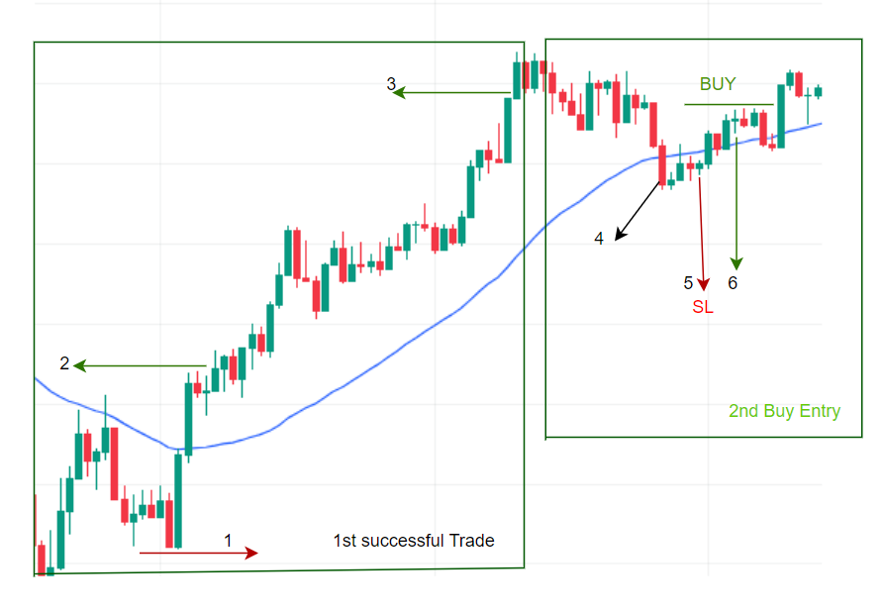

**Case-3**

**Stop loss checks for Buy Signal.**

* Once candle was break upside the MVW-50
* In the below Screenshot 1, Stoploss Expected (refer above STOP LOSS ) candle was not created.
* Then break upside candle (2) low was the Stoploss

