Indicator:- "MACD + SMA 200 Strategy (by ChartArt)

High level of the Strategy rules:-

1:- Two parallel threads required

* One always looks for the buy signal.
* One always looks for the sell signal.

2:- Where to provide Entry /SL/TP signals based on the rules

3:- Lots calculation

4:- Strategy

* Signals Settings:-

In the indicator MACD + SMA 200 Strategy (by ChartArt) we only using

-> MACD slow Moving average

value = 33 (value should be dynamic)

colour= Red

-> very slow-moving average

value =200 (value should be dynamic)

colour= Green

Buy signals :-

If candle break the above both (red and green) lines. Then look for the candle that.

not touch both lines . once candle was created now take the order

Example for the entry point :-

If red line was below and the green line was above , candle was broken the green line and entry point was created above the green line , then stop loss was below the green line candle that does not touch the green line.

Example of Take Profit :- 1:2 (Target should be dynamic )

Some More Example of the Entry points :-

Example 2:-

Example3-

Example :- In this Below Example we can see the 2nd **buy** signal entries

🡪Once we close the first entry buy signal (it can TP & SL)

🡪 Next, we need to look for the Next Entry candle , Next Entry candle should.

break the line and next it should create the candle below the line and cand.

not touch the line

* Once Next Entry candle was formed ...look for the next buy Entry Signal

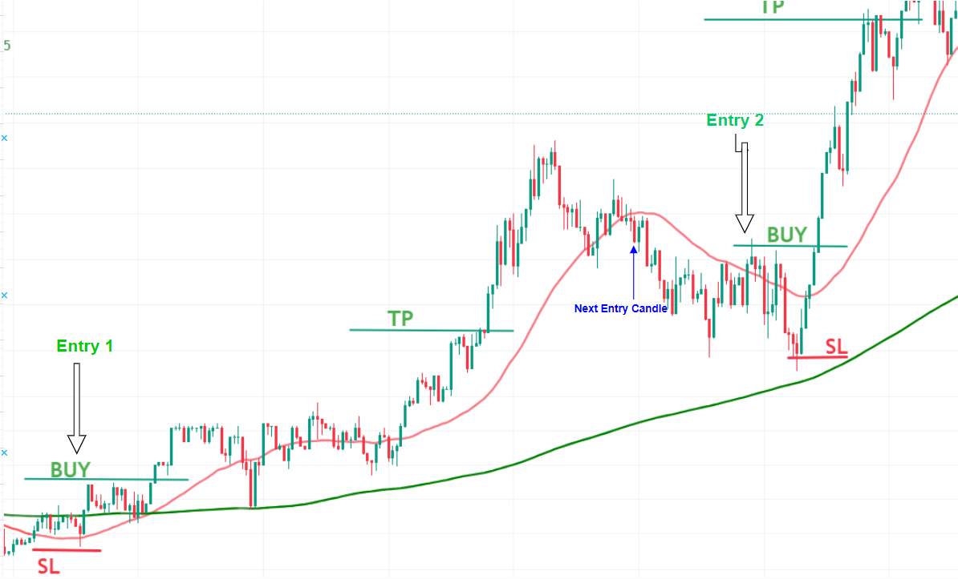

**Filter conditions for the Buy signals :-**

**Condition 1**

* If difference between **SL** and **Buy** signal was not more than **0.00300 (value should be dynamic)** then only place the order
* In the Below Example Difference was 0.00684 it was more than Expected value , in this case skip the buy signal order.

**Numbering:-**

130*0.08 =10.4

(0.0013*100000)*0.08 ====10.4

10.4/(0.0013*100000) =0.08