How to create clientId-Enforcement

Step1:- create the RAML

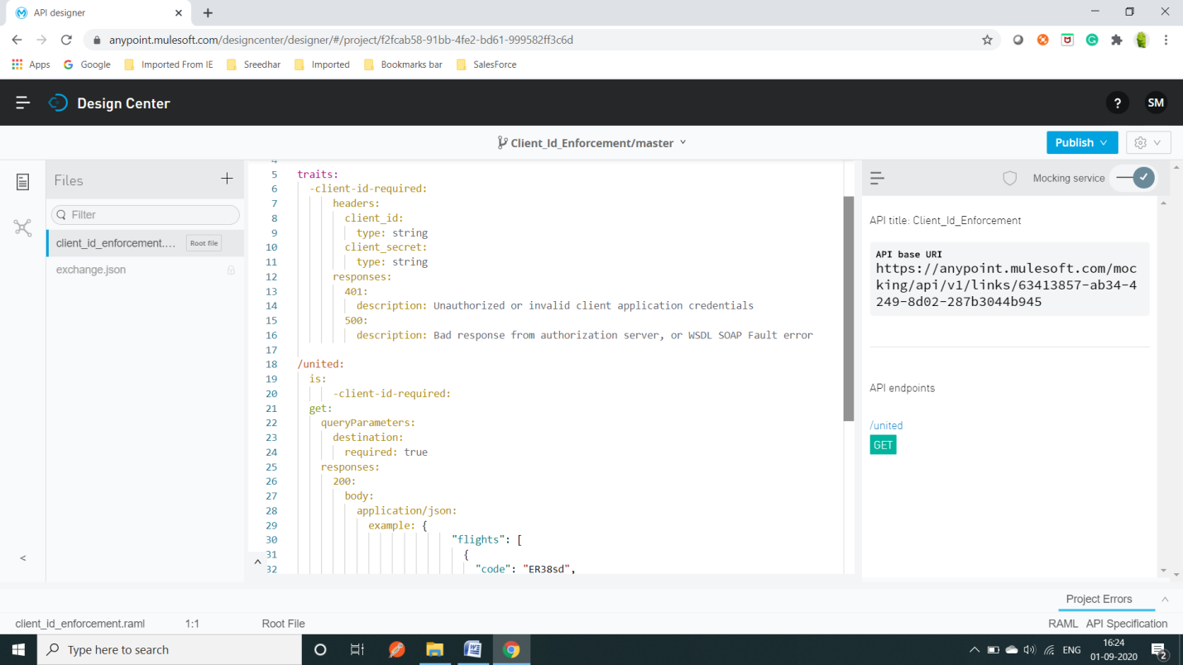

Step2:- Publish to exchange

Step3:- download to studio and generate the flows

Step4:-go to ApiManager 🡪 select the Api( you need toapply the policy) 🡪

Check in contracts :- initially there is no contract

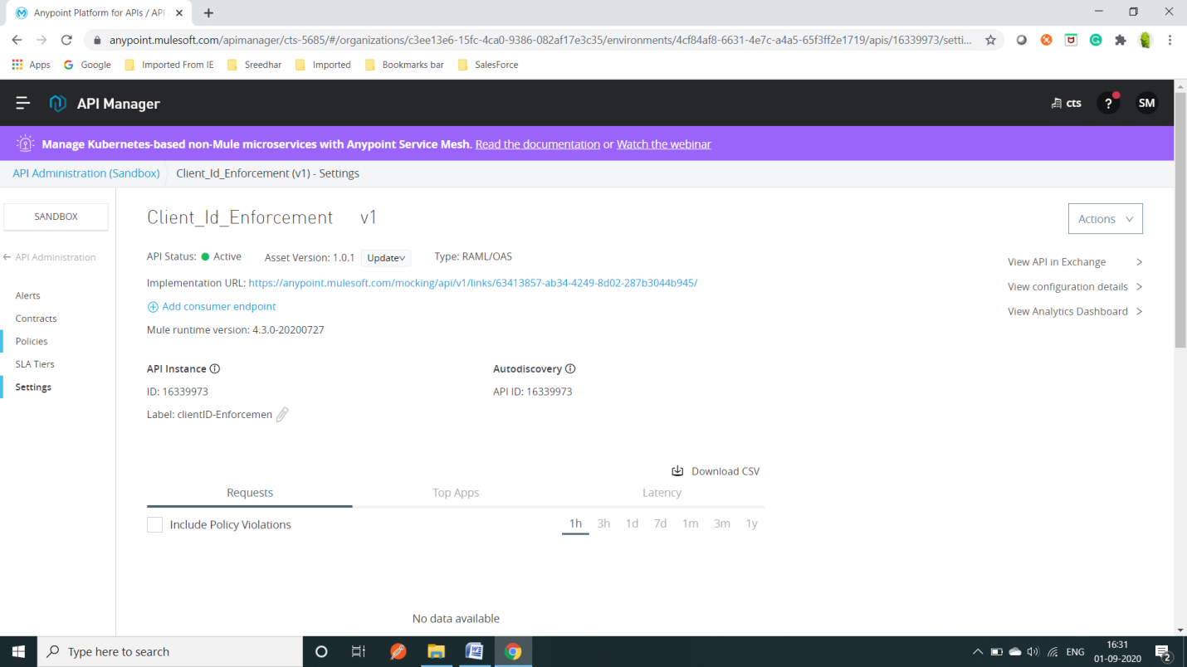

Step5:- go to exchange give the 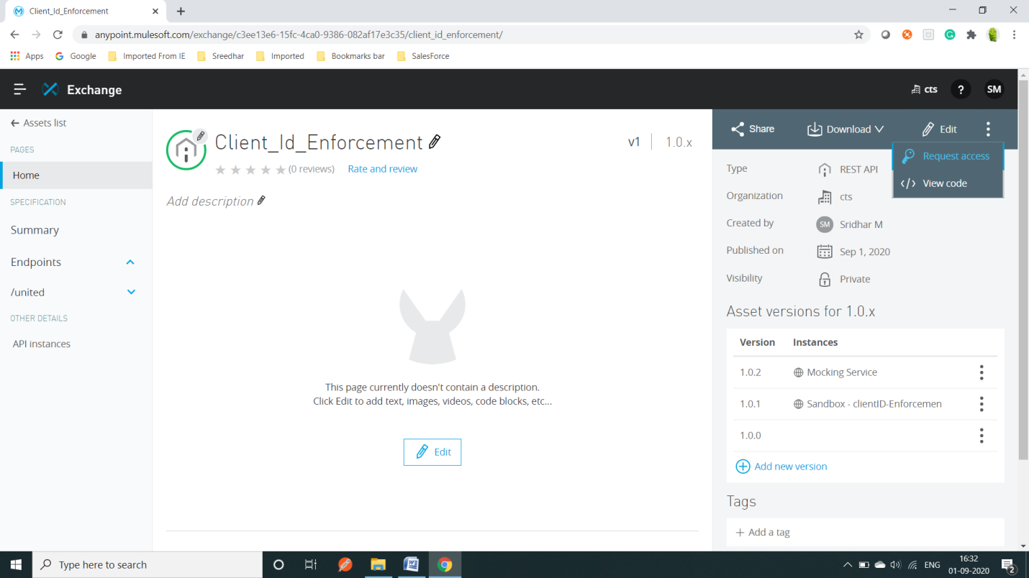

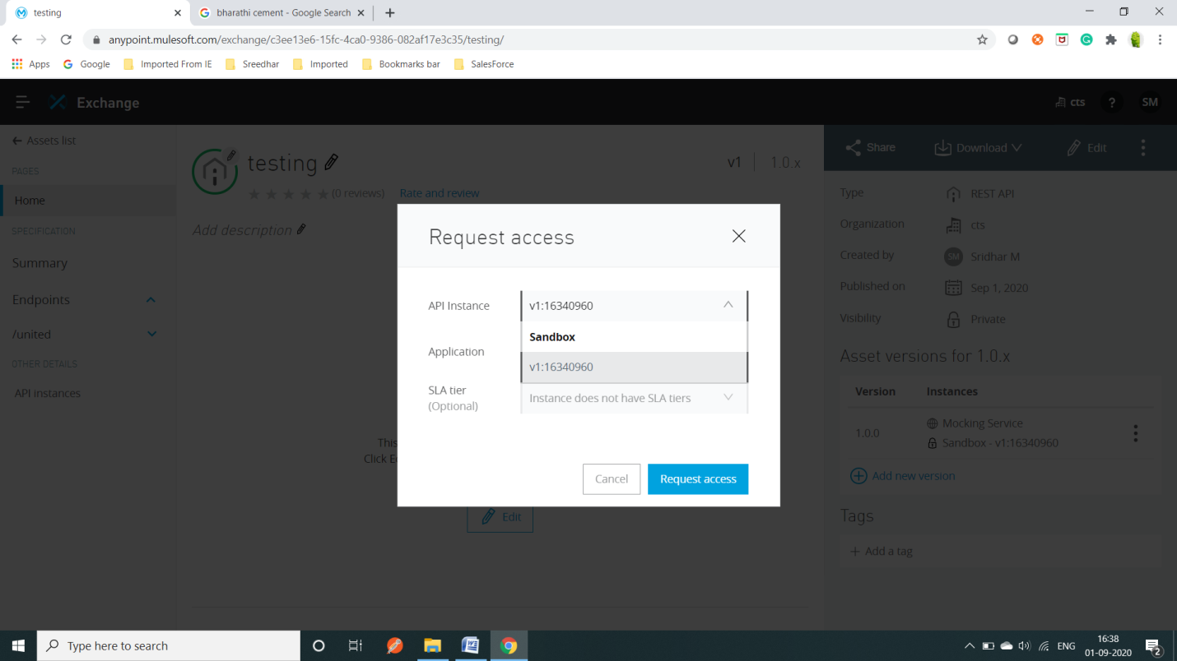

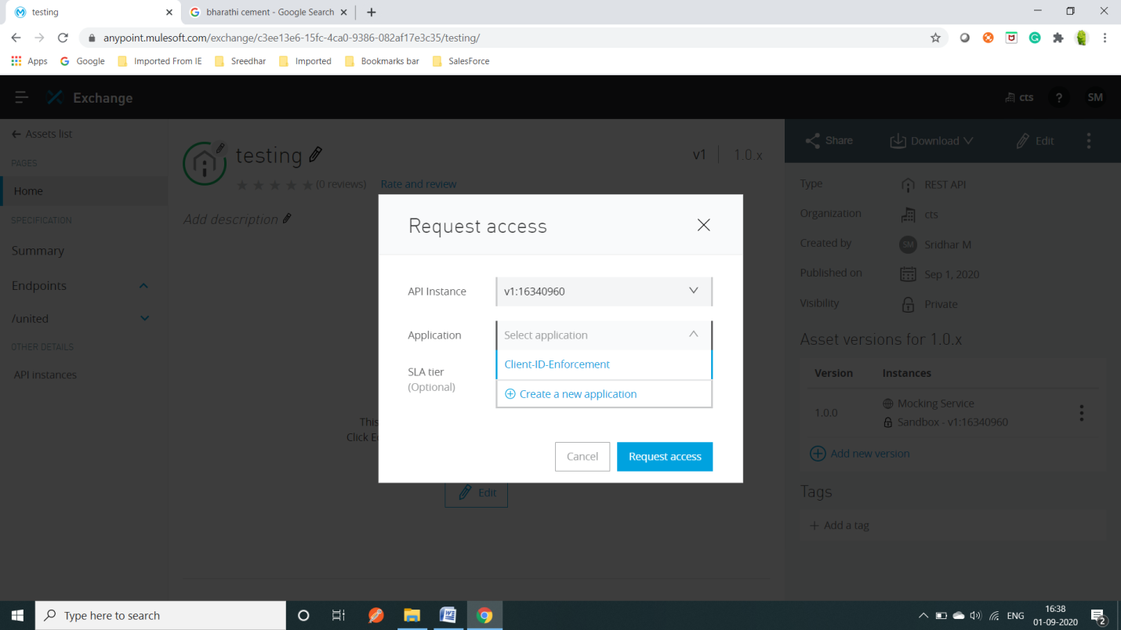

Create a new application

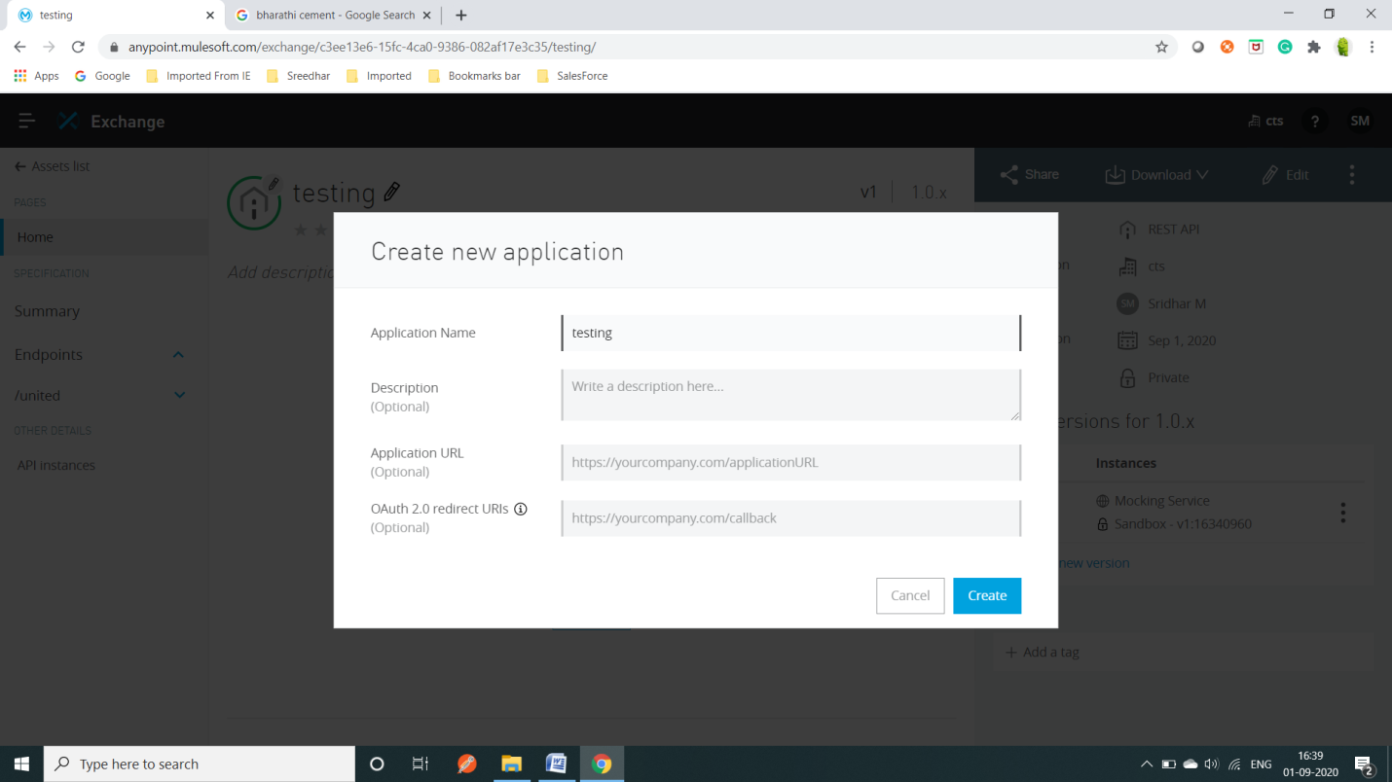

Once it done select ok. It give client-id &client-secret

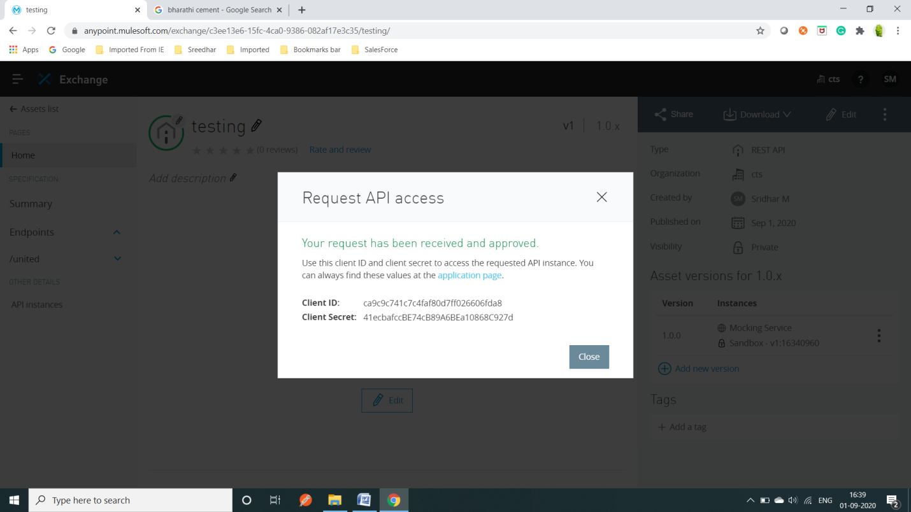

Click on api instances:- select you requirement api need in private and public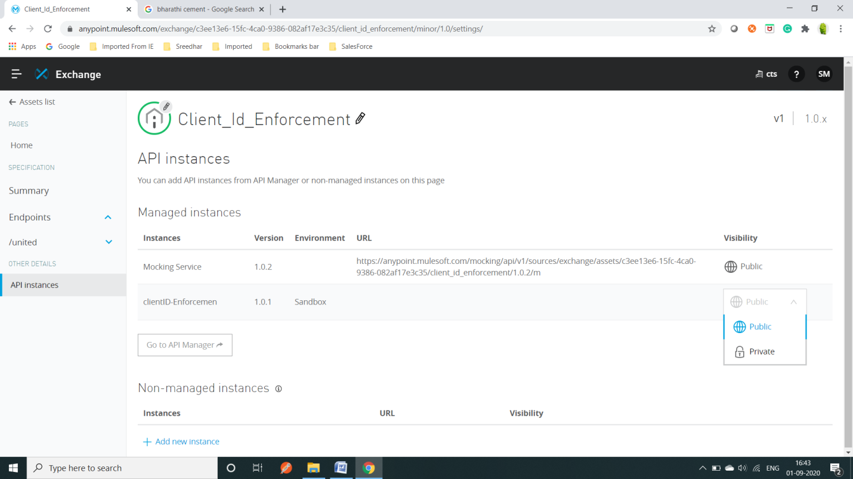

Once we done respecter URL come to the selected service :- there you can test your api

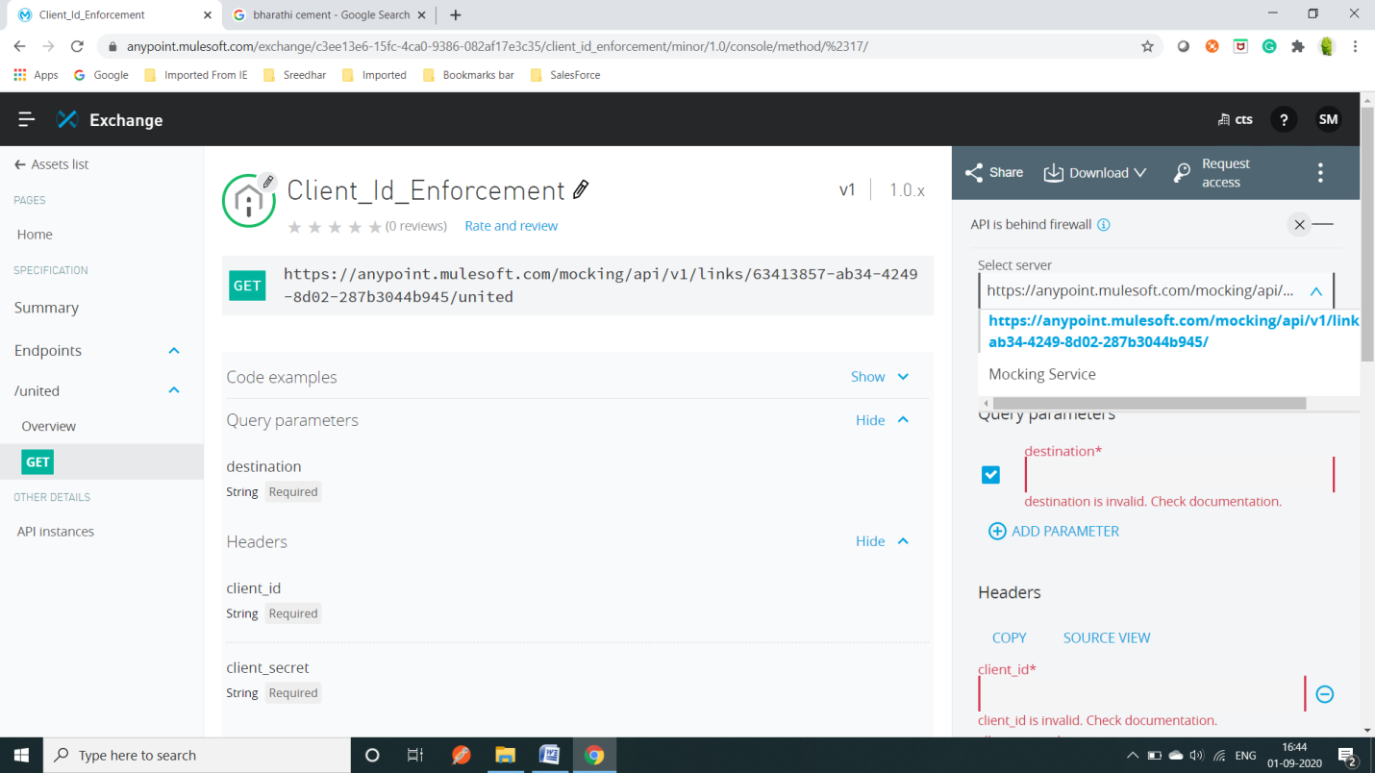

To check the clientId enforcement :

Goto exchange🡪my application 🡪click the api name🡪

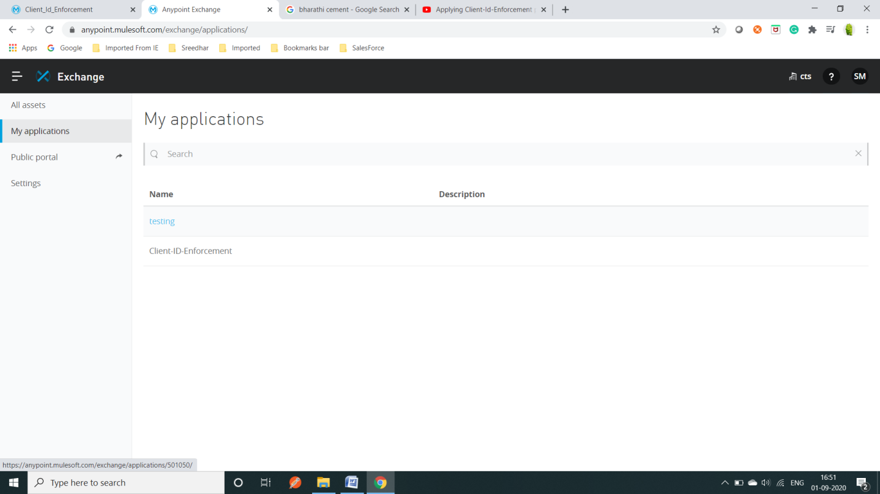

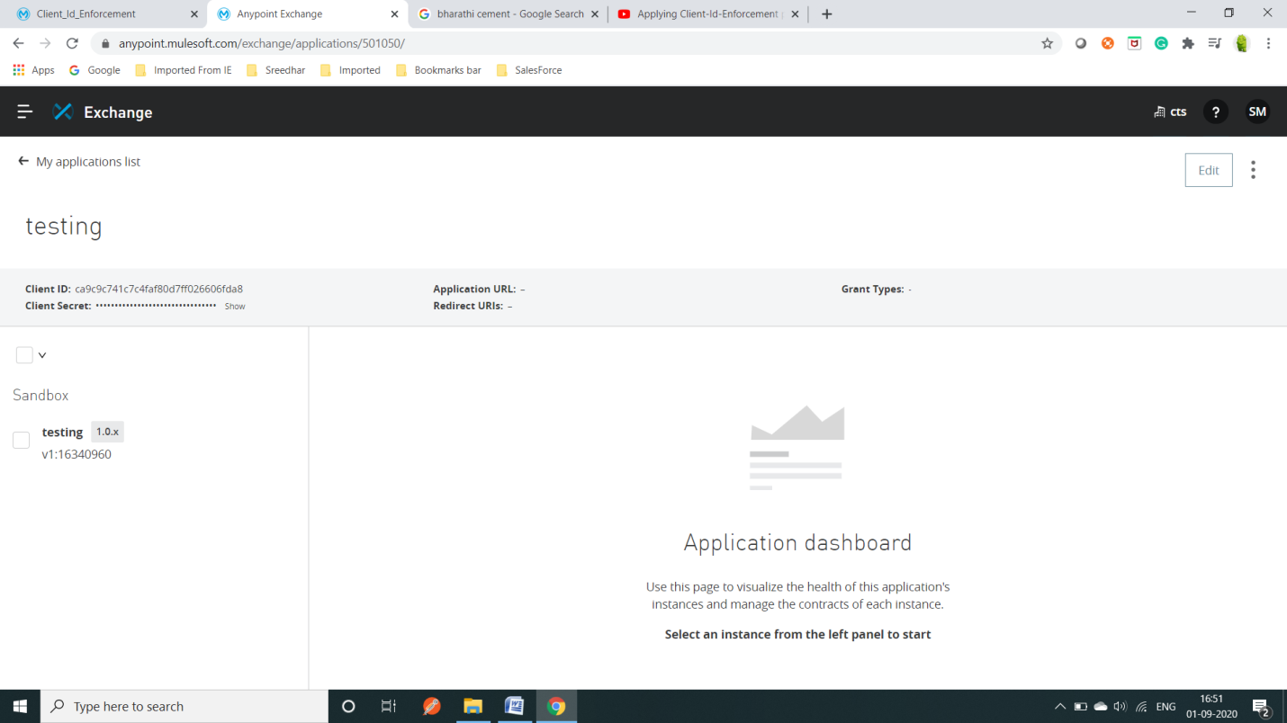

Step6:-

Now apply the policy:- 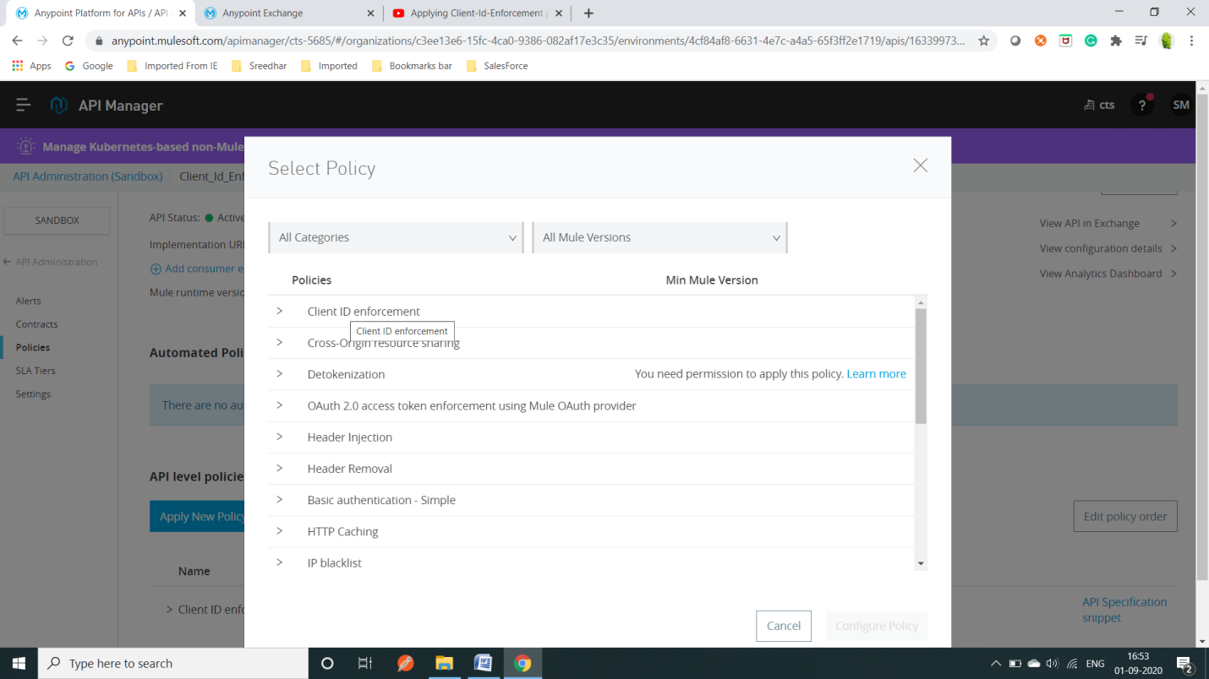

Video:- <https://www.youtube.com/watch?v=qMkB5IXq0CA>