GitHub

==============================

Version Control System:-VCS

Source Code Management:-SCM

Change directory : CD

Git have three stages

Working directory

Staging Area

Git directory `

What Type of Files Track

🡪All text Base Files

What Type of Files Not Track

🡪 Images, videos, Audion

How to DownLoad Git?

🡪 search git Download in google(<https://git-scm.com/download/win>)

How to Install GIt?

🡪Install the download software , after completing installation finally select gir bash

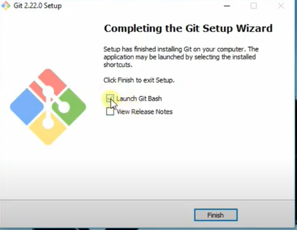

How to Place Git In you System?

🡪create one folder in pc

🡪 Right click the mouse 🡪select git bash in the new folder

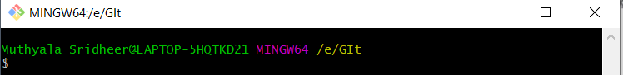

Or

🡪 Go To local Directory from any place of you system

Ex: you got local directory in “E” folder

🡪we login from desktop with commands

* Open git bash in desktop

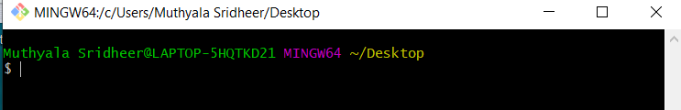

🡪 Now it got to e folder

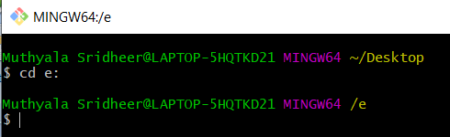

🡪now it go to git folder

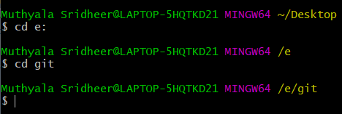

🡪if you want to go to one step back

🡪Use This Command cd ..

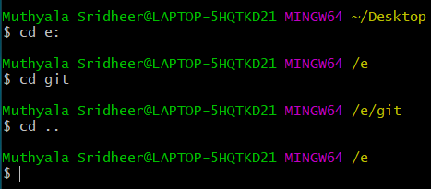

🡪 To list the files in directory

Use this command:-ls

How to initialize GIt repository ?

* To initialize git repository

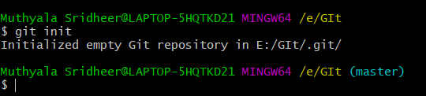

* It create .git hidden folder in local git repository

How to create Git repository from local git commands

URL:- https://github.com/sridharmuthyala/mule.git

Git Commands :-

To check the git Versions

🡪git --version

To initialize git repository

🡪 git init

To configure the user Id

🡪git config --global user.name “userName”

To configure the Email Id

🡪 git config --global user.email “ username ”

To check already existing userid and user email

🡪git config --list

To add the file

🡪git add filename

To check the status

🡪 git status

To commit the file in local directory

**🡪** git commit –m ”comment ”

To check the Status in local directory

**🡪** git log

To finally push the code to centeral repository

🡪git push

To clone repository

🡪Git clone (past the repository clone url )

To get update records in local pc

🡪 Git pull

To list the files in directory

🡪 Use this command:-ls

To list the hidden files in directory

🡪 Use this command:-ls -a

To Clear Screen

🡪clear