Explain the below linux commands with an example. Share the screenshot of each
command with the output:

1.pwd : This command is used to display the full pathname present working directory
of the user to the standard output screen
Command example: pwd

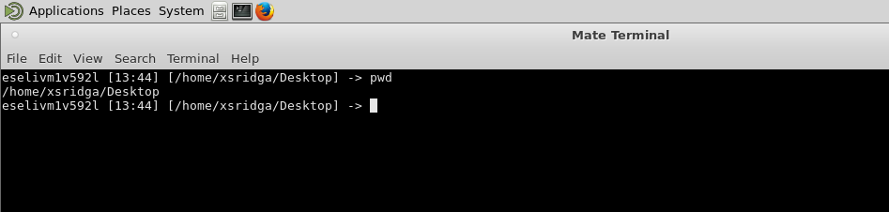

2. vi: vi is an editor to edit an existing file or to create a new file from scratch.
Command Example : vi filename
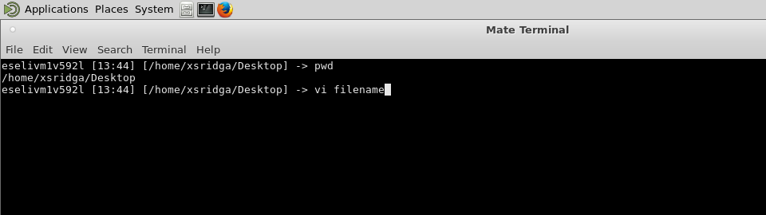
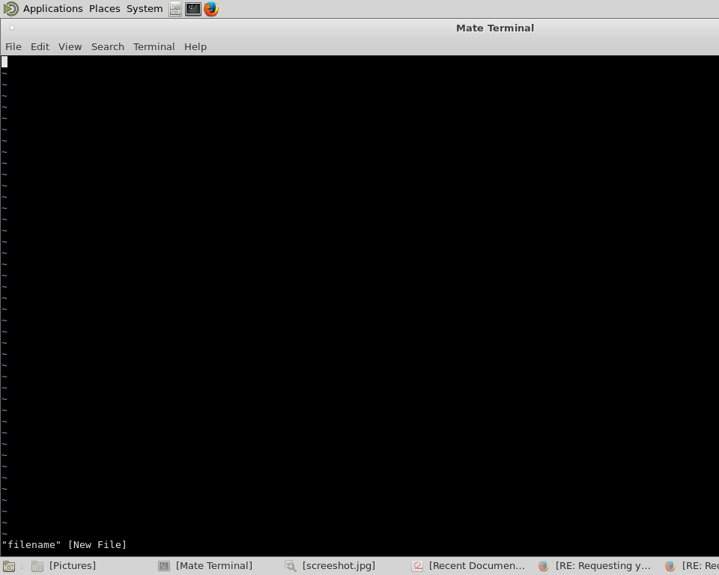

3. touch: touch command Update the access and modification times of each FILE to the current time.
A file argument that does not exist is created empty,
Command example: touch fileTouch // creates new file since already not available
Command example : touch file2 //updates access time of the already present file file2
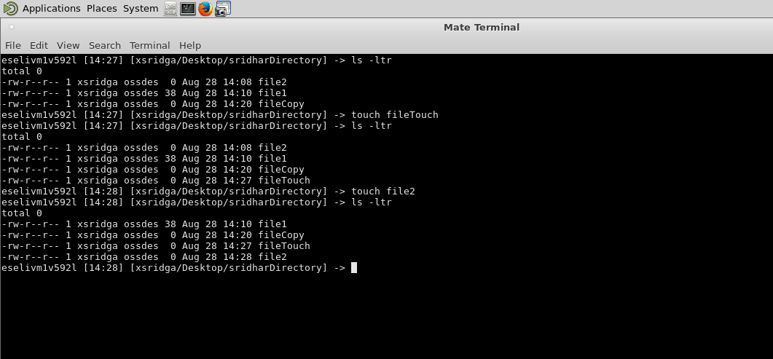

4. mkdir: The mkdir command is used to create the specified directory.
Command example: mkdir newDirectory
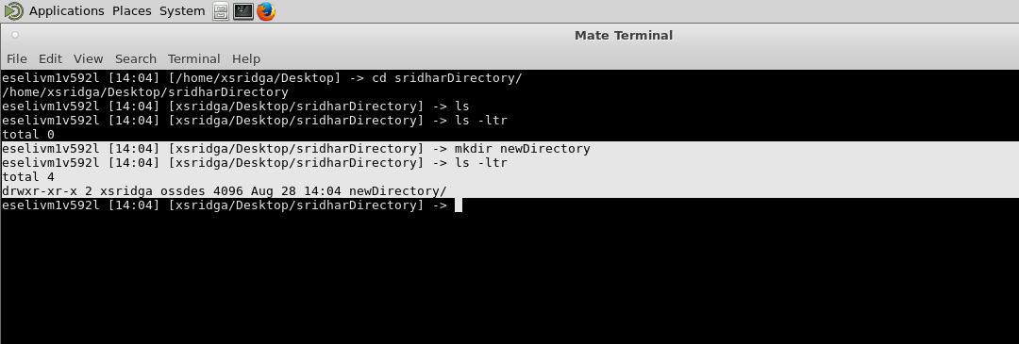

5. rm : rm removes each specified file. By default, it does not remove directories.
Command example: rm file1

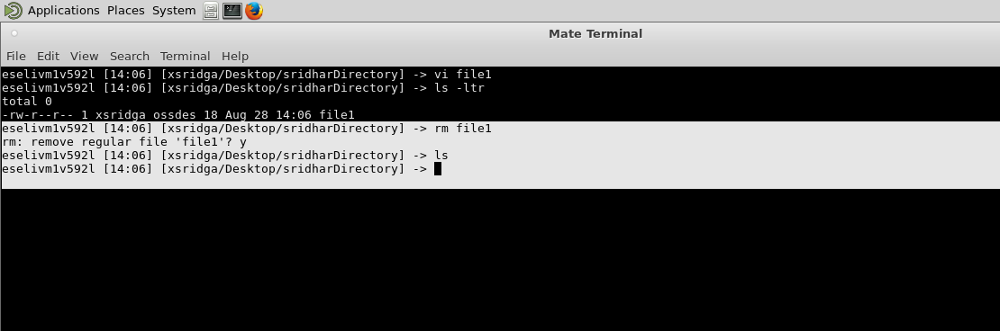

6. ls : List information about the FILEs (the current directory by default).
Command example: ls
ls -ltr

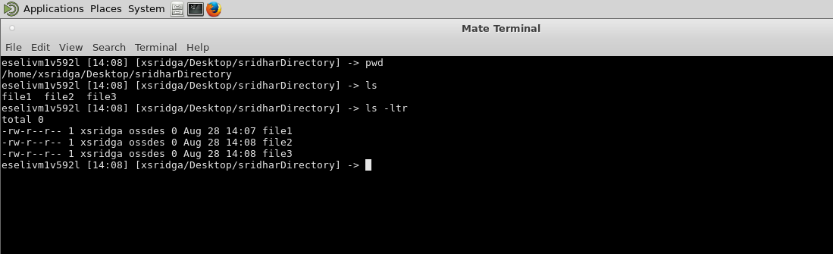

7. echo : Echo is used to display the Strings in the standard output.
Command example: echo “This is Unix tutorial”

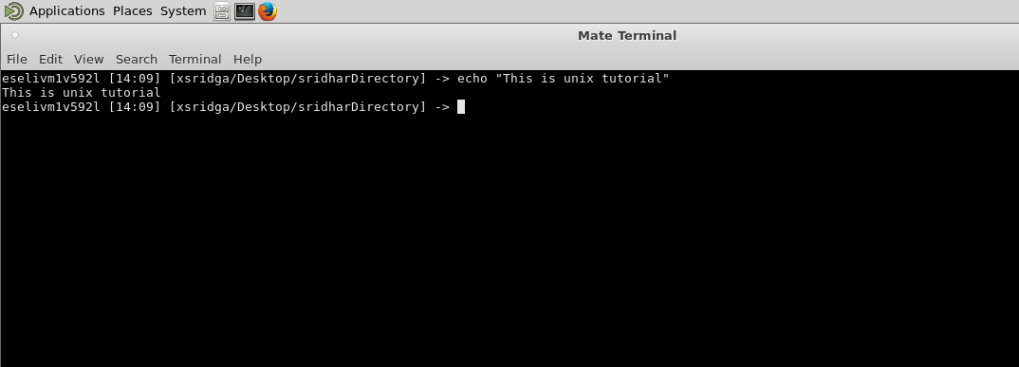

8. cat : It is used Copy standard input to standard output.
Command example: Cat file1
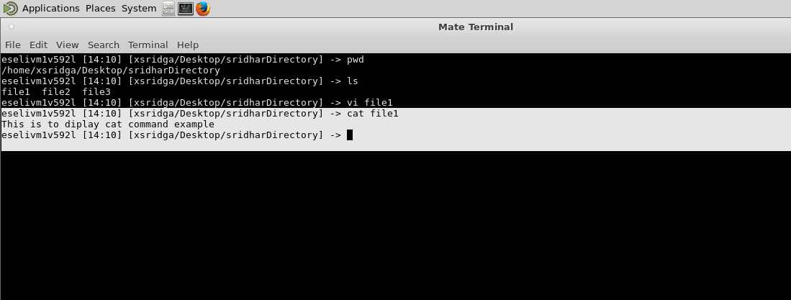
9. who : This command is used to print information about users who are currently logged in.
Command example: who

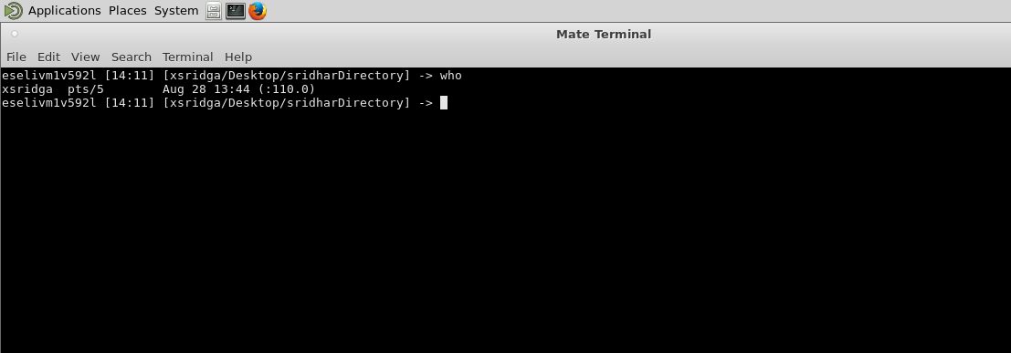

10.cd : This command is used to change the current directory to directory passed as argument
Command example: cd /
cd /home

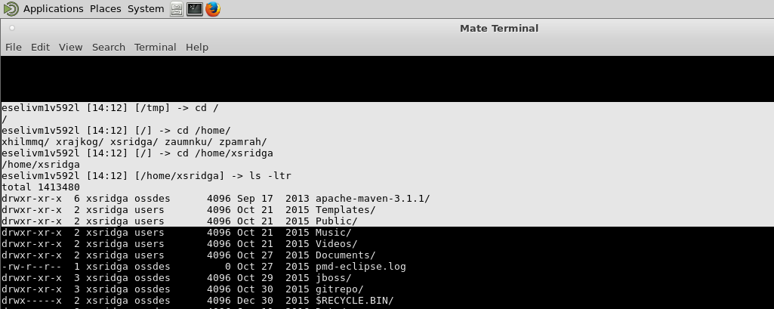

11.date : This comman is used print or set the system date and time
Command example: date

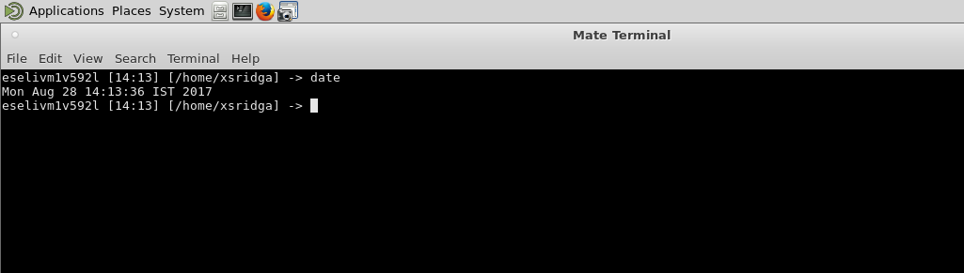

12.cal : This command displays a simple calendar. If no arguments are specified,
the current month is displayed.
Command example : cal

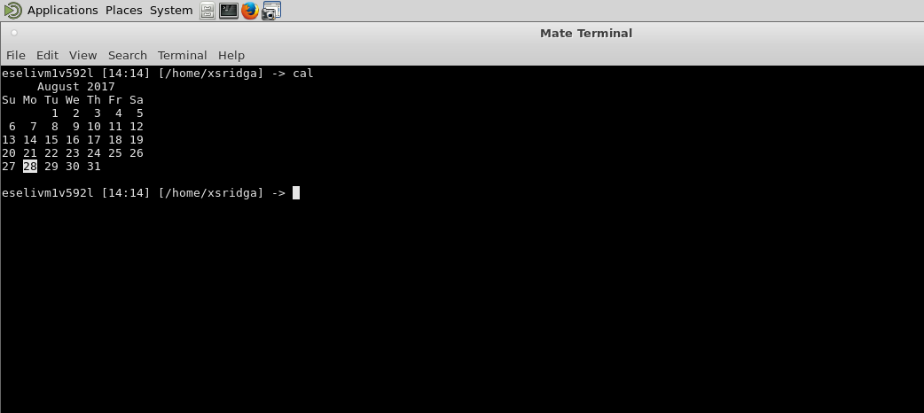

13.mv : This command is used to rename source file to destination file, or move source file(s) to destination directory.
Command example: mv file3 fileNameChange //renaming
mv fileNameChange /home/xsridga/Desktop

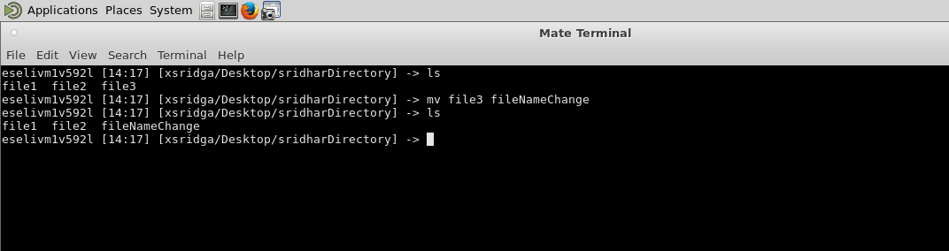
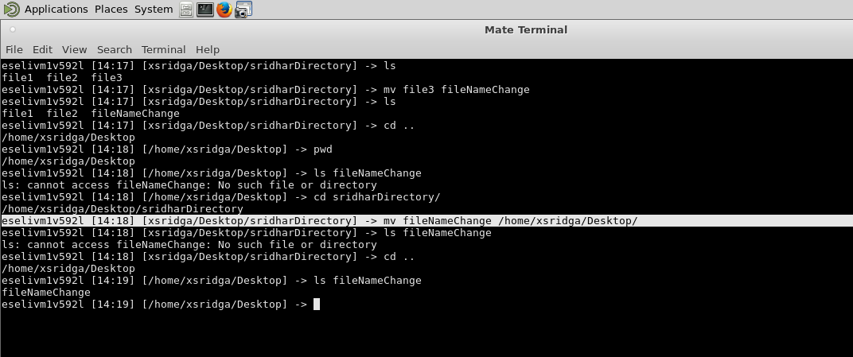

14.cp : This command is used to copy source file to destinaltion file, or multiple source filess) to DIRECTORY.
Command example: cp file2 fileCopy

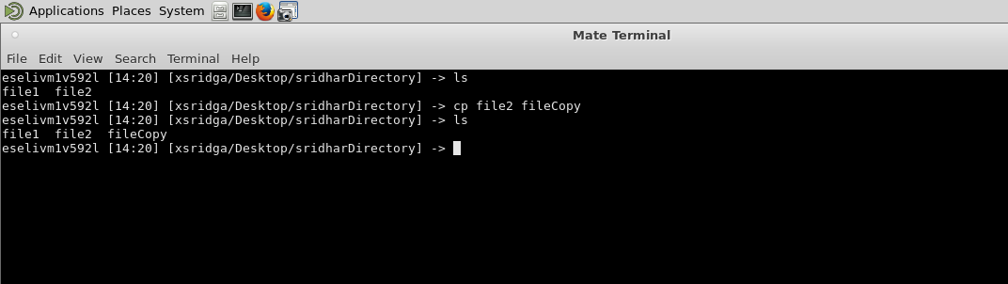

15.which: Which takes one or more arguments. For each of its arguments it prints to stdout the full path of the executables that would have been executed when this argument had been entered at the shell prompt
Command example: which cat
which ssh
