Session 2: HDFS

Assignment 2.1

Problem Statement

Task 1:
Check whether /user/acadgild directory exists or not in the HDFS.
If it doesn't exist, then create this.
Create a directory /user/acadgild/hadoop.

Solution: To check whether directory exist using command: hadoop fs –ls /user/acadgild
And then to create directory : hadoop fs –mkdir –p /user/acadgild/hadoop
Using option –p since /user/acadgild directory was not present already

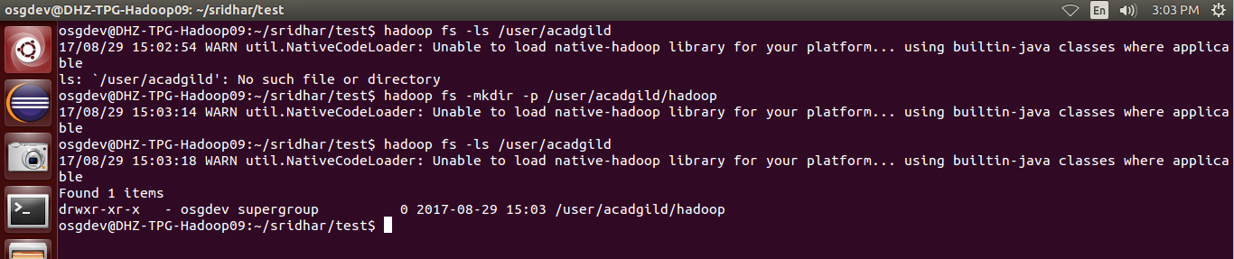

Task 2:
Create a file in HDFS under directory /user/acadgild/hadoop, with name word-count.txt.
Whatever we type on screen should get appended to the file.
Try to type (on screen) few lines from any online article or textbook.

Solution:
Create a file using command: hadoop fs –touchz /user/acadgild/hadoop/word-count.txt
This command will create an empty file.
To append to a file whatever we type on screen use command:
hadoop fs –appendToFile - /user/acadgild/hadoop/word-count.txt
<write the contents>
Ctrl+c to flush the text to the File
