**Assignment2.2**

**Problem Statement**

**Task:3**

Create a file max-temp.txt in local FS.

Put some 10-15 records of date and temperature example:

dd-mm-yyyy,temperature

Example:

10-01-1990,10

10-02-1991,20

Move this file to HDFS at /user/acadgild/hadoop.

**Soultion:**

Create file locally using vi editor

By using command: **vi max-temp.txt.**

File created locally:

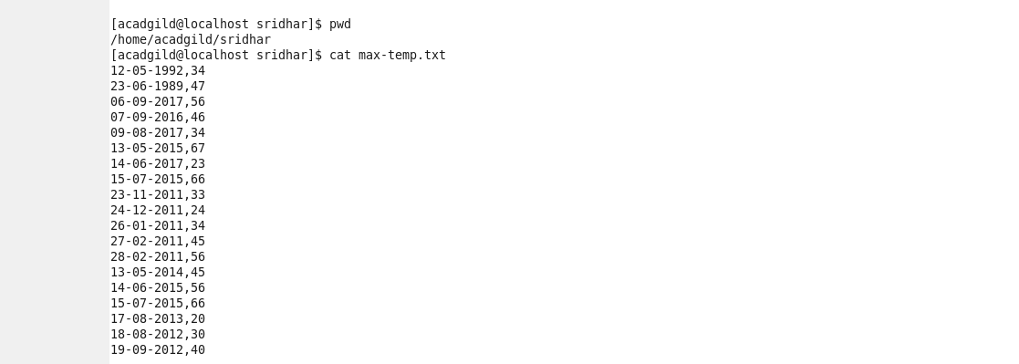

To move this file to hdfs location /user/acadgild/Hadoop

Use command : **hadoop fs –moveFromLocal max-temp.txt /user/acadgild/hadoop/**

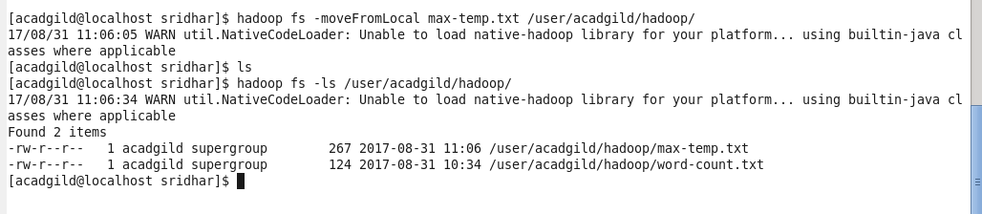

**Task:4**

Change the permission of the file /user/acadgild/hadoop/max-temp.txt, such that

only the owner and the group members have full control over the file.

Others do not have any control over it.

**Solution** Use command: **hadoop fs –chmod 770 /user/acadgild/hadoop/max-temp.txt**

Read is equivalent to ‘4’.Write is equivalent to ‘2’.Execute is equivalent to ‘1’

When we want to set permissions, we just add up the number. For example, to set the permissions to read and write, we will use ‘6’ (4 + 2) for the permission. For read, write and execute, we will use ‘7’ (4 + 2 + 1) for the permission.

