# **Ques 1: Find the list of players that have been selected in the qualifying round (DEFENCE>55).**

REGISTER ‘path-for-piggybank.jar’;

1. sourceFile = LOAD '/home/acadgild/sridhar/pig/problem3/Pokemon.csv' USING org.apache.pig.piggybank.storage.CSVExcelStorage(',','NO_MULTILINE','UNIX','SKIP_INPUT_HEADER');

--load the source file using CSVExcelStorage load func

1. selectedPlayers = FILTER sourceFile by $7 > 55;

--Get the list of player who rualify round , by filtering defence > 55 , which is at index $7

dump selectedPlayers;

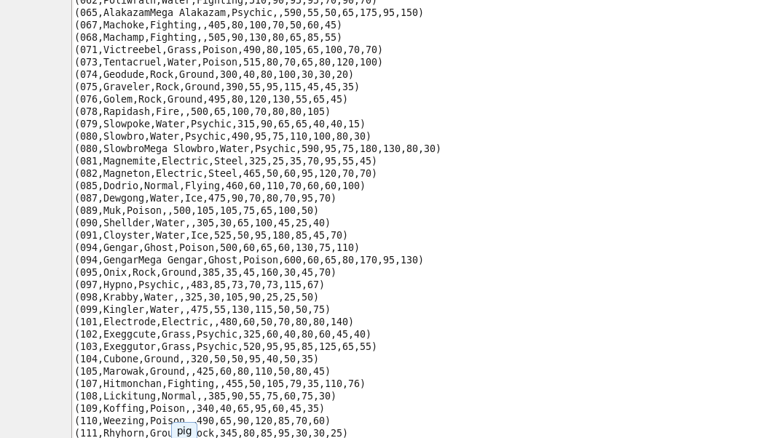

# **Ques 2: State the number of players taking part in the competition after getting selected in the qualifying round.**

1. groupPlayers = GROUP selectedPlayers ALL;

--Group relation selectedPlayers to get the count of number of players

1. countPlayers = FOREACH groupPlayers GENERATE COUNT(selectedPlayers);

* Count the number of players using count()

dump countPlayers;

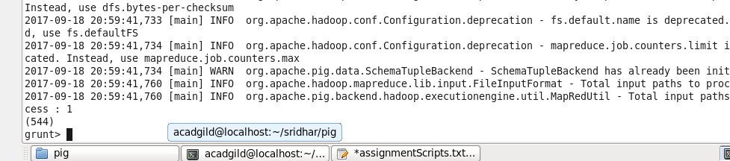

# **Ques 3: Using random() generate random numbers for each Pokémon on the selected list.**

1. GenerateRandon = FOREACH selectedPlayers GENERATE $0, $1 ,$2 ,$3 , $4, $5 , $6, $7 , $8 , $9 , $10 , RANDOM();

--generate random numbers for for each pokemon by using random()

dump GenerateRandon;

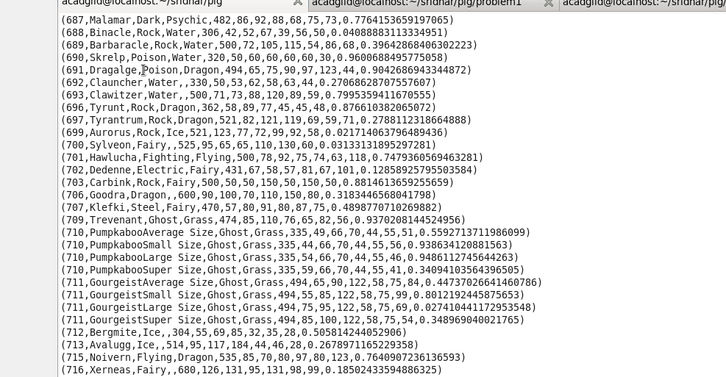

# **Ques 4: Arrange the new list in a descending order according to a column randomly.**

1. descRandom = ORDER GenerateRandon by $11 DESC;

--Sort the relation GenerateRandon in descending order of random column which is at index $11

dump descRandom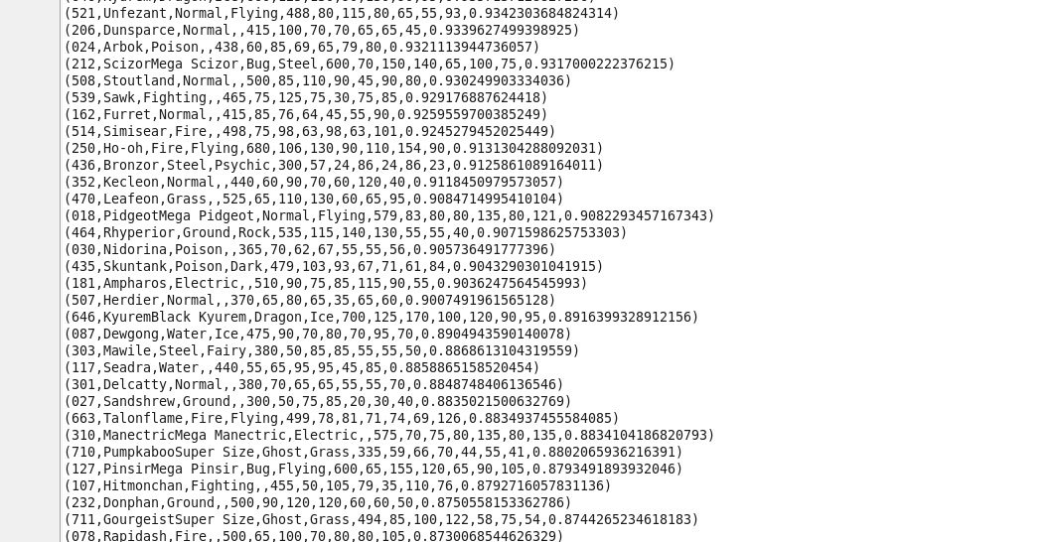

# **Ques 5: Now on a new relation again associate random numbers for each Pokémon and arrange in descending order according to column random.**

1. randomAgain = FOREACH descRandom GENERATE $0, $1 ,$2 ,$3 , $4, $5 , $6, $7 , $8 , $9 , $10 , $11 , RANDOM();

--Get the random list again on the newly created random relation

dump randomAgain;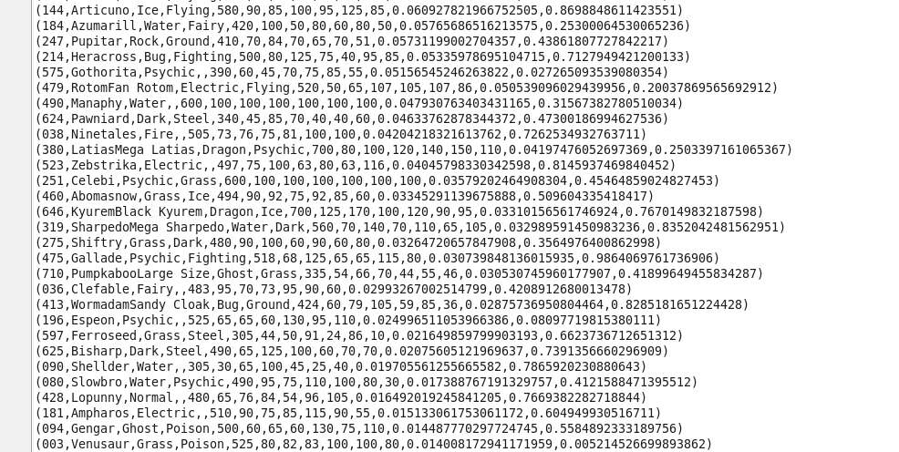

1. randomAgainDesc = ORDER randomAgain by $12 DESC;

--sort the relation by random column which is at $12 by using desc

dump randomAgainDesc;

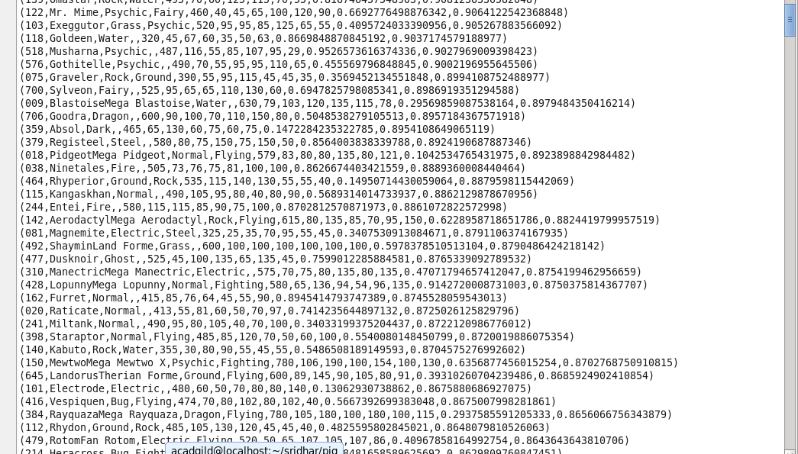

# **Ques 6: From the two different descending lists of random Pokémons, select the top 5 Pokémons for 2 different players.**

1. top5Random1 = LIMIT descRandom 5;

--Get the top 5 list using limit operator

dump top5Random1;

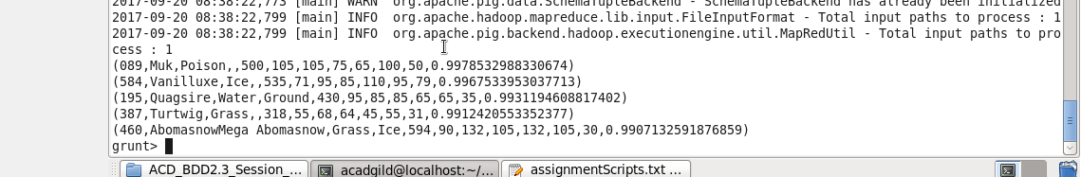

1. top5Random2 = LIMIT randomAgain 5;

--Get the top 5 list using limit operator

dump top5Random2;

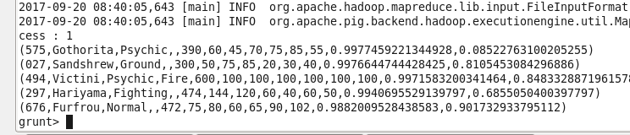

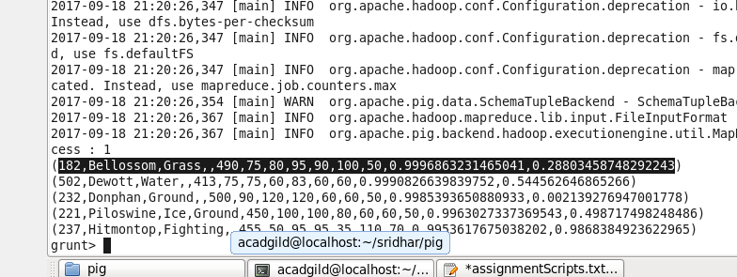

# **Ques 7: Store the data on a local drive to announce for the final match. By the name player1 and player2 (only show the NAME and HP).**

1. player1 = FOREACH top5Random1 GENERATE $1 ,$5;

--Fetch name($1) and HP($5) from the relation

dump player1;

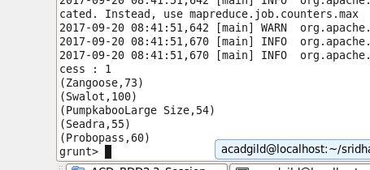

1. player2 = FOREACH top5Random2 GENERATE $1 , $5;

--Fetch name($1) and HP($5) from the relation

dump player2;

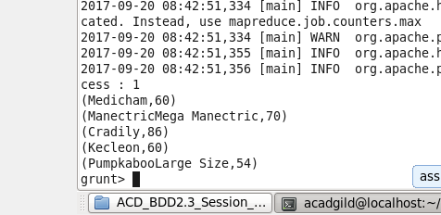

STORE player1 into 'player1/' USING org.apache.pig.piggybank.storage.CSVExcelStorage();

STORE player2 into 'player2/' USING org.apache.pig.piggybank.storage.CSVExcelStorage();

--Store both players

