**Session 06: Hive Introduction**

**Assignment 1**

Create a database named 'custom'.

Create a table named temperature_data inside custom having below fields:

1. date (mm-dd-yyyy) format

2. zip code

3. temperature

The table will be loaded from comma-delimited file.

Load the dataset.txt (which is ',' delimited) in the table.

CREATE DATABASE IF NOT EXISTS custom;

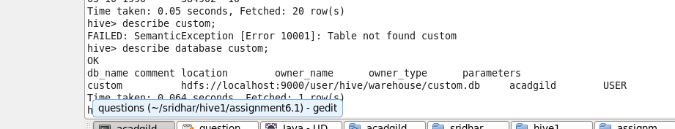

1. **First we will create a staging table with data type String so that we can store all the values.**

CREATE TABLE stg_temperature_data(

date string,

Zip_code string,

temperature string

)

ROW FORMAT DELIMITED

FIELDS TERMINATED BY ','

STORED AS TEXTFILE;

1. **Load the staging table:**

LOAD DATA LOCAL INPATH '/home/acadgild/sridhar/hive1/assignment6.1/dataset_Session 14.txt' INTO TABLE custom.stg_temperature_data;

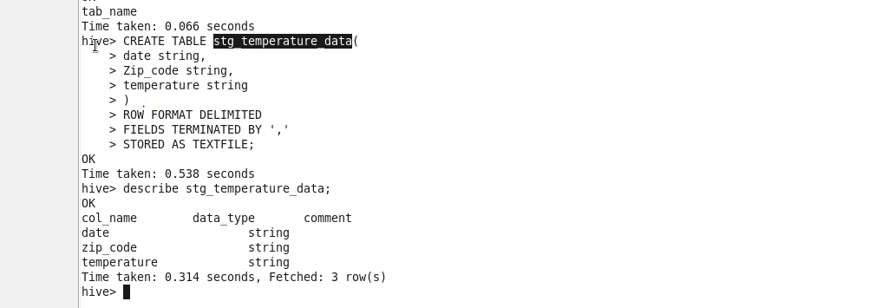

Output records:

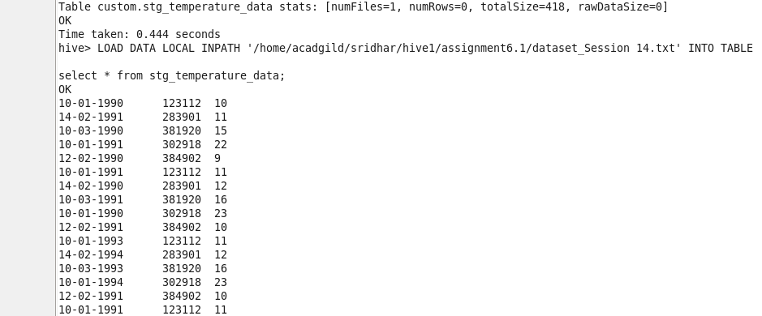

1. **Next we will create final table with proper data types , which could be used for data processing**

CREATE TABLE temperature_data(

date string comment 'Date' ,

Zip_code int comment 'Zip code',

temperature string comment 'Temperature'

);

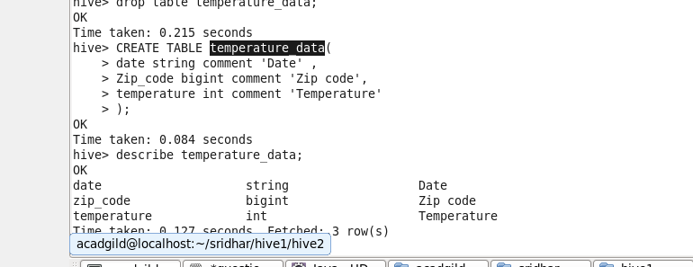

1. **Loading data into target table:**

INSERT INTO TABLE custom.temperature_data

select

from_unixtime(unix_timestamp('10-03-1990','dd-MM-yyyy'),'MM-dd-yyyy') as date,

Zip_code,

temperature from custom.stg_temperature_data;

