**5. Problem Statement**

## **• Fetch date and temperature from temperature_data where zip code is greater than**

## **300000 and less than 399999.**

SELECT

from_unixtime(unix_timestamp(date,'yyyy-MM-dd'),'MM-dd-yyyy') as date,

temperature

FROM temperature_data

WHERE zip_code > 300000 AND zip_code < 399999 ;

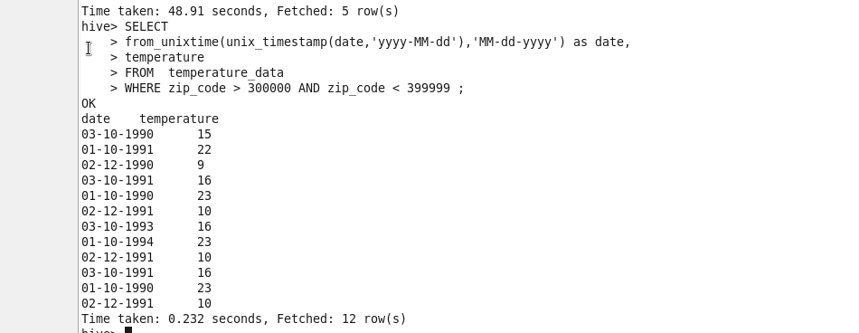

## **• Calculate maximum temperature corresponding to every year from temperature_data**

## **table.**

//Make use of rank over analytic function first to get the maximum temperature corresponding to years

//To verify proper result I am displaying RANK and as well

select year , temperature , RANK from

(

select YEAR(date) as year ,

temperature,

rank() OVER (PARTITION by YEAR(date) ORDER by temperature DESC) AS RANK

FROM temperature_data

) temp

WHERE RANK = 1;

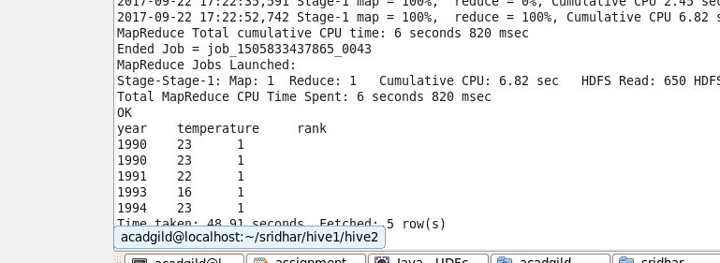

## **• Calculate maximum temperature from temperature_data table corresponding to those**

## **years which have at least 2 entries in the table.**

//Make use of rank over analytic function first to get the maximum temperature corresponding to year , and again use count over function on year and partitioned on year to get the entry with atleast 2 entries

//To verify proper result I am displaying RANK and count of YEAR as well

select year,

temperature,

RANK,

countYear

FROM

(select year,

temperature,

RANK,

count(year) over (PARTITION BY YEAR) as countYear

from(

select YEAR(date) as year ,

temperature,

rank() OVER (PARTITION by YEAR(date) ORDER by temperature DESC) AS RANK,

COUNT(YEAR(date)) OVER (PARTITION by YEAR(date) ) AS count

FROM temperature_data

)temp

WHERE RANK = 1

) temp2

where countYear>=2;

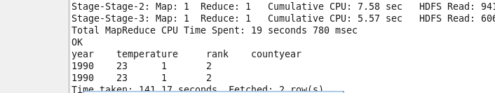

## **• Create a view on the top of last query, name it temperature_data_vw.**

View with maximum temperature from temperature_data table corresponding to those

years which have at least 2 entries in the table.

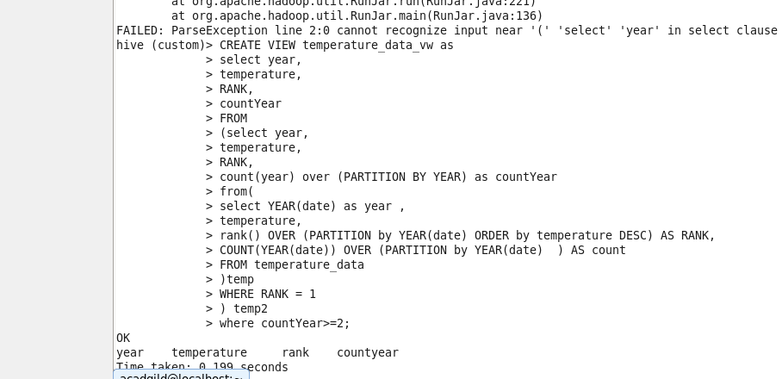

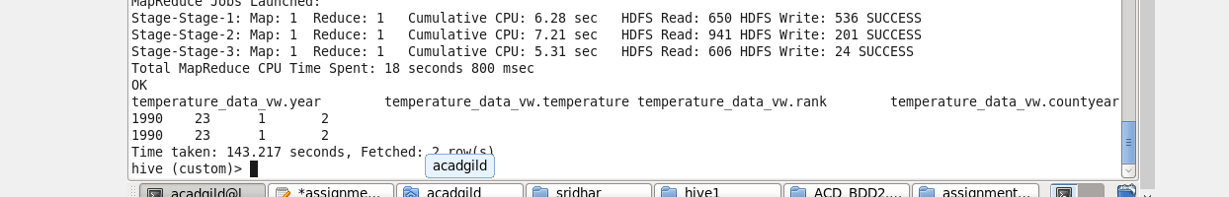

## **• Export contents from temperature_data_vw to a file in local file system, such that each**

## **file is '|' delimited.**

Storing year, temperature a, rank and the count of years for validation.

Could have stored only temperature but with that couldn’t shown that fields were delimited with ‘|’.

INSERT OVERWRITE LOCAL DIRECTORY'/home/acadgild/sridhar/hive1/assignment6.2'

ROW FORMAT DELIMITED

FIELDS TERMINATED BY '|'

select * from temperature_data_vw;

Displaying output in local file system

