Session 06: Hive Introduction
Assignment 3 Question
Problem Statement:
● Explain Hive Architecture in Brief.

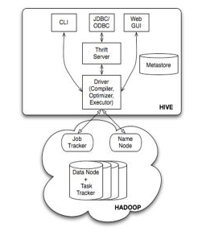
The above diagram shows the basic Hive architecture. This primarily represents CLI(Command Line Interface), JDBC/ODBC, Web GUI.
That means when user comes with CLI is hive terminal, They can directly connect to Driver program.
When the user comes with JDBC/ODBC program they can connect to Driver program through Java Thrift Server (Thrift API) .
When the user comes with Web GUI (Ambari server), they can directly connect to Driver program.

The Hive Driver receives users queries or tasks and send it to Hadoop . The Hadoop architecture uses Job tracker, Task tracker , Namenode and data node for receiving and dividing the work what hive sends to Hadoop.

Internal working of Hadoop Hive Arcitecture.
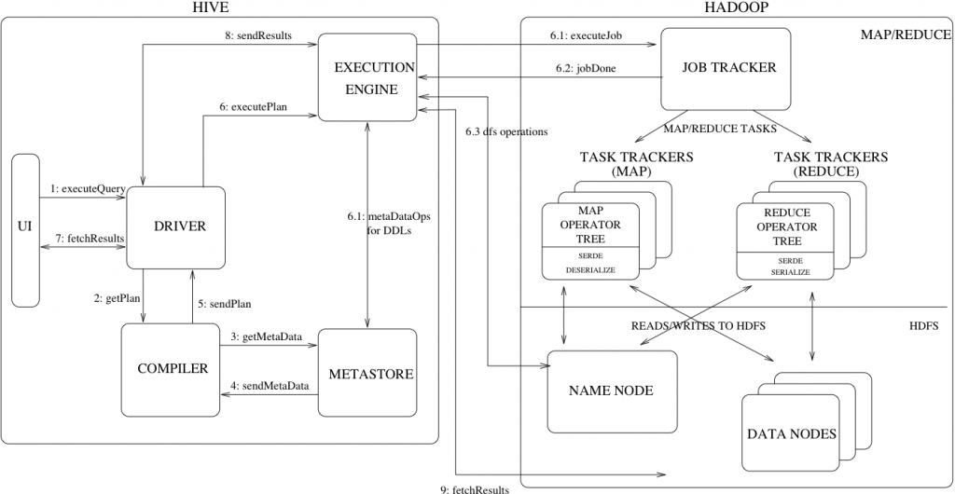
Step 1:The user through UI( either CLI or Web GUI) sends queries as a request to the Driver
Step 2: The Driver program sends the queries to the complier to get the execution plan of the query.
Step 3 & 4: The complier gets the metadata information from the Metastore .
Step 5: The compiler , after receiving the metadata information , does optimization, prunes partitions from the queries and prepares the DAG of the stages , these stages could be either be Mapper operation or reducer operation or HDFS operation or a metadata operation and passes it to the Execution engine.
Step 6:Based on the operations to be performed , the execution engine submits these operation to appropriate components(6.1,6.2,6.3) .Each operation result is stored in a temporary table, which could be read by applying deserialization. And for DML operation by applying serialization the results are stored in temporary tables/locations.
Step7,8,9: The query output is fetched to the user from these temporary tables by the execution engine directly from HDFS.

● Explain Hive Components in Brief.
Hive Components:
UI: The UI interface through which the user executes the query and fetches results , it could either be CLI (Hive Terminal)or Web GUI(Ambari Server)
Driver: This component receives queries from the UI .This components is responsible for handing sessions of the queries. This Drivers provides APIs for fetch and execute for JDBC/ODBC program , through Thrift Server(API).
Compiler: This component is responsible to check the semantics of the query. Prune the partitions , optimizes the query, and provides the execution plan which is DAG stages.
Metastore: This component hold all the metadata information like the partitions of the tables, information about column types, the HDFs location of the data stored etc,
Execution Engine: This component receives the execution plan from the Driver and submits operation on appropriate components. This engine is responsible for managing the dependencies of all the DAG stages

