Session 07: Hive Operations
Assignment 3 Question

Explain the below concepts with an example in brief.
● Hive Data Definitions
● Hive Data Manipulations
● HiveQL Manipulations

Hive Data Definitions
These statements are used to build and modify the tables and other objects in the database.
Example :
CREATE, DROP, TRUNCATE, ALTER, SHOW, DESCRIBE Statements.

Example:
Create command: This command can used to create DATABASE/SCHEMA, TABLE, VIEW, FUNCTION, INDEX.

Syntax:

CREATE DATABASE/SCHEMA, TABLE, VIEW, FUNCTION, INDEX
DROP DATABASE/SCHEMA, TABLE, VIEW, INDEX
TRUNCATE TABLE
ALTER DATABASE/SCHEMA, TABLE, VIEW
MSCK REPAIR TABLE (or ALTER TABLE RECOVER PARTITIONS)
SHOW DATABASES/SCHEMAS, TABLES, TBLPROPERTIES, VIEWS, PARTITIONS, FUNCTIONS,INDEX[ES], COLUMNS, CREATE TABLE
DESCRIBE DATABASE/SCHEMA, table_name, view_name

Example:

CREATE DATABASE IF NOT EXISTS <DB_NAME>
COMMENT <comments>
LOCATION <directory path>
WITHDBPROPERTIES<<propertyName>=<propertyValue>>;

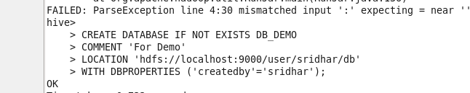

Example to create table:
CREATE TABLE IF NOT EXISTS sridhar
(
Id int,
Name string
)
ROW FORMAT DELIMITED
FIELDS TERMINATED BY ‘,’
STORED as textfile;

Example for Creating table
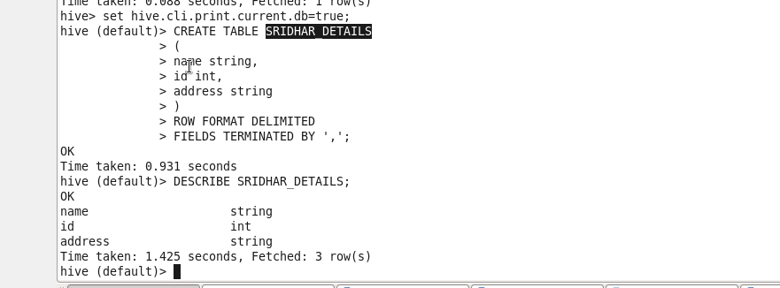

ALTER: ALTER command can be used to modify the metadata of a namespace , a database , a table , a macro etc

Example: Renaming table name using ALTER

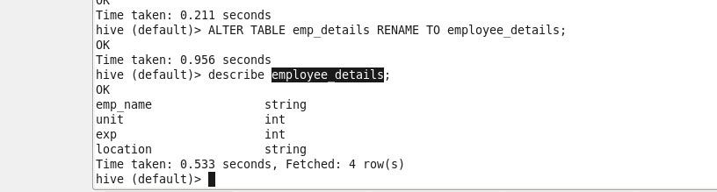
Using ALTER command to change the column name:
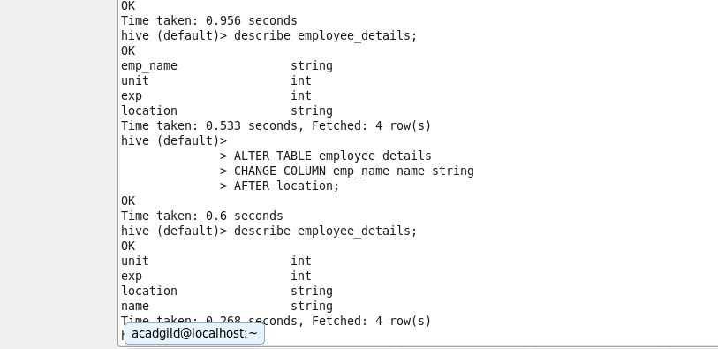

DROP:
DROP DATABASE DB_DEMO;
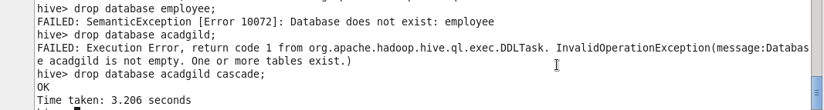

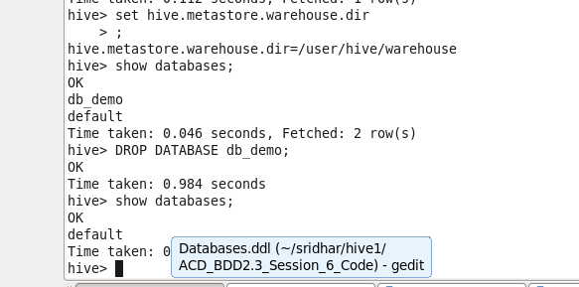

Describe provides information about the schema of the table.

Hive Data Manipulations
These statements are used to retrieve, store, modify, delete, insert and update data in the database.
Example :
LOAD, INSERT , SELECT Statements.
Syntax :
LOAD data <LOCAL> inpath <file path> into table [tablename]
The Load operation is used to move the data into corresponding Hive table. If the keyword local is specified, then in the load command will give the local file system path. If the keyword local is not specified we have to use the HDFS path of the file.

LOAD DATA LOCAL INPATH '/home/acadgild/sridhar/hive/assignment7/emp_details.txt' INTO TABLE employee;
Insert Statement
This statement can be used to insert data from one table to

INSERT INTO TABLE olympics
SELECT
Athlete_Name,
Age,
Country,
Year,
to_date(from_unixtime(unix_timestamp(Closing_Date,'MM-dd-yy'))) ,
Sport,
Gold_Medals,
Silver_Medals,
Bronze_Medals,
Total_Medals
FROM olympics_stg;

SELECT Statement:
To retrieve records
select DISTINCT Country, No_of_medals FROM
(
SELECT
Country,
COUNT(Total_Medals) OVER (PARTITION by(Country)) as No_of_medals,
sport
FROM olympics
)temp
WHERE Sport='Swimming';
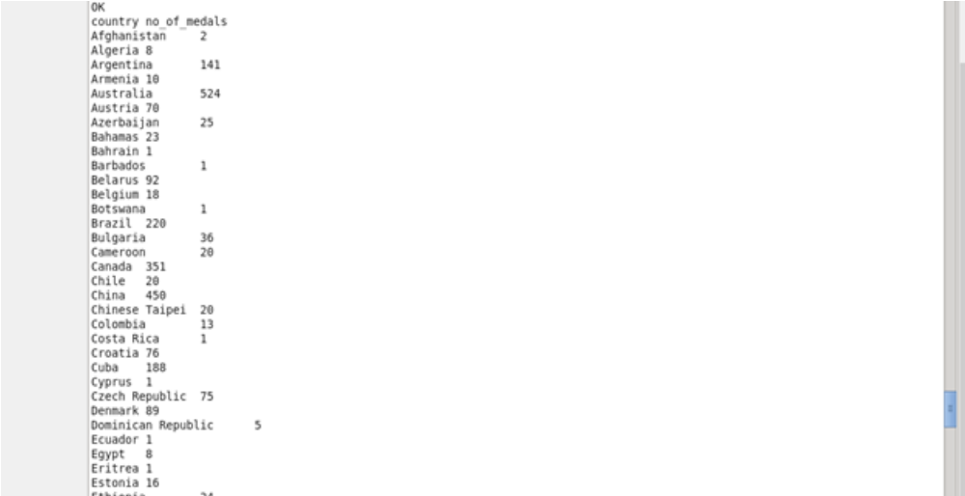

HiveQL Manipulations
If we have more than one command to execute then we can dump those commands into an HQL file which we can run using the command from the terminal like
hive -f filename.hql

