**Session 08: Advanced Hive**

**Assignment 1**

## **\*Get a list of employees who receive a salary less than 100, compared**

## **to their immediate employee with higher salary in the same unit**

CREATE TABLE users

(

id INT,

name STRING,

salary INT,

unit STRING

)

ROW FORMAT DELIMITED

FIELDS TERMINATED BY '\t';

**Records of employee with Department as unit ,and their salaries**

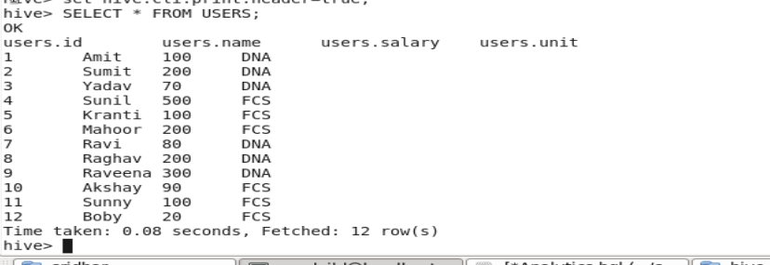

**Query:**

SELECT NAME ,UNIT, SALARY , LEAD_SALARY FROM(

SELECT NAME,UNIT, SALARY,LEAD(SALARY) OVER (PARTITION BY (UNIT) ORDER BY SALARY ) AS LEAD_SALARY

FROM USERS

)table

WHERE table.SALARY <100;

**Output**: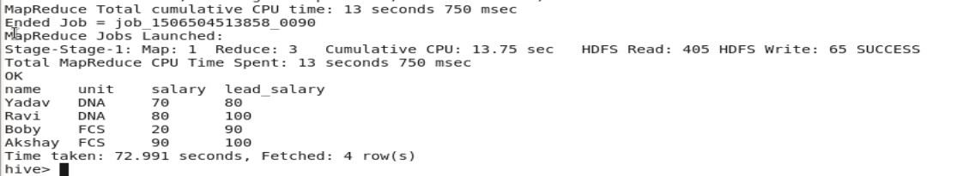

## **\* List of all employees who draw higher salary than the average salary**

## **of that department**

**Query:**

SELECT NAME ,UNIT, SALARY , AVERAGE_SALARY FROM

(

SELECT NAME ,UNIT, SALARY , AVG(SALARY) OVER(PARTITION BY (UNIT)) AS AVERAGE_SALARY FROM USERS

) TABLE

WHERE TABLE.SALARY > TABLE.AVERAGE_SALARY;

**Output**:

