ACID stands for four traits of database transactions:
- Atomicity (an operation either ACID stands for four traits of database transactions
- Consistency (once an application performs an operation the results of that operation are visible to it in every subsequent operation)
- Isolation (operations by one user do not cause unexpected side effects for other users)
- Durability (once an operation is complete it will be preserved even in the face of machine or system failure).

Properties that needs to be set appropriately in hive shell
SET hive.support.concurrency=true;
SET hive.enforce.bucketing=true;
SET hive.exec.dynamic.partition.mode=nonstrict;
SET hive.txn.manager=org.apache.hadoop.hive.ql.lockmgr.DbTxnManager;
SET hive.compactor.initiator.on=true;
SET hive.compactor.worker.threads=1;

Creating a Table That Supports Hive Transactions
create table hive_dml
(emp_id int,
first_name string,
last_name string)
clustered by (emp_id) into 4 buckets
stored as orc
tblproperties ('transactional'='true');

Inserting Data into a Hive Table

insert into hive_dml values
(1001501,'alaister','briito'),
(1001502,'anifa','mohammed'),
(1001503,'piyush','manish'),
(1001504,'vijay','karthik'),
(1001505,'narasingh','rao');
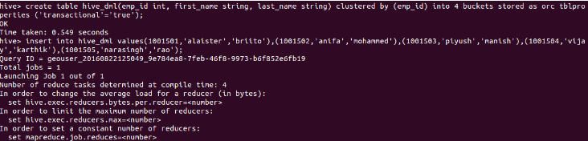

select * from hive_dml;
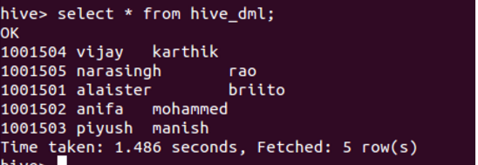

Updating the Data in Hive Table

update hive_dml set last_name='yadav' where emp_id=1001505;

View the data after complete the update
select * from hive_dml;

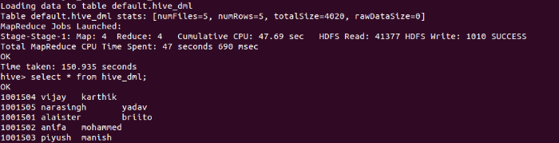

Deleting a Row from Hive Table

delete from hive_dml where emp_id=1001502;

View the data after complete the delete
select * from hive_dml;
