**PROJECT REPORT:**

Encryption and Decryption between users in Morse using a Flashlight.

**1.ABSTRACT**

* **Morse code** is the most basic emergency communication method. It expresses alphabet and numbers by using the combinations of dots and dashes.
* **Morse code** is a method of encoding text characters based on signal duration. Alphabets and numbers are represented as dots and dashes

**2. Table of Contents**

* Introduction
* Existing Method
* Proposed method with Architecture
* Methodology
* Implementation
* Conclusion

**3. Introduction**

* **Morse code**
* It is one of the methods used in telecommunication to encode text characters as standardized sequences of two different signal durations, called dots and dashes, or dits and dahs.
* Morse code is named after Samuel Morse, one of the inventors of the telegraph.

**4. Existing Method**

* An original solution to the problem that caretakers have to learn to decode has been an electronic typewriter with the codes written on the keys.
* Morse code can also be translated by computer and used in a speaking communication aid.

**5. Proposed method with Architecture**

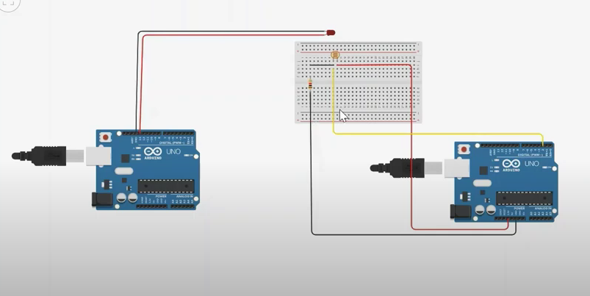

**6. Methodology and Implementation**

* One of the most common methods of code communication is Morse code. This work is carried out in three steps,

1: First the message is encrypted to morse code. The encrypted morse code should be made visible to the target. For this purpose flash light is used. This flashlight should blink according to the encrypted morse code.

2: To link this flashlight and the encrypted morse code Arduino UNO is used. Arduino UNO toggles the flashlight according to the user input.

3: Flash-toggling which is received on the target side gets reconverted into morse code and then decrypted into text is done successfully.

The code for encryption and decryption is compiled successfully in Terminal

**8. Conclusion**

* It worked by transmitting electrical signals over a wire laid between stations.
* In addition to helping invent the telegraph, the Morse code assigned a set of dots and dashes to each letter of the English alphabet and allowed for the simple transmission of complex messages across telegraph lines.