

Codec Memory Management(CMM) Driver User’s Manual
(WinCE)

S3C6400
July 23, 2008
REV 1.1

Important Notice

The information in this publication has been carefully checked and is believed to be entirely accurate at the time of publication. Samsung assumes no responsibility, however, for possible errors or omissions, or for any consequences resulting from the use of the information contained herein.
Samsung reserves the right to make changes in its products or product specifications with the intent to improve function or design at any time and without notice and is not required to update this documentation to reflect such changes.
This publication does not convey to a purchaser of semiconductor devices described herein any license under the patent rights of Samsung or others.
Samsung makes no warranty, representation, or guarantee regarding the suitability of its products for any particular purpose, nor does Samsung assume any liability arising out of the application or use of any product or circuit and specifically disclaims any and all liability, including without limitation any consequential or incidental damages.
"Typical" parameters can and do vary in different applications. All operating parameters, including "Typicals" must be validated for each customer application by the customer's technical experts.
Samsung products are not designed, intended, or authorized for use as components in systems intended for surgical implant into the body, for other applications intended to support or sustain life, or for any other application in which the failure of the Samsung product could create a situation where personal injury or death may occur.
Should the Buyer purchase or use a Samsung product for any such unintended or unauthorized application, the Buyer shall indemnify and hold Samsung and its officers, employees, subsidiaries, affiliates, and distributors harmless against all claims, costs, damages, expenses, and reasonable attorney fees arising out of, either directly or indirectly, any claim of personal injury or death that may be associated with such unintended or unauthorized use, even if such claim alleges that Samsung was negligent regarding the design or manufacture of said product

S3C6400 RISC Microprocessor
Release Note
Copyright © 2007-2007 Samsung Electronics Co.,Ltd.
All rights reserved. No part of this publication may be reproduced, stored in a retrieval system, or transmitted in any form or by any means, electric or mechanical, by photocopying, recording, or otherwise, without the prior written consent of Samsung Electronics Co.,Ltd.
Samsung Electronics Co., Ltd.
San #24 Nongseo-Dong, Giheung-Gu
Yongin-City Gyeonggi-Do, Korea
446-711

Home Page: http://www.samsungsemi.com/
E-Mail: mobilesol.cs@samsung.com

Printed in the Republic of Korea

Revision History
Revision No | Description of Change | Refer to | Author(s) | Date
0.8 | Draft Version | - | Jiyoung Shin | 2008-04-23
1.1 | Add Cache Operation | - | Jiyoung Shin | 2008-07-23

Contents

1 Introduction 1
1.1 Purpose 1
1.2 Scope 1
1.3 Intended Audience 1
1.4 References 1
2 Software Architecture 1
2.1 Overview 1
2.2 API 2
2.3 Scenario 2
2.4 Padded Buffer 3
3 Package Guidelines 4
3.1 Directory Structure 4
4 How to Test CMM 5
4.1 Procedure to build API and test application 5
4.2 The architecture of CodecMemTest 5

Introduction

Purpose
The purpose of the document is to describe the Codec Memory Management Driver for easy portability into different platforms by developers.

Scope
The scope of this document is to describe
- Software architecture of Encoder/Decoder
- Data structures and API used for Encoder/Decoder
- Usage example of Encoder/Decoder

Intended Audience
Intended Audience | Tick whenever Applicable
Project Manager | Yes
Project Leader | Yes
Project Team Member | Yes
Test Engineer | Yes

References
Number | Reference | Description
1 | SMDK6400_WinCE6.0_FMD_PortingGuide.doc | OS porting guide
2 | SMDK6400_WinCE6.0_VideoDriver_UserManual.doc | Video Driver specification

Software Architecture

Overview
When multimedia player use s/w decoder, Performance problem is often issued. CMM(Codec Memory Management) driver helps to improve rendering performance.

In common multimedia player, Decoded YUV data is transferred to video memory using memcpy(). It decreases much performance when the resolution of movie is large.

CMM Driver provides the interface to transfer decoded YUV data to video memory directly. At first, the player request YUV buffer allocation to CMM. And, CMM driver returns virtual address of YUV buffer. The virtual address can be configurable. So, if s/w decoder want cacheable area, CMM driver will allocate cacheable area. Therefore s/w decoder can utilize cache. After decoding, the player request for CMM to flush cached area. And then, the player request physical address of YUV buffer to CMM. With the physical address, the player calls video driver API for rendering. YUV data is transferred to h/w post processor by DMA.

It does not only reduce memcpy() time, but also make player to decode and render at the same time. Because rendering is done by only h/w, decoding performance is not decreased. You should make decoding and rendering as multi-threaded.

There are 2 methods to render YUV data. The one is using local path between h/w post processor and LCD. It doesn’t posses data BUS. But local path only supports RGB888. The other is using DMA between post processor and LCD. Please refer SMDK6400_WinCE6.0_VideoDriver_UserManual.doc to see details about video driver API.

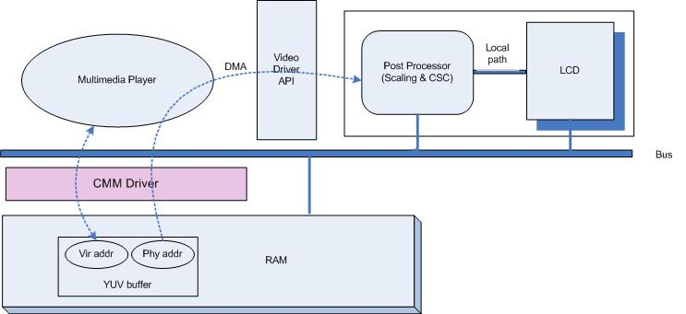

Figure 1. Architecture of CMM Driver

API

API | Description
IOCTL_CODEC_MEM_ALLOC | CMM allocate memory. It returns virtual address.  If you want cacheable area, set Cacheflag = 1.  If you want non-cacheable area, set Cacheflag = 0
IOCTL_CODEC_MEM_FREE | Free allocated memory.  If you don’t free memory, It will be free automatically when you close handle.
IOCTL_CODEC_GET_PHY_ADDR | CMM returns physical address mapped to virtual address
IOCTL_CODEC_CACHE_INVALIDATE | Just clear data in cache.
IOCTL_CODEC_CACHE_CLEAN | Copy data from cache to memory.
IOCTL_CODEC_CACHE_CLEAN_INVALIDATE | Invalidate cache and clean cache.
IOCTL_CODEC_CACHE_FLUSH | This is same as IOCTL_CODEC_CACHE_CLEAN_INVALIDATE for backward compatibility

Scenario

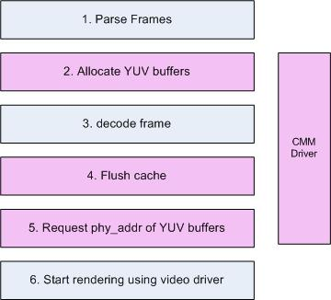

Figure 2. Simple Decoding Scenario using CMM

s/w decoder request YUV buffers using IOCTL_CODEC_MEM_ALLOC. For cacheable area, CMM driver only reserve 2MB. If you want to allocate more, please change CODEC_MEM_SIZE at CMMDriver.h. for non -cacheable area, there is no limits
- s/w decoder do decoding.
- s/w decoder request to flush YUV buffer using IOCTL_CODEC_CACHE_FLUSH.
- To render YUV data, multimedia player request physical address of YUV buffer.
- using video driver API, rendering can be started.

Padded Buffer
CMM also supports padded buffer like below picture. Both virtual addr and physical addr points the start of buffer including padding. After decoding, you should set padding size in video driver API.
In the case of below picture, offset is 16.

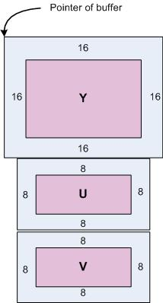
tParamPost.dwSrcBaseWidth = IMG_WIDTH + 16;
tParamPost.dwSrcBaseHeight = IMG_HEIGHT + 16;
tParamPost.dwSrcOffsetX = 16;
tParamPost.dwSrcOffsetY = 16;
tParamPost.dwSrcWidth = tParamPost.dwSrcBaseWidth -2* tParamPost.dwSrcOffsetX;
tParamPost.dwSrcHeight=tParamPost.dwSrcBaseHeight- 2*
tParamPost.dwSrcOffsetY ;
DeviceIoControl(hVideoDrv, IOCTL_SVE_POST_SET_PROCESSING_PARAM, &tParamPost, sizeof(SVEARG_POST_PARAMETER), NULL, 0, &dwBytes, NULL);

RETAILMSG(1,(L"[VDE:ERR] IOCTL_SVE_POST_SET_PROCESSING_PARAM Failed\n"));
return 0;
}

Package Guidelines

Directory Structure

Directory | Files | Description
/CMM | *.c, *.h | CMM Driver source files
/test | *.c. *.h | Sample Test application
/files | Platform.bib, platform.reg | O.S Registry file to register CMM driver
/doc | *.doc | documents

How to Test CMM

Procedure to build API and test application
- Copy CMM to /SMDK6400/src/drivers
- Add CMM path to /SMDK6400/src/drivers/dirs.
- Merge platform.bib and platform.reg.
- Build BSP.
- Boot BSP
- open /test/CodecMemTest.sln.
- check the path of test.yuv. and, build CodecMemTest.exe
- copy CodecMemTest.exe and test.yuv to SMDK6400 board.
- execute CodecMemTest.exe.
- you may see displaying

The architecture of CodecMemTest
The below picture describes the architecture of CodecMemTest application.
It doesn’t have decoder. So, it reads test.yuv file to get yuv data.

