1. Business Understanding:
The company wants to understand how investments in R&D, Marketing, and Administration influence its Profit. By performing regression analysis, the company can identify which department has the greatest impact on profit and whether any department is over- or under-invested. Based on these findings, management can make informed decisions about allocating future budgets more effectively. Additionally, using the developed regression model, the company can predict the expected Profit for new investment combinations provided by management.

2. Scope:
Retrieve data, preprocess it, build and evaluate a regression model, create dashboards, generate predictions, and provide business recommendations.

3. Challenges:
- The dataset contains only 50 startup records, which may limit the model's ability to generalize to future data.
- The independent variables (R&D Spend, Administration, and Marketing Spend) may exhibit multicollinearity, so correlation Matrices should be performed.
- The State column is categorical and must be converted into numerical form using encoding techniques (Method used to convert data from one format into another) before applying Linear Regression.
- The dataset may contain outliers, which can affect the regression model and reduce prediction accuracy if not handled properly.
- Linear Regression assumptions (linearity, independence, and normally distributed residuals) should be verified to ensure reliable results.

4. Project Solution:
- Dataset Source
- Data Preprocessing
- Analysis
- Final Regression Model and Profit Prediction:
- Dashboard Development
- Business Insights
- Project Documentation

4.1 Dataset Source:
Retrieve the Profit Analysis dataset from the Data Mites MySQL database server for regression analysis.

4.2. Data Preprocessing:
- Fetching data.
- Clean data.
- Verify data types.
- Remove duplicates.
- Outlier detection.
- Adding or removing column.
- Handle missing values.
- Prepare the dataset.
- Exploratory Data Analysis.
- Correlation Analysis.

4.2.1. Fetching Data:
Imported the Profit Analysis dataset (CSV file) into Power BI and opened it in the Power Query Editor for data preprocessing.

4.2.2. Cleaning Data:
Split the data into separate columns using the semicolon (;) delimiter to ensure the dataset was correctly structured.

4.2.3. Verify Data type:
Verified and assigned the appropriate data types for all columns using the Data Type Indicators in the Power Query Editor. The Column details are as below
Column Name | Data Type
RD_Spend | Decimal Number
Administration | Decimal Number
Marketing Spend | Decimal Number
State | Text
Profit | Decimal Number

4.2.4. Remove duplicates:
Checked for duplicate records using the Column Distribution, Column Profile, and Column Quality features. No duplicate records were found.

4.2.5. Outlier detection:
Outlier detection was performed using the Interquartile Range (IQR) method. The analysis identified potential low-end outliers in Profit and Marketing Spend. R&D Spend and Administration did not contain observations outside their respective IQR boundaries. The identified outliers were not automatically removed because extreme values may represent legitimate business observations. Their impact on model performance was therefore considered during subsequent model evaluation.

4.2.6. Adding or Removing of column:
Added an Index (Identifier) column starting from 1, as the dataset did not contain a unique identifier for each record. Since, this is a CSV file, it doesn't have a database primary key, so "unique identifier" is more important.

4.2.7. Handle missing value:
Verified the dataset for missing (null) values using the Column Quality feature in the Power Query Editor. No missing values were identified.

4.2.8. Prepare the dataset:
After completing the preprocessing steps, the cleaned dataset was prepared for Exploratory Data Analysis (EDA) and regression analysis.

4.2.9. Exploratory Data Analysis:
- Dataset Overview.
- State-wise Analysis-explain the findings of state wise analysis.
- Department wise analysis- Relationship Between Departmental Spending and Profit.

4.2.8.1 Dataset Overview:
- Number of companies: 50
- Average Profit: 112.01K
- Average R&D Spend: 73.72K
- Average Marketing Spend: 211.03K
- Average Administration Spend: 121.34K

4.2.8.2 State-wise Analysis:
The analysis of the data at the state level helps us identify the following key findings:

California:
Count of companies :17 companies
Average Profit :103.91K
Sum of Profit :1.77M

New York:
Count of companies :17 companies
Average Profit :113.76K
Sum of Profit :1.93M

Florida:
Count of companies :16 companies
Average Profit :118.77K
Sum of Profit :1.90M

The startups are almost equally distributed across the three states.
Florida has the highest average profit, followed by New York and California. However, the differences are relatively small.

Conclusion:
State does not show a substantial variation in profit and is therefore unlikely to have a strong influence on startup profitability.
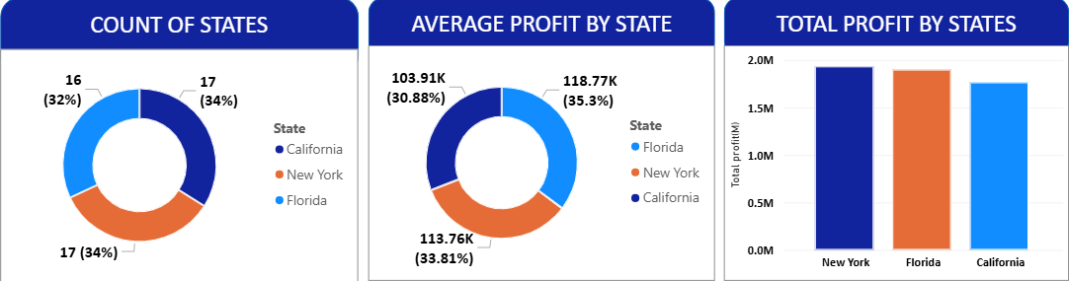

4.2.8.3 Department-wise Spending Analysis:
R&D Spend:
Average Spend: 73.72K
Total Spend: 3.69M

Marketing Spend:
Average Spend: 211.03K
Total Spend: 10.55M

Administration Spend:
Average Spend: 121.34K
Total Spend: 6.07M

Marketing has the highest average and total investment, followed by Administration and R&D.
Conclusion:
The startups allocate the largest amount of investment to Marketing, followed by Administration and R&D. However, the amount of investment alone does not indicate which department contributes most to Profit. Therefore, the relationship between each department's spending and Profit is analyzed separately using correlation analysis.

4.2.9 Correlation Analysis by Department-Wise Spending:
The correlation analysis was performed to examine the relationship between department-wise spending and Profit. The average spending and Profit were analyzed using scatter plots to understand the strength and direction of the relationships.
- R&D Spend vs Profit: Strong positive relationship.
- Marketing Spend vs Profit: Moderate positive relationship with some variation.
- Administrative Spend vs Profit: Weak or negligible relationship.
Conclusion:
R&D Spend has the strongest relationship with Profit, followed by Marketing Spend. Administrative Spend shows little linear association. For Multiple Linear Regression, all three variables can initially be included and their contribution evaluated using model performance metrics.
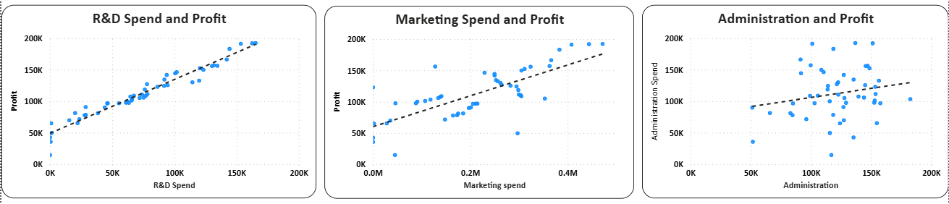

4.3 Analysis :
Model Evaluation:
Model | R² | RMSE | MAE | MAPE
Linear Regression | 0.856 | 14,911.997 | 10,719.997 | 30.933%
KNN | 0.605 | 24,706.018 | 17,635.954 | 54.721%
Random Forest | 0.876 | 13,841.907 | 9,592.022 | 29.823%
Gradient Boosting | 0.893 | 12,882.695 | 10,102.552 | 25.551%
Neural Network | -7.246 | 112,879.200 | 105,814.653 | 99.985%
SVM | 0.000 | 393,104.482 | 30,368.876 | 81.523%

The regression analysis was conducted using multiple machine learning algorithms to predict the numerical target variable. During the initial evaluation, Gradient Boosting achieved the highest R² of 0.893 and was therefore selected for further investigation.
Cross Validation:
To obtain a more reliable estimate of model generalization, 5-fold cross-validation was subsequently performed across all candidate regression models. The cross-validation results changed the model ranking. Linear Regression achieved the highest R² of 0.943, together with the lowest MSE, RMSE, MAE, MAPE, and sMAPE among the evaluated models. Gradient Boosting achieved an R² of 0.933, while Random Forest achieved 0.929.
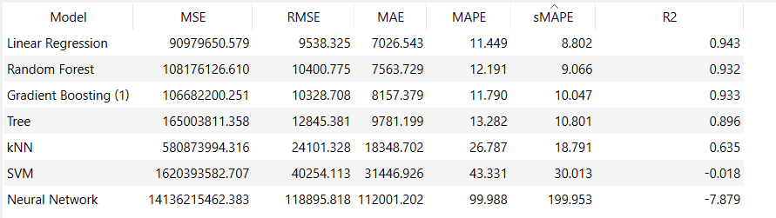

Based on the cross-validation results, Linear Regression was selected as the final candidate model. Linear Regression model demonstrated stronger and more consistent generalization performance than the tree-based ensemble models.

4.3.1 Linear Regression Analysis:
- Regression analysis using department wise spend.
- Regression analysis using decoded state with department wise spend.
- Summary table of all regression analysis.

4.3.1.1 Regression Analysis using department wise spend:
The initial Multiple Linear Regression model included R&D Spend, Administration, and Marketing Spend as independent variables and Profit as the dependent variable. The dataset was divided into 80% training data and 20% testing data. The training data was used to build the regression model, while the testing data was used to evaluate its predictive performance. The model achieved an
- R² = 0.872
- RMSE =14,039.168
- MAE =9,704.382
Since Administration Spend showed a weak relationship with Profit during EDA, a second regression model was developed by excluding Administration Spend. The same 80:20 training-testing split was used for this model. The reduced model achieved an
- R² =0.876
- RMSE =13,821.213
- MAE =9,337.711
The reduced model showed a slight improvement in all three-evaluation metrics.

4.3.1.2 Regression analysis using decoded state with department wise spend:
A second Multiple Linear Regression model was developed by including State as an additional predictor along with R&D Spend, Administration, and Marketing Spend. Since State is a categorical variable, it was encoded in Excel using three binary variables: New York, Florida, and California, where each state was represented by a value of 1 or 0. The encoded dataset was then imported into Orange and configured using R&D Spend, Administration, Marketing Spend, New York, Florida, and California as the independent variables, with Profit as the target variable. An 80:20 ratio of training and testing data was used, where 80% of the data was used to train the model and the remaining 20% was used to evaluate its predictive performance. The resulting model achieved an
- R²=0.856
- RMSE=14,911.997
- MAE=10,719.997

4.4 Final Regression Model and Profit Prediction:
The regression models were compared based on their predictive performance and the availability of input variables for the new startup scenarios. Although the reduced model using R&D Spend and Marketing Spend achieved slightly better performance than the full model, the new data provided for prediction contains R&D Spend, Administration Spend, and Marketing Spend, but does not contain State.
Therefore, the state-encoded regression model cannot be used for the final predictions because State information is not available for the new observations. The model including State also showed lower predictive performance, with an R² of 0.856, compared with the models that used only department-wise spending.
For the final prediction, the full Multiple Linear Regression model using R&D Spend, Administration Spend, and Marketing Spend was selected. This model matches the variables available in the new data and allows all three provided spending values to be used for predicting Profit.
Although the reduced model achieved slightly better evaluation metrics, selecting the full model is appropriate for this prediction task because it is directly compatible with the available input variables. The Administration Spend variable is therefore retained in the final prediction model, while State is excluded because no State information is available for the new startup scenarios.
R&D Spend |  | Administration | Marketing Spend | Predicted Profit
21,892.92 |  | 81,910.77 | 164,270.70 | 113,070
23,940.93 |  | 96,489.63 | 137,001.10 | 112,679

4.5. Dashboard Development:
The dashboard provides a comprehensive overview of startup profitability across states and spending categories. It highlights total and average profit, company distribution, and state-wise performance. The analysis shows that R&D spending has the strongest positive relationship with profit, followed by marketing spending, while administration spending has the weakest relationship.
The Dashboards below are developed using Power BI.
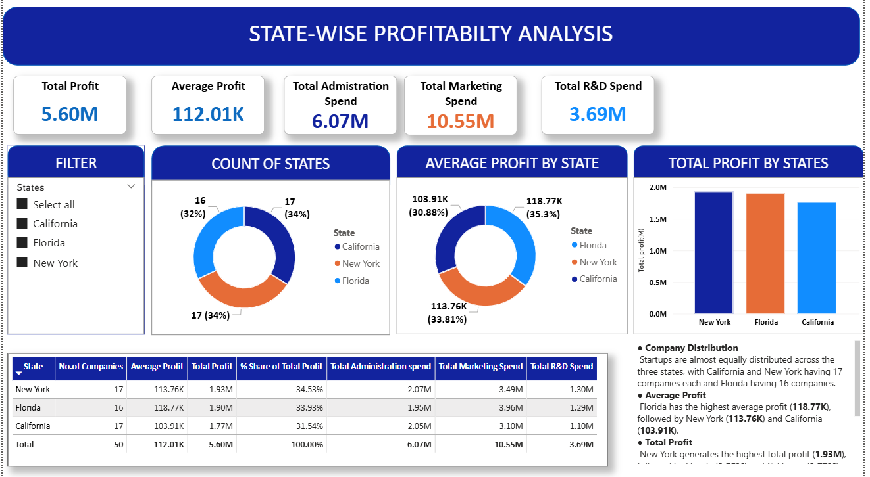

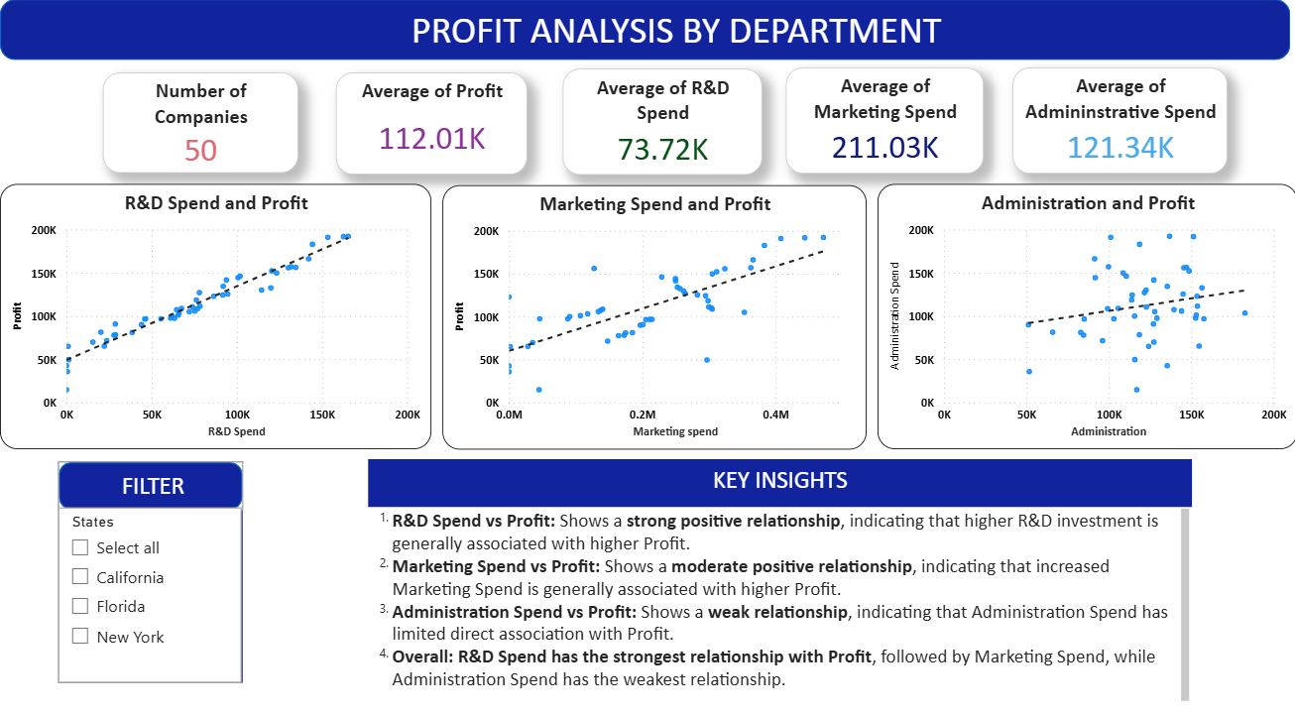

4.6 Business Insight:
Based on the overall analysis, the following business insights were identified:
- R&D Spend has the strongest relationship with Profit. Startups that invest more in R&D generally tend to achieve higher profits. Therefore, companies should prioritize R&D investment to support innovation, product development, and long-term profitability.
- Administration Spend has limited impact on Profit. The correlation analysis showed a weak relationship between Administration Spend and Profit, and removing Administration from the regression model did not significantly reduce model performance. Therefore, increasing administrative expenditure alone may not lead to higher profits.
- Marketing Spend has a positive relationship with Profit. Marketing investment contributes to profitability, although its relationship with Profit is weaker than that of R&D Spend. Companies should maintain an effective marketing budget rather than increasing spending without considering its returns.
- State has limited predictive impact in this analysis. Including the encoded State variables did not improve the model performance; the State-encoded model achieved an R² of 0.856, compared with 0.876 for the reduced model. This suggests that State does not provide substantial additional predictive value for this dataset.
- Profit does not show substantial variation across states. The state-wise analysis indicates that profitability levels are relatively comparable, suggesting that geographical location is not a major differentiating factor in the profitability of these startups.
- Overall business recommendation: Startups should focus on optimizing R&D and Marketing investments while controlling unnecessary administrative expenditure. Investment decisions should be based on expected returns rather than simply increasing spending.

4.7 Project Documentations:
All the relevant project files are attached as zip files and contains below items
- Machine Learning Models created in Orange Tool
- IQR Calculation File
- Power Bi Dashboard

