EXPERIMENT 4b – EXPLORATORY DATA ANALYSIS (EDA) – DATA INSPECTION, FILTERING, STATISTICAL ANALYSIS AND CORRELATION

Aim
To perform data inspection, filtering, grouping, aggregation, descriptive statistical
analysis, and correlation analysis using Pandas and visualize the results using
Matplotlib.
Procedure
- Import the required libraries and load the tourism dataset.
- Check and understand the data in the dataset.
- Analyze the Visitors, Rating, and Revenue data.
- Filter and organize the data based on requirements.
- Create graphs to visualize and understand the results.

Program
1. Import Libraries and Read Dataset
import pandas as pd i
mport numpy as np
import matplotlib.pyplot as plt
# Read dataset
df = pd.read_csv(r"C:\Users\kalap\Downloads\tourism_dataset (1).csv")
# Display
dataset print(df)

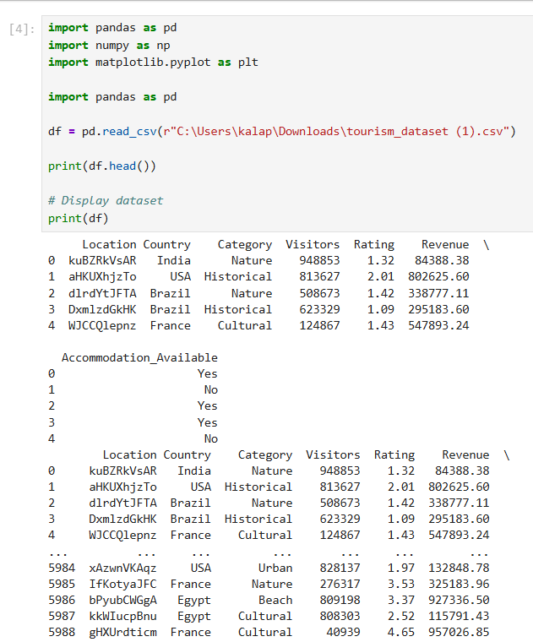

2. Basic Data Exploration
# Display first five records
print("First Five Records:")
print(df.head())

# Display shape
print("\nDataset Shape:")
print(df.shape)

# Display data types
print("\nData Types:")

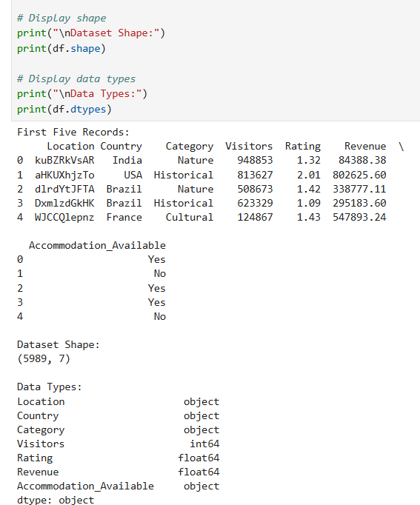

3.
# ==========================================
# FILTERING DATA
# ==========================================

# Tourist locations with Rating greater than 4
print("\n===== LOCATIONS WITH RATING > 4 =====")
high_rating = df[df["Rating"] > 4]
display(high_rating.head())

# Tourist locations with Visitors greater than 500000
print("\n===== LOCATIONS WITH VISITORS > 500000 =====")
high_visitors = df[df["Visitors"] > 500000]
display(high_visitors.head())

# ==========================================
# SORTING DATA
# ==========================================

print("\n===== SORT BY VISITORS (DESCENDING) =====")

sorted_df = df.sort_values(by="Visitors", ascending=False)

display(sorted_df.head())

# ==========================================
# STATISTICAL ANALYSIS
# ==========================================

print("\n===== VISITORS STATISTICS =====")

print("Mean :", df["Visitors"].mean())

print("Median :", df["Visitors"].median()
print("Mode :")
print(df["Visitors"].mode())

print("Standard Deviation :", df["Visitors"].std())

print("\n===== DESCRIPTIVE STATISTICS =====")

display(df.describe())

# ==========================================
# GROUPING AND AGGREGATION
# ==========================================

print("\n===== AVERAGE RATING BY COUNTRY =====")

country_avg = df.groupby("Country")["Rating"].mean()

display(country_avg)

# ==========================================
# CORRELATION ANALYSIS
# ==========================================

print("\n===== CORRELATION =====")

corr = df[[
"Visitors",
"Rating",
"Revenue"
]].corr()

display(corr)

# ==========================================
# VISUALIZATION 1 - BAR CHART
# ==========================================

# Top 10 countries based on average rating

top_countries = country_avg.sort_values(ascending=False).head(10)

top_countries.plot(kind="bar")

plt.title("Average Rating by Country")
plt.xlabel("Country")
plt.ylabel("Average Rating")

plt.show()

# ==========================================
# VISUALIZATION 2 - SCATTER PLOT
# ==========================================

plt.figure(figsize=(8,5))

plt.scatter(df["Visitors"], df["Revenue"])

plt.title("Visitors vs Revenue")

plt.xlabel("Visitors")

plt.ylabel("Revenue")

plt.show()

OUTPUT:

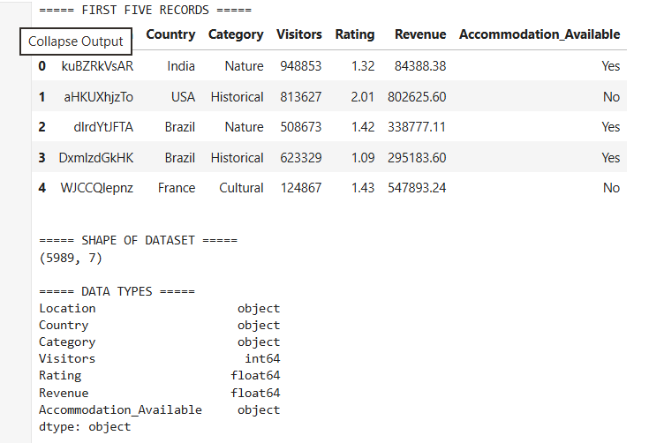

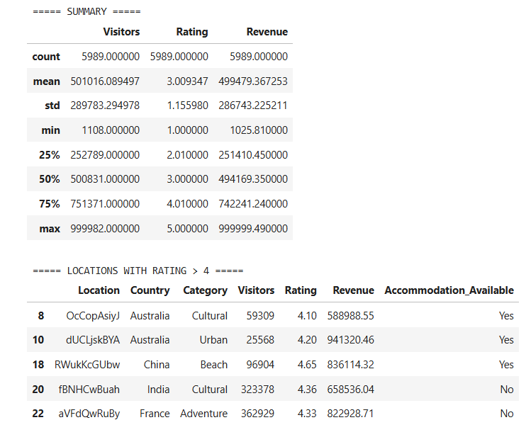
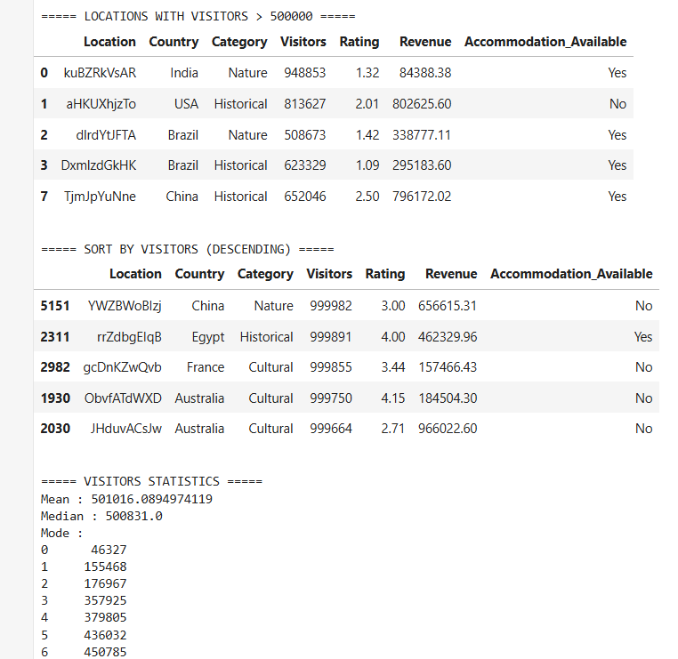

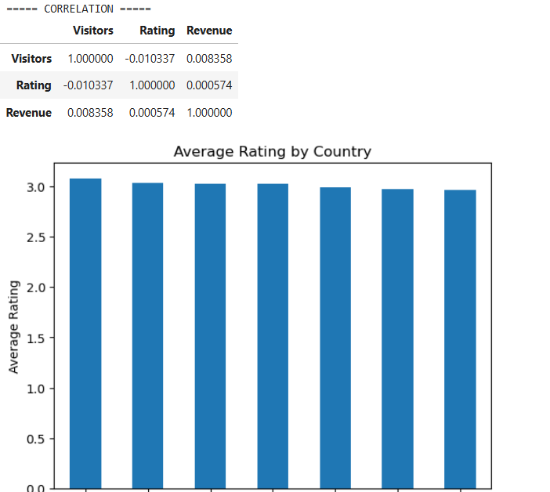

RESULT:

