EXPERIMENT 4a – EXPLORATORY DATA ANALYSIS (EDA) – DATA INSPECTION, FILTERING, STATISTICAL ANALYSIS AND CORRELATION

Aim
To perform data inspection, filtering, grouping, aggregation, descriptive statistical
analysis, and correlation analysis using Pandas and visualize the results using
Matplotlib.
Procedure
- Import the required libraries and load the tourism dataset.
- Check and understand the data in the dataset.
- Analyze the Visitors, Rating, and Revenue data.
- Filter and organize the data based on requirements.
- Create graphs to visualize and understand the results.

Program
1. Import Libraries and Read Dataset
import pandas as pd i
mport numpy as np
import matplotlib.pyplot as plt
# Read dataset
df = pd.read_csv(r"C:\Users\kalap\Downloads\tourism_dataset (1).csv")
# Display
dataset print(df)

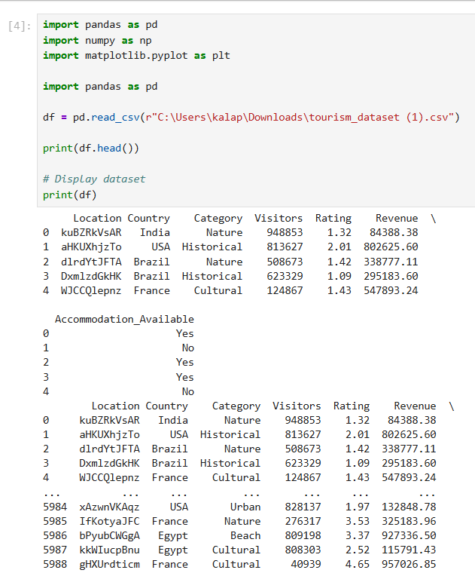

2. Basic Data Exploration
# Display first five records
print("First Five Records:")
print(df.head())

# Display shape
print("\nDataset Shape:")
print(df.shape)

# Display data types
print("\nData Types:")

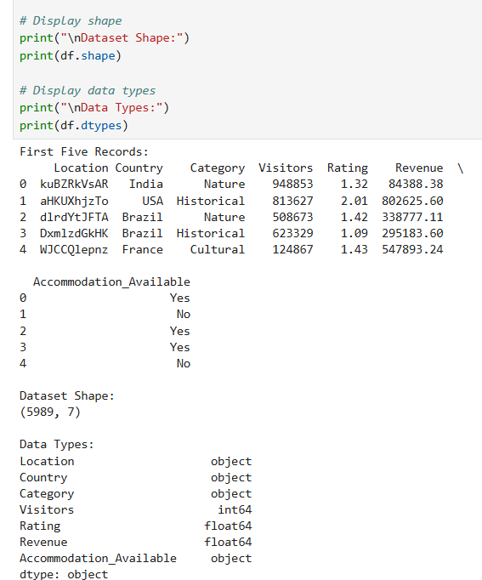

3. Statistical Summary and Filtering
# Display statistical summary
print("Statistical Summary:")
print(df.describe())

# Filter tourist locations with rating greater than 4
print("\nLocations with Rating greater than 4:")
print(df[df["Rating"] > 4])

# Filter tourist locations with visitors greater than 500000
print("\nLocations with Visitors greater than 500000:")
print(df[df["Visitors"] > 500000])
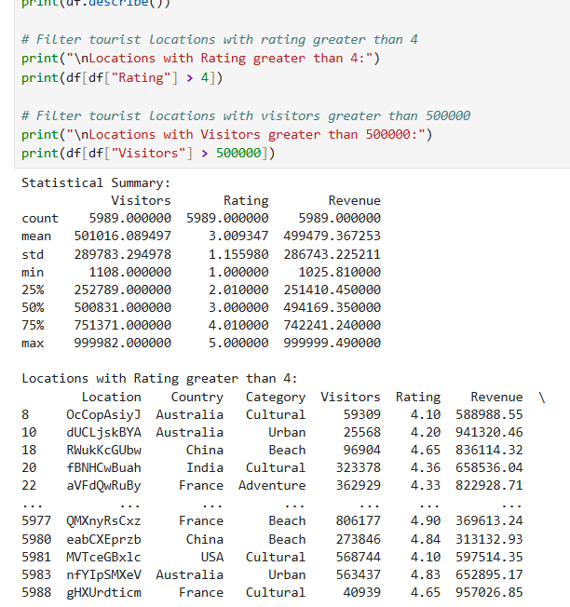

4. Sorting and Grouping Data

# Sort tourist locations by rating
print("Locations Sorted by Rating:")
print(df.sort_values("Rating", ascending=False))

# Sort tourist locations by visitors
print("\nLocations Sorted by Visitors:")
print(df.sort_values("Visitors", ascending=False))

# Country-wise average rating
print("\nCountry-wise Average Rating:")
print(df.groupby("Country")["Rating"].mean())

# Country-wise average visitors
print("\nCountry-wise Average Visitors:")
print(df.groupby("Country")["Visitors"].mean())
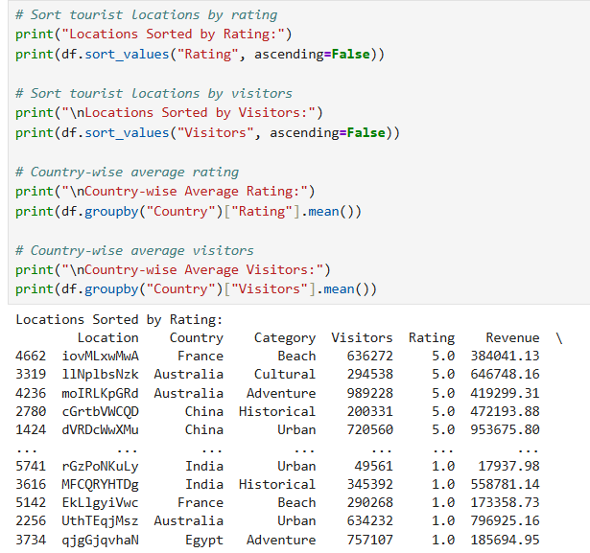

5.Statistical Measures and Correlation
# Calculate mean
print("Mean Visitors:", df["Visitors"].mean())

# Calculate median
print("Median Visitors:", df["Visitors"].median())

# Calculate minimum
print("Minimum Visitors:", df["Visitors"].min())

# Calculate maximum
print("Maximum Visitors:", df["Visitors"].max())

# Calculate standard deviation
print("Standard Deviation of Visitors:", df["Visitors"].std())

# Display correlation matrix
print("\nCorrelation Matrix:")
print(df[["Visitors", "Rating", "Revenue"]].corr())

# Display correlation between Visitors and Rating
print("\nCorrelation between Visitors and Rating:")
print(df["Visitors"].corr(df["Rating"]))
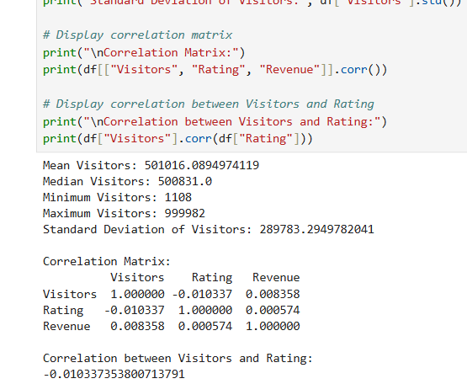

6. Scatter Plot – Visitors vs Revenue
# Scatter plot
plt.figure(figsize=(10, 6))

plt.scatter(df["Visitors"], df["Revenue"])

plt.title("Visitors vs Revenue")
plt.xlabel("Visitors")
plt.ylabel("Revenue")

plt.show()
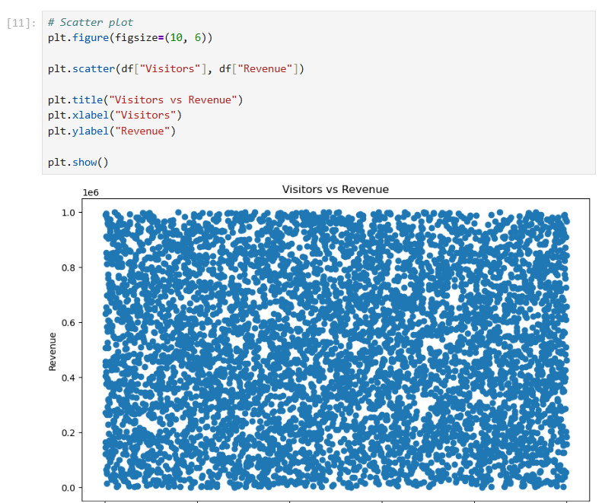

7. Box Plot – Visitors
# Box plot
plt.figure(figsize=(8, 6))

plt.boxplot(df["Visitors"])

plt.title("Visitors Box Plot")
plt.ylabel("Visitors")

plt.show()
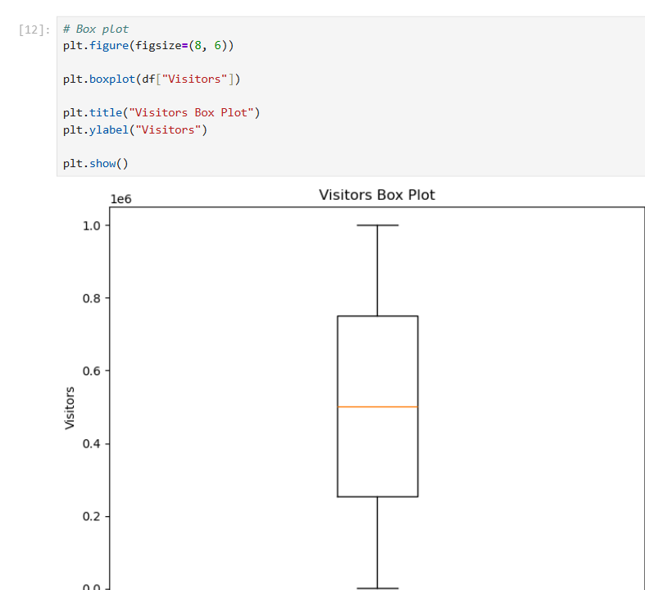

RESULT:

