ADDITIONAL QUERIES 7/11/2025
- List employees with their department name & location

select e.empno,e.ename,d.dname,d.dloc
from employee e,department d
where e.deptno=d.deptno;

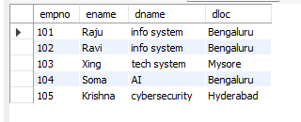

- Employees who are not assigned to any project ,Project-wise headcount

select e.ename,e.empno
from employee e
where empno not in(
select empno from assigned_to);

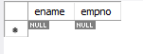

select p.pno,p.pname,count(a.empno) as headcount
from project p,assigned_to a
where p.pno=a.pno
group by p.pno,p.pname;

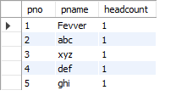

- Department-wise average & max salary

select d.deptno,d.dname,avg(e.sal) as avg_salary,max(e.sal) as max_salary
from department d,employee e
where e.deptno=d.deptno
group by d.deptno,d.dname;

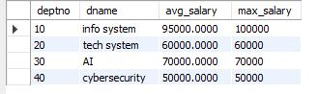

- Total incentives earned by each employee (lifetime)
select e.ename,sum(i.incentive_amount) as total_incentives
from employee e,incentives i
where e.empno=i.empno
group by e.ename;

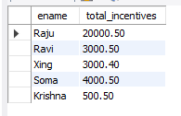

- Employees working on a given project (project name :Alpha Project)
select e.empno,e.ename,p.pname
from employee e,assigned_to a,project p
where e.empno=a.empno and p.pno=a.pno and p.pname='alpha projects';



- Departments with no employees

select d.deptno,d.dname
from department d
where d.deptno not in(
select deptno from employee);

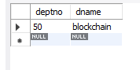

- Managers and their direct report counts (MGR_NO references EMPNO)

select e.mgr_no as manager_id,m.ename as manager_name,count(*) as report_count
from employee e,employee m
where e.mgr_no=m.empno
group by e.mgr_no,m.ename;

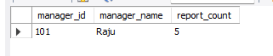

- Employees assigned to more than one project.

select empno
from assigned_to
group by empno
having count(pno)>1;



