KUBERNETES - 06
- Create a ConfigMap from a directory containing multiple files and inject the variables into a pod as environment variables.
Step 1: Create directory
mkdir config
Step 2: Create first file
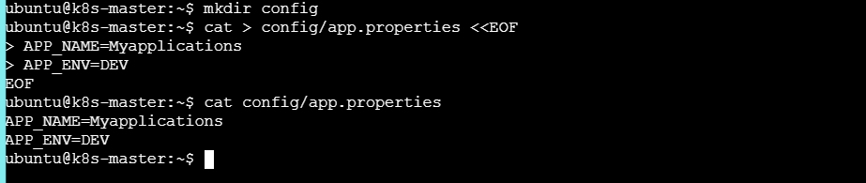Step 3: Create second file
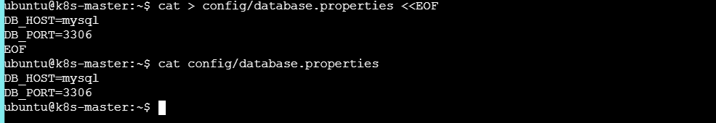Step 4: Create ConfigMap
kubectl create configmap app-config --from-file=config/
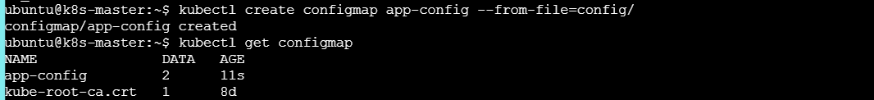
Check details:
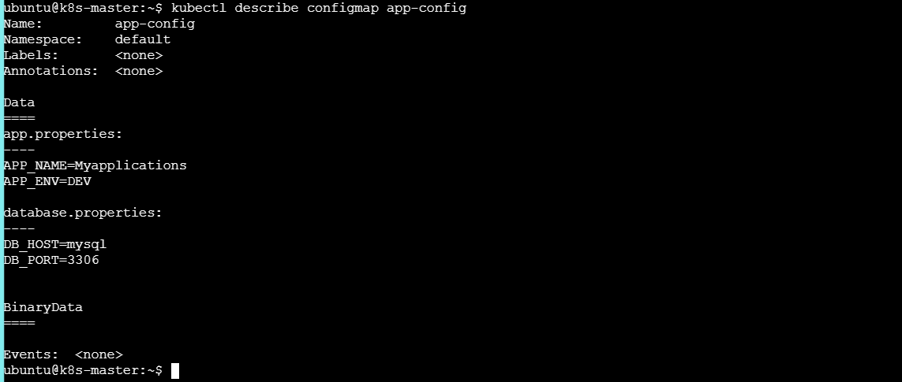Here the ConfigMap contains 2 keys:
app.properties
database.properties
Step 5: Create Pod
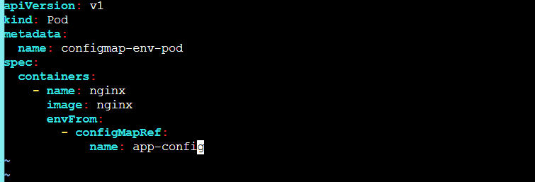Step 6: Verify
kubectl get pod configmap-env-pod
Enter the Pod:
kubectl exec -it configmap-env-pod -- /bin/bash
Check:
env
You should find:
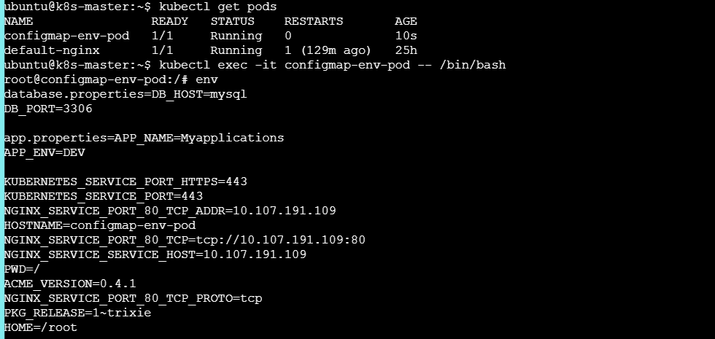Result
ConfigMap values are available as environment variables.

- Create a ConfigMap from a file and mount it as a volume inside a pod, ensuring the configuration data is available as files.
Requirement
Create a ConfigMap from a file and mount it inside a Pod.
The configuration should appear as a file inside the container
Step 1: Create configuration file
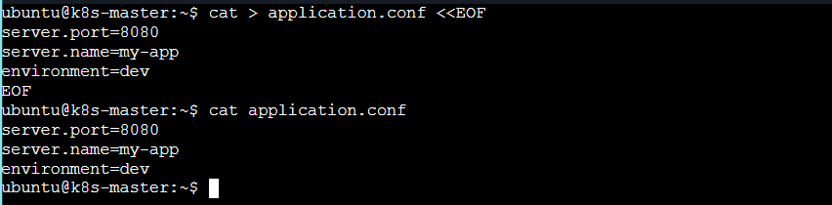
Step 2: Create ConfigMap
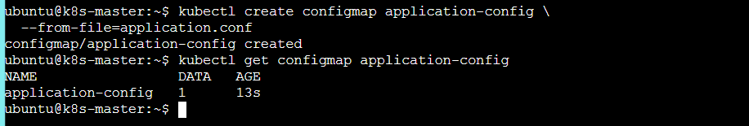Step 3: Create Pod YAML & apply
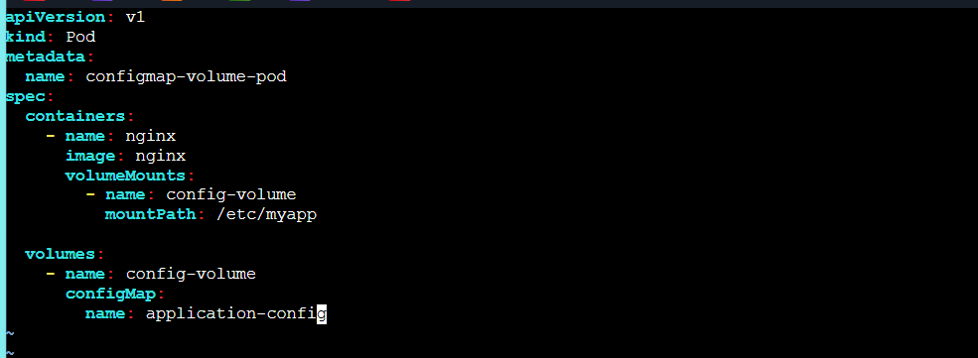
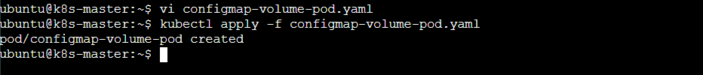

Step 5: Enter the Pod and Check inside pod
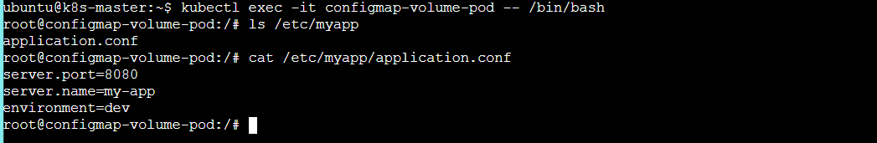Understand the flow:
application.conf
↓
ConfigMap
↓
Volume
↓
Pod /etc/myapp/
↓
application.conf

- Create a Secret with sensitive information (username and password) and inject it into a pod as environment variables.
Step 1: Create Secret
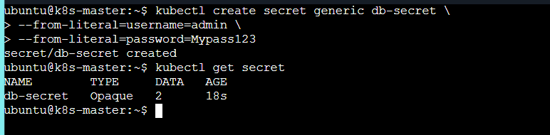
Step 2: Create Pod
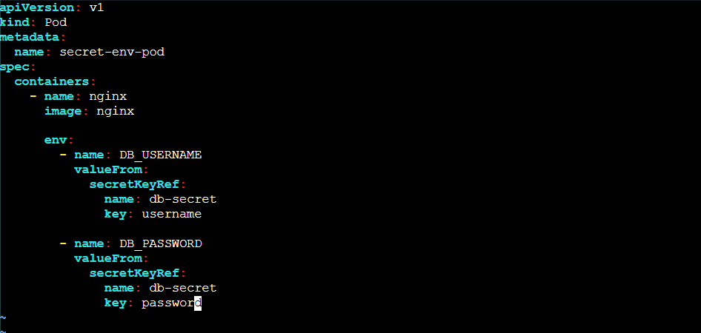
Step 3: Apply & Check pods
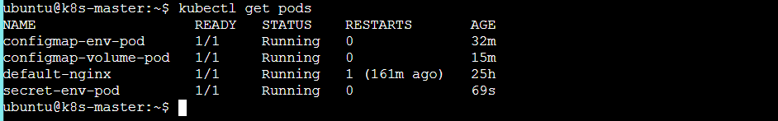
Step 4: Check inside Pod & Check output
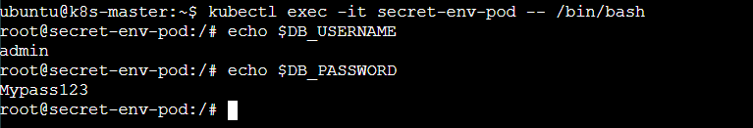
- Create a Secret using a YAML file, mount it as a volume in a pod, and verify the specific Secret values are available as files.
Step 1: Create Secret YAML
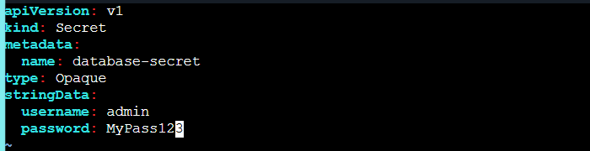Why did I use stringData?
Because it is easier for learning.
You don't need to manually convert:
admin
to Base64.
Kubernetes handles it.
Step 2: Create Secret & Check: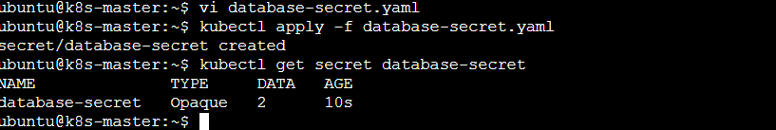
Step 3: Create Pod
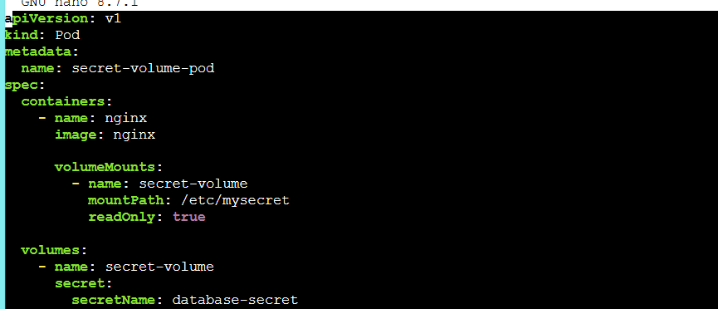
Step 4: Apply and Check
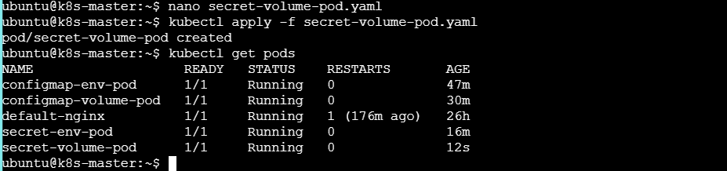
Step 5: Check files
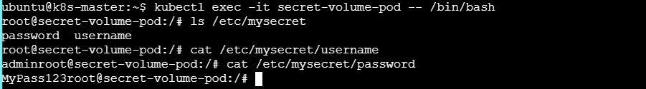

Flow:
Secret
↓
Volume
↓
Pod
↓
/etc/mysecret/
├── username
└── password
- Inject a ConfigMap as environment variables and a Secret as files into the same pod, ensuring both are accessible within the pod.
Step 1: Create ConfigMap
Step 2: Create Secret
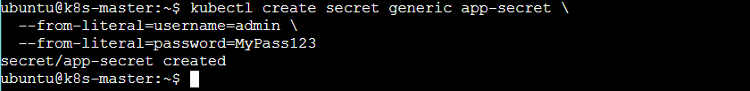
Now we have:
ConfigMap
|
├── APP_NAME
└── APP_ENV
Secret
|
├── username
└── password

Step 3: Create Pod
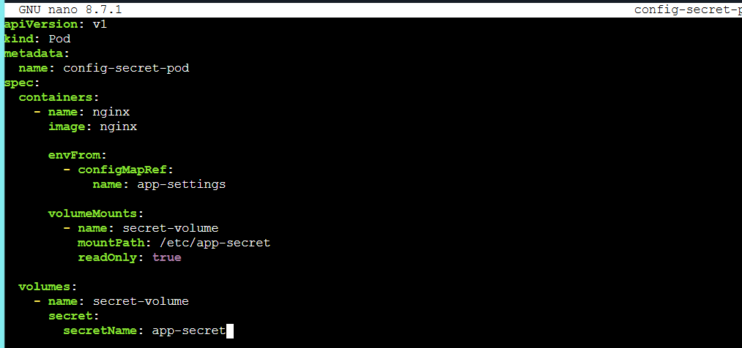
Step 4: Apply
Check:
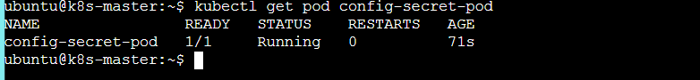
Step 5: Check ConfigMap
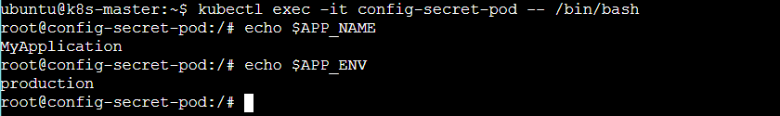
So ConfigMap is working as environment variables.
Step 6: Check Secret
Still inside the same Pod:
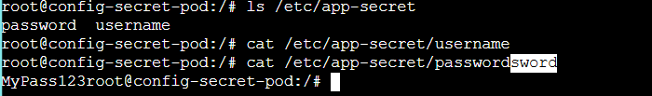
So Secret is working as files.

⭐ Now understand all 5 tasks in one table
Task | Resource | How it enters Pod | Result
1 | ConfigMap | Environment | $APP_NAME
2 | ConfigMap | Volume | /etc/myapp/application.conf
3 | Secret | Environment | $DB_USERNAME
4 | Secret | Volume | /etc/mysecret/username
5 | ConfigMap + Secret | Both | ENV + Files
The complete picture
KUBERNETES POD
|
┌───────────┴───────────┐
| |
ConfigMap Secret
| |
┌─────┴─────┐ ┌─────┴─────┐
| | | |
ENV FILE ENV FILE
| | | |
$APP_NAME /etc/... $USERNAME /etc/...
One-line interview answer
ConfigMaps store non-sensitive configuration and Secrets store sensitive data. Both can be injected into Pods either as environment variables or mounted as files using volumes.
Don't worry about the directory part yet. First practice these 5 using the simple commands above. Once these are clear, the --from-file directory requirement becomes much easier to understand.

