SENTIMENT ANALYSIS BASED ON STUDENT’S REVIEW



DONE BY,

**Guidance by, S.Pavithra (1733016)**

**MS.CHANDIA. S.Pradeep Kumar (1733017)**

**D.Sowmya (1733025)**

**R.Sri Dhanuja (1733026)**

**K.V.Srihari (1733028)**

ABSTRACT:

The real time data been collected from the students through google sheets. The students were asked to give feedbacks on faculties of the current semester. The feedback was given in the form of sentences. Using the sentiment analysis tools which include finding the polarity and strength of the words used. The positive and negative words were segregated and the corresponding weightage was given. Using the analysis, each faculty was given ratings among them and these ratings were represented in a statistical plot. A control chart was plotted. Using these results, further actions can be taken as a prior measure to improve student’s understanding and recognise which faculty’s teaching was most preferred.

**INTRODUCTION:**

[Sentiment analysis](https://www.paralleldots.com/sentiment-analysis)is contextual mining of text which identifies and extracts subjective information in source material, and helping a business to understand the social sentiment of their brand, product or service while monitoring online conversations. However, analysis of social media streams is usually restricted to just basic sentiment analysis and count based metrics. This is akin to just scratching the surface and missing out on those high value insights that are waiting to be discovered.

**DATASET USED:**

We have collected the real time student reviews via Google sheets.We had 39 respondents and each of them gave reviews about their 5 staffs.Thus, we have come to a conclusion based on their feedbacks.

**STATISTICAL TOOL USED:**

We have used the Control chart to check whether the satisfaction of students about their faculties is under control or not. Control charts, also known as Shewhart charts(after Walter A. Shewhart) or process-behavior charts, are a statistical process control toolused to determine if a manufacturing or business process is in a state of control.

**IMPLEMENTATIONS:**

We have read the data in Google sheets into python and we have used **textBlob** to analyze the reviews given by the students. **TextBlob** is a **Python** (2 and 3) library for processing textual data. It provides a simple API for diving into common natural language processing (NLP) tasks such as part-of-speech tagging, noun phrase extraction, sentiment analysis, classification, translation, and moreWe have created GUI using **tKinter** package. **Tkinter** is **Python's** de-facto standard GUI (Graphical User Interface) package. It is a thin object-oriented layer on top of Tcl/Tk. **Tkinter** is not the only GuiProgramming toolkit for**Python**. It is however the most commonly used one.

**INFERENCES:**

Looking into the Control chart we have analyzed that the satisfaction of all the students are under control.The faculties are ranked based on the student reviews and this is represented using pie-charts and graph.Students opinion on teachers can be infered from bargraph.

**SCREENSHOTS:**

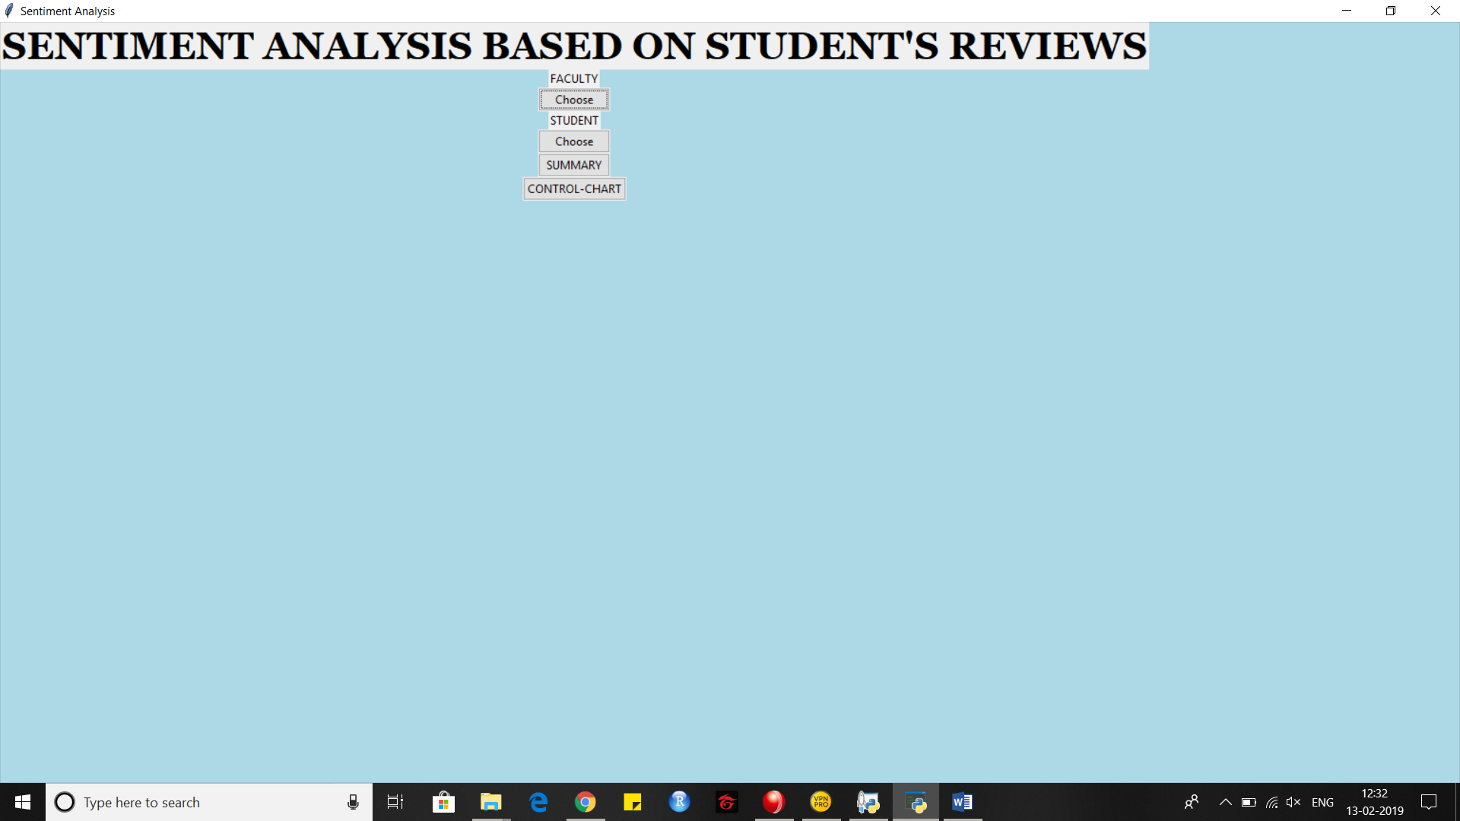

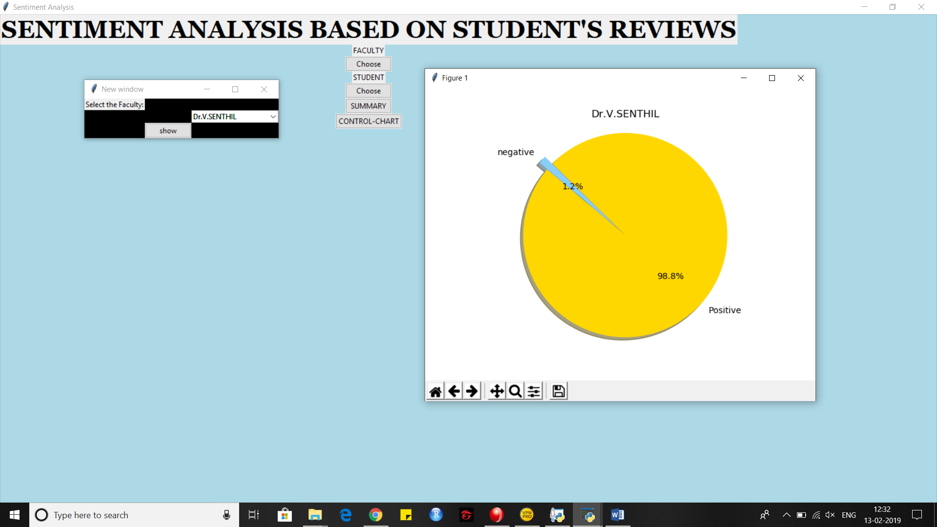

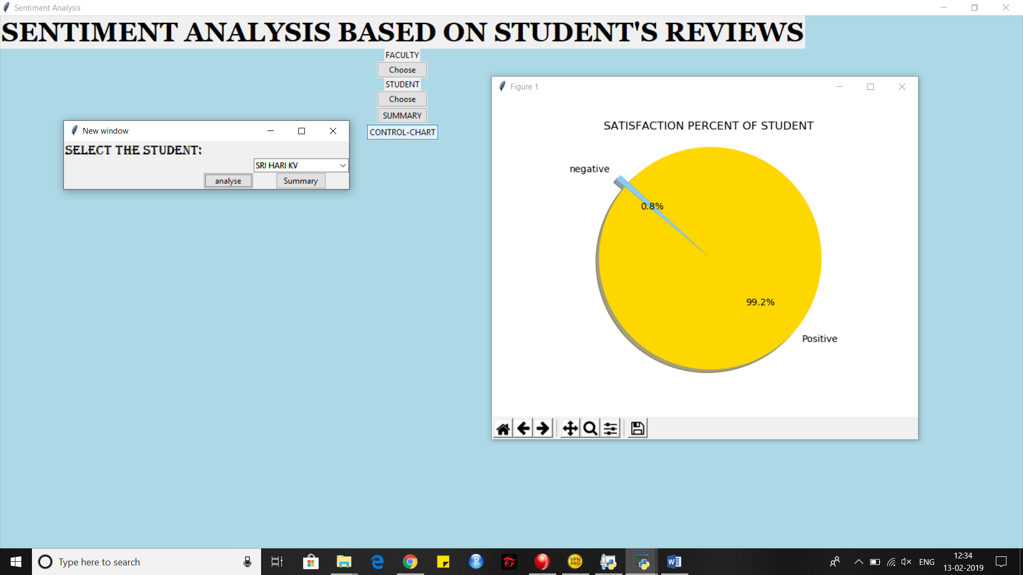

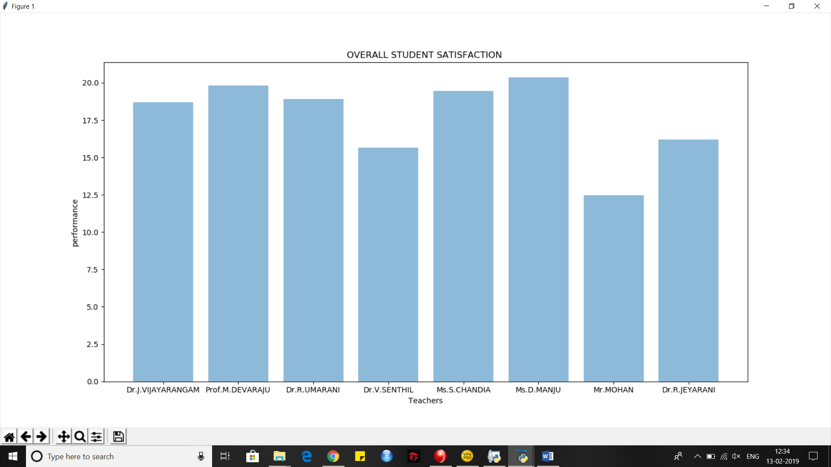

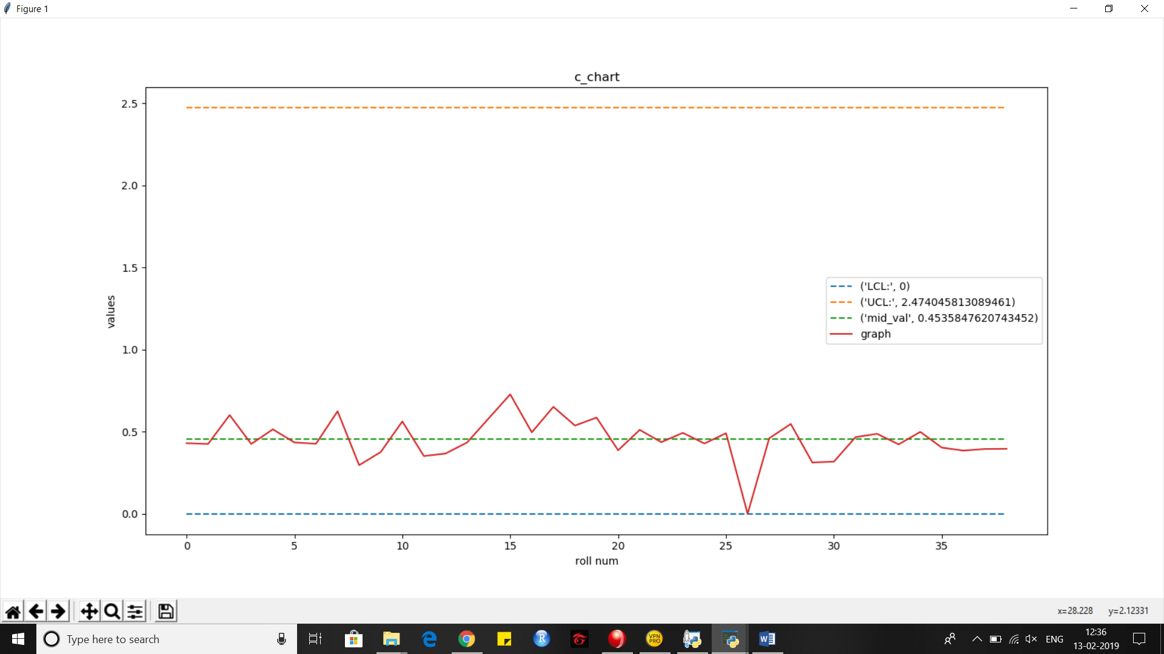

**FUTURE SCOPE:**

This can be extended for future purpose.This software model can be used for any set of students and teachers .This can be used at every end of the semester to acknowledge Student’s opinion about teachers and this will help the teachers to do progress in next semester.This can be develop as an application to calculate teacher performance based on students review.