**ARTIFICIAL INTELLIGENCE**

**ASSIGNMENT-2**

**Ans 1**

1. **Breadth First Search**

A->B->C->D->E->F->G

1. **Depth First Search**

A->B->D->E->C->F->G

1. **Iterative deepening Search**

A->B->D->E->C->F->G

1. **Uniform Cost Search**

A->C->F->G->B->E->D

**Ans 2**

1. Breadth First Search, Iterative Deepening Search, Uniform Cost Search
2. 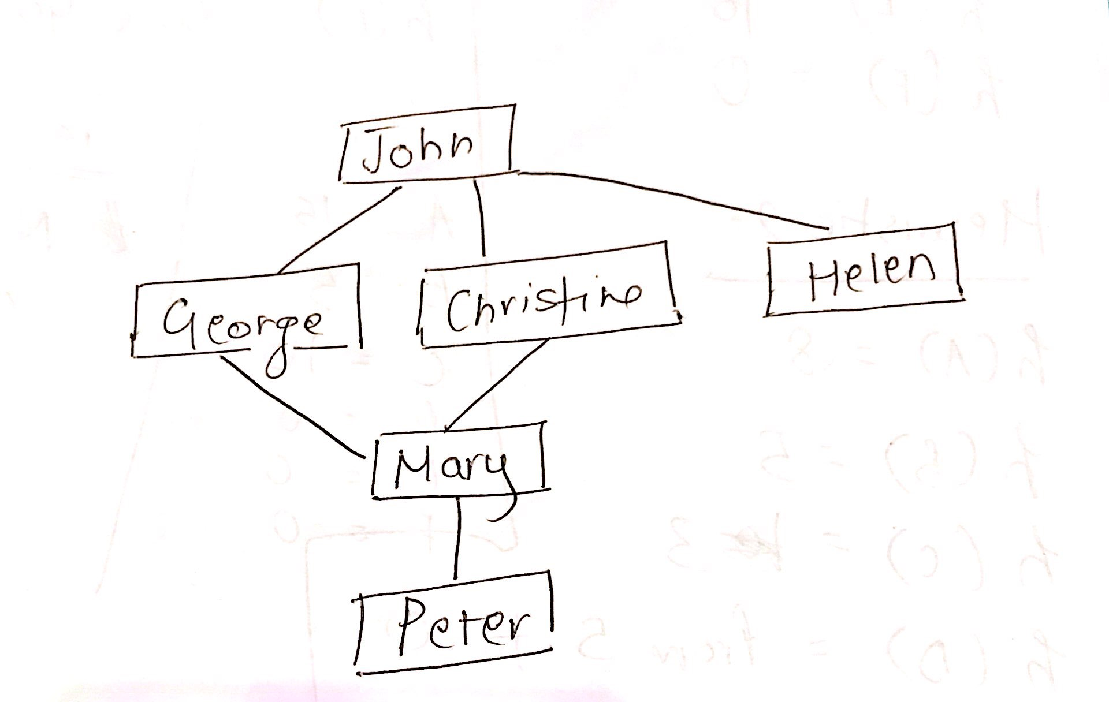

No, there is no one to one correspondence between the nodes and the vertices. This is because in the above diagram, John has more than one connections and Mary has connections from more than one person. One to one correspondence means that all nodes must have one connection only.

1. The SNG diagram with 5 nodes with at least 2 nodes with degree 4 is as follows:

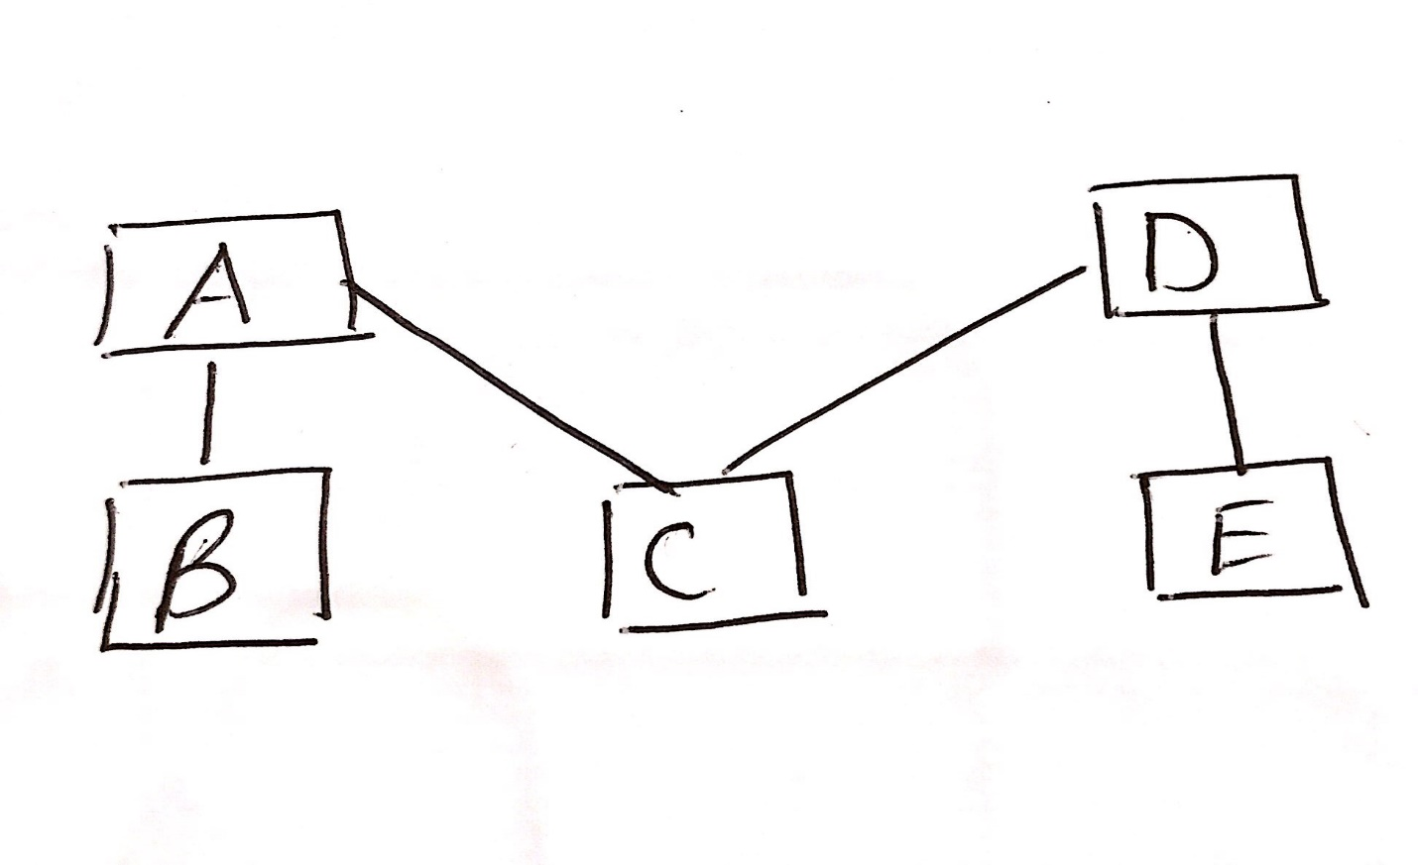

Here, node B and node E has a degree 4.

1. An SNG containing exactly 5 people, where all people have 1 degree of separation between them is as follows:

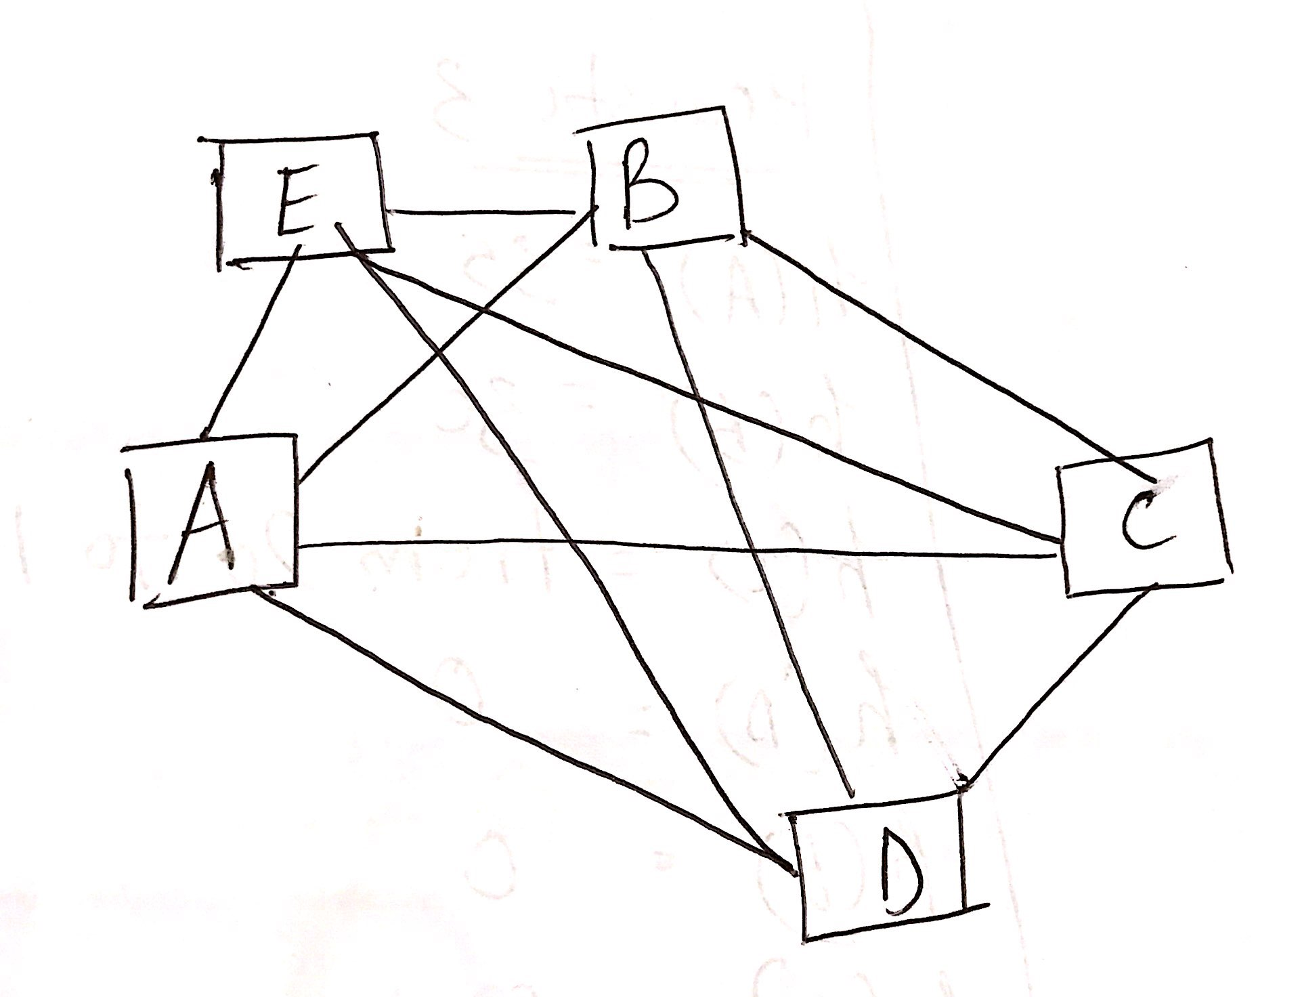

1. In a 32 bit system, there will be 2 pointers for each node. Each pointer has 4 bytes of memory. Hence for 1 million nodes, the memory required will be 1 million*8 bytes that will be greater than 1 GB of memory space. In order to make it efficient, we can remove the pointers and store the graph in an array. We can then traverse to the left nodes with respect to 2(n) and right nodes w.r.t 2(n)+1 where n is the number of nodes. By doing that, we can make sure that the memory will not exceed 1GB.

**Ans 3**

**Heuristic 1:**

h(A) = 5

h(B) = 30

h(C) = 10

h(D) = 0

h(E) = 10

h(F) = 0

**Heuristic 2:**

h(A) = 8

h(B) = 5

h(C) = 3

h(D) = 0 Modified as admissible (Earlier value 5)

h(E) = 5

h(F) = 0

**Heuristic 3:**

h(A) = 35

h(B) = 30

h(C) = 10 Modified as admissible (Earlier value 20)

h(D) = 0

h(E) = 0

h(F) = 40 Modified as admissible (Earlier value 50)

**Heuristic 4:**

h(A) = 15

h(B) = 5

h(C) = 10

h(D) = 0

h(E) = 0

h(F) = 0

**Heuristic 5:**

h(A) = 0

h(B) = 0

h(C) = 0

h(D) = 0

h(E) = 0

h(F) = 0

**Ans 4)**

H(red) =70 Red to Green to Yellow to Black[20 + 50]

H(green) =50 Green to Yellow to Black[50]

H(blue) =40 Blue to Yellow to Black [40]

H(yellow) =0 (Since not mentioned)

H(black) =0

**Ans 5)**

1. For **Breadth first Search**, the space complexity is O(b^d+1). Lets assume b=1000 bytes and d=208 (given in question)

= (1000^208)+1= very large number that is greater than 50 kb

For **Depth first search** and **Iterative deepening Search**, the space complexity is O(b*m) which means that 1000*208=208000 bytes which is approx. 208 KB

For **A\*** the space complexity is O(b^d)=O(1000^208)=infinity

For **IDA\*** the space complexity is O(b^m)=O(1000^208)=infinity

For Uniform Cost Search the space complexity O(B^(C/e)) = infinity

**From the above observations, we can infer that there are no methods that can guarantee to search all the nodes with memory less than 50KB.**

1. From the above, we can infer that Depth first search and iterative deepening search can guarantee to search all the nodes within 1200 KB of memory that is around 208KB