Sentence Generation using N-gram Language Models with Laplace, Back-off, and Interpolation Smoothing
MINIPROJECT REPORT

SUBMITTED BY
SRIHARI T
REGISTER NO: 23TN0096

Under the guidance of

Mrs. S. LAVANYA, M.TECH.,
Assistant Professor, DEPT OF AI&ML
in partial fulfilment for the award of the degree
of

BACHELOR OF TECHNOLOGY
in
DEPARTMENT OF ARTIFICIAL INTELLIGENCE AND MACHINE LEARNING

MANAKULA VINAYAGAR INSTITUTE OF TECHNOLOGY,
KALITHEERTHALKUPPAM, PONDICHERRY
PONDICHERRY UNVIERSITY, INDIA.
JANUARY 2026

TABLE OF CONTENTS
CONTENT NO | TITLE | PAGE NO
1 | ABSTRACT | 3
2 | INTRODUCTION | 4
3 | EXISTING SYSTEM | 5
4 | PROPOSED SYSTEM | 6
5 | FLOW CHART MODEL | 7
6 | APPLICATION | 8
7 | CONCLUSION | 9
8 | REFERENCES | 10

1. ABSTRACT

Natural Language Processing (NLP) is a fundamental area of artificial intelligence that focuses on enabling machines to understand, analyze, and generate human language. One of the core components of NLP is the language model, which assigns probabilities to sequences of words and plays a crucial role in applications such as text prediction, speech recognition, machine translation, and sentence generation. Among various language modeling techniques, n-gram language models are widely used due to their simplicity and effectiveness in capturing local word dependencies. However, basic n-gram models often suffer from data sparsity and zero-frequency problems, which negatively affect sentence generation quality.

This mini project focuses on sentence generation using unigram, bigram, and trigram language models, with a special emphasis on handling probability estimation challenges through smoothing techniques. Unigram models consider individual word probabilities, while bigram and trigram models capture contextual relationships between consecutive words. Although higher-order n-gram models improve contextual accuracy, they also increase the likelihood of unseen word sequences, resulting in zero probabilities and unnatural sentence generation. To address this issue, smoothing techniques are essential for redistributing probability mass to unseen n-grams.

The results demonstrate that smoothing techniques significantly improve sentence generation by reducing zero-probability issues and producing more meaningful and readable text. Among the implemented methods, interpolation smoothing provides the most balanced performance by effectively combining contextual and general word information. This project highlights the importance of smoothing in n-gram language models and provides practical insights into probabilistic language modeling for NLP applications. The work also serves as a foundation for future advancements using neural language models and larger datasets.

2. INTRODUCTION

Natural Language Processing (NLP) is a rapidly evolving field of artificial intelligence that focuses on enabling computers to understand, interpret, and generate human language in a meaningful way. With the increasing availability of digital text data, language modeling has become a core component of many NLP applications such as speech recognition, machine translation, text prediction, chatbots, and automated content generation. A language model estimates the probability of a sequence of words and helps determine how likely a given sentence is in a language.
One of the earliest and most widely used approaches to language modeling is the n-gram language model. N-gram models are statistical models that predict the probability of a word based on the occurrence of the previous n−1 words. Depending on the value of n, these models are categorized as unigram, bigram, and trigram models.
To overcome the zero-frequency and data sparsity problems, smoothing techniques are applied to n-gram language models. Smoothing methods adjust probability estimates to assign small non-zero probabilities to unseen n-grams, thereby improving model robustness and output quality. Common smoothing techniques include Laplace (Add-One) smoothing, Back-off models, and Interpolation smoothing. Each of these methods addresses the zero-probability issue in a different manner and has its own advantages and limitations.
This mini project focuses on the implementation of unigram, bigram, and trigram language models for sentence generation, along with a comparative study of three smoothing techniques: Laplace, Back-off, and Interpolation. By analyzing the quality of sentences generated using different smoothing methods, the project aims to demonstrate the importance of probability estimation techniques in language modeling. The work provides a practical understanding of fundamental NLP concepts and highlights how smoothing improves the effectiveness of statistical language models in real-world applications.

3. EXITING SYSTEM

Existing language modeling systems primarily rely on basic statistical approaches such as unigram, bigram, and trigram models without advanced probability adjustment techniques. In these systems, the probability of a word is calculated based on its frequency of occurrence in the training corpus. Sentence generation is performed by selecting the next word with the highest probability given the preceding context. While this approach is simple and computationally efficient, it presents several limitations when applied to real-world language data.

One of the major drawbacks of existing n-gram-based systems is the zero-frequency problem. When a particular word sequence does not appear in the training corpus, the corresponding n-gram probability becomes zero. During sentence generation, encountering a zero-probability sequence can abruptly terminate the generation process or force the model to produce repetitive and unnatural output. This problem becomes more prominent in bigram and trigram models, where the number of possible word combinations increases significantly.

Although some existing systems attempt to mitigate these issues by increasing the size of the training corpus, this solution is not always practical due to data availability and computational constraints. Without appropriate smoothing techniques, even large datasets may still contain unseen n-grams. As a result, existing language modeling systems without smoothing are insufficient for reliable sentence generation.

These limitations highlight the need for enhanced language modeling techniques that can handle data sparsity and zero-frequency issues effectively. By incorporating smoothing methods such as Laplace, Back-off, and Interpolation, the proposed system aims to overcome the drawbacks of existing approaches and produce more fluent and coherent sentences.

4. PROPOSED SYSTEM
The proposed system aims to improve sentence generation in n-gram language models by addressing the limitations of basic probability estimation techniques. The system integrates unigram, bigram, and trigram language models with effective smoothing methods to handle data sparsity and zero-frequency issues. By incorporating Laplace, Back-off, and Interpolation smoothing techniques, the proposed approach ensures that unseen word sequences are assigned meaningful probabilities, leading to more fluent and coherent sentence generation.
The system begins with the selection of a text corpus, which serves as the training data for building the language models. The input text is first preprocessed to remove noise and standardize the data. Preprocessing steps include converting text to lowercase, removing unnecessary punctuation, and segmenting the text into sentences and tokens. This step ensures consistency and accuracy in probability calculations across different n-gram models.
After preprocessing, unigram, bigram, and trigram models are constructed using frequency-based probability estimation. The unigram model calculates the probability of each word independently, while the bigram and trigram models capture contextual dependencies by considering one and two preceding words respectively. These models form the foundation for sentence generation but are prone to zero-probability issues when encountering unseen n-grams.
To overcome this limitation, the proposed system applies three smoothing techniques. Laplace smoothing adjusts all n-gram counts by adding a constant value, ensuring that no probability is zero. Back-off smoothing enables the model to revert to lower-order n-grams when higher-order probabilities are unavailable, thereby maintaining continuity in sentence generation. Interpolation smoothing combines unigram, bigram, and trigram probabilities using weighted averaging, allowing the system to balance contextual specificity and general word usage.
Once the smoothed probability distributions are obtained, sentence generation is performed by selecting words based on conditional probabilities rather than raw frequency counts. The system continues generating words until a termination condition such as an end-of-sentence token is reached. The generated sentences from each smoothing technique are then compared to evaluate fluency, coherence, and handling of unseen word sequences. Through this structured approach, the proposed system demonstrates how smoothing techniques significantly enhance sentence generation quality in n-gram language models.

5. FLOW CHART MODEL

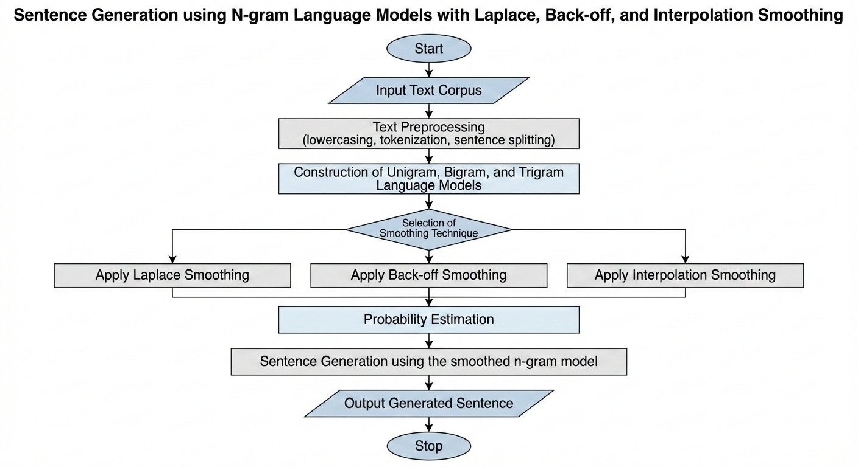

6.APPLICATION

Language models form the backbone of many Natural Language Processing applications, and sentence generation using n-gram language models has practical relevance across various domains. One of the primary applications of the proposed system is text prediction and auto-completion. N-gram language models are commonly used in predictive text systems, where the next word is suggested based on previous words typed by the user. By applying smoothing techniques, the system can handle unseen word combinations more effectively, resulting in smoother and more accurate predictions. This is particularly useful in environments with limited training data.
Another important application is sentence generation and text synthesis. The proposed system can generate meaningful sentences by learning word sequence probabilities from a given corpus. This can be useful in applications such as automated content generation, chatbot response templates, and text simulation for testing NLP systems. Smoothing techniques ensure that generated sentences do not abruptly stop due to zero-probability issues and maintain better fluency.
In addition, the proposed system can be used in speech recognition and machine translation preprocessing. Language models help determine the most likely word sequences in these applications. Smoothed n-gram models improve robustness by assigning probabilities to unseen sequences, thereby enhancing overall system performance.
Overall, the proposed sentence generation system demonstrates how fundamental language modeling techniques can be effectively applied across multiple NLP applications. By incorporating smoothing methods, the system becomes more reliable, flexible, and suitable for practical use cases, making it a valuable tool for both academic learning and basic real-world NLP solutions.

7. CONCLUSION

This mini project focused on sentence generation using n-gram language models and the application of smoothing techniques to overcome the limitations of basic probability estimation. Unigram, bigram, and trigram language models were implemented to study how word sequence probabilities influence sentence generation. While n-gram models are simple and effective for capturing local dependencies, they suffer from significant challenges such as data sparsity and zero-frequency problems, especially when higher-order n-grams are used.
The project demonstrated that sentence generation using unsmoothed n-gram models often leads to incomplete, repetitive, or unnatural sentences due to zero probabilities assigned to unseen word sequences. To address this issue, three smoothing techniques—Laplace smoothing, Back-off smoothing, and Interpolation smoothing—were applied and analyzed. Each smoothing method modifies probability estimation in a different manner, allowing the language model to assign non-zero probabilities to unseen n-grams and generate more fluent sentences.
Overall, this project highlights the importance of smoothing techniques in statistical language modeling and demonstrates their impact on sentence generation quality. The implementation provides a clear understanding of foundational NLP concepts and reinforces the relevance of n-gram models in language processing. Although modern neural language models have gained popularity, n-gram models remain valuable for learning, experimentation, and lightweight applications. The project successfully meets its objectives and lays a strong foundation for future exploration in advanced language modeling techniques.

8. REFERENCES

- Jurafsky, D., & Martin, J. H. (2023). Speech and Language Processing (3rd ed.). Pearson Education.
- Manning, C. D., & Schütze, H. (1999). Foundations of Statistical Natural Language Processing. MIT Press.
- Jelinek, F. (1997). Statistical Methods for Speech Recognition. MIT Press.
- Church, K. W., & Gale, W. A. (1991). Probability scoring for spelling correction. Statistics and Computing, 1(2), 93–103.
- Katz, S. M. (1987). Estimation of probabilities from sparse data for the language model component of a speech recognizer. IEEE Transactions on Acoustics, Speech, and Signal Processing, 35(3), 400–401.
- Brill, E., & Moore, R. (2000). An improved error model for noisy channel spelling correction. Proceedings of the ACL.
- Goldberg, Y. (2017). Neural Network Methods for Natural Language Processing. Morgan & Claypool.
- Brown, P. F., et al. (1992). An estimate of an upper bound for the entropy of English. Computational Linguistics, 18(1), 31–40.
- Chen, S. F., & Goodman, J. (1999). An empirical study of smoothing techniques for language modeling. Computer Speech & Language, 13(4), 359–394.
- Jurafsky, D. (2014). The Language Technology Ecosystem. ACL Tutorial Notes.

