Forecasting German electricity demand, 2015-2020
7PAM2016 - applied data science assignment

Introduction
This report works through a forecasting problem on German electricity load: hourly demand for the whole of Germany (country code DE) from the Open Power System Data 60-minute file, covering January 2015 to October 2020. The task was to build up from the simplest possible forecasts to a seasonal ARIMA, then to bring in weather data and hand the same problem to machine-learning models, and finally to an LSTM working at the raw hourly resolution. Throughout, the last two years (104 weeks) were held out as a test set, and a seasonal-naive forecast was used as the bar that everything else had to clear.
The headline result is worth stating up front. The seasonal-naive benchmark scored an RMSE of 3,007 MW on the held-out two years. Only the tree models beat it: Random Forest came in about 14% lower, gradient boosting about 10% lower. The classical SARIMA was roughly 24% worse than the benchmark, and adding temperature barely moved it. The LSTM produced by far the lowest error, but only in a one-step setting that is not a fair comparison; its honest multi-step error was more than twice the benchmark. Most of the discussion below is about why the numbers fell out this way rather than just what they were.

Data and exploratory analysis
The load column used was DE_load_actual_entsoe_transparency, the ENTSO-E actual total load for Germany. The raw hourly series ran from January 2015 to the end of September 2020, 50,400 hours with no missing values to fill. It was aggregated to daily and weekly means, giving 301 weekly points. Most of the modelling happens on the weekly series, which is smooth enough to see structure in and short enough to fit classical models on without waiting all day.
One small decision is worth recording. The OPSD timestamps are in UTC. I dropped the timezone and treated the index as naive, because at a weekly mean an hour’s offset against Berlin local time makes no practical difference, and carrying the timezone around only causes friction later when temperature is merged in. For an hourly operational system this shortcut would not be acceptable, but for weekly forecasting it is harmless.
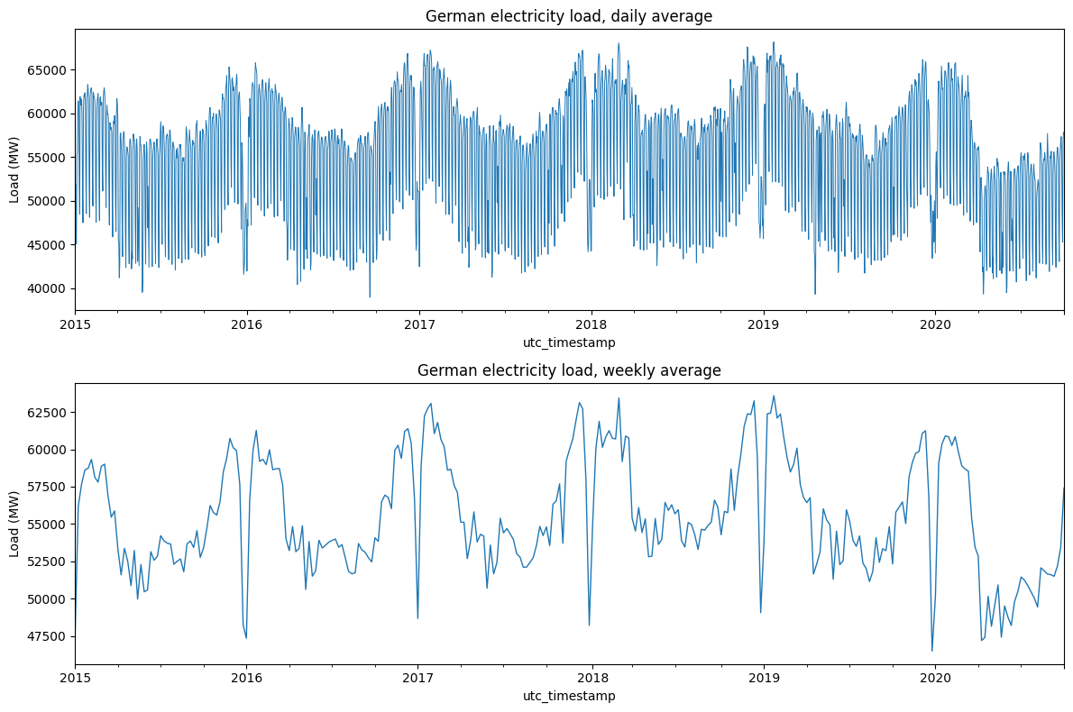
Figure 1. German load at daily and weekly resolution, 2015-2020. The daily line shows the short-term noise; the weekly line makes the annual rise and fall obvious, with demand peaking in winter and falling in summer, and a visible dip in early 2020.
The brief asked what components are in the series. An STL decomposition answers this directly. The seasonal component has a standard deviation of about 3,460 MW, against a remainder of about 1,270 MW, so the annual cycle is by some way the largest feature in the data. The trend is mild and mostly flat, with a dip around early 2020 that lines up with the first pandemic lockdown. The size of the seasonal swing relative to everything else is the single most important fact about this dataset, and it is the reason a seasonal-naive forecast is so hard to beat.
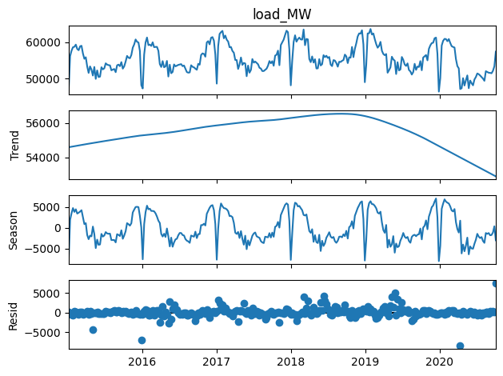
Figure 2. STL decomposition of the weekly series. The seasonal panel dwarfs the trend and the remainder, confirming that the yearly cycle drives demand.
For stationarity I ran both the Augmented Dickey-Fuller and the KPSS test, since they ask opposite questions and using only one is easy to over-read. On the weekly level the two agree: ADF rejects a unit root (p around 0.001) and KPSS does not reject stationarity (p around 0.10), so the level series is already broadly stationary in the mean. That might look like an argument against any differencing, but the annual cycle is plainly still there in the ACF, with a clear band of structure out to lag 52. Taking one seasonal difference at lag 52 keeps ADF firmly happy (p around 0.0005) but pushes KPSS to reject (p around 0.01), which is the textbook signature of mild over-differencing. The practical lesson is that the differencing for SARIMA should be driven by what the model needs to represent the seasonality, and by AIC, rather than by the unit-root tests on their own.
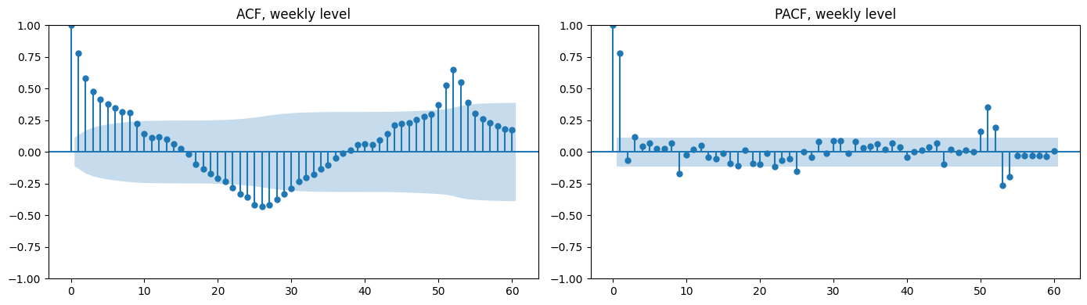
Figure 3. ACF and PACF of the weekly level. The slow decay and the structure stretching towards lag 52 are the fingerprints of the annual cycle.

Benchmark forecasts
Four reference forecasts were fitted over the two-year horizon: the mean, the naive (last value carried forward), the seasonal naive (last year’s weekly pattern repeated), and the drift method. Only the seasonal naive is a serious contender. It scored an RMSE of 3,007 MW, well clear of the mean (4,397), the naive (4,459) and drift (5,118). With a seasonal pattern this regular, replaying last year’s 52 weekly values is a genuinely strong forecast, and it sets the bar that the rest of the report is measured against.
The other three are useful mainly as a sanity floor. A flat line or a single carried-forward value cannot track a series that swings by thousands of megawatts across the year, and any model that cannot beat the naive forecast has gone wrong somewhere.
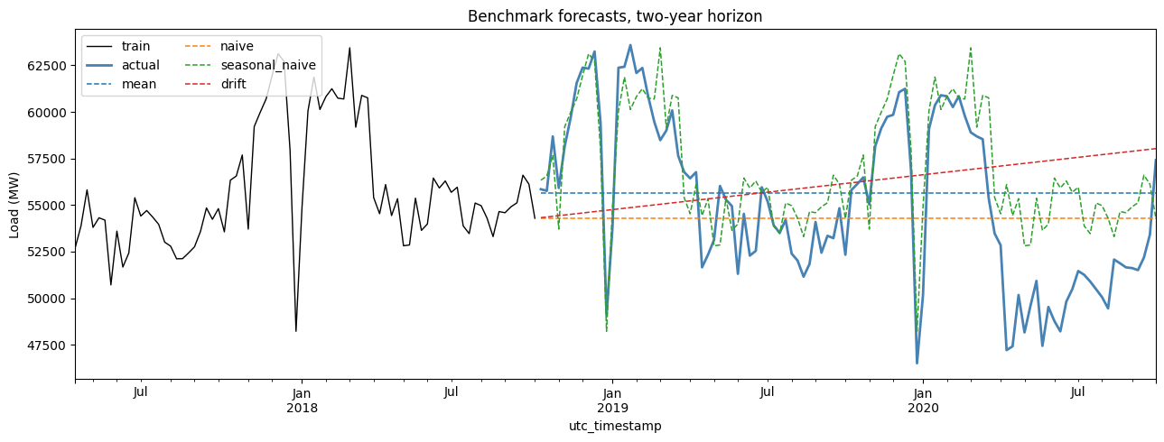
Figure 4. The four benchmark forecasts against the held-out two years. Seasonal naive tracks the shape of demand; the others sit flat or drift away.

Seasonal ARIMA
The seasonal differencing was fixed around D = 1 at period 52, and the full grid the brief asked for was run: every combination of p from 0 to 6, d from 0 to 2 and q from 0 to 6, 147 fits, ranked by AIC. At a seasonal period of 52 this is the slow part of the whole exercise, and a fair number of combinations fail to converge, which is why each fit is wrapped so one blow-up does not stop the search. The non-seasonal order with the lowest AIC was (6, 1, 2). A short comparison of seasonal orders on top of that preferred (1, 1, 1) at period 52, giving a final model of SARIMA(6, 1, 2)(1, 1, 1, 52).
One detail in that result is worth flagging rather than glossing over. The AR order ran all the way to p = 6, the top of the allowed range. When the search pushes a parameter to its limit it usually means the model is reaching for more terms to mop up in-sample structure, and it is a mild warning that the chosen order is partly chasing fit. As the test results show, the extra AR terms did not buy good out-of-sample performance.
The residual diagnostics on the chosen model are reasonable: the residual ACF is mostly inside the band, the histogram is roughly bell-shaped, and the Q-Q plot is close to the line apart from heavier tails. The Ljung-Box test still picks up some leftover autocorrelation at longer lags, so the model has not captured everything, but the residuals are close enough to white noise to treat the fit as adequate.
[Figure 5 here - SARIMA residual diagnostics, from notebook cell 20. This is the one plot the uploaded run did not save; re-run that cell and paste the four-panel figure here.]
Figure 5. Residual diagnostics for SARIMA(6,1,2)(1,1,1,52): residuals over time, ACF, distribution and Q-Q plot.
The two-year forecast is the sobering part. The SARIMA forecast scored an RMSE of 3,726 MW, about 24% worse than the seasonal-naive benchmark, with a MASE of 2.25 and a large positive bias of around 2,740 MW, meaning it systematically forecasts too high. The confidence band widens quickly across the horizon, which is at least honest about the uncertainty in a 104-week-ahead forecast. The reason for the underperformance is structural rather than a bug. SARIMA extrapolates a fixed seasonal pattern learned from differenced data, and over two years small errors in the seasonal shape and level accumulate, here as a steady upward bias. The seasonal naive sidesteps that accumulation entirely by replaying the most recent full year. When the dominant signal is a clean repeating season, a method that simply copies the season is hard to improve on with a parametric model fitted to differences.
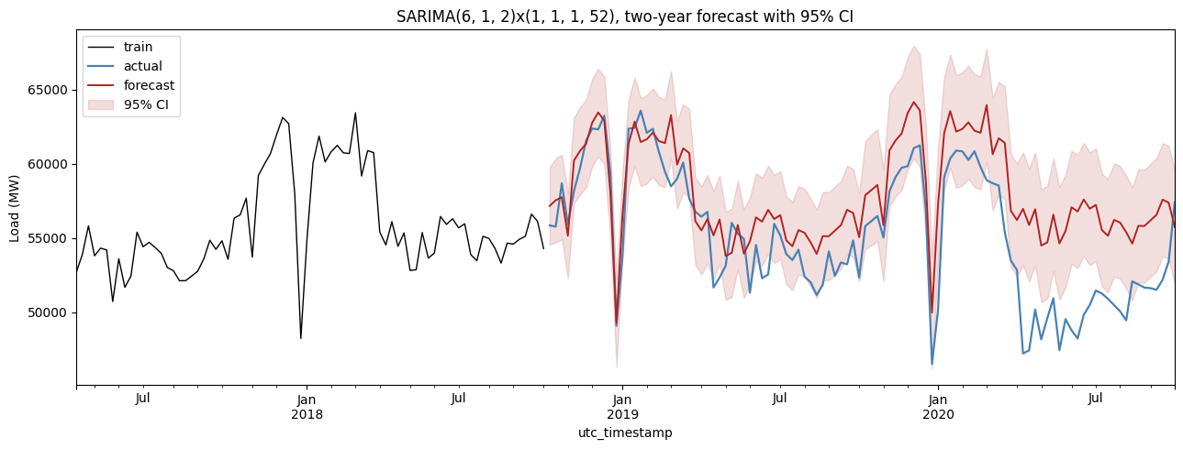
Figure 6. SARIMA two-year forecast with 95% confidence interval. The forecast holds the seasonal shape but drifts high, and the band widens substantially over the horizon.

SARIMAX with temperature
Electricity demand and temperature are physically linked: cold weeks drive heating, hot weeks drive cooling, and both lift load. Berlin temperature was pulled from the Open-Meteo archive as a stand-in for Germany, aggregated to weekly, and turned into a small set of features. The relationships are strong and in the expected direction: weekly load correlates +0.69 with heating degree-days and -0.64 with mean temperature, while cooling degree-days correlate only -0.16, which fits a country where winter heating matters far more than summer cooling.
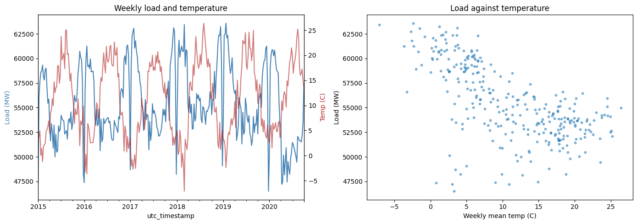
Figure 7. Weekly load against temperature. Load climbs as temperature falls, and the scatter shows the heating-driven relationship that dominates in a temperate climate.
Two versions of the SARIMAX were fitted, and the distinction between them is the most important methodological point in this section. The first feeds the model the temperature actually observed in the test window. This is an explanatory or conditional forecast: it answers “given the weather that happened, how well does the load model do?”, and it is not a forecast you could have made at the time, because the future weather was not known. The second uses only lagged temperature, which genuinely is known at the forecast origin, and is closer to an operational forecast.
The numbers are revealing. The conditional SARIMAX scored 3,667 MW, a small improvement on the plain SARIMA’s 3,726 and enough to nudge it just ahead, but still well short of the seasonal-naive benchmark. The operational version, with only lagged temperature, was markedly worse at 4,364 MW. So knowing the actual weather helps a little, but a one-week-lagged temperature is a poor substitute and adds more noise than signal once the seasonal terms are already in place. The wider point is that temperature and the time of year are almost the same variable at weekly resolution, so bolting temperature onto a model that already has an explicit annual season is largely redundant.
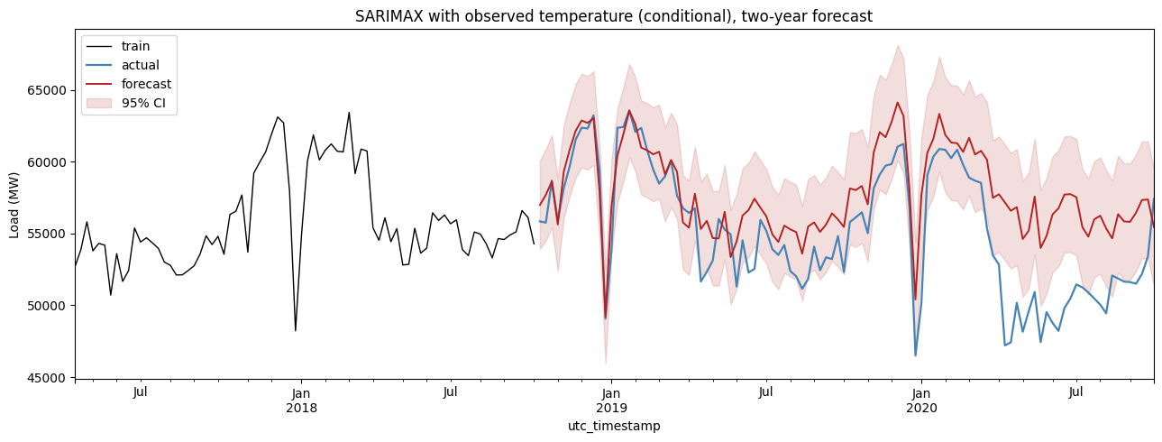
Figure 8. SARIMAX forecast using observed (conditional) temperature, with confidence band. The gain over plain SARIMA is small because the seasonal terms already carry most of the temperature information.

Feature-based regression
The same weekly target was then reframed as ordinary supervised learning. A feature table of 24 columns was built from lagged load (at 1, 2, 4, 8, 13, 26 and 52 weeks), rolling means over several windows, calendar terms, a few Fourier pairs for the yearly cycle, and the temperature features. Random Forest and histogram gradient boosting were trained on it.
A point of care runs through the whole table: every feature looks backwards only. Each rolling mean is computed on load shifted by one week, so the current week never appears in its own predictors, and the temperature lags are shifted in the same direction. Without that discipline the models would quietly read information they would not have at forecast time, and the test scores would be meaninglessly good.
Both tree models beat the benchmark. Random Forest was the strongest model on the weekly task at 3.66% MAPE and an RMSE of 2,582 MW, about 14% below the seasonal naive, with gradient boosting close behind at 2,708 MW, about 10% below. The feature importances explain why. The recent load lags and the rolling means dominate, with the 52-week lag and the temperature features a step behind. In effect the trees learn a flexible version of “this week looks like a blend of last week, the same week last year, and the recent local average”, which is a richer rule than either the seasonal naive or the SARIMA can express, and it adapts to the level shift around 2020 better than a fixed seasonal extrapolation does.
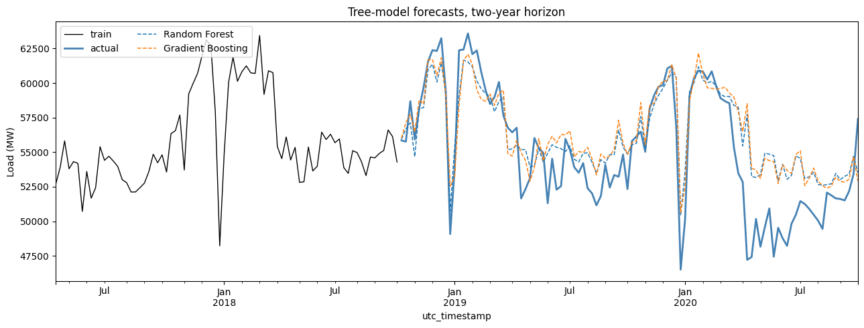
Figure 9. Random Forest and gradient boosting forecasts against actual. Both track the held-out two years closely and beat the seasonal-naive benchmark.
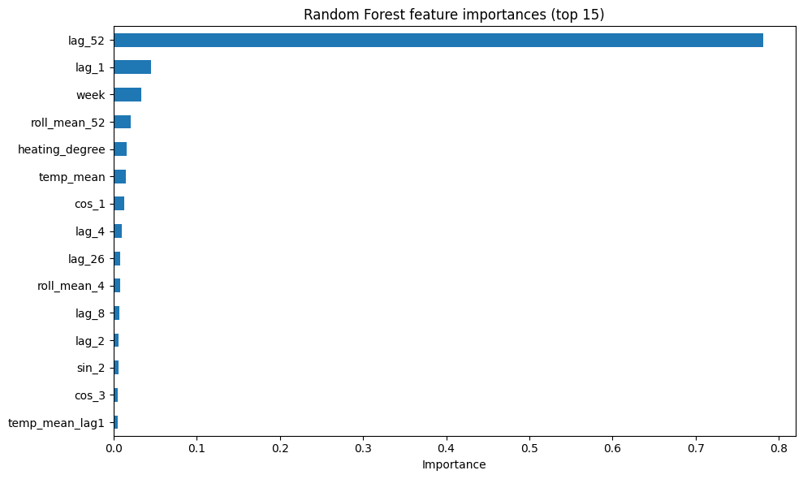
Figure 10. Random Forest feature importances. Recent load lags and rolling means carry most of the weight, with the annual lag and temperature behind them.

LSTM on hourly data
The classical and tree models all ran on weekly means. An LSTM can work at the raw hourly resolution and learn the daily and weekly rhythm directly, which is why it has become a common tool for short-term load forecasting since the deep-learning wave of the mid-2010s (Hochreiter and Schmidhuber, 1997; Kong et al., 2019). The usual finding in that literature is that LSTMs do well on short horizons where the daily and weekly shape dominates, but that their advantage over well-engineered simpler models narrows once those models are given good calendar and weather features, and that they cost considerably more to train and maintain.
The model here uses a 168-hour lookback (one week of history), two stacked LSTM layers of 64 and 32 units with dropout, about 29,000 parameters, trained with early stopping on a GPU. The scaler is fitted on the training data only, and the test windows are seeded from the tail of the training set, so the network never sees a value it is about to predict.
The result needs careful framing, because it would be easy to mislead with it. The walk-forward one-step forecast, in which every prediction is fed the real previous 168 hours, produced an RMSE of about 779 MW on the hourly series and only 147 MW once aggregated to weekly, which is roughly 95% below the benchmark. But that is an easy task: predicting the next single hour given a full week of true recent history is not the same problem as forecasting two years ahead, and the one-step number is not comparable to the SARIMA forecast. The honest comparison is the recursive forecast, where the model is fed its own predictions. Over four weeks the recursive RMSE climbed to about 6,883 MW, more than twice the seasonal-naive benchmark, as the error compounded. That gap between 147 MW one-step and 6,883 MW recursive is the whole story, and it is exactly the behaviour the literature describes. Both are reported, and the one-step result is labelled as such on the results table so it cannot be read as a clean win.
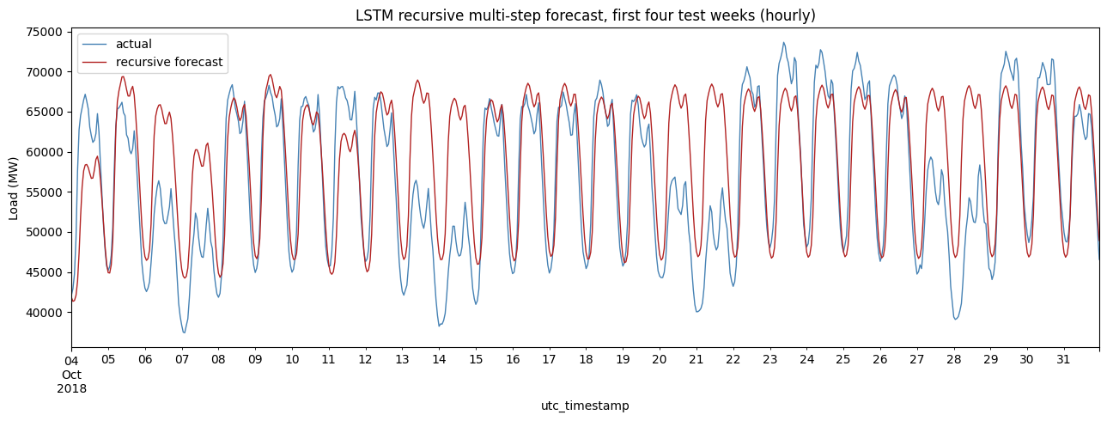
Figure 11. LSTM recursive multi-step forecast over the first four test weeks. Accuracy decays as the model forecasts on its own output, in sharp contrast to the flattering one-step result.

Results and discussion
The table below collects the test-window error for every model, sorted by RMSE. The all-model overlay that follows it shows the weekly forecasts against the actual two years.
Model | RMSE (MW) | MAE (MW) | MAPE (%) | MASE | vs seasonal naive
LSTM (one-step, weekly aggregate) | 147 | 123 | 0.23 | 0.09 | -95.1% (not comparable)
Random Forest | 2,582 | 1,915 | 3.66 | 1.39 | -14.1%
Gradient Boosting | 2,708 | 2,007 | 3.83 | 1.46 | -9.9%
Seasonal naive (benchmark) | 3,007 | 2,319 | 4.41 | 1.73 | baseline
SARIMAX + temp (conditional) | 3,667 | 2,879 | 5.51 | 2.15 | +21.9%
SARIMA | 3,726 | 3,015 | 5.72 | 2.25 | +23.9%
SARIMAX + temp (operational) | 4,364 | 3,557 | 6.76 | 2.66 | +45.1%
Mean | 4,397 | 3,789 | 6.97 | 2.83 | +46.3%
Naive | 4,459 | 3,783 | 6.79 | 2.83 | +48.3%
Drift | 5,118 | 4,340 | 8.05 | 3.24 | +70.2%
Table 1. Test-window error by model over the held-out 104 weeks. The LSTM row is a one-step result and is not comparable to the rest.
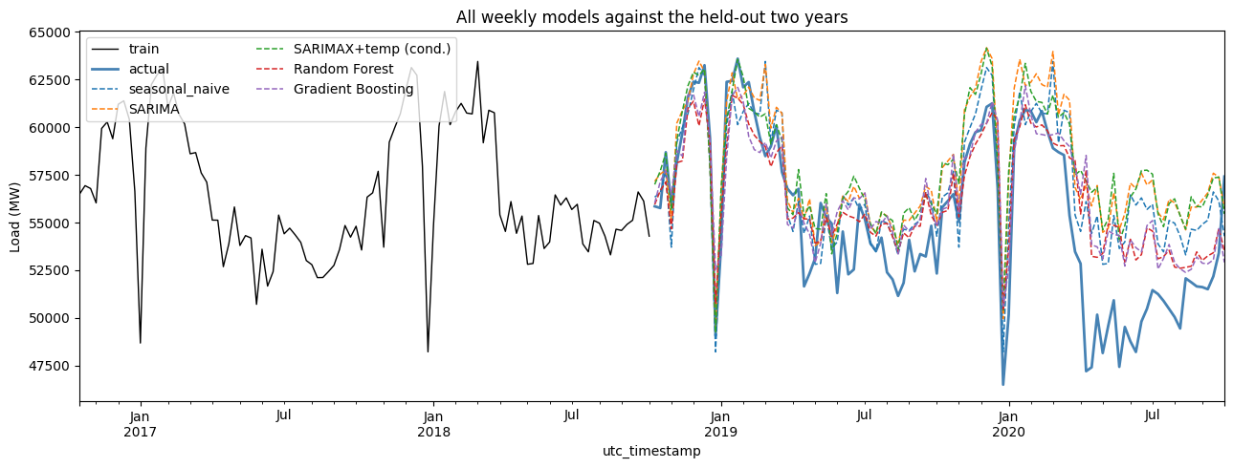
Figure 12. All weekly models against the actual two years. The tree models hug the actual line; SARIMA and the operational SARIMAX sit above it.
The rest of this section answers the analysis questions the brief set, since it asks for them in the report.

Which models actually beat the benchmark
Against the seasonal-naive benchmark of 3,007 MW, only the tree models give a meaningful improvement on a like-for-like basis: Random Forest at 14% lower RMSE and gradient boosting at 10% lower. SARIMA and both SARIMAX variants are worse than the benchmark. The LSTM’s one-step error is far lower, but it is solving an easier problem and does not belong in the same column; its recursive multi-step error is more than double the benchmark and would not beat it over a long horizon. So the honest answer is that the feature-based models are the only clear winners, and the classical models are a cautionary tale about extrapolating a parametric seasonal model a long way out when a simple seasonal replay is already very good.

How data leakage was avoided
Leakage was handled in two places. For the temperature features, every lag is created with a backward shift, so a row for a given week can only contain temperature from earlier weeks, never the week itself or later. For the supervised feature table, the same rule applies to load: every rolling mean is computed on load shifted by one week before the window is taken, which keeps the current target out of its own features, and the train/test split is strictly chronological so the model is never trained on anything that comes after the test period. Scaling for the LSTM is fitted on the training set alone and then applied to the test set, rather than fitted on the whole series.

Why those differencing orders and that seasonal period
The seasonal period is 52 because the data is weekly and the dominant cycle is annual, so the season repeats every 52 observations. The interesting part is that the unit-root tests call the level series stationary, so the differencing is not there to fix a unit root. One seasonal difference (D = 1) is included so the model can represent the annual cycle directly, which the lag-52 structure in the ACF clearly calls for, even though KPSS flags this as mild over-differencing. One regular difference (d = 1) came out of the AIC grid, where the best order was (6, 1, 2); it handles the residual low-frequency movement, including the 2020 dip. Going to d = 2 was allowed in the grid but generally raised AIC, which is consistent with over-differencing a series whose trend is already mild, so the lower order is preferred.

Do the covariates help, and are they known in advance
Temperature has a strong relationship with load (a +0.69 correlation with heating degree-days), but it helped the model only a little, because at weekly resolution it overlaps heavily with the seasonal terms the model already carries. Knowing the actual test-window weather nudged the conditional SARIMAX just ahead of plain SARIMA, while using only lagged temperature made the operational model clearly worse. The important practical distinction is what is known at the forecast origin. Future temperature is not known, so any model that uses observed test-window temperature is a conditional forecast and overstates what an operational system could do; only lagged or forecast temperature is legitimate. Holidays are a different case. The notebook does not model them explicitly, which is a genuine gap, and the Christmas and New Year demand dip is only partly absorbed by the seasonal and week-of-year terms. A dedicated holiday flag would likely help, and unlike weather it is fully known in advance because the calendar is deterministic. Adding one is the most obvious quick improvement to make.

Interpretability and complexity
The three families sit on a clear scale. SARIMAX is the most interpretable: the orders, the seasonal terms and the temperature coefficients all have a meaning you can explain to a non-specialist, and it produces calibrated confidence intervals for free. The feature-based models are middling: feature importances give a good intuition for what drives the forecast, but the model is a black box of hundreds of trees and the uncertainty has to be bolted on. The LSTM is the least interpretable and the most complex by a distance: tens of thousands of parameters, sensitive to architecture and training choices, no native uncertainty, and the heaviest to retrain. Complexity rises in the same order, and so does the maintenance burden.

A recommendation for operational use
For operational use I would recommend the Random Forest, with the seasonal naive kept alongside as a permanent baseline. On accuracy it is the best of the models that solve the actual forecasting problem, at 14% below the benchmark. It handles the level shift around 2020 better than the fixed seasonal extrapolation. It is cheap to retrain and tolerant of messy features, which matters for a system that has to keep running. Its weaknesses are real but manageable: it does not produce native confidence intervals, so prediction intervals would need to be added through quantile regression forests or conformal methods, and tree models do not extrapolate beyond the range of the training data, so a sustained shift in demand would need monitoring and periodic retraining. The seasonal naive stays in the pipeline precisely because it is so strong here, and because a forecast you cannot beat with a simple baseline is a forecast worth questioning. The classical SARIMA, despite being the most elegant model, would not be my operational choice on this horizon, and the LSTM is hard to justify given its cost and its poor recursive long-horizon behaviour on this data.

Comparison with the real test period and limitations
Because the test set is the genuine held-out tail of the data, comparing the forecasts with what really happened is built into every metric and plot above. The pattern that comes through, and that Figure 12 makes plain, is that methods which replay or flexibly recombine recent observed behaviour (the seasonal naive and the tree models) track the real two years better than methods which extrapolate a fitted parametric structure a long way forward (SARIMA, which drifts steadily high). The early-2020 demand dip is part of the test window, and the tree models, which can lean on recent lags, adapt to it more gracefully than the seasonal extrapolation does.
Several limitations are worth being honest about. The temperature features use observed Berlin weather, and a single city is a rough proxy for a country with real regional variation. The LSTM tuning is light, only two configurations, so its potential is probably understated rather than overstated. Holidays are not modelled. And the two-year horizon is long for any of these methods; much of the apparent failure of SARIMA is really a statement about how hard long-horizon point forecasting is when the world can shift under the model, as it did in 2020.

Future work
The most useful next steps are practical rather than exotic. Add an explicit German holiday calendar, since it is known in advance and cheap to include. Add prediction intervals to the tree models through quantile or conformal methods, so the best-performing model also reports its uncertainty. Use a temperature forecast rather than observed temperature, to turn the conditional SARIMAX into a fair operational forecast. Evaluate with rolling-origin cross-validation instead of a single split, which would give a more stable read on which models really win. And if the LSTM is pursued, give it a proper tuning budget and a sequence-to-sequence design rather than recursive one-step rollout, which is the standard remedy for compounding error (Kong et al., 2019).

References
Box, G.E.P. and Jenkins, G.M. (1970) Time Series Analysis: Forecasting and Control. San Francisco: Holden-Day.
Breiman, L. (2001) ‘Random forests’, Machine Learning, 45(1), pp. 5-32.
Chen, T. and Guestrin, C. (2016) ‘XGBoost: a scalable tree boosting system’, Proceedings of the 22nd ACM SIGKDD International Conference on Knowledge Discovery and Data Mining, pp. 785-794.
Hochreiter, S. and Schmidhuber, J. (1997) ‘Long short-term memory’, Neural Computation, 9(8), pp. 1735-1780.
Hyndman, R.J. and Athanasopoulos, G. (2021) Forecasting: Principles and Practice. 3rd edn. Melbourne: OTexts.
Hyndman, R.J. and Koehler, A.B. (2006) ‘Another look at measures of forecast accuracy’, International Journal of Forecasting, 22(4), pp. 679-688.
Kong, W., Dong, Z.Y., Jia, Y., Hill, D.J., Xu, Y. and Zhang, Y. (2019) ‘Short-term residential load forecasting based on LSTM recurrent neural network’, IEEE Transactions on Smart Grid, 10(1), pp. 841-851.
Open Power System Data (2020) Time series data package, version 2020-10-06. Available at: https://data.open-power-system-data.org/time_series/ (Accessed: 2020).
Taylor, J.W. (2003) ‘Short-term electricity demand forecasting using double seasonal exponential smoothing’, Journal of the Operational Research Society, 54(8), pp. 799-805.

