Correcting Post-Rationalised Citations in Retrieval-Augmented Generation

A causal feedback loop and the generator property it makes visible

submitted as a requirement for the degree of
Master of Science, Computer Science, Big Data and Artificial Intelligence

Berlin, Germany

by
Srihari Ananthan
Matriculation Number 100001648

Primary Thesis Supervisor: Prof. Dr. Joel Dokmegang
Associate Thesis Supervisor: Maximilian Erdmann Sanchez, Startup Insider GmbH

written in conjunction with Startup Insider GmbH

Abstract
Retrieval augmented generation systems have a known issue called post rationalization. A model answers the user's prompt from memory and then adds a citation that looks correct but never supported the claim. Existing methods only measure this after the citation is made. This thesis asks if the same test can correct post rationalization during generation.
The method involves removing a cited passage from the context and regenerating the answer. If the answer barely changes, the citation was purely decorative, but if it changes substantially then the citation was genuine. This removal test is not new; the new part is feeding that verdict back as a correction signal and re-prompting the generator.
This study covered 75 questions against 38,692 company profiles using three generator models, three discriminator models and 12 conditions at zero sampling temperature. The correction loop works, but its effect depends on the model. Post rationalization fell 12.8 percentage points for Mistral 7B (p = 0.0012, Wilcoxon signed-rank, surviving Bonferroni correction) and 6.4 points for Llama 3 8B (nominally significant, p = 0.032, not after correction). Gemini showed no measurable changes. A new property called generator correction receptivity shows us how much a re-prompt removes the post rationalized citation. It ranges from 14.8% to 59.1% across the three models. It also moves in the same direction in which the post rationalization rate falls.
LLMs cannot detect post rationalization from context alone, catching only 8.5% of cases. The test is less reliable when an answer cites several companies since the remaining citations cover the loss of the one removed. A single annotator validation study agreed with the test 63% of the time at kappa 0.308. So, the causal measure’s construct validity is not yet established. Correction is possible, but its extent depends on the model answering.
Keywords: retrieval augmented generation, citation faithfulness, post rationalization, causal correction, generator correction receptivity

Acknowledgements
I would like to thank my primary thesis supervisor, Prof. Dr. Joel Dokmegang, for his guidance, feedback, and the critical questions that sharpened this work throughout the research. I am equally grateful to my associate thesis supervisor, Maximilian Erdmann Sanchez of Startup Insider GmbH, for his continued support, practical insight, and the detailed review of this thesis. I also thank Startup Insider GmbH for providing the data and the industry context that made this research possible.

TABLE OF CONTENTS
Abstract i
Acknowledgements ii
TABLE OF CONTENTS iii
LIST OF FIGURES v
LIST OF TABLES vi
LIST OF FORMULAS vii
LIST OF ABBREVIATIONS viii
Introduction 1
1.1 Introduction to the research topic and subject relevance 1
1.2 Subject relevance 2
1.3 Research gap 2
1.4 Objectives and goals 3
1.5 Research questions 3
1.6 Scope and limitations 4
1.7 Structure of the thesis 4
Literature Review and Theoretical Framework 6
2.1 How this review was conducted 6
2.2 Retrieval augmented generation 6
2.3 Hallucination and faithfulness 7
2.4 Attribution and citation evaluation 8
2.5 Attempts to correct citations 9
2.6 Self correction and self critique 10
2.7 Language models as judges 11
2.8 Causal and ablation based evaluation 12
2.9 Semantic similarity and sentence embeddings 13
2.10 Research gap 13
Methodology 16
3.1 Research design 16
3.2 Corpus construction 16
3.3 Evaluation query design 18
3.4 The post rationalisation rate 19
3.5 The chunk removal procedure 19
3.6 The similarity threshold 20
3.7 Generation determinism 21
3.8 The correction loop 22
3.9 A worked example 23
3.10 Models 25
3.11 Experimental conditions 26
3.12 Metrics 27
3.13 Construct validation study 28
3.14 Statistical treatment 29
Findings 31
4.1 Baseline post rationalisation 31
4.2 The effect of correction across all conditions 31
4.3 The inter model trust matrix 33
4.4 Generator correction receptivity 35
4.5 Correction by query type 36
4.6 Replicate analysis 36
4.7 Threshold sensitivity 37
4.8 Citation correctness 38
4.9 Per query analysis 38
4.10 Construct validation 39
4.11 A structural limit of whole answer similarity 41
4.12 Sensitivity to the aggregation choice 42
4.13 Summary of results 43
Discussion of Findings 45
5.1 Overview 45
5.2 The discriminator has no causal path to the outcome 45
5.3 What the discriminator results say about verbal judgment 46
5.4 Generator correction receptivity 46
5.5 The threshold dependence 47
5.6 Validity of the measure 47
5.7 Reproducibility and hosted models 49
5.8 Practical implications 50
5.9 What the loop improves, and what it leaves alone 50
5.10 Limitations 51
Conclusion 53
6.1 Answers to the research questions 53
6.2 Contributions 53
6.3 Limitations on what is claimed 54
6.4 Future work 54
6.5 Closing remark 55
Appendix A: Experimental Conditions 56
Appendix B: Annotation Codebook 56
Appendix C: Reproduction 56
Prompts used in the experiment 58
Appendix D: Per query PRR, All 75 Queries, All 12 Conditions 59
Alphabetical List of References 63
LIST OF GENERATIVE AI TOOL USAGES 66
AFFIDAVIT 67

LIST OF FIGURES
No. | Caption | Page
Figure 1 | Corpus record to embedding vector, schematic | 17
Figure 2 | The chunk removal audit loop and the correction loop | 23
Figure 3 | Post rationalisation rate after correction, by query type and condition | 27
Figure 4 | Post rationalisation rate before and after correction, all twelve conditions | 32
Figure 5 | Discriminator flag rate, same model vs cross model | 34
Figure 6 | Generator correction receptivity, by model | 35
Figure 7 | Similarity score vs. pilot annotator judgment | 40
Figure 8 | Whole answer similarity misses enumerated answers | 42
Figure 9 | Baseline PRR under macro- vs micro averaging | 43
Figure 10 | The correction effect peaks at 0.85; validation agreement does not | 49
Figure 11 | Screenshot of chunk_removal.py where the chunk removal technique is implemented | 57

LIST OF TABLES
No. | Caption | Page
Table 1 | List of papers used in the literature review | 14
Table 2 | Example query for each of the four query types | 18
Table 3 | The five retrieved profiles used in this worked example | 24
Table 4 | Chunk removal verdicts for this worked example, before and after Mistral's revision | 25
Table 5 | Before and after post rationalisation for a stratified sample of six queries, across all twelve conditions | 25
Table 6 | The twelve experimental conditions, C1 to C12 | 26
Table 7 | Queries with a different post rationalisation rate, by condition | 26
Table 8 | Distribution of PRR by generator and query type | 31
Table 9 | PRR by condition, generator, and discriminator, before and after correction | 32
Table 10 | PRR change in percentage points, by generator/discriminator combination | 33
Table 11 | Discriminator disagreement numbers against the outcome | 34
Table 12 | Post rationalisation citations caught, by discriminator model | 34
Table 13 | Discriminator/generator pairs flagged as post rationalised | 34
Table 14 | Generator correction receptivity (GCR), by model | 35
Table 15 | Generator correction receptivity (GCR), by query type and model | 35
Table 16 | PRR change in percentage points, by query type and model | 36
Table 17 | Replication spread, by generator model | 37
Table 18 | PRR before correction, at varying similarity thresholds | 37
Table 19 | PRR change in percentage points, at varying similarity thresholds | 38
Table 20 | CCR before and after correction, by generator model, including Type D | 38
Table 21 | PRR before and change in PRR, by query type | 39
Table 22 | Result of the single annotator construct validation pilot pass | 39
Table 23 | Human judgment agreement, at other thresholds | 39
Table 24 | Agreement distribution, by query type | 39
Table 25 | Post rationalisation under three readings of the same construct | 40
Table 26 | Removal audit verdict where the cited company disappears from the answer | 41
Table 27 | Baseline post rationalisation rate under macro versus micro averaging | 42
Table 28 | PRR versus CCR, compared | 51
Table A.1 | Experimental conditions and each model's role | 56
Table C.1 | Location of each artefact needed to reproduce the experiment | 56
Table C.2 | The three prompt templates used in the experiment | 59
Table D.1 | Per query PRR before and after correction, all 75 queries across all twelve conditions | 60

LIST OF FORMULAS
No. | Caption | Page
Formula 3.1 | PRR = post rationalised citations / total citations | 19
Formula 3.2 | CCR = correctly cited answerable questions / 50 answerable questions | 27
Formula 3.3 | GCR = re-prompts where PRR decreased / re-prompts triggered | 28

LIST OF ABBREVIATIONS
Abbreviation | Meaning
AI | Artificial Intelligence
API | Application Programming Interface
AUROC | Area Under the Receiver Operating Characteristic curve
BERT | Bidirectional Encoder Representations from Transformers
CCR | Citation Correctness Rate
DACH | Germany, Austria and Switzerland (Deutschland, Österreich, Schweiz)
GAN | Generative Adversarial Network
GCR | Generator Correction Receptivity
LLM | Large Language Model
ML | Machine Learning
PRR | Post Rationalisation Rate
QA | Question Answering
RAG | Retrieval Augmented Generation
ROC | Receiver Operating Characteristic
RQ | Research Question

Introduction

1.1 Introduction to the research topic and subject relevance
, RAG stands for retrieval augmented generation. It is a technique used to provide LLMs with a way to access information beyond this memory so that they can answer questions from a source instead of retrieving it just from memory. A RAG system is built by using an LLM and attaching a set of documents to it. These documents are then used to create a vector database where the LLMs can access the required information. Once it's trained on these documents, the system can answer queries from the user by retrieving the relevant information from the document instead of the LLM's own memory and also cite the document or the source where it retrieved information from. RAG is now the standard way to build a system to answer a question over a fixed document collection. Rashkin et al. (2023) mentions that a citation asserts the source entails the statement. That means that citations are what make an answer provided by an LLM or a RAG system checkable and verifiable. When a reader has a doubt and doesn't trust the answer provided by the model, they can check it themselves through the citations. This isn't an extra regulation. It's the reason the system is allowed to exist in a high degree of importance field like law, medicine, or finance. This verification aspect of the system is what makes it to be used. If there is no traceable citation trail, then approvals for these kinds of systems would be very difficult. The issue here that occurs sometimes is called post rationalization. What it means is that, for a given query, the model writes what it knows from memory and then attaches the closest looking document from the RAG system to support its answer. The instructions would have mentioned to cite the source, so it grabs whatever source or chunk that was about the same as the subject or just related to it. The citation decorates the answer, but it does not support the answer. The term post rationalization comes from Wallat et al. (2024), who named the behavior and measured this. A cited passage could be real, on topic and even the claim it makes could often be true but it still could be post rationalized. This is the problem that we face. A fabricated citation to a document that doesn't exist is usually very easy to spot, but a real, retrieved, related topic document to answer a question which exists in the document submitted or provided to the system is hard to spot when it doesn't match or when the model never consulted on the information. Fabricated Citation is a simple yes or no check. The verification is done by looking up the URL or the DOI number or the document and to see if it even exists and to read through the document to verify it completely. Any human or even a system can do this and confirm a real citation exists in the document and is even related to the topic but still unused to create the answer is more harder to verify since the citation actually is on topic and might even seem relevant to the topic but is not actually used to write the answer. In a sense, what is false is the relationship, but not the actual document or the source.
Wallat et al. (2024) says that 50% to 57% of citations from one retrieval optimized model fail a faithfulness check. From this, we can see that these are different fields, different methods, but the conclusions are similar. Even Magesh et al. (2025) say that commercial legal texts like LexisNexis and Thompson Reuters sold on hallucination for free citations. These tools measure at 17% to 33% hallucination. Huang et al. (2025) mentioned that the open problems currently are no RAG specific faithfulness and also an issue with controlled empirical evaluation. Van Dort and Heuss (2026) also mention that rather an LLM uses a source when it does a citation is currently an unverified assumption.

1.2 Subject relevance
RAG system was expected to fix the problem of hallucination by grounding answers with the support of real documents, but sometimes grounding turned out to constrain the field of the answer and not the reasoning behind the answer. A model can stay relevant to a topic, answer the question of the user, and attach a real citation, but still have the answer written from memory and attach a citation to this answer post generation of the answer. The real question here isn't whether a citation exists, but whether that citation carries any weight behind producing this answer that the model generated. This question is what this thesis actually measures.
, RAGAs and ALCE are the standard evaluation frameworks for RAG systems and their answers, and they are good at what they do. They score an answer after it's finished or after it's generated, but not while it's being produced. During evaluation of a model or a RAG system, these metrics are provided for evaluation, so these are after the fact scores, not fixed to the current question being asked to the RAG system. When a question is asked by a person and an answer is generated, deciding whether to trust this answer and its citation is difficult and not served by these frameworks. The issue in question is about the timing of evaluation, and it's not about the tools being weak. In a research prototype, a citation that costs nothing but is decorative is just an academic curiosity. These systems are now used in production systems, in real world scenarios like feeding diagnoses, creation of contracts, investment decisions, and real important situations. Once a production level RAG system is created, its citation stops being decorative and becomes part of the record of that decision, whether it is post rationalized or not. So what is needed to ensure that a record and its citation holds up when checked by someone later not just a developer but an external person maybe someone unrelated to this subject in the minimum we need four things or four questions to be answered and that is why the decision to use the citation was made what details and context the system see when deciding the answer and which part of the system made the decision and enough context for an outsider to make the decision themselves without asking a developer or a technical person a simple citation with an answer gives none of this.

1.3 Research gap
Most of the existing work on citation faithfulness is about measuring it. Measuring the metrics proposed, building benchmarks, and the different model comparison removal based no chunks and source space removal technique specifically is well established and is not something that this thesis reinvents or invents. Reference section 2.8 for the three groups who have already built it.
What is new in this work is the correction. Once a citation is flagged as unused or post rationalized, nobody sends that verdict back to the generator during the inference. This thesis tests this idea and measures all, and also measures how well this works or if it even works in all existing literature. In existing literature, the results end in measurements, and these measurements end in a report. The process ends over there.
A second gap only becomes visible once you actually run the experiment and try the correction loop. Does the RAG system comply with the correction signal, or does it produce different text that still isn't grounded? If genuine compliance is actually dropping the unsupported citation or claim, rather than just rewording the answer to fit the correction request, is also a test to see if it is the property of a model itself or not. To measure this property, we must build a system that sends a correction signal in the first place, which has not yet been characterized by anybody. This thesis investigates both these gaps, one being the chunk removal not used as an evaluation metric but as a correction signal sent back during the loop and tested across three different models, and two to compare the data and investigate. Thus when a generator writes an answer to a question and cites n number of chunks the chunks are removed one by one and evaluated again and then this evaluation feedback is sent back to the generator for the generator to rewrite its answer this way the chunk removal and audit acts as a feedback loop to give advice to give feedback to the generator to rewrite again.

1.4 Objectives and goals
What are the objectives and goals of this thesis? Whether the idea of chunk removal, that is, deleting a cited passage and re-asking the question, could work as a correction mechanism in the RAG system. If a model's answer barely changes after the cited passage or chunk is removed, that passage or chunk probably wasn't carrying the weight or doing as much work as mentioned in the original answer. This removal and check verdict becomes feedback that is sent back to the RAG system, herein known as the generator, which is then checked to see whether the post rationalization actually fell. To find out whether that effectiveness depends on which model is generating the answer. Three different models or three different generators are compared in this thesis under identical conditions, with the fixed retrieved passages and fixed starting answers. The only thing that actually varies here is the model. Three different models are used here and are selected based on the size of the model and whether the model is open or closed. To test whether an LLM model can identify post rationalization just by reading the text, as in simulating a verbal check by an LLM, without running the causal chunk removal and re-asking the question correction mechanism loop at all. This verbal check matters, as it would be far cheaper than a causal one, which requires multiple loops and carries extra generation cost for every passage cited. If a model could simply be asked whether a citation looks load bearing or whether it's post rationalized, the idea of the causal procedure might be unnecessary and is a logical step that must be checked. All three objectives need to be tested together as they're interlinked with each other objective two needs objective one to be tested first since in objective two we are trying to find out which model is dependent on the generating on generating the answer and objective one is needed as a system to test objective 2 again objective for objective three objective one is required as a system to then be placed as an external judge.

1.5 Research questions
Thus, in this thesis, we pose three research questions: Can the causal chunk removal work as a real time correction signal that reduces post rationalization during the generation of the answers, rather than only measuring it afterwards, by feeding it back to the generator as a correction signal? Does the effectiveness of this correction depend on which LLM model generates the answer? Can this be characterized as a measurable property of the model? What differences can varying the model size and open or closed model have on this? Can a language model detect post rationalization from the text and context alone, without running a causal test? To recap: RQ1 asks whether this method works at all. RQ2 asks whether it works the same way across different models and how different models vary in this. RQ3 asks whether all of this expensive causal test and loops are even necessary and if a cheap verbal judgment by an LLM can work equally well. RQ3 is built as a hypothesis test and a passive measurement rather than a live signal to be sent back to the generator in the loop. This design was made because we need something to measure and compare against. The causal chunk removal test in RQ1 and RQ2 is the standard considered here And we compared RQ1 and RQ2 with the measurements from RQ3. If the RQ3's verbal check in were actually sent back and driving the corrections then we could never be sure whether the corrections came from the causal test or from the verbal layer every loop gets a verdict from the causal audit removal and from the verbal check so we can compare them fairly.

1.6 Scope and limitations
This thesis is done in conjunction with the company Startup Insider, and the data is provided by Startup Insider. The corpus that we use for the data contains company profiles from Germany, Austria, and Switzerland, drawn from a commercial database. The company profile here follows the same structure, the profiles are short, factual and similar in structure and that is why they are ideal for controlled experiments. But it also must be noted that these kinds of structures do not represent how RAG behaves in long documents, narrative texts or even technical material. Let us take an example for the case of long documents, narrative text, or technical materials. A merged story where one paragraph mentions three companies at once. As a return chunk from the long document text. When this chunk is removed, all three companies are lost, not just the one company we are trying to test. So in this case, we are losing multiple pieces of evidence or chunks at the same time. And this cannot be controlled in such long text situations. Three different Generator LLMs are compared. Two of them are open models running locally and one is a hosted model available commercially and needs to be used using its API. Three generator models are enough to produce a ranking between them, but it's not enough to support a strong claim about categories of models and similar models in general. When results appear to separate the local models from the commercial hosted models, that reading is offered as a hypothesis, but not a finding. The queries are in English, and similarity between the queries is computed with a single embedding model. The similarity threshold that separates a load bearing citation from a post rationalized one is a chosen methodological parameter. It is not a constraint derived from data, so every figure in this thesis, depending on it, inherits that as a limitation, not just a detail.
Chapter 3 goes on to explain how the threshold for this methodological parameter was chosen, and then in Chapter 4, we report how sensitive the results are to this choice above.
The language model generation is stochastic by default and thus affects the audit process in ways not anticipated going in. Section 3.7 explains the problems, the fix, and also the part that couldn't be fixed, which is hosted API models due to their ability to not control their temperatures and stay non deterministic even when configured not to be. For future validation, the central measure can be validated against human judgment.

1.7 Structure of the thesis
The structure of the thesis is built in a way to: Introduce the topic and the context. Mention the literature review. Move on to the methodology. Move on to the findings. Move on to the discussion about the thesis and our results. Conclude with the answers to the research. In chapter 2 we talk about the literature review on RAG systems, hallucination, faithfulness, existing metrics for attribution, research on self correction systems and more related topics. Chapter 3 describes the methodology on how the corpus was built. How the evaluation queries, the 75 questions, were designed and the reason behind them. How post rationalization rate (PRR) is defined. The procedure for the causal chunk removal. The architecture and planning for correction loops. The complete design behind the experiment and the 12 conditions. Chapter 4 discusses the results across all 12 conditions, broken down by query type and by generator, and also looks into how sensitive those results are to the similarity threshold and how the rates have been aggregated. Chapter 5 discusses what the findings actually mean and why one of the three research questions led to an unexpected answer. It also discusses what the limitations are, and how much weight the conclusions carry. Chapter 6 concludes with all of the research findings and then talks about future work and what can happen next. There exists a worked example taken from one of the questions in the study. The worked example lives in chapter 3. and not in chapter 4. And in the worked example we talk about the mechanism on this one question, the removal and the verdict before the result even exists. In chapter 4 we aggregate these results and we assume that you have already read the example in chapter 3 so skipping directly to chapter 4 will lead to lost context that is only present in Chapter 3.

Literature Review and Theoretical Framework

2.1 How this review was conducted
The research for this thesis covered IEEE Xplore, the ACM Digital Library, and SpringerLink as institutional database searches, alongside a systematic search across three open databases, arXiv, OpenAlex, and Semantic Scholar, using 14 different queries. The search window was from 2019 to 2026. The 14 queries returned 2,224 records before any filtering.
, In these 2,224 records, 421 duplicates existed, which were removed first by DOI to remove duplicates, then by title matching, leaving 1,803 records to screen on abstract and title. After reviewing the title and abstract, 596 records were carried forward to the next step. Lewis et al. (2020) was added by hand as a historical anchor, since it predates most of the field. It was a manual decision. The screening of these 1,803 documents was done by creating a rule set, because that would be the most reliable and efficient at that scale. But the rule based screening also had some hitches. For example, at least one image generation paper scored highly in this system just because of the use of the word refinement, and similarly, 327 records were uncertain and the rule system could not settle them. Also, for sanity check, 8 papers which were known to be relevant were searched for and added manually. Roy et al. (2025) was found manually and had been added by hand. The screening rules involved a filter that checked for at least three required word families. Word families like brag terms, citation or attribution terms, faithfulness or hallucination terms and other supporting families like causal removal correction refinement evaluation model judging interpretability and more at least two of these word families plus at least one of the supporting families were need to be checked for the citation or paper to be auto included into the list an off topic list was created to auto exclude papers unless it hit related rag terminology in brackets example robotics astronomy biology etc some common words between topics as RAG ML include refine and correction for example diffusion image model refine a noisy image so there is a chance that unrelated image processing and image related work are picked up but they are also excluded in the next step.

2.2 Retrieval augmented generation
Retrieval augmented generation systems (RAG) are built on two ideas, first a large language model, and second an outside set of documents it can look up and generate answers based on the user's prompt, following Lewis et al. (2020). LLMs' own knowledge is fixed and stops at whatever point it learned during its training, and it cannot be updated without retraining or fine tuning the model. Also, once a large language model is built, there is no way to see where any specific action actually comes from. This matches also in the idea of the black box issue we have in AI and LLMs. We understand the math behind large language models and how to build them, but once they are actually built the neural network together acts as a black box that we cannot investigate. Because they are so complex it is hard to map out their thought processes and how they work internally down to the dot. The RAG system fixes two problems related to the above. One is that the model’s memory stops at some point when its training stops. Second is the updation problem where a document system solves this, by being able to be updated at any point separate from the model. Retrieved answers also give a record of where and at what point the answers might have come from, and what version the answers might have come from. This system has become the standard way to answer this question over a private set of documents with abstraction or specialized document collection. Such systems can be found in support system bots, help chats, help desks, and even in governmental organizations. An example where post rationalized citation could lead to an issue is a rag production use case of an internal support desk assistant helping with internal policy documents. The question “what is our refund policy for late delivery cases?” So when the RAG system which answers and cites a passage to this question and if the citation is decorative the wrong policy goes out and there is no human check in between this can lead to economical and financial problems. The basic pattern is that you look up things in the document system, and based on the answer that is found, the model generates an answer. Going into deeper technicalities, a RAG system works by embedding the documents into a vector space and then storing it in a vector database. The question, the user's prompt, is also embedded into the same vector space, and then they are compared as to how similar the question and answers are. The top k passages, chunks, answers, or information related to the vector space the question occupies are retrieved and sent back to the model as information. The model then reads or looks into this data and answers the queries. The main expectation of this system was to ground the model in fixed data so it does not hallucinate or come up with things that it does not have answers to. This expectation turned out to be partially true, but the gap that people expected from this RAG system was that it sometimes answers the question first on its memory and then looks for a citation to back up this. Here, the citation becomes decorative, and this is where this thesis roughly sits and investigates.

2.3 Hallucination and faithfulness
Hallucination is the effect where a model responds to a prompt or a question that either contains false fabrications or misleading information with a high level of confidence. There are two kinds of hallucinations: Intrinsic hallucination, where the output actually contradicts the source it was given. Extrinsic hallucination, where the output adds content the source never supported. This is shown by Ji et al. (2023). An example for intrinsic hallucination is when the model replies the company was founded in 1998 in Munich but the source says founded in 1998 in Berlin so there is a direct contradiction here. Whereas an extrinsic hallucination example would be the source says the company was founded in 1998 and the model adds with over 500 employees, so it adds something that does not exist in the source. The two types of hallucination have different causes and need to be evaluated differently. Rack systems help with the extrinsic kind of hallucinations, since supporting them with documents can actually help with the answers. Intrinsic hallucination isn't completely helped by a RAG system, since the model can still misread or contradict the source even though it's given clear data. But any of the RAG system doesn't stop the model from producing content that fits the data it was trained on, even though there is no evidence or data to support it in the document system. The RAG also does not help in the model misrepresenting how it looks at its own output related to the source it points at and how confident it is with its own answers or output.
Faithfulness means whether the LLM's output is actually backed up by the source in the document system it actually cites. It is not related to whether the answer is factually correct. This makes sense because the document system could contain wrong information or even fictional information in examples of a RAG system, which is built on fictional books and is a chatbot to answer fan mail.
Post rationalization is the mix where an answer can be true but still be unfaithful, even if the data or the source cited doesn't actually say it. Post rationalization is when the claim is true, and the citation also often looks like it's on the right topic, but what is wrong is the connection between these two.

2.4 Attribution and citation evaluation
, , , , What existing work is present on the RAG system and the evaluation and the measurement? RAGAs proposes a way to check RAG answers without needing the reference answer to compare with. It does this by breaking the answer into individual claims and checking each claim with the retrieved chunks from the document store. It breaks the answer into its individual constituents, and then checks each of these constituents against the retrieved text. Usually done by another LLM. And then a score is computed. The score is the fraction of the claims or constituents that pass this test. Malin et al. (2025) say that when LLM stand as judge it best correlates with the human judgment for faithfulness and that a RAG system with prompting based approaches lead to better faithfulness. This study, which is an independent and worked with a database, finds the similarity that faithfulness and correctness are treated as genuine things worth measured in this field. ALCE checks citation quality in long answers. It does this by looking at whether the cited answer actually backs up their claims and whether claims that need citation actually have one in the answer at all. Saxena et al. show the difference between the two types of citation issues. One is where a citation mistake the model makes while it's still writing the answer. The other is when a citation is added post the answer is written just as decorative. Post rationalisation issue is the second kind. Rashkin et al. say that a citation can only be counted as a valid citation if an ordinary reader would also agree on the same, almost all later works and most of the later works build on this rough same idea. This definition by Rashkin talks about the relationship between statement and its source, and does not actually talk about how the answer gets built. FActScore breaks down the answer into smaller individual answers and checks each one against the knowledge source or the document source. LongCite says that citing the complete passage or chunk is too much for a RAG model and a RAG system, and instead it should cite at sentence level. FaithScore (Jing et al., 2024) does a similar fine grained decomposition, but for vision language models checking claims against an image, not a retrieved text passage -- a contrast case rather than a direct comparison, and not to be confused with FActScore above.
This will help us narrow down what could be the issue and pinpoint the exact sentence that is causing this post rationalization and whether this sentence is actually needed or not. We have mentioned multiple tools and multiple research projects above. All the above works have a common factor and that factor is that an answer is written based on the document system then it's broken down according to some rule and then the broken down components are checked against the document source.
They also have the common assumption that if a citation is used to back up a claim, then that claim actually used that citation. As we will see further in this study, a passage can actually back up a claim without even being the thing that produced their answer, and every one of these above mentioned projects would still mark the citation as correct.

2.5 Attempts to correct citations
Until now, we have talked about RAG systems and how they detect post rationalization and how they measure post rationalization. Now let's talk about the attempts to correct these post rationalizations. RARR does post editing. going to the model's output once the answer is produced, finding evidence for each of the claims, and then re-editing the text to match the text with the correct claims. Self-RAG trains a model on how to look up things and then judge whether the sources that it looked up are actually relevant and supportive of what it finds, and then writes the answer. It's an intermediate step, similar to a correction loop inside the RAG, and it looks into the source again before writing the answers. The difference between this thesis and self-RAG is that the middle judgment of how relevant and well supported the answer and the citations are comes from the same model that will write the answer. This thesis's correction signal comes from an outside test in the retrieved text itself, making changes to the prompt and asking the model to pay more and more close attention to how it wrote the answer. By looking at the context and the answers through framing and examples and other techniques, it makes it lean on the context even more. It is another option to fix this post rationalization problem, and it is the cheapest option available. Another system is where you train a model to detect and be aware of fake passages and wrong citations, and make it more resistant to being a bad retrieval system. ATM, does this ask whether a model can be trained to ignore a bad passage rather than asking whether it used the passage in the claim at all? CiteFix does something different it checks the answer citation with real articles using keyword matching, semantics matching, and a small LLM. And it reports a 15.4 citation accuracy improvement. Trust-Align is another system that works on the retraining idea. A retrained model should be more careful when answering questions and refuse when answering the questions more approximately. It reports gains and improvement across 26 of the 27 models it tested. Both CiteFix and Trust-Align make citations better, but they don't check whether a citation was genuinely used. SynCheck takes up another method of checking the faithfulness of each of the sentences the model produces. It uses signals from how the model is generating and then cancels the unfaithful sentences with a 0.85 area under the Receiver Operating Characteristic curve across six different datasets. It is not the closest match to this thesis because it intervenes during the generation stage but it differs in the idea that its correction signals comes from the model's own statistics rather than an outside causal test. It operates more on how the word and which word gets picked rather than asking the model to redo its answer during the correction loop. SynCheck does not have a correction loop but actually edits during the answer creation. Zhou et al. (2023) show that careful prompting alone can make a model lean more on the retrieved context, without any correction step after the fact -- the cheapest alternative this thesis's removal and reprompt loop is implicitly measured against. None of the above actually sends a verdict back in the loop in the form of a correction loop to the generator and watches it redo or correct its mistake, which is the gap this thesis aims to look at.
At a closer glance let's compare uh site fix and our thesis idea side fish site fix checks after the answer is done using keyword and meaning matching and then also uses an LLM model in brackets small to check and it makes sure it's model cost and the check cost stays constant no matter how big the question or the answer or even the citations are but this thesis removal test and check generation calls so the cost grows with the factor of the number of citations and is not dependent to the length of the answer so site fix is cheap and constant but only checks the correctness after the answer is generated the removal test in this thesis is more expensive but handles the check and correction during the generation but this thesis also looks at whether the citation is really needed rather than just judging whether it looks right after the answer is generated. Ajmal et al. (2025) Built a similar research. They created a 500 question data set across 15 academic categories. They deliberately introduced hallucination effect into some of these answers and questions and they wanted to introduce a new metric to detect it the metric is that a post hoc retrieval step improves the accuracy across the three models that they tested which is gpt4, gpt4 turbo and gpt 3.5 turbo. The two findings of this thesis is similar to our finding. One being that the accuracy depends upon the models, even though the same design is used to test the three models. The second is that this research uses the fix after the answer approach, which is different to our fix during the answer approach.

2.6 Self correction and self critique
Self correction is where a system or a model writes an answer, has the system evaluated, and sends a feedback loop or sends a correction and corrects it.
Self critique is where a model critiques itself on its answer. It produces self refine, where a model writes something, gives feedback to itself, and corrects itself based on the feedback, and then creates analytics and reports on these test conditions.
Constitutional AI does something similar: it uses the model's own critique, measured against a set of principles, rather than using an outside test. Huang et al. (2024) later finds that language models actually struggle to fix their own reasoning mistakes without the provision of outside feedback. Self correction and improvements from this can often come from the model changing its own answers as correct, or maybe even changing the wrong ones. Pan et al. (2024) looks at the same area of correction strategies more deeply and ´ broadly. It places the strategies of self correction, external feedback correction, and retrieval rounded correction as different points on the same spectrum. This thesis is removal and re-prompt loops sits in the external feedback strategy and also the retrieval grounded strategy. The generator/discriminator language used throughout this thesis borrows its name from Goodfellow et al. (2014), the original generative adversarial network -- though, as section 5.2 makes clear, the discriminator here never actually trains the generator the way a real GAN's does.
What we know is that self correction works when the model has outside signal and something to compare against, and works poorly when it's checking and correcting itself. SR-NLE, Wang and Atanasova (2025) both look into how faithful these models' natural language explanations are and they try to improve them through repeated critique and revision techniques. They use feature attribution check as the feedback signals. SR-NLE already shows that sending a correction signal back to the model is not a new idea. What is different in this thesis is that this thesis corrects the citation to the actual source of the retrieved documents, while SR-NLE uses the model's explanation and its own predictions. Further, SR-NLE looks at the individual words of the input of the passages, but this thesis removes the passages and regenerates an answer. This thesis's signal counts as external because the chunk removal test is an external test against the rAG world, and it's not just judgment. SR-NLE’s Loop is built around the same model the same model produces the answer the same model is prompted again to critique its answer and then the model is again prompted the third and final time to revise its own answer the same model is talking to itself with no outside conversation and no outside input but this thesis is correction signal is an external signal and it comes from actually deleting the passage and is a causal signal.

2.7 Language models as judges
So how about using language models to serve as judges for other language models in the RAG system? There are some problems known with this approach. Zheng et al. (2023) say that this system tends to favor the answers that come first from the first model, and sometimes favors the answers that are longer and also favors answers that match the judge's model's own style. This can also be seen in this thesis's results.
This thesis asks a question and that is if a model can tell just from reading the context (the question, the returned passages, and the answer that the first model generates), whether the citation is actually needed to produce the answer. This is a much harder concept than just asking to measure how good the answer is, because to generate the answer, the model follows some intrinsic methods that are not visible to the judging model. The judging model is asked to judge something that it cannot even observe.
Turpin et al. (2023) note that a model's step by step explanation post its generation of its answer does not usually match what the model actually produces. This is also a form of post rationalization, but just showing up in a different perspective. In post rationalization, the model usually attaches a source that is decorative to match its actual answer.
Atanasova et al. (2023) build tests for this. They change the input and check whether the explanation or the answers change, which is the similar logic that this thesis uses on retrieval passages and chunk audit removal. FACTUM (2026) works on catching the citations and hallucinations that occur in rack systems that are built to give long answers. They look inside the model and then frame the mismatch between the model part that reads the document and the part that actually recalls what it already knows. van Dort and Heuss (2026) also look inside the model to find out which internal parts decide how citation gets produced. Sun et al. (2025), with ReDeEP, take this same mechanistic approach one step further, tracing hallucination to a specific internal mechanism -- knowledge feed forward layers that overweight what the model already knows over what it just retrieved -- a plausible account of why some generators resist correction more than others in this thesis's own results. These approaches that need access to the models in terminals are available to only the open models and do not account for the commercially available models, which are available through only APIs. A limitation written plainly is that asking a model to judge its own writing and asking it to explain something it was never given the information of Is similar to asking the model to answer blindly

2.8 Causal and ablation based evaluation
This thesis used the removal based chunk audit system. The process of removing something and then watching what happens and its effect is a standard technique used in the machine learning space. Ablation studies remove parts of the architecture, and leave one out analysis removes training examples.
Methods like LIME and SHAP are feature attribution methods. They work by removing or even changing the inputs to see how everything changes. What we do is similar: we remove a passage. What this thesis does is also very similar in that we remove a passage and if it does not contribute to an answer removing this passage should change the answer significantly. If not, then the passage did not contribute anything at all, but this idea is new. Roy et al. (2025) do this similarly in their RAGonite system. They compare the answer before and after a piece of chunk is taken away. Cohen-Wang et al. (2024) formalize this removal based attribution system. Liu et al. (2025) make the leave out one version of the machine learning test fast enough to actually run. CUE-R Jain and Vedam (2026) do this on a whole other family of operations. They do it by removing, replacing, and duplicating the evidence and then they also measure how much of these items actually contribute to the text or answer.
One finding of theirs is interesting. Duplicating a chunk usually doesn't affect the answer but is also not completely harmless. The answer still shifts in small ways, which can be measured, but none of these papers actually feed this removal system as a signal back to the generator. They all just compute the measurement for post rationalization and other metrics. What this thesis does is add the feedback loop built on this removal system.
The same underlying mechanism, mask or drop a span and re-query the generator to see whether the output actually depended on it, also shows up outside citation faithfulness. Cui and Liu (2026) use exactly this masking and replay idea to trace which retrieved span caused a poisoned RAG system to misgenerate, tested across six target language models. They perform an attack after the fact, not correcting a citation during normal operations, and also their pipeline does not re-trigger the generator prompt with the verdict either. They do this as a forensic analysis to collect data. That a second independent group reached for the same removal and replay mechanism for a different problem is a useful sign that it generalizes, but it does not close the gap this thesis is about.
CUE-R’s tests a different question from this thesis. Instead of removing a passage this study replaces a certain passage with another one and checks whether the answer changes and how much the model is sensitive to the actual content of the passage. Another test it does is inserting a duplicate of the passage in question and checking whether the answer changes and again how sensitive the model is to the content. These are interesting questions but not what this thesis needs. This study is more similar to the test of sensitivity to content and alternate content which are real properties that need to be studied but outside of what post rationalization is actually defined here.

2.9 Semantic similarity and sentence embeddings
When a similar RAG system post rationalizes, people have figured out ways to measure it and maybe even some ways to tackle it. How do you compare when two different answers differ in the effect of being post rationalized and not? We need a way of measuring these that does not care about matching exact word for word sentences.
Reimers and Gurevych (2019) set the standard for this. They turn each sentence into a fixed length vector, then they calculate the angles between these two vectors, which is now called the cosine similarity as a measurement of how close they are in this vector space. When a certain text is embedded into an n dimensional vector space, the closeness is measured by how close their angles are, especially specifically their cosine angles.
A lot of tools take this approach, and this approach is what is used behind most of today's similarity work in the AI and ML space, especially embedding models used in real rag production systems. This cosine similarity number near 1.0 means that the meanings are almost identical, and a number near 0.0 means that they are almost unrelated. What isn't measured in the number itself is how meaningfully different these two comparison texts are and what kind of text it is. This somewhat depends on which embedding model you use, but it must be noted that there is no single cutoff number that works everywhere.
Let us take an example. The two sentences: “The company was founded in Munich in 1998” and “the firm was established in Munich in 1998.” They basically mean the same things but are written with different words. And the cosine similarity for these two are high. Next, let's take the sentence, “the company reported record profit last quarter.” It's talking about the same company but the content and the meaning here is different so the similarity score here is low from this example we can see that the similarity score actually takes into consideration the meaning and not the actual words so a sentence written differently but meaning the same thing will score high in the cosine similarity.

2.10 Research gap
, , , Detecting and measuring post rationalization already exist. There are many tools that work on this, and they are improving day by day. A system that measures and detects a post rationalization and then hands this measurement to a developer or a manager or a person in charge is just feedback. The person who built this system says nothing about the trust in this system. Telling a citation apart from one that was genuinely needed by the system and one that just happens to fit is really difficult. Telling this apart needs evidence about how the answers are actually generated and whether there is something intrinsic about the model. Removal based systems can make this distinction, but not actually explain why. Such systems were already researched by several groups, covered in Section 2.8. Research works suggest that self correction from an outside signal actually helps and improves the model, rather than relying on their own judgment and their own self correction signal. Roy et al. (2025), Cohen-Wang et al. (2024), and Liu et al. (2025) are also in the same space and measure how much a passage in a RAG system actually contributes to CiteFix repairs citations by matching them. Trust-Align improves them by retraining the model. SR-NLE also feeds an attribution result back to the model as feedback. What is missing is that no existing work uses a real removal test as a live correction signal for citations in a RAG system and sends back the results to the generator using the chunk audit and checking after for its re-prompted answer. The questions that open up after the above statement are: Does a correction loop like this actually solve anything? Once the loop is built, does the generator actually listen to these corrections, and how well does it do? Can people tell the difference between the models being tested on when it's being given feedback signals in the live loops? No existing system sends a signal like this, and thus there is no measurement created for this. An idea that might occur in the reader's mind is can an LLM given the full context (the retrieved passages, the answer, the first model generates, and the question) detect if a passage is actually required for the answer or whether it's something that is post rationalized? And also might be a cheaper alternative. This is a cheaper test as compared to their expensive removal loop and attribution test and re-correction. Specifically, Wallat et al. (2024) state this as an open question which is worth answering.
The research gaps makes us think about three questions first is an audit removal loop for correction actually reduce post rationalization at all we need to build and test this against a real generator rather than an assumption that it works second when this loop exists did the generator actually listen to the loop or not and does the uh way in which generators listen to this correction loop depend upon models third can we just replace the correction loop with another LLM to judge verbally whether a citation is post rationalized or not.
Woesle, Fischer-Brandies and Buettner (2025) use a PRISMA style review published in IEEE access, they use an institutional database and search just like this thesis’s own literature review and they classify 125 hallucination papers the categories they use are unaugmented generation, post hoc reactive validation, proactive detection and mitigation, and fully integrated detection and mitigation. They find that only 8.8 percent of these studies built fully integrated safeguards and 87.5 percent rely on after the fact reactive fixes. The correction loop built in this thesis sits in another small category and also uses the same level of institutional database search and filterring of research papers.

Table 1: List of papers used in the literature review
# | Reference | Venue | Cited in this chapter for | Basis
1 | Lewis, P., Perez, E., Piktus, A., et al. (2020) | NeurIPS 33, 9459–9474 | Introducing RAG, parametric plus non-parametric memory | abstract
2 | Ji, Z., et al. (2023) | ACM Computing Surveys 55(12), Art. 248 | Intrinsic versus extrinsic hallucination distinction | abstract
3 | Es, S., James, J., Espinosa-Anke, L., Schockaert, S. (2024) | EACL 2024 System Demonstrations, 150–158 | RAGAs reference-free faithfulness by claim decomposition | abstract
4 | Gao, T., Yen, H., Yu, J., Chen, D. (2023) | EMNLP 2023, arXiv:2305.14627 | ALCE citation quality evaluation in long-form generation | abstract
5 | Saxena, Y., Bommireddy, R., Padia, A., Gaur, M. (2025) | arXiv:2509.21557 | G-Cite and P-Cite paradigm distinction | full
6 | Maheshwari, H., Tenneti, S., Nakkiran, A. (2025) | ACL 2025 Industry Track, arXiv:2504.15629 | CiteFix post-hoc citation correction, 15.46% relative gain | abstract
7 | Song, M., et al. (2025) | ICLR 2025, arXiv:2409.11242 | Trust-Align alignment for grounded attribution and refusal | abstract
8 | Wu, D., Gu, J.-C., Yin, F., Peng, N., Chang, K.-W. (2024) | EMNLP 2024, arXiv:2406.13692 | SynCheck monitoring, 0.85 AUROC, faithfulness-oriented decoding | abstract
9 | Madaan, A., Tandon, N., et al. (2023) | NeurIPS 2023 | Self-Refine iterative self-feedback and revision | abstract
10 | Bai, Y., et al. (2022) | arXiv:2212.08073 | Constitutional AI, model-generated critique against principles | abstract
11 | Wang, Y., Atanasova, P. (2025) | EMNLP 2025, arXiv:2505.22823 | SR-NLE, feature attribution as a refinement feedback signal | full
12 | Huang, J., Chen, X., Mishra, S., et al. (2024) | ICLR 2024, arXiv:2310.01798 | Limits of self-correction without external feedback | abstract
13 | Zheng, L., et al. (2023) | NeurIPS 2023 Datasets and Benchmarks, arXiv:2306.05685 | Position, verbosity and self-enhancement bias in LLM judges | abstract
14 | Ribeiro, M. T., Singh, S., Guestrin, C. (2016) | KDD 2016 | LIME, perturbation-based feature attribution | abstract
15 | Lundberg, S., Lee, S.-I. (2017) | NeurIPS 2017 | SHAP, additive feature attribution | abstract
16 | Roy, R. S., Schlotthauer, J., Hinze, C., et al. (2025) | WSDM 2025, arXiv:2412.10571 | Counterfactual attribution by removal in RAGonite | full
17 | Cohen-Wang, B., Shah, H., Georgiev, K., Madry, A. (2024) | NeurIPS 2024, arXiv:2409.00729 | ContextCite, context attribution via linear surrogate | abstract
18 | Liu, F., Kandpal, N., Raffel, C. (2025) | ICLR 2025, arXiv:2411.15102 | AttriBoT, efficient leave-one-out approximation | abstract
19 | Jain, S., Vedam, V. N. (2026) | arXiv:2604.05467 | CUE-R, remove/replace/duplicate perturbation operators | full
20 | Wallat, J., Heuss, M., de Rijke, M., Anand, A. (2024) | arXiv:2412.18004 | Post-rationalisation, 57% unfaithful citations | full
21 | Reimers, N., Gurevych, I. (2019) | EMNLP-IJCNLP 2019 | Sentence-BERT, cosine similarity of sentence embeddings | abstract
22 | Cui, H., Liu, W. (2026) | arXiv:2605.01782 | Mask-and-replay traceback for RAG poisoning, six target LLMs | full

Methodology

3.1 Research design
The research is a controlled experiment of 75 questions running on a fixed retrieval pipeline. The two factors that are mainly varied here are the model of the generator (LLM) and the discriminator model (LLM). We pick three different models, Gemini 2.5 Flash, Mistral 7B, and Llama 3 8B. These three models fill the generator and the discriminator role giving rise to nine possible combinations plus a baseline condition for each of the three models as generator where there is no correction signal sent back. This brings up to 12 conditions (9 + 3), all of these running the same 75 queries against the same company database corpus. An important choice in the design was that, for conditions where the generator is the same, they also share the starting answers. These starting answers are generated once per model and are reused across every condition that uses this model. We have these shared starting answers because a difference in post rationalization between these conditions could just reflect which answers they happen to originate from, not the treatment itself. For a given model, let's say Mistral 7B, the answers are generated for all 75 questions once, and then they are saved. These same answers are reused across every experiment that uses the model Mistral as a generator so that we have a fixed baseline. Chen et al. (2024) mentions four points that a RAG system needs to be tested on for its question and answer, for its capability to answer questions using retrieved documents. They are noise robustness, negative rejection, information integration, and counterfactual robustness. In section 3.3, the query topology explains the same. Type D (unanswerable queries) is a direct test of this negative rejection, and type B (ambiguous queries) is a test of what happens in the situation where several documents sort of fit the answer or answer the question, but there is no clear answer.
This combination of nine pairings plus three baseline conditions is what makes it possible to answer the two questions we have. If not these two questions would stay mixed and would be hard to separate. If a generator responds to a correction loop at all and if the identity or the model of the discriminator changes this response. The prompt sent to the generator is mentioned below since the wording of a prompt like this can itself affect the behavior of the answers and how it cites we stated here as a fixed prompt used for every generator. “You are a research assistant answering questions about the DACH startup ecosystem. Answer the question using ONLY the sources provided below. For every claim you make, cite the source number in square brackets, e.g. [1] or [2]. Only cite a source if it directly supports that specific claim, do not cite sources that are not relevant to the claim.” The five retrieved citations and passages are numbered with square brackets. We keep this template fixed. across all of the twelve conditions thus ensures that any behavior of citations comes from the model and not from the varying instructions or prompt.

3.2 Corpus construction
The corpus or the database used in this thesis comes from a commercial database of companies operating in the DACH region (Germany, Austria, Switzerland). This database is maintained by the company Startup Insider GmbH. This thesis was done in conjunction with this company, and this database holds roughly 65,000 company records with pre computed embeddings. Generally, there are two ways of retrieval in a document system: Lexical retrieval, which does the matching based on shared words. It matches the question and the document with keywords, and when there is a match, it's considered an accurate answer. Second is Dense Retrieval (this is what this thesis uses following Karpukhin et al. (2020)), which converts both the question and the document to a vector that captures meaning rather than exact words. These vectors are embedded in high dimensional space, and whichever document's vector sits closest to the question's numerical space is considered a match. Dense retrieval is important here because just surface level matching of words would not give enough meaning. Sometimes, due to paraphrasing and other reasons, the match could fail. From these roughly 65,000 company records, further filtering was done. Records with at least 30 words in their description and records with the company marked as active were used, and the rest were filtered out. Since shorter profiles just tend to have basic data like location and company name, it would be difficult to tell them apart based on deeper information. After applying these filters, we were left with 38,692 companies. Of which 26,466 are in Germany, 9,172 in Switzerland, and 3,054 in Austria. An earlier and simpler version of this experiment used a corpus of 2,835 companies as a test of this idea. Each company profile is one chunk or one retrieval unit. The database is designed in such a way that each of the chunk embeddings for a company is connected to its actual row as a relational database.As mentioned above, each company profile is one chunk, and it is created by concatenating: the company name founding year size of the company country city the sector tax description mission or vision statements where they exist The range of the profile runs from 30 to 416 words, with the median being 45 words and the mean being 53 words, so the distribution is skewed toward the shorter profiles. The reason the profiles were not split into fixed size windows or fixed chunks, as is generally or sometimes used in RAG systems, is that they were already short enough to fit into the context window. One company equals one citable unit or one chunk. This way, when a query is sent we would be returning the top five companies that match the query. Breaking the profile into fixed size chunks would also make it difficult for the citation to be checked by a person or verified by a person the way a citation naming a company can be verified. The vector embeddings are stored in a chroma DB collection, and the chunk size was set to 5. This is a conventional choice rather than a tuned one. The embedding model that was used to create this company corpus was gemini-embedding-001, which is a 768-dimensional embedding model.
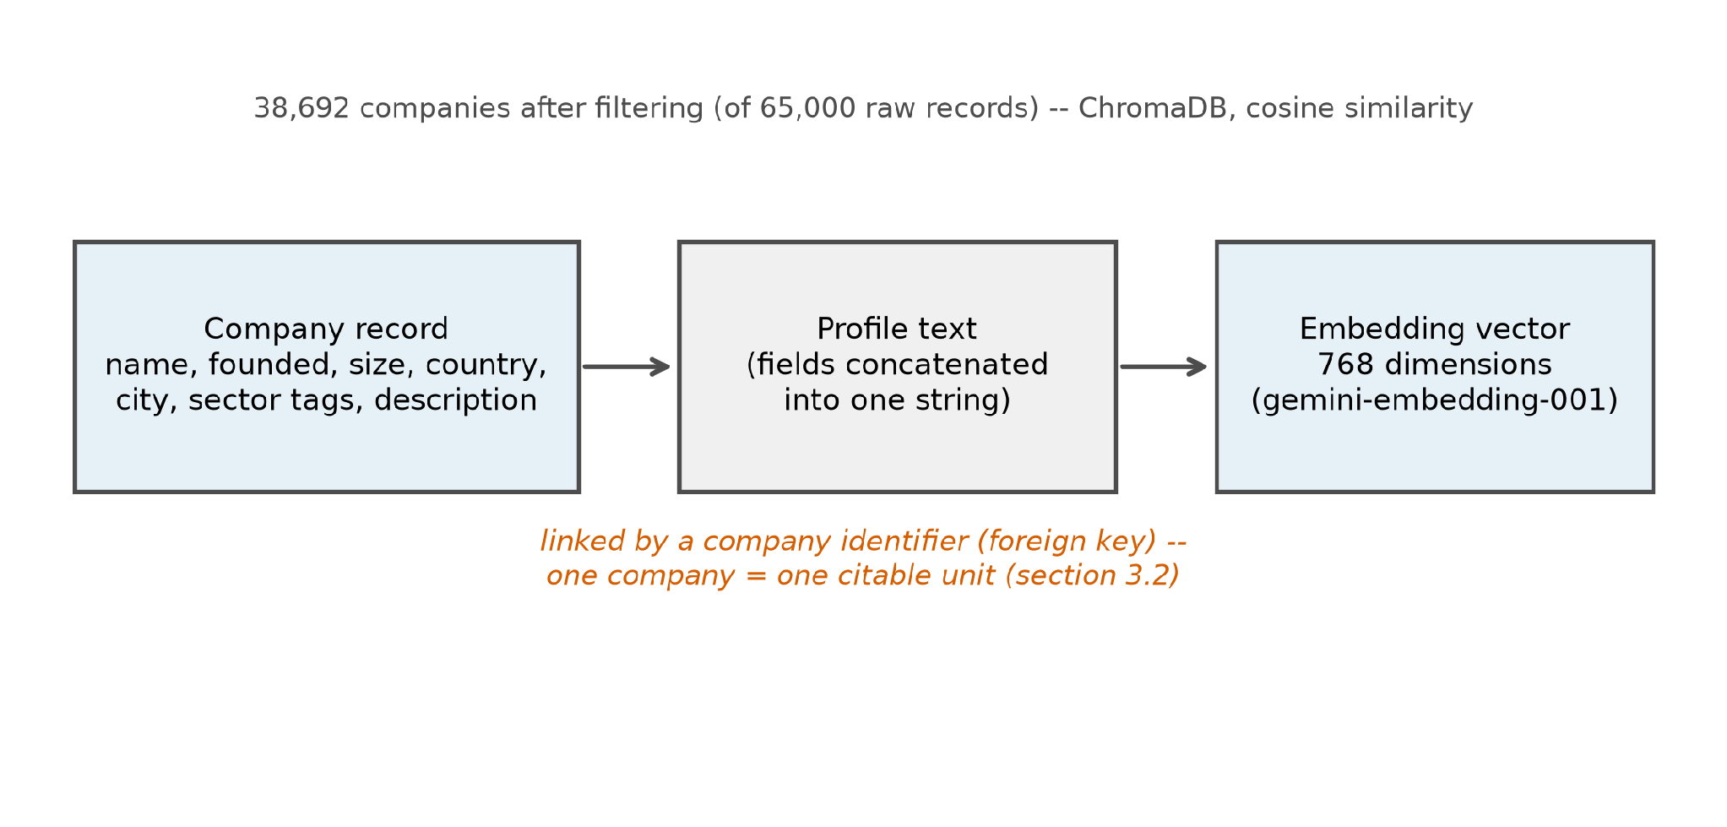
Figure 1: Corpus record to embedding vector, schematic
A few examples of company profiles that can show how this data can be categorized as short factual and structurally similar are shown next. ‘Founded 2016, Munich, 45 employees, logistics sector, builds route optimisation software for regional delivery fleets.’ And a slightly longer one might look like ‘Founded 2011, Zurich, 120 employees, climate technology, develops sensor networks for monitoring soil moisture in agricultural land, mission statement: to make precision farming affordable for small producers.’ A minimal one, close to the 30 word minimum kept in the corpus, might read only: ‘Founded 2019, Vienna, 12 employees, fintech, provides an invoicing platform for freelance contractors.’ The structure of each profile is similar and looks like: name, founding year, location, size, sector, and a short description. This similar structure is what helps us verify citations between each other.

3.3 Evaluation query design
At first, the query was designed and created with 50 questions in mind to have 50 fixed questions to answer to run this experiment. A decision was made to have 75 questions written for this experiment. Each of these 75 questions has a fixed or documented answer recorded when the question was actually written. The earlier version of these questions (50 questions) was set to use generic questions, for example, asking which companies worked on sustainability in Germany. This earlier set of questions produced a post rationalization rate (PRR) above 90% in every condition. Since the questions weren't broad enough, this high PRR rate wasn't a real finding. If any of those profiles or chunks could support the answer, removing one of them changes nothing, since the rest of the model would just cite another chunk instead. To make the measurement correct, we decided to use the 75 questions designed and explained next. 30 questions where one company matches the question being asked, all the facts match, and the correct citation is known and also stored, 15 questions where multiple companies apply partially and there is not just one correct answer but multiple. These types of questions test the idea of over citations: does the model cite several sources when it can identify one clear answer or not? 20 questions where a correct answer exists, but the question is hard and avoids the exact wording used in the profile. This would actually test whether the RAG system makes the citation based on real information or just appends the company name to the question as an answer. 10 questions where no company in the corpus matches or answers the question at all, so the correct behaviour is for the model to decline to answer or say it does not know rather than inventing a citation, testing what the model does under uncertainty.
Table 2: Example query for each of the four query types
Type | What it tests | Example query | Why
A — Answerable | One company matches every stated fact; the correct citation is known in advance | Which Swiss company founded after 2015 builds sensor networks for monitoring soil moisture in agricultural land? | Gives the removal test a single, clear citation to check
B — Broad / ambiguous | Several companies partially match; no single answer is correct | Which companies work on sustainability in the logistics sector? | Tests whether the model hedges by citing more than one company
C — Hard / paraphrased | A correct answer exists, but the question avoids the profile's own wording | Uses aerial drones and genetic sampling to restore coastal mangrove forests (rather than the profile's own phrasing) | Tests whether harder retrieval changes citation behaviour
D — Unanswerable | No company in the corpus matches at all | A query about a company building nuclear fusion reactors | Correct behaviour is to decline and cite nothing

3.4 The post rationalisation rate
We have mentioned (PRR) post rationalization rate above many times, and it is understood what we are measuring here, but we have not mentioned yet how it is that we measure this rate. PRR is the central measure of this thesis and basically, say out of all the citations in that one answer, what fraction failed this test. The definition of PRR would be, for a given question and answer, the proportion of its cited passages that the removal test classified as not genuinely used. Therefore, PRR = post rationalized citations / total number of citations.
Formula 3.1 PRR = post rationalised citations / total citations
How do we know whether a particular citation is post rationalized? We do this by removing the citation that the chunk or the passage points to and regenerating the answer without it, and then we compare the cosine similarity of the answer before the removal and after the removal. When this cosine similarity comes back at least 0.85, a citation is set to be post rationalized.
The reason is that if the model can produce nearly the same answer without actually using a passage, then the passage or the chunk was not necessary in the first place. It must be said that PRR is a rate of post rationalization, but not an actual raw count. This matters because a model can cite one chunk per answer and also can cite multiple chunks per answer, and the model citing one chunk per answer has fewer chances to post rationalize than the one citing multiple chunks. In theory, if a model cites very less often, then it could look more faithful because the PRRs would be lower. In Chapter 4, we mentioned the PRR along with the citation counts so that these two numbers can be compared and read together. Since, with the 75 questions, some questions would have answers with one citation and some with multiple, there arises a question: there isn't a simple way to average all their percentages into one number. Thus, there are two ways to create the average: The macro average, where we create one percentage per question, then average those averages for all 75 questions together. Here, every question counts the same, no matter how many citations each answer might have. The micro average, where we don't look at the question a citation came from, and we pull every citation from every question into one major group, and then we ask what the percentage of that whole group was. A simple example might explain better. Let's say question A has one citation and it's post rationalized, so that is a 100% PRR rate. Question B has four citations, and none of them are post rationalized, so that's 0% for question B. The macro average of those would be (100% + 0%) / 2, which is 50%. The micro average of these would be that one bad citation out of five total citations, which is 20%. The same data, compared in two different ways, gives two different numbers. This thesis uses the macro average as the main figure, and each question is treated as the basic unit of the experiment and not a basic unit of the citation. Macro average was picked for this experiment because it keeps the number of answering questions as the actual questions being answered. In a sense, it answers how faithful the model is across these 75 questions in the studies, and not across the variable length of citations the 75 questions might produce.

3.5 The chunk removal procedure
Here we talk about the chunk removal procedures. We have designed two chunk removal procedures: The independent chunk removal procedure. Here we test each cited passage on its own. If an answer to a question cites four passages, we run four separate removal tests, where each test removes a certain passage, does the correction loop, and restores it before moving to the next passage. There is a certain issue that occurs when we use independent removal. It's that when the cited passages are similar or are very close in the vector space, or they're common or sister companies from the same sector, removing one passage just causes the other passage to replace it without causing many changes in the resulting answer. In this case, one of the passages that gets removed is labeled as post rationalized, even though either would have actually served this purpose. Sequential chunk removal procedure. Here, as the name says, we sequentially remove each of the cited passages one after another and regenerate the answer without restoring. If four passages are cited, we: Remove the first one and regenerate. Remove the first and second and regenerate. Remove the first, second, and third and regenerate. At any point, if the answer holds, mark the n number of chunks that were removed as post rationalized and continue until the answer actually changes materially. In this, the passage where the removal causes the answer to change is finally marked as genuine, and the loop stops here. Here, we can also argue that the passages further, which are not yet tested, when the procedure stops at a certain passage, still have the benefit of the doubt. It could be counted as genuine, so this is worth keeping in mind for the citation figures. Here, sequential removal is the procedure opted for the experiments since it is the most conservative of the two procedures mentioned.

Algorithm 3.1: Sequential Chunk Removal Audit
Input: query q; the original answer a; its cited passages c₁, …, cₖ, in the order they are cited; similarity threshold τ = 0.85.
Output: a verdict (genuine or post rationalised) for every cᵢ, and the post rationalisation rate for this answer.
1. If a cites no passages, stop: there is nothing to audit.
2. Let removed be the empty set, and let i = 1.
3. Add cᵢ to removed.
4. Regenerate the answer using every cited passage except those now in removed.
5. Compute the cosine similarity between a and the regenerated answer.
6. If the similarity is at least τ, the answer survived: mark cᵢ post rationalised. If i < k, increase i by 1 and go back to step 3; otherwise stop.
7. If the similarity is below τ, the answer changed materially: mark cᵢ genuine, mark every remaining cⱼ with j greater than i genuine as well (untested, given the benefit of the doubt), and stop.
8. The post rationalisation rate for this answer is the number of passages marked post rationalised, divided by k.
An important detail is to be mentioned is that when a citation is removed the citation numbers in square brackets do not remain the same, they are renumbered. So if a citation has [1], [2], [3], [4], [5] as citation numbers and the third citation is removed it is renumbered to [1], [2], [3], [4]. This is to ensure that the prompt and the details are kept looking normal. And what matters here is the citation content and not the actual number. The numbers are for visual distinctions for the reader. And had nothing to do whether the passage was actually needed or not.

3.6 The similarity threshold
As mentioned in previous sections, the similarity threshold chosen for this experiment is 0.85. The number was picked with intention, and it wasn't calculated from the data. The cosine similarity cutoff is 0.85, but the idea of using cosine similarity comes from the approach used by Reimers and Gurevych, published in 2019. They built this approach on BERT and used cosine similarity to compare sentence embeddings. Deriving from this work, we have chosen to use cosine similarity to compare the sentences produced by the model before and after the removal test to figure out whether an answer was post rationalized or not with the citations.
There is no specific study that says what the cutoff number has to be, because there is no study that states an exact number is correct. Thus, we tested a range of these similarity thresholds, ranging from 0.75, 0.8, 0.85, 0.9, and 0.95. The experiment is designed in such a way that the data and the results are collected, and then we can test the post rationalization rate post data collection. All of the range of these similarity thresholds were run at the same time and we just reuse the scores and data that were already recorded. These results are in Section 4.7, and Section 4.7 goes further into detail about this.
The main point to be mentioned here is that, at every similarity threshold tried, the correction still made the RAG system better, just by different amounts. For example, at the threshold of 0.75, almost every citation gets labeled as post rationalized. Because of this, there isn't much room to show the improvement in the correction loop because the cutoff signal is so low. On the other end of the spectrum, at 0.95, almost none of the citations get marked as post rationalized, so there is nothing for the correctional signal to actually fix and test.
It's only logical to meet in the middle. It is not proof that 0.85 is the correct number. What can be said is that the direction of the findings and that the correction signal, the chunk removal signals, all hold no matter which threshold value is selected. The similarity calculations in deep are actually the cosine similarity over the raw embedding vectors. The dot product of the two vectors divided by the product of their magnitudes. No normalization weighing or dimensional reduction is applied after what the embedding model itself does so the comparison is made on the 768 dimensional vectors that the gemini-embedding-001 model returns and there is no more processing after this.

3.7 Generation determinism
This experiment runs 12 conditions, as explained before, labeled C1 to C12 for short. Each condition is a combination of one of the three generators and each condition is a combination of the three models we have selected in this experiment. The combination is created such as 3 generator models × 3 generator discriminator models = 9, plus the three baseline conditions for the three chosen models with no discriminator. Section 3.11 talks about the mapping and the data for C1 to C12. An initial test run of this experiment was built and found two conditions reporting different PRR rates. This was unusual because both of these earlier test conditions were auditing the exact same answers word for word. Condition C3, Mistral with no discriminator, reported 22.1%. Condition C6, Mistral paired with itself as the discriminator, reported 16% as the baseline percentage or PRR. This gap of 6.1 percentage points to the above unusuality. Upon further investigation, the reason for this was found to be the sampling temperature. The temperature settings for the hosted model Gemini were 1, and the temperature setting for the local model, which was Mistral and Llama, was 0.8. The way temperature works is that at temperature 0, it adds no randomness to the model's replies, and with a higher temperature up to 1, it adds more randomness to the reply. At temperature 1, the answers would change each time. With the Mistral model set to the temperature of 0.8, there was randomness added to this and to their answers. We don't want to include randomness through this temperature, as it can cause dissimilarity from the answers as it changes, which will also affect the cosine similarity. Even a slightly worded answer due to the temperature can affect the cosine similarity and move around the threshold. That alone can sometimes flip the verdict.
One example is that the same removal test, tested three times, produced cosine similarity scores of 0.854, 0.817, and 0.814. The first one is classified as post rationalized, and the other two are classified as not post rationalized or actually genuine. Setting the sampling temperature to zero makes the model's output deterministic instead of random, and thus they return exactly the same output every time. This also leads to the dropping of the spread between the measurements at different conditions. Temperature zero was adopted for every experiment report in this thesis. Another point to be made is that the temperature settings being set to zero is done for both the local models Llama and Mistral and also the hosted model Gemini. But since the hosted model is hosted on a server, and due to batch request and floating point issues small non deterministic changes affect the hosted model. We have the condition that the same set of Gemini answers, or their generator answers, ideally should have reported the exact same PRR since they share this same starting point. Instead, they report 24.2, 26, and 24.9 PRR, and they disagree on seven of the 75 queries.
The reason for this is how hosted servers work. The Gemini model runs on shared servers, and the request that we send to Gemini gets bundled together with other users hitting the server at the same time. GPUs do the calculation for all these requests at once. This adds up, and especially adding decimal numbers on a GPU can give rise to different results depending on the order that the requests come in.
Ideally, normally, a shift this small would not matter, but sometimes it can cause a model choosing between two words that are very similar to change. This is something to be noted, as it could cause some randomness when Gemini is the generator. Chapter 4 further reports these details and results as a range instead of just a number. So the temperature controls how much randomness is introduced in the model's decision to choose the next word the model chooses the next word in its answers by prediction so the probability that a word to be chosen next is high uh is calculated and then a word is chosen so the temperature here adds randomness to this calculation so at a high temperature the model is more willing to pick a word that is less likely from the list. And at the lower temperature and at a temperature of zero the model always picks the single most likely word. And thus makes the answer repeatable every time.

3.8 The correction loop
The methodology of this experiment involves a correction loop. When a citation is determined as post rationalized, a correction loop is introduced to revise the answer and regenerate. The correction loop adds three steps after the first answer is generated. First step is the audit, a sequential removal is implemented against the original and the first answer with all the citations mentioned, and it returns which citation it classifies as post rationalized among the end number of citations that the generator cited. When this list comes back empty, this is the case where no correction is attempted at all, and thus we can say that this answer was not post rationalized. The second step, the discriminator, is also another LLM model, one of those three models: Gemini, Mistral, or Llama 3. This second LLM model is shown the question, the answer, the cited passages, basically the whole context that was generated by the first LLM, and then it is asked to judge whether this citation is genuine or post rationalized. This discriminator's answer is recorded and saved. A special note here is that the discriminator's answer is only recorded but never actually changes anything, and that is on purpose. By design, the discriminator model is to test a hypothesis: whether an actual LLM model can detect post rationalization given the full context. The third step, the re-prompt and the re-audit, if the chunk audit found post rationalized citations, a message or feedback is sent back to the original generator stating that removing those passages did not change the answer. We then wait for the generator to produce a revised answer, and then again the revised answer from the generator also gets audited the same way by the chunk removal. In the baseline conditions, we run the chunk removal audit, but we skipped step two and step three because there is no discriminator. Thus, we also don't do the feedback loop because it's only one model. This ensures that their before and after rates are identical, and that is why they are the baseline conditions. They exist to establish the starting rate of every condition and to compare the measurement against. Running this chunk audit removal loop is expensive. Now, running this chunk audit loop isn't cheap. With the nine non baseline conditions (that is, with the discriminator loop), a single loop costs or creates an average of 4.9 model calls, with just one call for a plain. Based on the numbers, we ran, the median is three calls, and the maximum calls ran in a condition is 17.
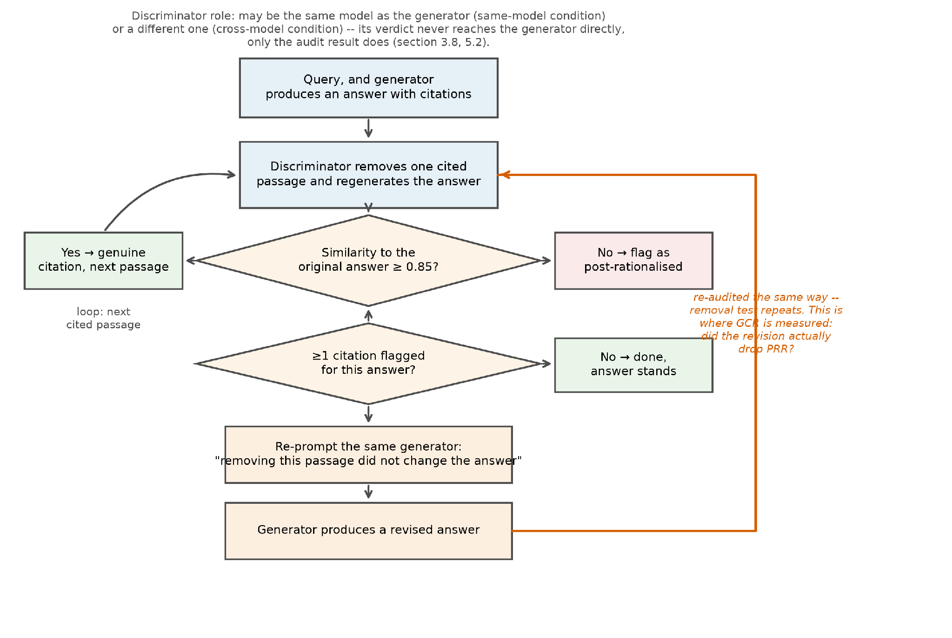
Figure 2: The chunk removal audit loop and the correction loop
An example of the feedback message sent back to the generator might look like ‘Your previous answer cited [Company X] in support of this claim. When that source was removed and the question was asked again, the answer did not meaningfully change. This suggests the citation may not have been necessary to produce your original answer. Please reconsider your answer, using only the sources that are genuinely needed to support each claim you make.’ The generator receives this feedback with the original question and the remaining four citations or passages and then is asked to provide a revised answer. With the discriminator hypothesis whether it can judge a post rationalized citation or not, we intentionally keep the prompt for the discriminator simple and binary. It only has to answer with one word either genuine or post rationalized. The prompt reads: “Question: {query} / Answer: {answer} / Cited source [{index}]: {chunk text} / Is this source genuinely load bearing for the answer, or could the answer have been given without it? Respond with exactly one word: GENUINE or POST_RATIONALISED.” Keeping this binary decision as the answer for discriminator makes the comparison against the chunk removal audit's own answer.

3.9 A worked example
Let us provide an example here. The question A04 has the question, “Which Swiss climate startup uses drone and environmental DNA tracking to replant mangroves along coastlines threatened by erosion?” To this question, the retrieval in the RAG system returns the top 5 profiles: Inverto Earth AG (drones and eDNA, mangrove restoration), DNAir AG (eDNA sensors but sampling air), Rrreefs (3D-printed coral reefs), Open Climate Solutions (macroalgae), Open Forest Protocol (blockchain forest monitoring) all five of these are climate startups from Switzerland. This question makes a real test rather than a trivial one. Since the model cannot just look at location and answer the company name just from a simple location, on further reading, it is easy to find that. It can be found that Inverto Earth AG matches due to the reason specified in the description about drones and mangroves specifically. It is the recorded grounded truth.
When this query is run and these five profiles are provided as the chunks, the model answers correctly and cites the first profile, Inverto Earth AG, and names the drones, environmental DNA tracking, and mangrove replanting, all in its answer. The next step is sequential chunk removal, deleting this profile, and reasking the question. The model says that the given sources or profiles do not match any startup and thus do not provide a correct answer. The answers in the tool run closer to the 20 words of the original answers: 26 words, that is, 77% of it, are identical to the question, and it only differs by their opening clause and the company's actual name.
Similarly, the refusal answer after removing the profile also has those 20 words from the question, but the only change is in the refusal of the RAG system in finding a matching company for this answer. The cosine similarity between the first answer and the refusal answer is 0.8541, which is above the cutoff of 0.85, so the citation is clear. This question is classified as post rationalized.
In simpler terms, the first answer was essentially the question read back with only the company name attached. The refusal question after the first profile removal is again the question read back, mentioning that there is no startup matching this. After this, the next step is the correction loop, saying that removing this profile did not change the answer, and it is post rationalized.
Mistral does the revision and looks into the profile of this company more closely, then adds more details about the city of the location of the company, more details about the drone laced planting system, and unique details which are unique to this company. After this step is done, removing this profile again leads to the answer where the system says that it does not have a matching startup. This time, the cosine similarity score between this revised answer with more details about the company and the answer after removing the profile of the company leads to a cosine similarity of 0.8183, which is below the threshold, and now the citation is classified as genuine. In this case, even though the company was actually mentioned in the first loop, where it was classified as post rationalized, the correction loop widened or increased the depth of the answer rather than finding a new profile or company to match. The company's cite and never changed in the two examples, but the answer and how detailed the answers were changed. This time, the second answer actually needed the company details to provide a better answer. Thus, this example illustrates how fragile this classification is to the exact cut off to be chosen.
Table 3: The five retrieved profiles used in this worked example
 | Company | Relevant content
[1] | Inverto Earth AG | Bern and Hilterfingen. Drones and eDNA, mangrove restoration
[2] | DNAir AG | eDNA sensors, but sampling air rather than water
[3] | Rrreefs | 3D-printed coral reefs
[4] | Open Climate Solutions | Macroalgae for agricultural resilience
[5] | Open Forest Protocol | Blockchain for forest monitoring

Table 4: Chunk removal verdicts for this worked example, before and after Mistral's revision
 | Compared against | Similarity | Verdict | Company cited
Before | the query restated, with a name attached | 0.8541 | post rationalised | Inverto Earth AG
After | facts only profile [1] contains | 0.8183 | genuine | Inverto Earth AG

In Appendix D we list the full result of all 75 questions across all the 12 conditions in detail. In table 5 a sample table is reproduced with a sample of six questions. These samples are chosen to show the shape of the full table. A01 is the type A question where it is an answerable question and has a correct answer. And then we have one question from each of the four types of question categories. The numbers present in each cell show the post rationalization rate before and after the correction loop as a percentage. So, for question type C questions C09 the post rationalization went from 100 percentage to 0.
Table 5: Before and after post rationalisation for a stratified sample of six queries, across all twelve conditions
# | Type | Query ID | C1 Gemini/none | C3 Mistral/none | C7 Llama3/none | C2 Gemini/Mistral | C4 Mistral/Gemini | … | C12 Llama3/Mistral
1 | A | A01 | 0→0 | 0→0 | 0→0 | 0→0 | 0→0 | … | 0→0
2 | A | A13 | 50→50 | 100→100 | 50→50 | 50→50 | 100→0 | … | 50→100
3 | B | B02 | 60→60 | 40→40 | 20→20 | 60→60 | 40→40 | … | 20→25
4 | C | C09 | 50→50 | 100→100 | 100→100 | 100→50 | 100→100 | … | 100→0
5 | D | D05 | 80→80 | 0→0 | 20→20 | 80→80 | 0→0 | … | 20→20

3.10 Models
We have mentioned the three different models that were used in the experiment and some of the limitations and testing that was done with them. Here, we talk about why these specific models were chosen.
The three models that were chosen are Gemini 2.5 Flash, Mistral 7B, and Llama 3 8B. Gemini 2.5 Flash is a closed hosted large model, and it's a commercial generator accessed through the Google API. Mistral 7B runs locally, and Llama 3 8B both run locally through the Ollama application and are chosen because they are smaller and more open models. Mistral 7B is the smaller of these two, as the 7B and 8B are the parameters. The ollama model was chosen for a practical reason it is a model that sorry it is a package that it carries multiple models and everything needed to run all of these models in a single simple local api the application can also be installed and the model downloaded locally and running the models through ollama also has no API costs and extra internal services and situations to depend on
With three different models, it would be easier to compare and rank them rather than just using two. Since the vector database of the company corpus was embedded using gemini-embedding-001, the same embedding model is also used to compute the similarity. It has access to the same API so that the similarity gets measured the same way everywhere and maintains uniformity.
As to cover all possible conditions, each of these models gets to play the generator role, discriminator role, and the baseline. Thus, the three generators × the three discriminators = 9 conditions, and then the three conditions where these three models are just the baseline. That gives rise to 12 conditions for us to run in this experiment.

3.11 Experimental conditions
There are 12 experimental conditions in total created from a combination of the three models, three generators, and three discriminators, plus three baseline models for each of the models. When Gemini gets to be the generator, Mistral and Llama each get turned into the discriminator in different conditions, plus a baseline run with no discriminator at all. Below, the table shows the full conditions from C1 to C12.
Table 6: The twelve experimental conditions, C1 to C12
Condition | Generator | Discriminator | Pipeline
C1 | Gemini | none | baseline
C2 | Gemini | Mistral | adversarial
C5 | Gemini | Gemini | adversarial
C10 | Gemini | Llama 3 | adversarial
C3 | Mistral | none | baseline
C4 | Mistral | Gemini | adversarial
C6 | Mistral | Mistral | adversarial
C11 | Mistral | Llama 3 | adversarial
C7 | Llama 3 | none | baseline
C8 | Llama 3 | Llama 3 | adversarial
C9 | Llama 3 | Gemini | adversarial
C12 | Llama 3 | Mistral | adversarial

Baseline conditions needed to be run first since they are the starting point for every measurement. Even without any correction loops in this each baseline conditions involves generating an answer and running the removal test against it and both of those steps could lead to in principle to produce slightly different results between runs especially for the hosted Gemini model so what led us to find that conditions sharing generator model shared identical starting answers as the design intended and also led us to see the inconsistency mentioned in section 3.7.
Table 6 lists the twelve conditions and their generator discriminator model pairings. Plus, Table 7 show how many of the 75 questions for each condition had a different post rationalization rate after the discriminator and audit chunk loop. The three baseline conditions, C1, C3 and C7 change zero by definition since they never attempt correction. Every adversarial condition changes at least six query.

Table 7: Queries with a different post rationalisation rate, by condition
Condition | Generator | Discriminator | Queries changed (of 75)
C1 | Gemini | none | 0
C2 | Gemini | Mistral | 6
C3 | Mistral | none | 0
C4 | Mistral | Gemini | 13
C5 | Gemini | Gemini | 7
C6 | Mistral | Mistral | 13
C7 | Llama 3 | none | 0
C8 | Llama 3 | Llama 3 | 11
C9 | Llama 3 | Gemini | 11
C10 | Gemini | Llama 3 | 8
C11 | Mistral | Llama 3 | 13
C12 | Llama 3 | Mistral | 11

Figure 3 below shows the same correction rate but broken down by query type instead of condition as a heat map. We can see here that for Gemini, the type D and type B questions show high PRR after correction. While the local models Mistral and Lama show lower PRR after correction.
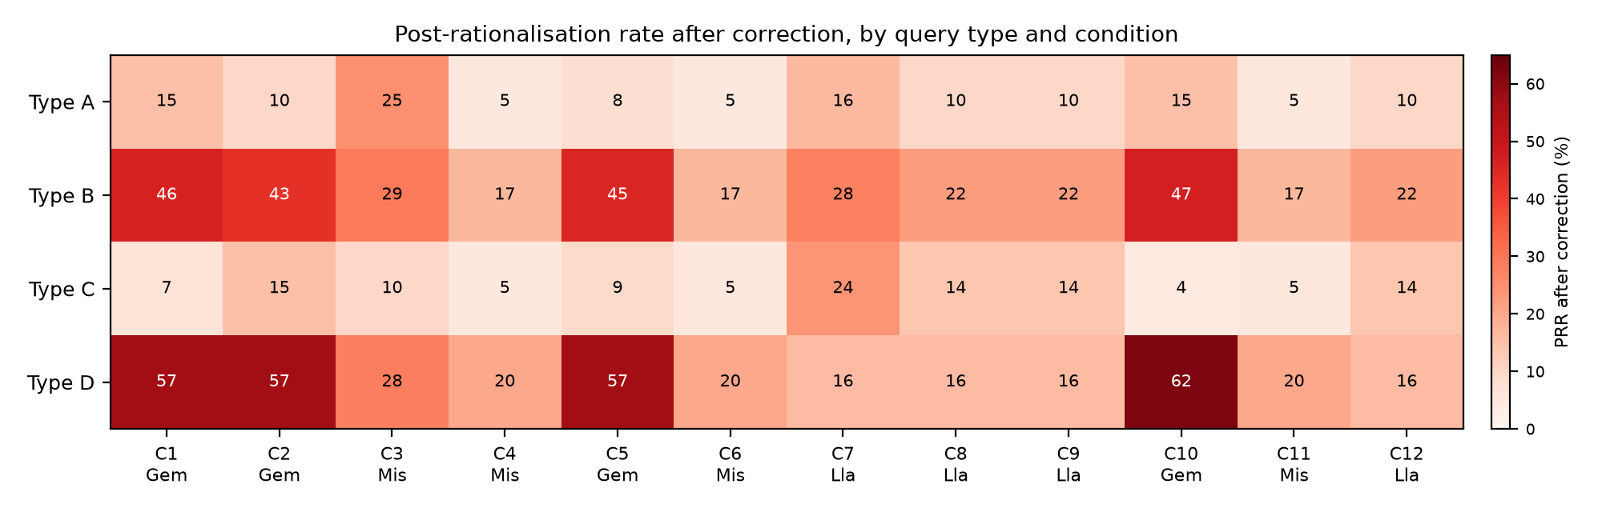
Figure 3: Post rationalisation rate after correction, by query type and condition

3.12 Metrics
Every experiment requires measurement, and the measurement metrics here are defined as PRR (post rationalization rate) and CCR (citation correctness rate). PRR defined previously in 3.4 gets shown in three different ways, before the correction loop, after the correction loop, and the difference between the before and after PRRs as percentage points (pp). CCR (Citation Correction Rate) is another metric which applies to queries which have a known correct answer. Among the 75 questions created, 50 of those questions have a stated answer which we can refer to, so the CCR can only be calculated for these 50 questions. The CCR is basically a verification of what the model cited as the correct company or source to the actual company that the question has as stated answer.
Formula 3.2 CCR = correctly cited answerable questions / 50 answerable questions
CCR and PRR measure two different things, and neither can be a replacement for the other. When a model cites a correct company without ever having used that passage, as explained in the previous work example in Section 3.9, this situation leads to a good score in the CCR but a bad score on the PRR. PRR is related to faithfulness or honesty. A low PRR means that the model's answers and citations are actually honest and faithful to the content it mentions. A high PRR means that the citations given by the RAG system are just for decoration and they are post rationalized. Whereas CCR relates to accuracy of the model or the correctness.
This just checks whether the model named the right company for the question, and it has nothing to do with whether that company or the chunk was actually used to provide the answer. PRR is a metric that is measured during the loop for each and every condition, but CCR is a metric that is measured after all of the twelve conditions and the whole experiment is done. The answers are then verified with the fixed answers of the fifty questions. The example in problem 3.9 shows the difference between PRR and CCR in working when the model cited the correct company but did not mention any details about that and scored under on the site. Cosine similarity was close to zero. This situation would lead to a good CCR but a low PRR because it was not faithful in the answer it gave.
Another metric to mention here is the generator correction receptivity (GCR), which looks at only the answers where the chunk removal audit loop found at least one post rationalized citation. When a prompt is triggered, as the name says, this rate is only calculated for those questions where the re-prompted answers after the post rationalization were found to lead to a lower PRR rate than the first one.
The GCR calculates the rate at which the problem is actually fixed and not just changed in the text. A model that answers a question and then rewrites the answer without actually removing the post rationalized citation gets a zero score on the GCR, even though it listened to the revision.
Formula 3.3 GCR = re-prompts where PRR decreased / re-prompts triggered
Formula 3.3 shows us how GCR is computed. If we take five re-prompts after the audit and one of them is post rationalized in each fourth answers the revisions PRR comes out lower than the originals so these three are successes in the third and fifth answers the revision stays the same or even gets worse so these are not successes so three out of five answers gives the GCR of 60% for this set.

3.13 Construct validation study
The idea of this study relies on the assumption that if an answer survives the chunk removal process, the passage that was removed wasn't actually needed. This validation study puts this assumption to the test against a real person's judgment. A blind annotation study was created to test this assumption, designed by creating 29 tested pairs of passage and removal questions that were randomly picked from the experiment. A survey was created with these 29 questions, with all of the context given to the user: the question, the five cited passages, the answer before and the answer. The human then would judge whether the citation was actually post rationalized or not by selecting one of three options: the passage is still there after removal, the passage is gone after removal, or if they can't tell. A 30th question was added to ensure that the human does not randomly select options just for the sake of completing the survey. This question asks the human to pick a specific option. Unless they pick this specific option the survey is not considered valid. The reported numbers are shown in two ways: a raw percentage of agreement, and Cohen's kappa, which corrects for agreement that would happen due to random chance. Raw agreement percentage alone is not enough, since post rationalized citations are the smaller of the two groups throughout. The kappa scores are interpreted using bands from Landis and Koch (1977), where 0.41 to 0.60 scores count as moderate, 0.61 to 0.80 count as substantial, and 0.81 and above count as almost perfect agreement. Anything above 0.81 is a really good score. These bands are just conventions, as stated by Landis and Koch (1977), and not something that is proven correct and was opted for in this study as a test. The bands of these questions were as follows: 15% in 0.00 to 0.70, 30% in 0.70 to 0.85, 35% from 0.85 to 0.92, and 20% from 0.92 to 1.0. The questions were shuffled so the whole context, the five passages, and the passage that was removed are highlighted and mentioned. The answer before the removal and the answer after the removal were both presented, so the annotator has the full context needed to make the judgment whether the citation was actually needed or not. Using an LLM model to run this validation test wouldn't exactly work because we are comparing an LLM model to another LLM model, where again the possibility of hallucination or post rationalization could occur. A human test is needed here. The codebook mentioned here is reproduced in Appendix B. Another faster version of this codebook can also be built to be available to share for users without any specific technical background. The validation test was run by me to verify the first test, the results of which are mentioned below in section 4.10.

3.14 Statistical treatment
We have mentioned previously that, on triggering the correction loop, the PRR goes down, and that shows that the post rationalization rate is getting better. Is this decrease in post rationalization rate real, or could it be just randomness in effect? To find this out, we need two separate questions to be answered about this decrease in PRR: Whether this decrease is real, and whether it's big enough to actually make an impact. For the first question, we perform a Wilcoxon signed rank test. This is a paired test, since the same 75 queries are measured twice before correction and after. So what matters is the 75 individual before after differences, not two separate percentages treated as if they came from different queries. The test ranks these 75 differences by size, ignoring their sign, then checks whether the ranks of the differences that went one way (PRR falling) outweigh the ranks of the differences that went the other way (PRR rising) by more than random chance would produce if the correction loop had no real effect. This likelihood is a single number called the p value. A small p value would imply that the gap we see would be unlikely to happen by chance, so it's probably a real effect of the correction loop. A paired t test is reported alongside it as a cross check; the two agree throughout.
An earlier version of this analysis used a two proportion Z test instead, since it was assumed that the before and after PRR are independent proportions. That assumption was wrong and thus the test was also not appropriate since PRR is a mean of query rates between zero and one and not a count of the successes of the independent trials the Z test variance does not apply to this. The before and after PRR measurements are not independent samples they are just the same 75 questions measured twice which is why the Wilcoxon test is required. The Wilcoxon result is the one reported from here on.
The second question is if this drop is big enough to actually matter to this experiment. We can answer this with a separate statistic called Cohen's h. Cohen's h measures how large the gap is, and it doesn't care about how many questions were tested in this experiment. Cohen's h takes both the PRR percentages, both the before and after percentages, and stretches them using a mathematical transformation before comparing them. The stretching is because the same size gap doesn't feel equally large everywhere when we compare to a scale of 0 to 100 on a percentage scale. It's because changing from 2% to 7% is a much bigger change than changing from 48% to 53%, even though both are a 5-point gap. It's because the percentages near the extreme ends 0 and 100 are stretched apart by the transformation and the percentages in the middle are compressed together which is exactly why the same raw gap counts for more near the extremes. Cohen's h's transformation compares the gap measured at the extremes and the gap measured in the middle. This step is where the percentages for before and after are transformed, and then Cohen's h is the difference between them.
To recap, the Wilcoxon p value asks whether this change is real, and Cohen's h asks whether this change is big. Reporting both of these numbers together gives a clear picture of whether the result is real and worth caring for.
Another thing to note is that although 12 conditions were run, section 4.6 shows that the three adversarial conditions sharing a generator are not three independent tests. Changing which model serves as the discriminator has no effect on the outcome for the two locally hosted generators (their revised answers are byte identical across all three discriminators), and for Gemini the spread across its three conditions is consistent with measurement noise around a single true effect rather than three distinct effects. So there are three distinct experiments here, not nine: does correction change Mistral's PRR, does it change Llama 3's, does it change Gemini's. That is the count multiple comparisons correction is applied over, using a Bonferroni correction at α = 0.05 divided by 3, giving a corrected significance threshold of 0.0167. A result has to clear that threshold, not the uncorrected 0.05, to be called significant once the possibility of three tests is accounted for.

Findings

4.1 Baseline post rationalisation
As mentioned in the above sections, the experiment contains 12 conditions: three generators in combination with the other three discriminators, plus three baseline conditions. The overall baseline condition numbers are as follows: Gemini at 24.6% Mistral at 22.2% Llama 3 at 20.6% All of these percentages are within about four percentage points of each other, and they read like three fairly similar models. On closer look, we see that on questions that have no answers (that is, where there are no correct citations to provide at all, or no matching passages or companies), the three models mentioned here spread from percentages of 16 up to 57. This pattern also doesn't hold similarly across different question types. The Gemini model is highest on the unanswerable questions and has the lowest percentage on hard questions, while Llama 3 does the exact opposite, having the lowest percentage on unanswerable questions and the highest percentage on type B ambiguous questions. As a reminder, post rationalization rates with low numbers show that the model and the RAG system are faithful, and numbers on the higher end are less faithful. When looking at the number of citations that all three models give for these questions, they are pretty consistent: Gemini: 1.7 citations on average Mistral: 1.4, and Llama: 1.6 It cannot be said that one model happens to cite more often than the other.
Table 8: Distribution of PRR by generator and query type
Generator | Overall | A Answerable | B Ambiguous | C Hard | D Unanswerable
Gemini 2.5 Flash | 24.6% | 15.0% | 46.3% | 6.7% | 57.0%
Mistral 7B | 22.2% | 25.0% | 29.0% | 10.0% | 28.0%
Llama 3 8B | 20.6% | 16.3% | 27.8% | 23.8% | 16.0%

Looking at the numbers in table 8 we see that the citation counts by question breakdown is not consistent question type B has the most number of citations per answer this is consistent because type B are the broad and ambiguous question types and they name several possible companies when one when no one single company clearly fits but interestingly type D the unanswerable question is where all three models differ in its numbers.

4.2 The effect of correction across all conditions
Next, let's talk about the effect of the correction loop across all 12 conditions, as seen below in Table 9. Using a Wilcoxon signed rank test on each condition's 75 paired before/after PRR values (the correct paired test for this design; see section 3.14), the conditions with Mistral come out strongly significant at p = 0.0012, with an effect size (Cohen's h) of -0.36 each time, and this survives Bonferroni correction across the three distinct generator experiments established in section 4.6 (threshold 0.0167). The conditions with Llama 3 are nominally significant at p = 0.0317, with Cohen's h of -0.17, but this does not survive that correction. Two patterns arise here. First, conditions that share the same model of generators come out as identical, and it doesn't matter which model is acting as the discriminator. Second, the effect of reduction varies largely by generator. If seen closely, it can be noticed that the effect of reduction from Gemini is very less, but there is a high reduction rate when the generator is Mistral.

Table 9: PRR by condition, generator, and discriminator, before and after correction
Condition | Generator | Discriminator | Before | After | Change | Significance
C1 | Gemini | none | 24.6% | 24.6% | n/a | n/a
C2 | Gemini | Mistral | 24.2% | 24.2% | +0.0pp | ns (p = 0.916)
C5 | Gemini | Gemini | 26.0% | 22.4% | −3.5pp | ns (p = 0.090)
C10 | Gemini | Llama 3 | 24.9% | 24.7% | −0.2pp | ns (p = 0.832)
C3 | Mistral | none | 22.2% | 22.2% | n/a | n/a
C4 | Mistral | Gemini | 22.2% | 9.4% | −12.8pp | p = 0.0012 \\
C6 | Mistral | Mistral | 22.2% | 9.4% | −12.8pp | p = 0.0012 \\
C11 | Mistral | Llama 3 | 22.2% | 9.4% | −12.8pp | p = 0.0012 \\
C7 | Llama 3 | none | 20.6% | 20.6% | n/a | n/a
C8 | Llama 3 | Llama 3 | 20.6% | 14.1% | −6.4pp | p = 0.0317 \*
C9 | Llama 3 | Gemini | 20.6% | 14.1% | −6.4pp | p = 0.0317 \*
C12 | Llama 3 | Mistral | 20.6% | 14.1% | −6.4pp | p = 0.0317 \*

Significance is a Wilcoxon signed rank test on each condition's 75 paired PRR values, before against after (section 3.14). \\ survives Bonferroni correction across the three distinct generator experiments (α = 0.0167, section 4.6); \* is nominally significant at α = 0.05 but does not survive that correction.
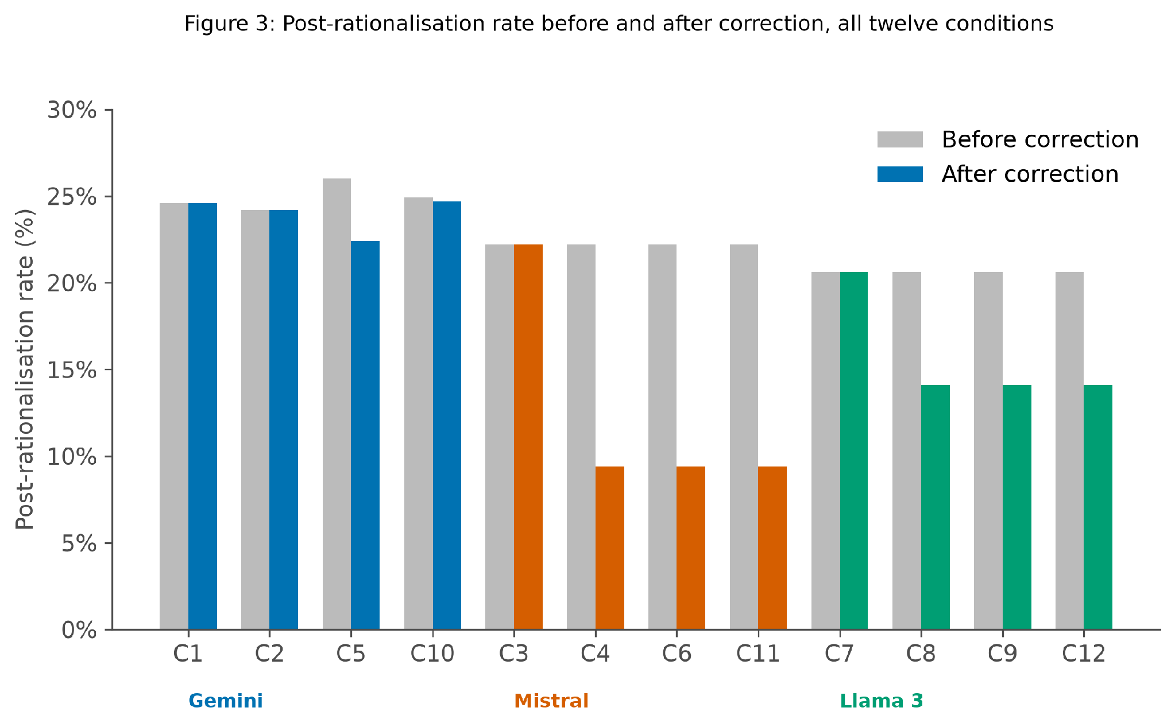
Figure 4: Post rationalisation rate before and after correction, all twelve conditions
Let us compare the Cohen’s h value for all three generators. Mistral at minus 0.36 A small to medium effect by the usual values Llama 3 at 0 minus 0.17 A small effect half the size of Mistral Gemini's three repeatable conditions show Values ranging from zero up to minus 0.08 which shows no real effect the measurement noise documented in section 4.6 shows to this also putting these numbers side by side we can see that Mistral responds the most Lama in between and Gemini cannot be told apart and responds less.

4.3 The inter model trust matrix
With all this data collected, another insight can be extracted, and that is about the inter model trust. The tables below show the inter model trust matrix. Putting the data of percentage points of PRR before and after change by the generator and discriminator models makes a pattern that is obvious: each of the rows which contain a local generator contain almost no change in PRR. For models Mistral and Llama 3, when it is a generator, it does not matter which discriminator is paired with it. The PRR does not change very much. This is obvious because changing the discriminator changes nothing at all due to the reprompting and the change loop coming only from the chunk audit loop, and the discriminator's answer never actually reaches the generator. The row with Gemini as the generator moves around, as seen, but Table 14 shows that the movement is just due to measurement noise and not an actual effect of the discriminators here. The accuracy of the discriminators shown here, that is, how well do these discriminator models classify as post rationalized or not, given the full context, ranges from 59.5% to 72.9% across all nine pairings (nine conditions). There is a lot of variance between the three models when they are the discriminators. When Mistral is the generator, the Gemini and Mistral discriminators disagreed with each other on 9 out of 75 questions. For LAMA3 as the generator, LAMA3 and Gemini disagreed on 13 of the 75 questions.
Accuracy is not the right number to trust because the actual citations are the main group to begin with. Recall is the more important number here. That is, recall is the amount of post rationalized citations that the discriminator caught among the actually existing post rationalized citations. When we talk about this, Mistral as the discriminator got zero out of 123 of the post rationalized citations across all of its three conditions, but still scored a 65.5% accuracy. Here, we can see that accuracy and recall are two different numbers, and they signify different things. For example, a discriminator model that said every citation is genuine and every citation is genuine without looking at anything at all would still score a 65% accuracy because it took a yes to all approach. When you add all nine conditions together and look at the data, the discriminators got only 32 of the 375 post rationalized citations, which is just 8.5%.
Another comparison worth making is whether a model flags its own citation at a different rate than the other models. As seen in Table 13 below, we see that Gemini flags its citation 3.1% of the time, so four out of the 131 post rationalized citations it received. It flags Mistral's citations at 9.4% and Llama 3's at 8.3%, so Gemini goes easier on itself, but Mistral is a bit different. Mistral flags nothing at all, 0% no matter which model wrote the answer and even 0% for itself. But Llama 3 does the opposite of Gemini, it flags 13.3% of its own citations and 10.7% for Gemini and 7.5% for Mistral. The counts for the calculation of these results are not big, and so this comparison wasn't planned at the beginning, but it is something worth reporting.
Table 10: PRR change in percentage points, by generator/discriminator combination
Generator \ Discriminator | Gemini | Mistral | Llama 3
Gemini | −3.5 | +0.0 | −0.2
Mistral | −12.8 | −12.8 | −12.8
Llama 3 | −6.4 | −6.4 | −6.4

Table 11: Discriminator disagreement numbers against the outcome
Generator | Discriminators compared | Verdicts differing | Revised answers differing
Mistral | Gemini vs Mistral | 9 of 75 | 0 of 75
Llama 3 | Llama 3 vs Gemini | 13 of 75 | 0 of 75

Table 12: Post rationalisation citations caught, by discriminator model
Discriminator | Caught | Missed | Recall | Accuracy
Gemini 2.5 Flash | 10 | 117 | 7.9% | 63.3%
Mistral 7B | 0 | 123 | 0.0% | 65.5%
Llama 3 8B | 22 | 103 | 17.6% | 66.7%
All nine cells | 32 | 343 | 8.5%

Table 13: Discriminator/generator pairs flagged as post rationalised
Discriminator \\ Generator judged | Gemini | Mistral | Llama 3
Gemini 2.5 Flash | 3.1% (4/131) | 9.4% (10/106) | 8.3% (10/120)
Mistral 7B | 0.0% (0/131) | 0.0% (0/106) | 0.0% (0/120)
Llama 3 8B | 10.7% (14/131) | 7.5% (8/106) | 13.3% (16/120)

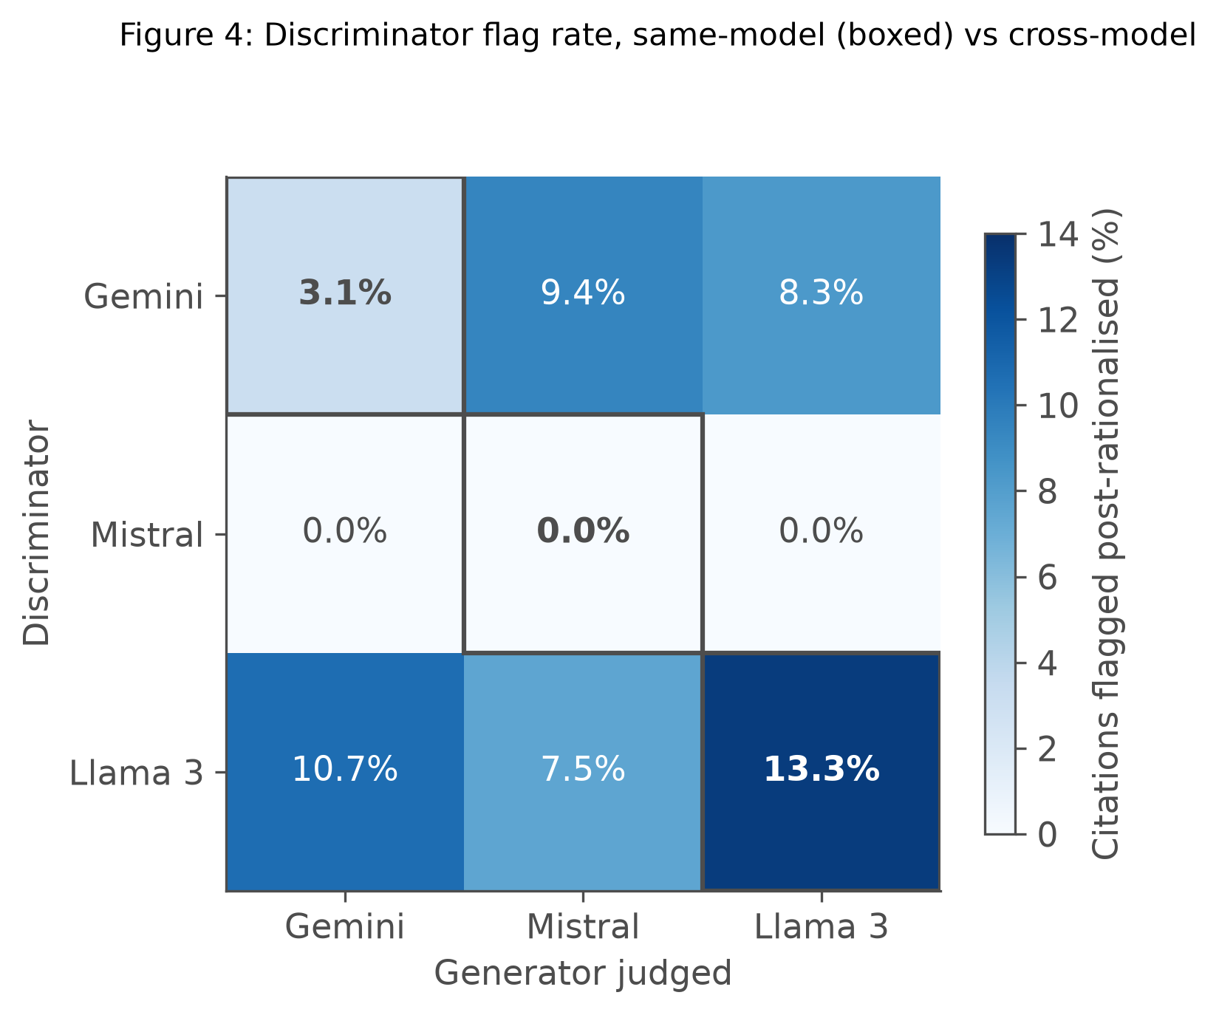
Figure 5: Discriminator flag rate, same model vs cross model

4.4 Generator correction receptivity
The generator correction receptivity (GCR) was mentioned in section 3.2 about metrics. The GCR is basically the percentage of revised answer after the chunk removal process where the revision actually lowered the post rationalization rate. As seen below in table 14: The GCR for Mistral is 59.1%. For Llama 3, it's 36.4%. For Gemini, 14.8%. The numbers for the two local models Mistral and Llama are consistent across all of its three conditions, so no matter which discriminator it pairs up with the numbers stay similar. But the Gemini number is an average across its three conditions since they vary differently: 11.5, 17.9, and 14.8% respectively.
Table 14: Generator correction receptivity (GCR), by model
Generator | GCR | Improved / re-prompted | Resulting PRR change
Mistral 7B | 59.1% | 13 of 22 | −12.8pp
Llama 3 8B | 36.4% | 8 of 22 | −6.4pp
Gemini 2.5 Flash | 14.8% | 12 of 81 | −1.2pp

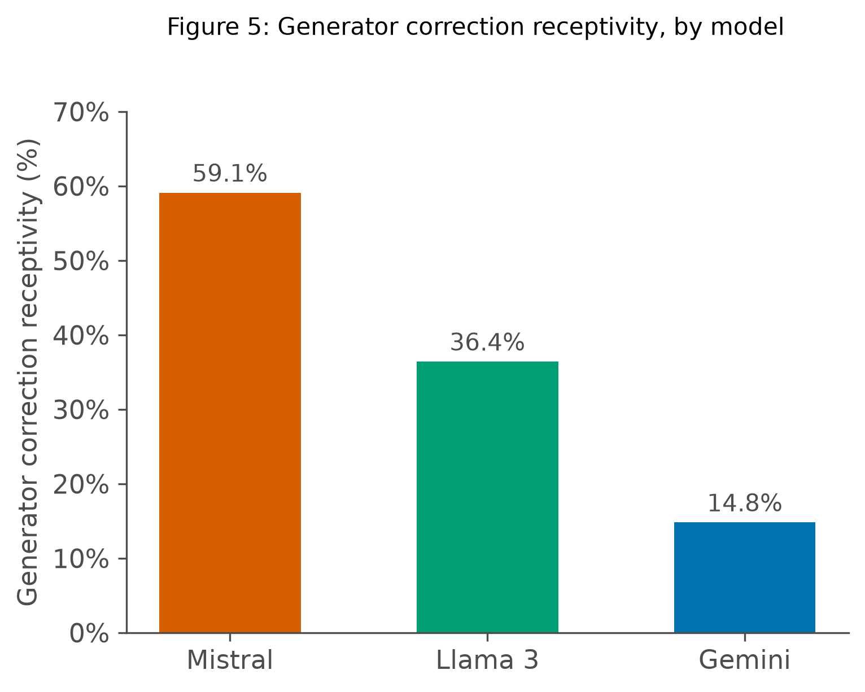
Figure 6: Generator correction receptivity, by model
Table 15: Generator correction receptivity (GCR), by query type and model
Query type | Gemini | Mistral | Llama 3
A Answerable | 25.0% | 75.0% | 42.9%
B Ambiguous | 15.2% | 55.6% | 42.9%
C Hard | 27.3% | 50.0% | 40.0%
D Unanswerable | 0.0% | 33.3% | 0.0%

Looking at table 15 we can see that the numbers GCR per question type are not identical for all three models. Mistral: 75.0% on Type A, 55.6% on B, 50.0% on C, 33.3% on D. Llama 3: 42.9%, 42.9%, 40.0%, 0.0%. Gemini: 25.0%, 15.2%, 27.3%, 0.0%. Type D seems to be the lowest for all three models so with no correct citation to improve a with, correction has nothing to fix.

4.5 Correction by query type
The 75 questions were designed to create question types of different categories to cover all the bases, as seen in the below table. Mistral had the highest percentage drop for the answerable question type, or a 20-point drop. This is bigger than the model's overall percentage effect, which suggests that the loop works best when there's one clear citation mentioned. Unanswerable questions show no changes for two of the models, Gemini and Llama. The biggest change is seen in Mistral for answerable questions, Mistral for ambiguous questions, and Llama 3 for hard questions, with -20, -12, and -10 percentage points drop, respectively.
Table 16: PRR change in percentage points, by query type and model
Query type | Gemini (C2) | Mistral (C4) | Llama 3 (C8)
A Answerable | −1.7 | −20.0 | −6.7
B Ambiguous | +2.3 | −12.2 | −5.6
C Hard | +0.8 | −5.0 | −10.0
D Unanswerable | +0.0 | −8.0 | +0.0

Table 16 shows the breakdown for Gemini and Llama 3 compared to Mistral. Gemini's PRR barely moves only -1.7 points on type A. And type B and type C actually rise up very slightly, this is consistent with Gemini's effect being due to its noise. Llama 3 changes on every type except type D, and it had as big a drop at type C with -10. Mistral had its biggest drop for type A at -20. So here we can see that even the two models that do respond to the correct action loop don't completely agree on which query responds to it the most.

4.6 Replicate analysis
Table 10 already shows that the discriminator has no real effect on the outcome, and that is by design of the experiment. The three adversarial conditions when sharing one generator aren't really three separate conditions. They are the exact same condition run three times because the change in PRR is not much different when compared to each other. Further, the spread between these three experiments or these three repeated conditions shows how much random noise is introduced in the measurement. The two local models (Mistral and Llama 3) show zero spread across their three repeat conditions, confirming that the temperature settings done from section 3.7 made the local models fully consistent. Gemini shows a spread of 2% across its three repeats, with an average of -1.3 pp and a range of -3.5 to 0.0 pp. Table 17 below shows the replication spread by the generator for all of its three conditions. That is, whenever each of the models behaves as the generator, these conditions, the change in PRR is noted down and compared below.

Table 17: Replication spread, by generator model
Generator | Conditions | Observed changes | Mean | Standard deviation
Mistral | C4, C6, C11 | −12.8, −12.8, −12.8 | −12.8pp | 0.00
Llama 3 | C8, C9, C12 | −6.4, −6.4, −6.4 | −6.4pp | 0.00
Gemini | C2, C5, C10 | +0.0, −3.5, −0.2 | −1.23pp | 2.00

A spread of zero seen in Table 17 doesn't just mean they are close together. It means they are byte identical answers on each of the repeated loops. This confirms and supports the temperature zero fix mentioned in Section 3.7. It is also seen in Gemini's two point spread that without a true zero baseline from the local models there would be no way to know the Gemini spread is unusual and due to noise.

4.7 Threshold sensitivity
As stated in the previous section, the threshold cutoff number of 0.85 is a number that was chosen. Although the approach to choose cosine similarity to compare the text before and after post rationalization rate was inspired from Reimers and Gurevych, published in 2019, the number 0.85 was a number that was chosen, and it was not a number picked from any citation, so we tested other numbers in the same range. The experiment is designed in such a way that every condition and every removal step save the actual similarity threshold number first, and then only the genuine or not post rationalization filter (0.85) is applied. The removal process only keeps on going until the similarity stays above this number or equal to this number.
To test a higher cutoff number, like 0.9, is easy to do after collecting and running the experiment, and we ran numbers for 0.90. Testing a lower cutoff number is not very accurate, but it can be done with an estimate with missing data. After this test with other numbers was done, we find out that the post rationalization changes a lot depending on the number we pick. At 0.95, only under 6% of all the citations are counted as post rationalized, whereas at 0.75, two thirds of all the citations are counted as post rationalized. This is expected, as the fewer citations will cross this threshold.
What we see is that testing with a number higher than 0.85 gives exact results, since the process would have stopped at the same point or earlier at 0.85 anyway. Testing with a number lower than 0.85 does not give us an exact result because the process actually stopped earlier and never went further to extra rounds to a lower number that would be needed. The 0.75 and 0.80 columns in Tables 18 and 19 are therefore lower bounds, not exact figures: the real post rationalisation rate at those thresholds could only be higher than shown, since some removal rounds that would have flipped a verdict to "post rationalised" were never generated.
We can look at it this way: the direction of these findings is that the correction of this post rationalization occurs at every number we test. It's only a matter of adjusting the scale to find the biggest improvement, and it is biggest at 0.85 and starts shrinking as we move the scale to either side.
Table 18: PRR before correction, at varying similarity thresholds
Generator | 0.75 | 0.80 | 0.85 | 0.90 | 0.95
Gemini | 70.8% | 39.0% | 24.6% | 17.4% | 5.7%
Mistral | 61.6% | 44.6% | 22.2% | 4.1% | 1.3%
Llama 3 | 67.9% | 47.6% | 20.6% | 6.5% | 0.9%

Table 19: PRR change in percentage points, at varying similarity thresholds
Condition | 0.75 | 0.80 | 0.85 | 0.90 | 0.95
C4, C6, C11 Mistral | −2.2 | −6.2 | −12.8 | −1.1 | +0.0
C8, C9, C12 Llama 3 | −2.3 | −2.4 | −6.4 | −1.1 | −0.4
C5 Gemini | −2.4 | −2.5 | −3.5 | −1.5 | −0.6

Comparing Table 18's before rates with Table 19's changes gives the after rate at every similarity threshold. Mistral: 59.4, 38.4, 9.4, 3.0, 1.3%. Llama 3: 65.6, 45.2, 14.2, 5.4, 0.5%. Gemini: 68.4, 36.5, 21.1, 15.9, 5.1%. All three fall the same way as the similarity threshold rises and how much of that fall is really correction rather than just a cutoff, is smallest at the extremes sides of 0.85 and largest at 0.85.

4.8 Citation correctness
Now let's look at the citation correctness. Does this correction process change which company gets cited? The correct citation correctness barely moves after the correction loop. Mistral, the model which has the highest drop in post rationalization rate, scores 70% before and after. In these cases, removing a citation that is just purely decorative doesn't seem to help or even change whether the right company got named. On unanswerable questions, Gemini declines to cite anything nearly 30% of the time, but the other two models do not cite nearly 50% of the time.
Table 20: CCR before and after correction, by generator model, including Type D
Generator | CCR baseline | CCR after correction | Type D abstention
Gemini | 76.0% | 76.0% | 30.0%
Mistral | 70.0% | 70.0% | 50.0%
Llama 3 | 74.0% | 72.0% | 50.0%

Citation correctness rate based on generator type does not change much.. Gemini: 76.7% (A) / 75.0% (C), unchanged. Mistral: 80.0% / 55.0%, unchanged. Llama 3 is the only one that changes. Type A drops from 76.7% to 73.3%, Type C stays at 70.0%. Type B isn't scored here either, same as at the model level. This pattern shows that removing a decorative citation almost never changes which company gets added in the answer.

4.9 Per query analysis
Another interesting note here is that, of the 75 questions, 33 of these questions were never flagged by any of these three models for post rationalized citations. Eight questions were noticed by all three models. Of those eight questions, two questions were noticed by all three of the models but were fixed by none of them. They are type B questions (the broad, ambiguous questions). Several companies partially match these questions, and yet there was no single right citation for them. Type B and D questions have the highest post rationalization rate at the start, when compared to the other types of questions.

Table 21: PRR before and change in PRR, by query type
Type | n | Mean PRR before | Mean change | Flagged by all three | Never flagged
A Answerable | 30 | 17.7% | −9.4pp | 1 | 15
B Ambiguous | 15 | 32.5% | −5.1pp | 6 | 2
C Hard | 20 | 16.0% | −4.7pp | 1 | 14
D Unanswerable | 10 | 33.7% | −2.7pp | 0 | 2

There are 8 questions flagged by three models, A13, B02, B03, B09, B11, B13, B15, C09. 6 are Type B. The two exceptions A13 and C09 both ask about the same narrow biomedical marketplace company category where more than one company fits, the same condition that makes Type B hard. What the 8 questions share isn't the type label itself, but that property that more than one company could answer them.

4.10 Construct validation
The validation study described in section 3.13 uses a study that shows each of the retrieved companies as a short point with information and asks the user a simple question for each of the items in the validation test. A list of 29 questions was sampled to cover questions with similarity scores around a 0.85 cutoff. Each question asked each item has one question. After removing the company's profile from the source, is there a specific detail about the company profile missing from the answer generated after or not? I ran this test and answered all of the 29 questions as a first pass. The result was that the audit agreed with 17 of 27 usable items, so 63%, and the kappa score for that agreement was 0.308. The raw agreement scores do not take into account that two people (me and the experiment) would sometimes guess correctly due to random luck, the same as each other. So, the kappa score is the agreement after the subtraction of that chance agreement. It tells you how much the person and the experiment actually agree beyond what random chance could actually produce. The agreement was checked at other cutoffs than the 0.85, which was used in the thesis. The agreement kept climbing all the way up to 0.95, and it does not peak at 0.85, actually.
By question type, if the breakdown is done by the question type, we see that the agreement percentage was 87.5 for type A, 83.3 for type C, and only 28.6% on type B. The similarity scores carried some signal: an area under the ROC curve of 0.691, where 0.5 would mean there is no signal at all. This ROC number rests on little data: only 5 of the 27 items were judged not really used.
Table 22: Result of the single annotator construct validation pilot pass
 | Result
Agreement with the audit | 17/27 (63.0%)
Cohen's kappa | 0.308 [0.095, 0.562]

Table 23: Human judgment agreement, at other thresholds
Threshold | Agreement
0.75 | 8/27 (29.6%)
0.80 | 12/27 (44.4%)
0.85 (used throughout this thesis) | 17/27 (63.0%)
0.90 | 18/27 (66.7%)
0.95 | 20/27 (74.1%)

Table 24: Agreement distribution, by query type
Type | Agreement
A, answerable | 7/8 (87.5%)
B, broad/ambiguous | 2/7 (28.6%)
C, hard/paraphrased | 5/6 (83.3%)
D, unanswerable | 3/6 (50.0%)

Table 25: Post rationalisation under three readings of the same construct
Reading | Operationalisation | Implied rate
The model attended to the passage | all five are in context on every call | 0%
Content traceable to it disappears on removal | entity level trace, all 1,200 rounds | 10.2%
The whole answer changes materially | cosine similarity ≥ 0.85, as used throughout | 20–25%

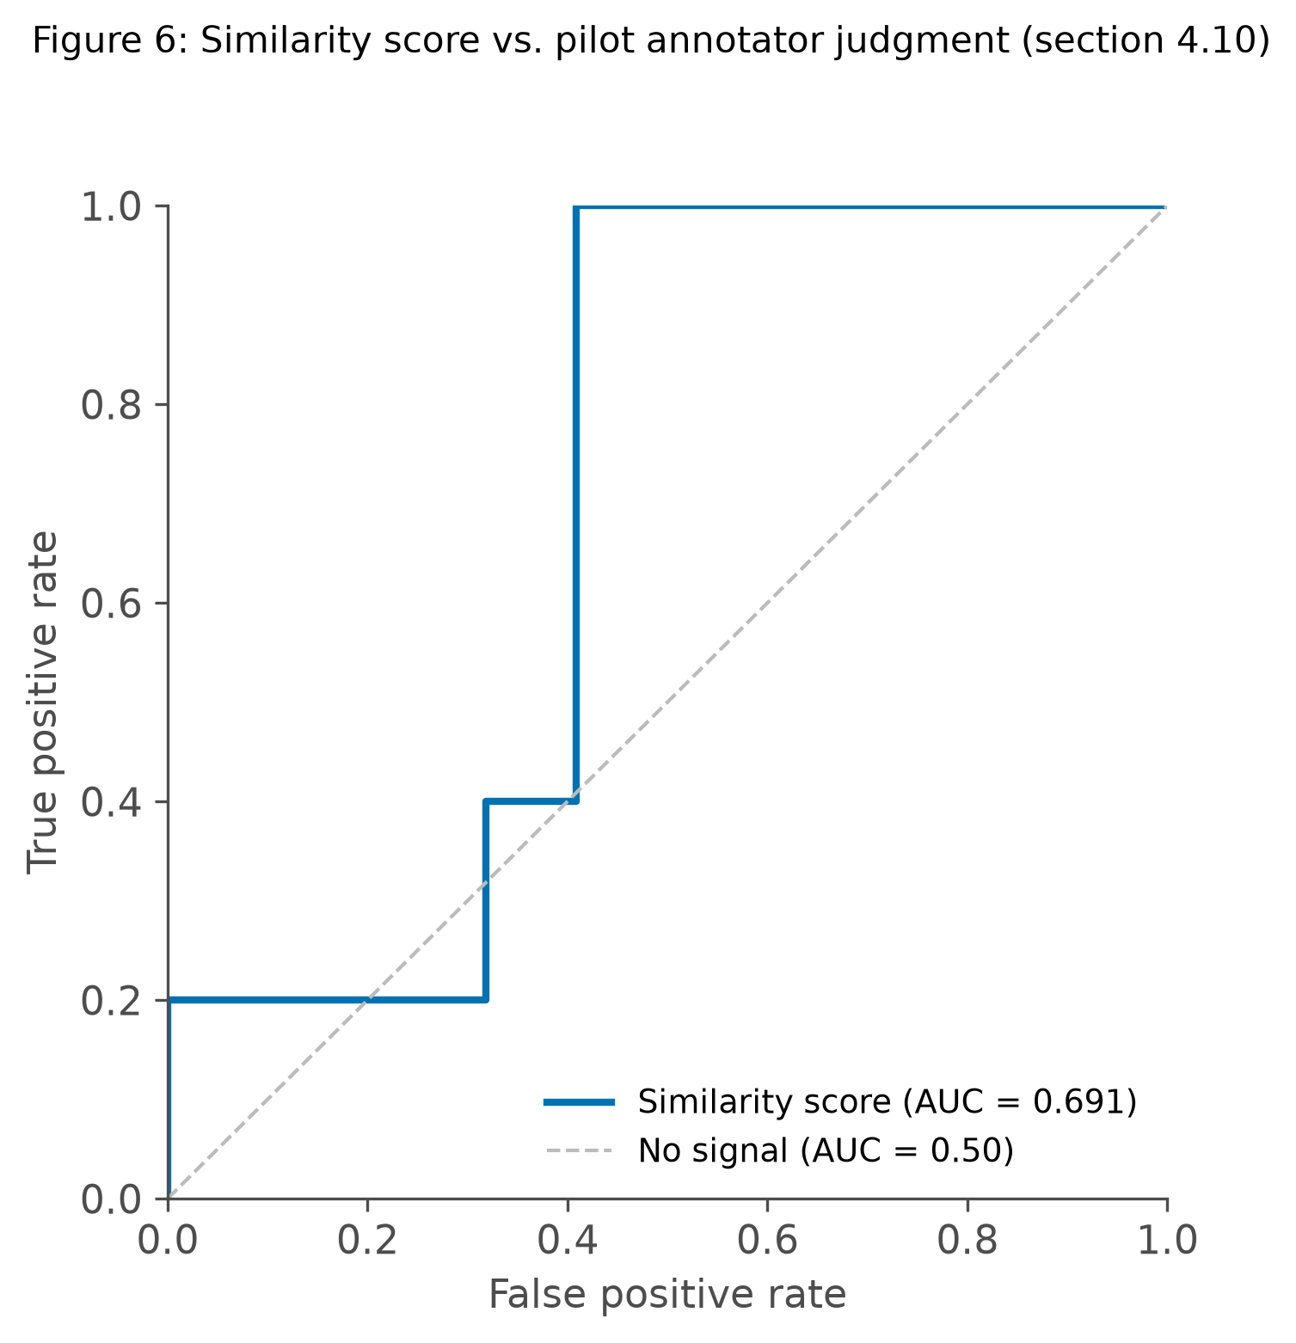
Figure 7: Similarity score vs. pilot annotator judgment
The confusion matrix behind the 0.691 AUROC (Area Under the Receiver Operating Characteristic curve), at the 0.85 operating point of 27 items, 5 were judged genuinely not needed. The audit caught all 5, 100% recall, no false negatives. Of the 22 judged genuinely needed 10 were wrongly flagged leading to 33% precision. So at this threshold on this small sample the audit catches every real case but with real false alarms another reason 5 positive cases isn't enough to trust this balance as stable.

4.11 A structural limit of whole answer similarity
Another data to look at is the situation where we have multiple companies cited in the answers. Checking across all of the conditions, whether a cited company still appears in the answer after its respective passage is removed, we find 1,031 cases where it generally doesn't. That means the real content from the passage was lost. But the audit only says 12 of these answers were post rationalized, and at the other end, 82 when the original answer named five companies for the citations. That is not because the answers are longer in length. If we restrict the answers to a length of 73 words (which is the median length) the same pattern still holds, 6% at one end when only one company is cited and 83% when five companies are cited.
Here is why it happens: comparing the full answer by similarity, by cosine similarity measures, the overall shape of the text. Removing one company among the five still leaves four companies in place, so the remaining text reads very similar in cosine similarity space, even though a really important fact or data point is gone. The question D05 (question type D, unanswerable questions) shows this clearly. Answer with 152 words: name five companies. After one of the companies is removed, the answer changes to a 34-word answer, but now it refuses to name any of the four remaining companies. The cosine similarity score is 0.935, so the citation is classified as post rationalized anyway. That's because this is an unanswerable question. The passage probably replies by refusing to answer the question or saying it does not know the answer, and then follows with citing the five companies with just the names. When the removal is done for one of the passages, the 34-word answer also refuses to answer the question, but this time it just doesn't cite the remaining four. The five or four companies that were cited were not actually load bearing. This is similar to the data in Table 8, with Type B questions in brackets. Several companies in the answer have the highest starting post rationalization for two of the three models. Also, Type B questions refuse to reply by mentioning that they cannot find the answer, but cite all of the five companies anyway. The removal test looks really trustworthy when one passage carries the whole answer and untrustworthy when the answer lists several.
Table 26: Removal audit verdict where the cited company disappears from the answer
Companies named in the original answer | Rounds | Classified post rationalised
1 | 405 | 12%
2 | 245 | 29%
3 | 100 | 51%
4 | 84 | 71%
5 | 197 | 82%

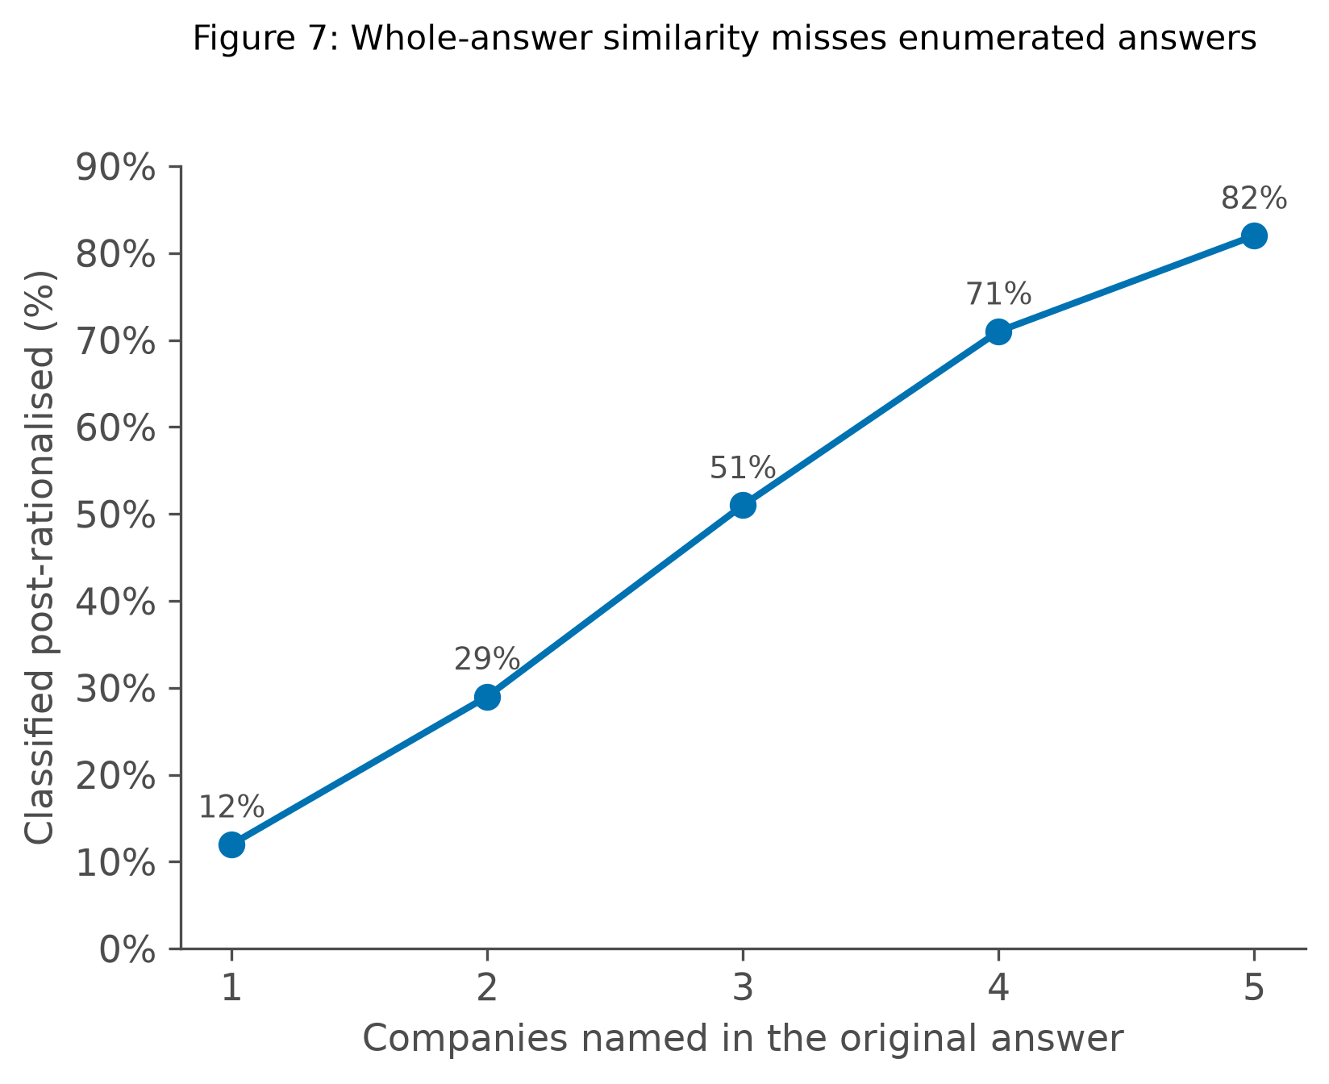
Figure 8: Whole answer similarity misses enumerated answers

4.12 Sensitivity to the aggregation choice
So how much does aggregation choice matter? How much post rationalization is shown on average depends on which averaging method is used, because for the Gemini model, the numbers differ by almost double the size. It's a 24.6% macro average with and against a 43.5% micro average. These two were first defined back in Section 3.4 when the PRR definition was mentioned. Micro average pools every citation from every question into one big group and then averages the group at once. A question with more citations will pull up this average number. Macro average is calculated for one score per question, and then the averages of those scores are calculated. Every question counts the same. The difference between the percentages above is because macro averaging counts a question with no citation as a zero and does not let questions with a lot of citations count more than one question. The actual correction method and effect, however, don't depend on the averaging method. It's just a calculation of the numbers. The direction stays the same across all of the 12 conditions, from C1 to C12. Even the numbers and the rankings between the models don't change either. MISTRAL, which is the most responsive model, actually comes out bigger under micro averaging, that is, 16.7%, while it's only 12.8% with macro averaging.
Table 27: Baseline post rationalisation rate under macro versus micro averaging
 | Macro (mean of per query rates) | Micro (pooled over citations)
Gemini baseline (C1) | 24.6% | 43.5%
Mistral baseline (C3) | 22.2% | 31.1%
Llama 3 baseline (C7) | 20.6% | 29.2%
Mistral change (C4, C6, C11) | −12.8pp | −16.7pp
Llama 3 change (C8, C9, C12) | −6.4pp | −5.7pp
Gemini change (C2, C5, C10) | −1.2pp | −0.3pp

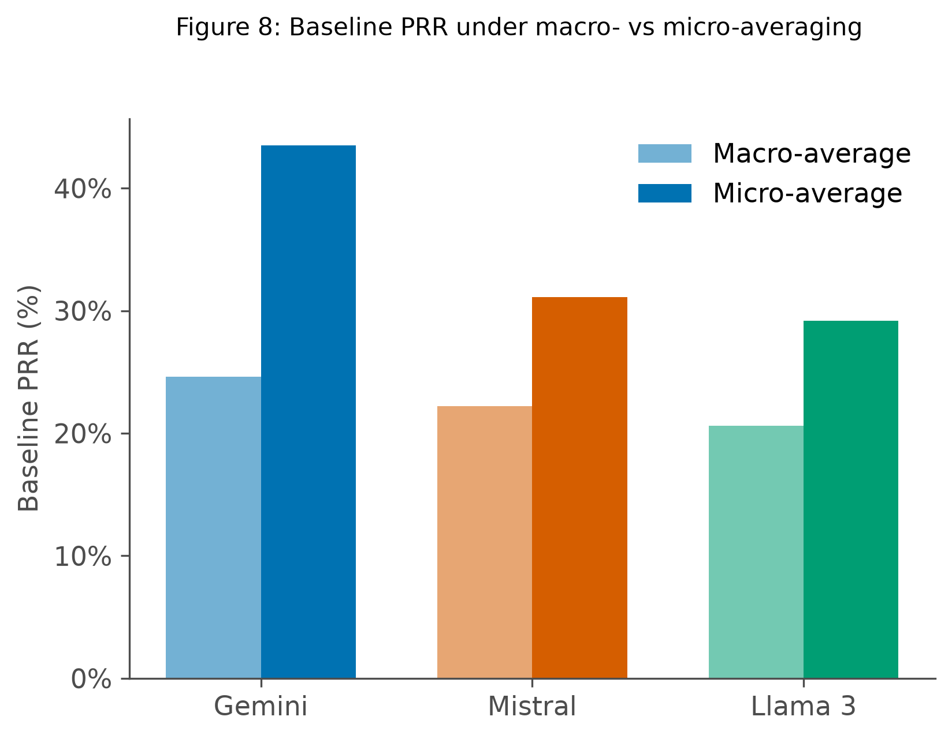
Figure 9: Baseline PRR under macro- vs micro averaging
Let us take the overall comparison. Llama 3's baseline PRR is 20.6% macro vs 29.2% micro, which is the same bar already in the figure. The headline result is correction helps most for Mistral and least for Gemini. Deriving Table 9 straight from the raw logs gives the same gap, direction, and ranking again. Macro vs micro changes the absolute level and not what the result says.

4.13 Summary of results
So here we talk about the summary of the seven findings in this study. The correction loops lower the post rationalization a lot for one model (Mistral), a little for the second model (Llama 3), and not very significantly for the third model (Gemini). At this sample size, Mistral's drop survives correction for testing three generators; Llama 3's is nominally significant on its own but does not survive that correction; Gemini's is not distinguishable from zero. Which model acts as the discriminator has no effect on the outcome at all, as it was by design. Even though the three discriminators were present to check the hypothesis, they clearly gave different verdicts from each other, and it was proven that the models do not serve as a valid judge for the post rationalization check.
The generator correction receptivity (GCR) ranges from 14.8% to 59.1%. The range in the percentage is in a similar order as how the post rationalization rate dropped. Correction of post rationalization doesn't change the citation correctness rate. How much the correction loop effects depends on the similarity threshold chosen. The size of the improvement is biggest at 0.85 and starts shrinking when we move to either side of this number.
The overall post rationalization levels depend on whether the rates are averaged by micro average or macro average (per question or per pool citation, respectively), and it differs by up to a double. The ranking of the treatment effects and the effects of the treatment stay the same. A simple study to measure the post rationalization against human judgment was done. One pass performed by me found 63% agreement and a kappa value of 0.308.
Comparing answers by similarity threshold works when one passage carries the whole answer as load bearing, but isn't so confident when the answer lists several companies disagreeing with a fact by fact checking 82% of the time when the original answer cited five companies.

S

Discussion of Findings

5.1 Overview
We mentioned three research questions above: RQ1. Can the chunk removal process work as a real time correctional signal that reduces post rationalization in a RAG system? RQ2. Does the correction depend on which LLM generates the answer, and can it be characterized as a measurable property of the LLM? RQ3. Can an LLM detect post rationalization from the text and context alone? Two of these three questions receive a fairly clear answer from this study, and the third one receives a rather strange answer. Chunk removal does work as a correction signal, but only on some of the models, not all of them. The answers for RQ1 and RQ2 end up saying that it depends entirely on which model is chosen. RQ3 asks whether a language model can detect post rationalization just from text and the context, but the answer is that we found that it had almost no effect. LLM models are not really good at detecting post rationalization. The most positive answers for all of the three research questions would be, RQ1 Is significant for every generator, not just one, RQ2 Receptivity varies by degrees and not just a total divide, RQ3 Is the verbal judgment hypothesis is close enough to the causal test and it is enough to replace it. But none of these ideal scenarios occurred. The method works for one model, the models differ vastly and the cheap alternative does not work at all.

5.2 The discriminator has no causal path to the outcome
In Table 10 above, we see that each row for the local model stays exactly the same, and it does not matter which of the three discriminators is used. In Table 11, we see that this isn't a coincidence and that the discriminators disagree with each other on the 9th and the 13th queries. The resulting answers still came similar every time. This is by design, since in Section 3.8, we already state that the reprompting only is due to the audit and never the discriminator. The discriminator is a hypothesis that we're testing. The question of whether a model judges another model's citation more harshly than its own can be answered by looking at this, because the discriminator's judgment is not actually shared back into the loop. It can be answered in another way by comparing the discriminator's own flag rate with a model which is similar to the generator. When the discriminator and generator models are different whether a model flags its own citation at a different rate than other models, section 4.3 and table 13 show this. And we see that Gemini goes easier on its own citation than the other two model citations. This also resembles something covered in section 2.7 which is similar to a self preference bias where a model judging output that resembles its own tends to score it more kindly. Llama 3 does the opposite of Gemini, judging itself more harshly than the other two but Mistral shows no pattern at all since it barely flags anything as post rationalized, regardless of whether it is Mistral that wrote itself or the other two models.
The main takeaway here is that a variable that has no effect on a particular outcome can still look like it had an effect when the measurement is a bit noisy. A story wound up to make believable can be told for either direction once a number shows up. A complete GAN similar architecture would involve the adversarial model’s verdict (discriminator model) Control the re-prompting directly to the generator model causing the changes to the regenerator in actual GAN methodology the generator and the discriminator are still steered against each other to make the generator overcome the discriminator and finally produce acceptable output but here keeping the discriminator passive and a test for hypothesis is what makes its accuracy accountable, and it's comparison with a causal test visible.

5.3 What the discriminator results say about verbal judgment
The accuracy of the discriminator to find out whether the model post rationalized or not ranged from 59.5% to 72.9% across the nine model pairings which used the discriminator. As mentioned previously, on a closer look, the accuracy here is mostly due to correctly spotting genuine citations, which is the bigger group to begin with.
A discriminator that just said "genuine" to every question without even looking at it would still score about 65% while actually catching nothing at all. The number that actually mattered here was the recall. Across the whole run, the discriminators caught only about 32 of the 375 post rationalized citations, which is only 8.5%. Mistral, as the discriminator, caught none of the 123 that it received while still scoring only a 65.5% accuracy.
This is the real reason why this is a hard task: the judgment of whether a model actually looked at the passage while writing the answer, can only be found out in the process, in the fact of how the answer was generated, but the finished text that the model generates doesn't record this process. A judge reading the text is being asked to judge something on a text that doesn't actually contain the evidence or the process by which it was generated.
This also connects to the self correction in section 2.6 that says the model tends to improve when an outside signal is used more than relying on its own judgment. This pattern is very similar, since the causal test here created is an outside test with a chunk removal, and the verbal test with an LLM is the internal one. Huang et al. (2024) report the same pattern directly: language models struggle to fix their own reasoning mistakes without an outside signal, which is consistent with why the discriminator's own verbal judgment underperforms the causal removal test here.
Whether the inclusion of reasoning rule would change the effect of recall is an open question. An argument for it can be made that allowing reasoning before answering a question could lead to errors being caught before and the argument for against it would be that the limitation mentioned in section 2.7 also applies here it's that context needed for a model to judge citations is never provided to it in the first place and also this was not tested so its effect remains open.
The main takeaway is this: a cheap verbal test (the LLM test - discriminator) can't stand in the way of a real test here. The chunk audit loop with extra generative calls is the more expensive route and also the only one that actually works.

5.4 Generator correction receptivity
What is the clearest positive result here? It is about the ranking and it is that, at 59.1% of the time Mistral acts on correction, 36.4% of the time Llama, and 14.8% Gemini. The drop in post rationalization also follows this exact same order, and this match between this ranking and the post rationalization drop matters the most. If receptivity and the GCR (general generator correction receptivity) and the actual drop in PRR had come out in a different order, that would make the GCR number look very suspicious, and there would be no way to tell which of them was misleading.
We can take a closer look at the Gemini numbers, and it's not that Gemini ignored the feedback it received. That is, 25 out of 75 questions it answered came back reworded after the re-prompt, so it did follow the instructions it received to revise, but it just did not remove the citations it was told to remove.
This is why the GCR is defined around whether the actual problem gets fixed or not, just whether the text changes or if it's reworded differently. This is the same way, similar reason why we use cosine similarity to compare the text before and after.
The question about why these models act so differently isn't something this experiment can explain. Whether it's training that rewards these models for sticking to a specific answer that we like, or whether these models have higher confidence in their own output, or whether the instructions need to be provided differently for these different models are all plausible reasons, but we haven't tested them here. Two candidate explanations from outside this thesis: Lanham et al. (2023) find that larger, more capable models can actually be less faithful to their own stated reasoning, which would fit Gemini's flat result here; and Sun et al. (2025), working inside the model rather than on its output, trace a similar resistance to internal layers that overweight what a model already knows over what it just retrieved. Another question to be asked is whether the model's receptivity to the correction signals is proportional to its benchmarks for instruction following? A possible way to answer this is to increase the pool of models being tested in the experiment and to draw the correlation from their data.
One reading that could be misinterpreted here is that both the open local models (Mistral and Llama) are beating the hosted commercial model (Gemini). This does not imply that the open models are easier to correct, since in this test we only test with one hosted commercial model, so it's a two against one situation. Also, the two models differ from each other by 23 percentage points.

5.5 The threshold dependence
An uncomfortable reading is that every single condition we ran (C1 to C12) shows the biggest improvement at exactly the threshold of 0.85, and it drops sharply on either side. The worrying way to read it, which I noticed, is that it looks like the number that made the results look best was the only one which is picked. Section 3.6 already shows that this isn't what happened. 0.85 was picked by convention before all of these tests and these numbers were calculated, which rules out the deliberate reverse engineering of this number. The more likely explanation is that at 0.75, almost every citation gets marked as post rationalized, so that leaves us no room to show any improvement. At 0.95, every citation gets marked as genuine, and almost no citation is marked as post rationalized, so there is nothing left for us to fix. Only somewhere in between this, there is enough room for us to actually show and test improvements.
What can be said with confidence is that the direction of the result, that is, the correction loop, lowers the post rationalization rate and makes the RAG more faithful for every number that we tested. When we talk about the improvement and the size of the improvement, it should be quoted with the cutoff number, since changing the cutoff number changes the size of the improvement.

5.6 Validity of the measure
The analysis rests on one inference: if removing a post rationalized citation leaves the answers unchanged, the passage was not even necessary in the first place to produce it.
In sections 3.13 and 4.10, it reports that a first pilot validation of the inference against a human judgment was done. The model used this passage in quotes, which has at least three readings that are defensible, implying rates of 0%, 10.2%, and 20-25% on identical data.
On the level of attention, every citation is marked genuine since all these five passages sit in context on each loop. So did the model even see the passages? By that measure, every citation would look genuine, since all passages are given to the model, and so this gives you a percent. At the level of a single named passage, almost every passage is load bearing. So, which means did any one specific fact from the passage survive being removed? By this measure almost every citation site counts as important, since when a model names a company just because it read that company's page it cannot read that company's name again once that passage is gone. At the level of the complete answer, which is what the cosine similarity threshold measures, a minority of these citations look decorative, but this thesis measures the third and hasn't been mentioned by the way until now, which is a gap and is a criticism reaching beyond this thesis.
Roy et al. (2025) use a similarity threshold on the output, and Jain and Vedam (2026) partly do, alongside other signals. Cohen-Wang et al. (2024) and Liu et al. (2025) measure something different: the drop in the model's own output likelihood when a passage is removed, rather than output similarity. None of the four works actually state why or what validates the verdicts against human judgment. A specific problem shows up even when we don't do the human validation test, and that is similar to what is mentioned in section 4.11. When an answer names only one passage or one company, the complete answer check and fact by fact company check agree 7 out of 8 times. When an answer names 5 companies as citations, the answer check and fact by fact company checks disagree 4 out of 5 times across the 1,031 removal rounds.
This happens because comparing the complete answers measures the shape of the text, and so we're removing only one company, leaving 4 in place. The text still looks a little bit similar to the original, even though a really important fact is missing or is gone. This again connects to a problem in section 2.8 which is redundancy. It's not about the passages overlapping in the content. What this means for the thesis specifically is that question types B and D, which usually have multiple companies to list, imply that they are the least trustworthy in table 8.
What still is consistent is that the measure works best when the result only comes from single citations, which are type A questions. That is where Mistral's biggest improvement shows up: that is a 20 point improvement.
We also test the validation tests: how well a real person's judgment matches the RAG system using different cutoff numbers. The agreement number kept getting better and better the higher the cutoff was set in these loops, all the way up to 0.95. Unlike the actual RAG system and the removal process, it never leveled off at 0.85. That means 0.85, the number used in this thesis, isn't the number that matches a person's judgment the best. A stricter number was better.
The thesis result of Mistral's citations improving by 12.8 points only shows up strongly at 0.85. At 0.9, it shrinks to 1.1 points, and at 0.95, it's gone completely. The number that agrees best with the human and the number that best agrees with our result, the thesis result, is not the same number, so choosing one costs the other. This just shows that which cutoff number we pick matters more than we initially thought.
One limitation is that this test was performed by only the author, me. This tells us the test worked and hints at some pattern, but isn't complete proof, since there might be a little bit of bias since I am the author. A possible next step is to get a pool of outside people with no connections to this project and run this test with them.

5.7 Reproducibility and hosted models
What could be the residual problem in the reproducibility of the hosted models? Setting the model temperature to zero, as mentioned in section 3.7, fixes the problem for the local models but not the hosted model.
Across the three conditions where the hosted model acted as either one of the generators or the discriminator, its own output still disagreed on seven of the 75 queries. This is a general problem and not something specific to the study. That is that the hosted models are on servers, and they batch your request together with other people's requests. Adding these decimal numbers on this server hardware doesn't always give exactly the same results. There is no client side fix or setting that can fix this.
Since this design happens to include repeats, the discriminator judgment has no real effect. They're just a hypothesis test. The three Gemini conditions are actually measuring the same thing three times, which gives us a spread of two percentage points. That is why the individual -3.5% number from condition C5 is withdrawn instead of being reported as a real effect.
A study that compared these hosted models without these repeated loops built in could not tell this small effect apart from plain noise because they would only have one single number to play with. The advice here would be to run the experiment on repeat and collect multiple data points whenever hosted models are involved.
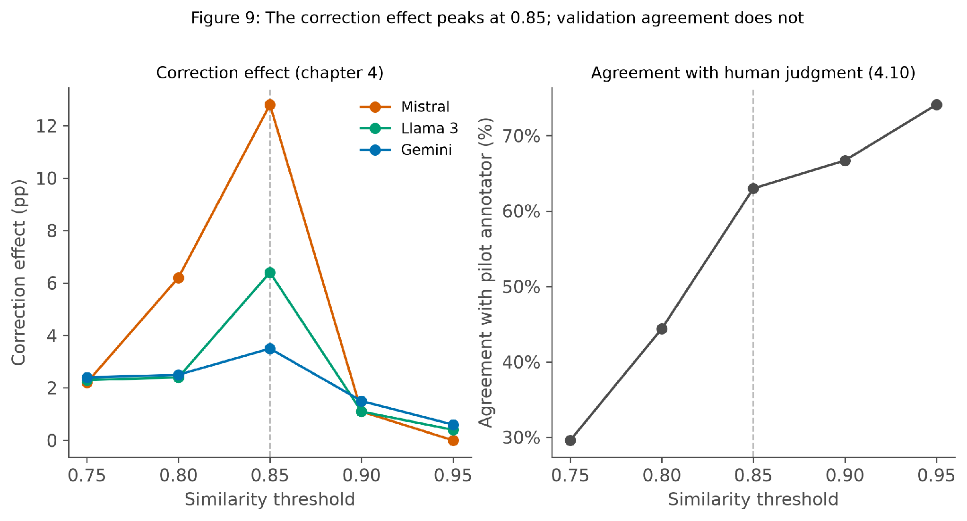
Figure 10: The correction effect peaks at 0.85; validation agreement does not
Sure, an offline version of this study could have removed the reproducibility issues but the cost is that most RAG production systems built on nowadays use a commercially hosted model since they actually are bigger and well trained and have lots of features. And also dropping these commercially hosted models would mean that we never observe its receptivity or its comparison with other model and the data that we collect. The whole point of the study was to test and compare different types of model.

5.8 Practical implications
Let's talk about the practical implications and the cost. The chunk audit and correction loop costs an average of 4.9 model calls and a maximum of 17. For a normal retrieval answer in a RAG system, it's only one call. That is okay if it's an offline check with local models, but it's really difficult for anything running on a server and running live.
This method has to be optimized to become a piece that you could actually deploy. Liu et al. (2025) shows the version of this, which is the leave the one out version, and this can be made much cheaper. This makes it much cheaper, but it was not tried here in this study. Zhou et al. (2023) show an even cheaper option: careful prompting alone, with no extra generation calls at all, can already make a model lean more on retrieved context -- a comparison point worth testing against this thesis's own removal and reprompt loop. Of the three models being compared here, the most receptive model listens to the correction loop about four times more, or four times as often, as the least receptive model. This doesn't relate to the model quality, as the model that scores best on most of these benchmarks turned out to be the least receptive of all three. The only reason we know the receptiveness effect and values of Mistral, Lama3, and Gemini is because we actually built the correction loop and tested it on them, and we received the numbers 59.1%, 36.4%, and 14.8%, respectively.
To find the receptiveness for any other models, we would actually have to build the correction loop again and test them on it. That is the only way to find out its receptivity, but unanswerable questions are a bit different. Correction has no effect on these questions (type D). For two of these three models, Gemini's post rationalization rate on these reaches 57%. It's because there is no genuinely correct answer, so there is no improvement to be made upon these citations. Liu et al. 's leave one out method shows a cheaper path where estimation of each passage's contribution from the model's existing computation instead of a fresh generation call per citation works. If applied similarly the audit step would drop from one call per citation to match the one call per answer. It does not change what gets measured but brings the cost close low enough to a plain answer's single call, thus could make the loop viable to run live.

5.9 What the loop improves, and what it leaves alone
So what does the loop actually improve, and what does it leave alone? We know that the correction lowers the PRR, but it does not affect the citation correctness rate (CCR). Mistral scores about 70% CCR before and after. Gemini scores 76 before and after, and Llama 3 goes from 74 to 72, even when the post rationalization dropped by 12.8% and 6.4% on those same runs. PRR and CRR are actually built to answer different questions defined in section 3.12, so they can actually move independently of each other.
PRR asks whether the answer actually depends on the passage the model cited and checks this by deleting the passage and reprompting the answer. CRR asks if the citation pointed to the right company or provided the right answer, checked against the correct answer list. As we've seen in the results, these two can disagree in different directions. A model can name the correct company in its citation without using the company profile in the answer. This gives a good CCR but bad PRR, which is what example A04 in the above sections mentioned, or it can even use a profile with all the details and name the wrong company, which is the opposite of this pattern. The correction loop is just adding meaning to the citation. Before the correction of the example A04, deleting the citation left the answers unchanged. Just a few words were changed. After the correction loop, the answer came with deep meaning with the citation, which only could come from the passage itself. The practical takeaway of this thesis is that a system that is built on this loop and this architecture will not answer the questions more correctly, but it will produce a citation that actually holds up when checked, thus increasing the faithfulness of this system.
Table 28: PRR versus CCR, compared
 | PRR | CCR
The question it asks | Did the answer depend on the passage it cites? | Does the citation point at the right company?
How it is measured | Delete the passage, regenerate, compare | Match the cited company against recorded ground truth
When | During the run, as extra generation calls | Afterwards, from the logs, at no cost

A second example showing the reverse of the reverse of question A04: two similar companies both fit a query but only one is correct. If the model's answer genuinely depends on the passage it cites, PRR marks it genuine since it was used. But if the cited company is the wrong one, CCR marks it incorrect. Here the citation is load bearing and still names the wrong company. Leading to the mirror image of questions A04 where the company was right and the citation was not carried.

5.10 Limitations
What are the limitations of this study? One corpus, same language, and one type of document, this means that the company profiles are short and are factual, which is useful for a controlled experiment but not an actual RAG system, which would use databases, long documents, unstructured data and more. Even with75 questions used per the 12 conditions, only the biggest effects reach statistical significance. This is seen as Gemini's result is reported as not distinguishable from zero rather than flatly as zero. The three generator models that we chose are enough to build a ranking system, but it's not enough to concretely make claims about the categories of LLM models. Adding more models to these experiments would certainly provide a solution.
Let us see how this works with this insight. Every condition used in this thesis runs against one rag setup with no alternative design tested against or compared with it. Nothing here supports a claim about the specific pipeline design, but only suggests what happens once a pipeline is already fixed and built.
The question set was built by one person (me, the author), including the correct answers and the type of labels assigned to it. Type B questions have type D questions in particular. There were no particularly involved decisions about whether a question is genuinely ambiguous, or if multiple citations or multiple companies can fit the answers. The "add an unanswerable question" (type D, having no answers) was also a judgment call, and maybe having a second person or multiple persons check would make this question design a bit more stronger. The threshold similarity and the comparison all use a single embedding model. A possibility is that using different embedding models and tests to collect different numbers and compare them could possibly lead to different site classifications of the same cutoff number.
The macro average (average per question) and macro average (pool per citation) also affect the citation. That is, how much citation shows up overall can differ up to double, depending on which of these we pick.
The word "adversarial" is used in a few places in this thesis, including the condition labels, but a note must be made that in an actual generative adversarial network (GAN) (Goodfellow et al., 2014), the discriminator signal is what trains the generator, here we only use the discriminator network to test our hypothesis.

Conclusion

6.1 Answers to the research questions
In the introductory section, section 1.5, we introduce the three research questions that are important to this thesis. Here, we try to concretely answer these questions. RQ1 asks whether chunk removal can work as a correctional signal for the RAG system. The answer is it can. For the most receptive model, the post rationalization fell from 22% to 9.4%, which is a 12.8% drop. This holds up under a paired Wilcoxon signed rank test on the 75 questions asked (p = 0.0012), surviving correction for testing all three generators. A small catch is that the strongest result held for one of the three models. A second model (Llama 3) showed a drop that is nominally significant on its own (p = 0.032) but does not survive that correction, and the third (Gemini) showed no effect that could be told apart from zero. This doesn't reflect that the system does not work, but actually hints into the insights about the characteristics of the model. RQ2 asks, How well does the chunk removal and the post rationalization effect with the correction signal depend on the model? The answer is that it depends on it almost entirely. The generator correction receptivity (GCR) ranged from 14.8% to 59.1% across all three models, and the post rationalization rate drop also followed the same order. The least receptive model among these three was not actually refusing the instruction. It actually wrote most of it as answers when prompted to, but the only problem was that it did not remove the citation that failed the real test. This is similarly the reason why GCR is defined around whether the citation problem is actually fixed upon correction, not whether the text simply changed or was reworded. Next, RQ3 asks if an LLM model can spot the post rationalization just from reading the context. This actually has two questions that can be split into: Whether the LLM can spot post rationalization from reading the context. Whether the LLM can correct the post rationalization from reading the context. It turns out the first question was answered, and it was found out that the LLM models are not a good judge of detecting post rationalization. The second question turned out to be unanswerable due to the design of this experiment, since re-prompting the generator from the discriminator's judgment was the only way to trigger the re-audit and check whether the discriminator had an effect on the outcome at all. An argument could be made that the reason why models could not catch post rationalization was a limit rather than failure or bad luck. This is because, to actually make this judgment, the model needs more context about how the answer was generated rather than just the finished answer or finished text.

6.2 Contributions
Now let us talk about the contributions this thesis provides to the AI and RAG community. 1. The contribution is that of correction instead of just measurement. Existing tools detect post rationalization, even score post rationalization, but stop here. This extends this: the same kind of check back to the model while it's still generating, showing that post rationalization can actually be reduced, not just reported. The contribution is that generator correction receptivity (GCR) is a property of a language model that nobody had measured before, since it's invisible in a system that never actually sends a correction signal in the first place. From this experiment and with the three models we compared, we find out that it varies by a factor of four across the three models, and it does not track the general model quality, though. The contribution is that the validation test built and the limits it uncovered. Since there is no published work that uses removal based attribution checks and checks its verdict against human judgment and also shows which level of detail the cutoff actually measures, a remark should be made that this thesis is a validation attempt. The whole idea is not yet settled and the three fair readings given in this thesis ranges from 0% to 20 to 25% depending on reading. The contribution is that the evidence that an LLM model used as a judgment for post rationalization cannot replace an actual causal test. Across the nine model pairings with the discriminator, it only caught about 32 of the 375 post rationalized citations, which only amounts to 8.5%, and one model even caught none of them. The contribution is about the repeatability of this experiment. The default setting of the models in the initial runs pointed out the instability produced that results in the answers flipping directions and the numbers fluctuating. Until the temperature of the models (two out of three) was fixed to always return the same output, this repeatability of the experiment was unstable.

6.3 Limitations on what is claimed
The limitations that matter the most are below. The similarity threshold chosen carries a lot of weight in how big every effect looks. The biggest effects show up at the cutoff used throughout this study, and the effect tapers down when we move towards either side of the scale. The direction of the findings holds up across every range of the similarity threshold tested, but the size of the effect should never be mentioned without mentioning which similarity threshold cutoff, was used. The central measure of this thesis, the chunk removal and the reprompting system, has not been completely verified against human judgment and only was done with a single attempt with the author or me. With the single run, the check found out that the question the model used this passage has at least three different readings, giving rates of 0%, 10.2%, and 20% to 25% on the same data. Another effect that does not need human checking is when an answer cites only one company. Our test with the similarity check almost always notices if that company is deleted or not, but when the answer lists four or five companies, the similarity check does not have such a strong effect. It misses 82% of the time, even though something actually disappeared from the citations in the answer. But the main result doesn't fall apart just because of this consequence. Since it rests on Type A questions where the measurement works best, the breakdown by question type in Table 8 shows the effects of all this.

6.4 Future work
Here we talk about the next steps and the future work in priority order. the highest priority is, before running any more validation tests with actual people, that we decide on what the model actually used this passage in quotes means. Do we mean: whether the model had just looked at or read the information whether a specific fact from the passage is mentioned in the answer whether the whole answer depended on this passage In section 3.4, we already mentioned that our definition for PRR is measured as the whole answer similarity of 0.85 or higher. So the important question here isn't whether we have to fix the definition. It's that if we have the right level of detail being measured in respect to post rationalization instead of comparing one or two other readings. This isn't something more validation tests and annotations can resolve on its own. Once the above is settled, only the human testing and measurement can actually mean something. The post rationalization calculation and reports can be done at more than one level instead of just mentioning the similarity threshold number and the cutoff. Second priority, the two levels of detail are: answers with one citation answers with more than one citation, up to five Disagree in a predictable way, growing from 12% to 82%. Since this experiment runs in such a way that the experiment is run and the logs are collected and stored, this test will just require another additional calculation. Due to the time constraints, this was not yet done but will be part of the future prospects. Third priority is that we need more models to test and compare, since having three models is enough to only build a ranking. Questions such as whether receptivity is related to types of model (open model, close model, hosted models, size of models, or the training choice of models) cannot be concretely answered with only three models. Fourth priority would be adding more types of documents since company profiles and the document corpus are only one type, and they all have the same shape in the same way. The open question about whether this works in long documents, stories, technical writing, etc., is yet to be answered. Fifth priority would be to find a way to handle the type D unanswerable questions, since correction doesn't help at all with this. With these questions, one of the models started out at 57% post rationalization, so since there is no catching and fixing, there is no way to make the answers look good. Proposing a unique fix of its own would be useful. Sixth and last priority would be that we could investigate how and why these models differ in the generator corrections receptivity (GCR). This thesis only shows that they do and by how much, but not exactly why.
Initial design for this would look like the following: Approximately 15 to 20 people can be chosen for this project who have no connection or background related to this project. Each are shown a randomized sample of questions drawn from the same way that the pilot question sample was drawn. Stratified across the similarity bands and making sure that these questions lie around the current cutoff of 0.85. Each person would see the three choices. And the person had to decide based on the context (the question, the cited passages, the answer before and after) and whether the selected passage was needed not needed or unclear).

6.5 Closing remark
On closing remarks, it can be mentioned that building something that sends the correction signals to an LLM made a property visible that had not been visible before. That is how willing a model is to accept this, except for itself being corrected. This is one finding that was not expected when going in with this thesis.
This property varies enough between these three models that we use that it decides whether the whole approach works at all. Tools already exist to measure the answers the model produces and whether it's post rationalized or not. There was no tool that could measure how a model reacts to being told it was wrong, since measuring this would actually require the model to be told this via a feedback loop. This requires building this whole loop first in this new AI era, and RAG systems being more and more opted in to production systems and really important locations will require that. In that regard, systems will require to be checked and fix their own output. How willing a model is to accept these checks and outputs may end up mattering as much as how well it performs on its own.
This matters a lot. As mentioned in the start of this thesis, areas like law, medicine, finance and production systems use cases where a citation stops being decorative and becomes part of the decision. A RAG system in any of these areas will eventually be told that it made a mistake either by a user, a regulator, or by a later audit. And how willing the model is to actually accept that correction rather than simply producing different words that look corrected, matters too. This thesis shows that willingness for correction cannot be assumed and cannot even be observed. Until a real correction signal is actually built and sent, we can't know for sure. For anyone building these systems for the domains this thesis opened with, that is the practical version of the closing thought: knowing whether your model can be corrected is not a detail to check later, it is a property worth measuring before the system is trusted with a decision that matters.

Appendix A: Experimental Conditions
Table A.1: Experimental conditions and each model's role
Condition | Generator | Discriminator | Role
C1 | Gemini 2.5 Flash | none | baseline
C2 | Gemini 2.5 Flash | Mistral 7B | cross model
C5 | Gemini 2.5 Flash | Gemini 2.5 Flash | same model
C10 | Gemini 2.5 Flash | Llama 3 8B | cross model
C3 | Mistral 7B | none | baseline
C4 | Mistral 7B | Gemini 2.5 Flash | cross model
C6 | Mistral 7B | Mistral 7B | same model
C11 | Mistral 7B | Llama 3 8B | cross model
C7 | Llama 3 8B | none | baseline
C8 | Llama 3 8B | Llama 3 8B | same model
C9 | Llama 3 8B | Gemini 2.5 Flash | cross model
C12 | Llama 3 8B | Mistral 7B | cross model

75 questions per condition where 30 are Type A answerable, 15 Type B ambiguous, 20 Type C hard or paraphrased, and 10 Type D unanswerable. Corpus of 38,692 DACH company profiles, top 5 retrieval, cosine similarity, and sampling temperature zero. As per section 4.6, the 3 adversarial conditions sharing a generator are replicates rather than distinct conditions because the discriminator has no effect on the outcome.

Appendix B: Annotation Codebook
The code book is a set of yes or no binary rules. An annotator applies to each answer in the validation study to judge whether a citation is actually needed or not and it is held at experiments/results/validation/CODEBOOK.md and the code book was committed or locked in before the validation pass we are trying to run. We can say that the rules weren't fit to adjust the results later. Even though it was logged in before the validation test the rules turned out to be loose even though 24 out of the 29 items satisfied the codebook's condition. The detail that “does the model use this source” need to be found in order to quantify or actually measure this with complete confidence.

Appendix C: Reproduction
Table C.1: Location of each artefact needed to reproduce the experiment
Artefact | Location
Experiment runner | run_experiment.py
Chunk removal audit | audit/chunk_removal.py
Correction loop | adversarial/loop.py
Query set | data/queries/eval_queries_v3.json
Deterministic run logs | experiments/logs/C*_38k_v7_*.jsonl
Analysis | evaluation/analyse_v7.py, evaluation/threshold_sensitivity.py
Validation instrument | evaluation/build_survey.py
Validation scoring | evaluation/score_annotations.py
Running record | EXPERIMENT_LOG.md

Every figure and calculation and table shown in chapter 4 is derived from the deterministic run log (the twelve *_38k_v7_*.jsonl logs), which holds the record for each answer and the answer after removal, the similarity score and the full text of all of the retrieved passages as a complete log. The threshold sensitivity mentioned in section 4.7, the comparison in section 4.12 and the analysis in section 4.11 were all computed from those logs without further generation.
Figure 11: Screenshot of the chunk_removal.py where the actual chunk removal technique is being used
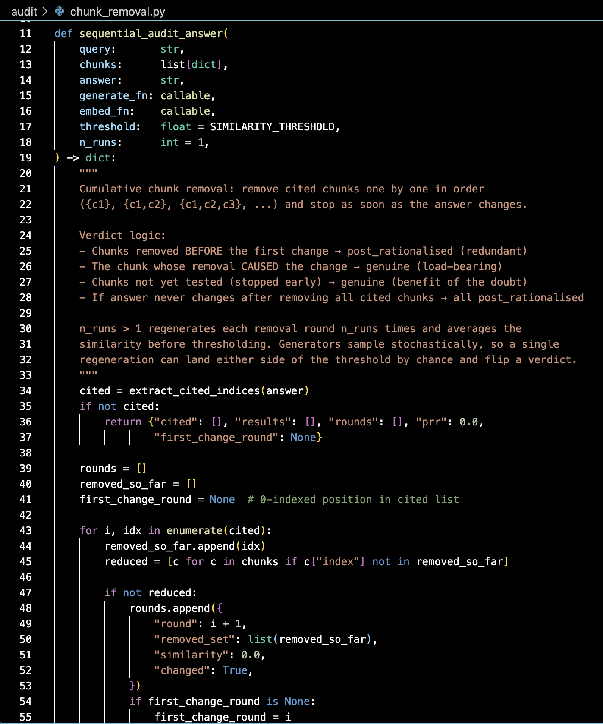
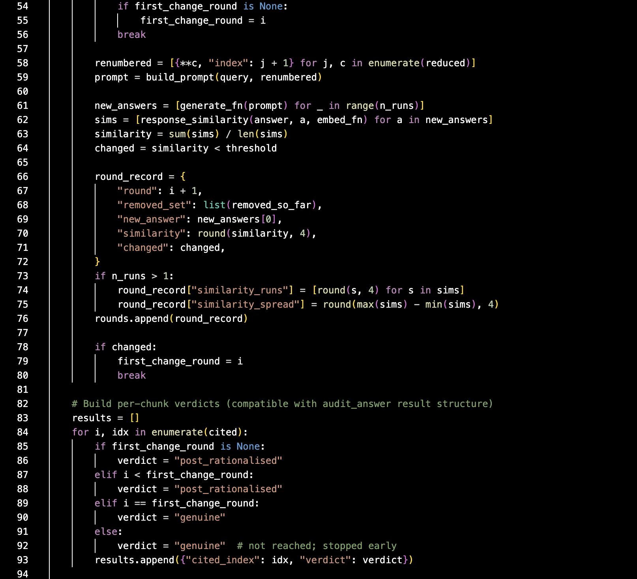
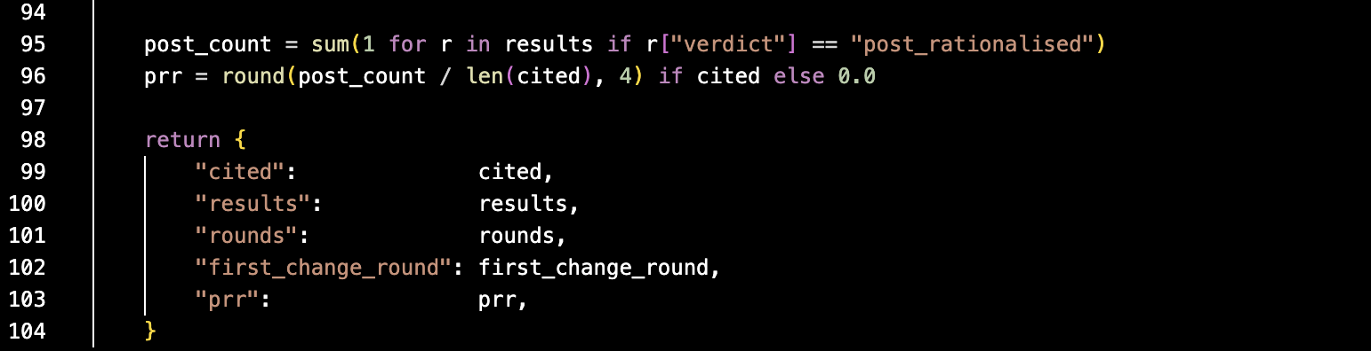
The corpus derives from a proprietary database held by Startup Insider GmbH and cannot be redistributed, which limits external reproduction to the method rather than the results.

Prompts used in the experiment
Three important prompts are used for every model in this study and these problems are fixed templates. Documenting these problems matters for two reasons. One is that the wording or the phrasing of the prompt itself can influence what a model chooses. to cite so keeping it fixed is really important. Second, reproducing this study requires the exact prompt and not just an idea of what the prompt does.

Table C.2: The three prompt templates used in the experiment
Prompt | Defined in / used for | Text | Times used
Generator prompt | pipeline/baseline.py; every answer generation, and every regeneration inside a removal-test round | “You are a research assistant answering questions about the DACH startup ecosystem. Answer the question using ONLY the sources provided below. For every claim you make, cite the source number in square brackets, e.g. [1] or [2]. Only cite a source if it directly supports that specific claim — do not cite sources that are not relevant to the claim.” | 1,903 total (225 initial answers + 1,678 removal-test regenerations)
Feedback / correction prompt | adversarial/loop.py; step 3 of the correction loop, only when the audit flags at least one citation | “You previously answered the question below and cited sources {flagged}. Testing showed that removing those sources did not change your answer — they were not genuinely needed. Revise your answer... Only keep citations that are load-bearing.” | 213
Discriminator prompt | adversarial/loop.py; step 2 of the correction loop, once per cited passage, every adversarial condition | “Is this source genuinely load-bearing for the answer, or could the answer have been given without it? Respond with exactly one word: GENUINE or POST_RATIONALISED.” | 1,071

Table C.2 shows the counts of how many times these prompts are used generator prompt is the highest because it is used for every generation call whether it is a gen baseline or generator that is it is used across all 12 conditions the discriminator prompt is the next in number since it is used in nine of the conditions and the feedback or correction prompt is an estimation and is used only when we need to send a feedback to the generator the feedback prompts low count shows how selective the correction loop actually is and it also and it only runs when the audit has actually found something worth correcting. Reading all these numbers together we can say that for every genuine correct attempt on citation roughly five discriminator judgments are run and a generator regenerations happen.

Appendix D: Per query PRR, All 75 Queries, All 12 Conditions
Every value in table D.1 shows the post rationalization rate for that query before and after the correction as a percentage value. The arrow direction shows the change in post rationalization before and after. In appendix A, we show the twelve conditions and each of the combinations of generator and discriminator. Those same twelve conditions are again reflected here but in this time with all the 75 questions. Baseline conditions (C1, C3, C7) never run correction, so their before and after values are identical by construction. Source: experiments/results/v7_deterministic/v7_per_query.csv.

Table D.1: Per query PRR before and after correction, all 75 queries across all twelve conditions
# | Type | Query ID | C1 Gemini/none | C3 Mistral/none | C7 Llama3/none | C2 Gemini/Mistral | C4 Mistral/Gemini | C5 Gemini/Gemini | C6 Mistral/Mistral | C8 Llama3/Llama3 | C9 Llama3/Gemini | C10 Gemini/Llama3 | C11 Mistral/Llama3 | C12 Llama3/Mistral
1 | A | A01 | 0→0 | 0→0 | 0→0 | 0→0 | 0→0 | 0→0 | 0→0 | 0→0 | 0→0 | 0→0 | 0→0 | 0→0
2 | A | A02 | 0→0 | 0→0 | 0→0 | 0→0 | 0→0 | 0→0 | 0→0 | 0→0 | 0→0 | 0→0 | 0→0 | 0→0
3 | A | A03 | 0→0 | 0→0 | 0→0 | 0→0 | 0→0 | 0→0 | 0→0 | 0→0 | 0→0 | 0→0 | 0→0 | 0→0
4 | A | A04 | 0→0 | 100→100 | 0→0 | 0→0 | 100→0 | 0→0 | 100→0 | 0→0 | 0→0 | 0→0 | 100→0 | 0→0
5 | A | A05 | 0→0 | 100→100 | 0→0 | 0→0 | 100→0 | 0→0 | 100→0 | 0→0 | 0→0 | 0→0 | 100→0 | 0→0
6 | A | A06 | 100→100 | 0→0 | 50→50 | 100→100 | 0→0 | 100→50 | 0→0 | 50→50 | 50→50 | 100→50 | 0→0 | 50→50
7 | A | A07 | 0→0 | 0→0 | 0→0 | 0→0 | 0→0 | 0→0 | 0→0 | 0→0 | 0→0 | 0→0 | 0→0 | 0→0
8 | A | A08 | 0→0 | 0→0 | 0→0 | 0→0 | 0→0 | 0→0 | 0→0 | 0→0 | 0→0 | 0→0 | 0→0 | 0→0
9 | A | A09 | 0→0 | 100→100 | 0→0 | 0→0 | 100→0 | 0→0 | 100→0 | 0→0 | 0→0 | 0→0 | 100→0 | 0→0
10 | A | A10 | 0→0 | 50→50 | 50→50 | 0→0 | 50→50 | 0→0 | 50→50 | 50→0 | 50→0 | 0→0 | 50→50 | 50→0
11 | A | A11 | 0→0 | 0→0 | 40→40 | 0→0 | 0→0 | 0→0 | 0→0 | 40→40 | 40→40 | 0→0 | 0→0 | 40→40
12 | A | A12 | 0→0 | 0→0 | 0→0 | 0→0 | 0→0 | 0→0 | 0→0 | 0→0 | 0→0 | 0→0 | 0→0 | 0→0
13 | A | A13 | 50→50 | 100→100 | 50→50 | 50→50 | 100→0 | 50→50 | 100→0 | 50→100 | 50→100 | 50→50 | 100→0 | 50→100
14 | A | A14 | 0→0 | 0→0 | 0→0 | 0→0 | 0→0 | 0→0 | 0→0 | 0→0 | 0→0 | 0→0 | 0→0 | 0→0
15 | A | A15 | 0→0 | 100→100 | 100→100 | 0→0 | 100→0 | 0→0 | 100→0 | 100→0 | 100→0 | 0→0 | 100→0 | 100→0
16 | A | A16 | 0→0 | 0→0 | 0→0 | 0→0 | 0→0 | 0→0 | 0→0 | 0→0 | 0→0 | 0→0 | 0→0 | 0→0
17 | A | A17 | 100→100 | 0→0 | 0→0 | 0→0 | 0→0 | 0→0 | 0→0 | 0→0 | 0→0 | 100→100 | 0→0 | 0→0
18 | A | A18 | 0→0 | 100→100 | 0→0 | 0→0 | 100→0 | 0→0 | 100→0 | 0→0 | 0→0 | 0→0 | 100→0 | 0→0
19 | A | A19 | 0→0 | 0→0 | 0→0 | 0→0 | 0→0 | 0→0 | 0→0 | 0→0 | 0→0 | 0→0 | 0→0 | 0→0
20 | A | A20 | 0→0 | 100→100 | 100→100 | 0→0 | 100→100 | 0→0 | 100→100 | 100→0 | 100→0 | 0→0 | 100→100 | 100→0
21 | A | A21 | 50→50 | 0→0 | 0→0 | 50→50 | 0→0 | 50→50 | 0→0 | 0→0 | 0→0 | 50→100 | 0→0 | 0→0
22 | A | A22 | 0→0 | 0→0 | 100→100 | 0→0 | 0→0 | 0→0 | 0→0 | 100→100 | 100→100 | 0→0 | 0→0 | 100→100
23 | A | A23 | 0→0 | 0→0 | 0→0 | 0→0 | 0→0 | 0→0 | 0→0 | 0→0 | 0→0 | 0→0 | 0→0 | 0→0
24 | A | A24 | 0→0 | 0→0 | 0→0 | 0→0 | 0→0 | 0→0 | 0→0 | 0→0 | 0→0 | 0→0 | 0→0 | 0→0
25 | A | A25 | 0→0 | 0→0 | 0→0 | 0→0 | 0→0 | 0→0 | 0→0 | 0→0 | 0→0 | 0→0 | 0→0 | 0→0
26 | A | A26 | 50→50 | 0→0 | 0→0 | 50→0 | 0→0 | 50→0 | 0→0 | 0→0 | 0→0 | 50→50 | 0→0 | 0→0
27 | A | A27 | 0→0 | 0→0 | 0→0 | 0→0 | 0→0 | 0→0 | 0→0 | 0→0 | 0→0 | 0→0 | 0→0 | 0→0
28 | A | A28 | 100→100 | 0→0 | 0→0 | 100→100 | 0→0 | 100→100 | 0→0 | 0→0 | 0→0 | 100→100 | 0→0 | 0→0
29 | A | A29 | 0→0 | 0→0 | 0→0 | 0→0 | 0→0 | 0→0 | 0→0 | 0→0 | 0→0 | 0→0 | 0→0 | 0→0
30 | A | A30 | 0→0 | 0→0 | 0→0 | 0→0 | 0→0 | 0→0 | 0→0 | 0→0 | 0→0 | 0→0 | 0→0 | 0→0
31 | B | B01 | 0→0 | 0→0 | 0→0 | 0→0 | 0→0 | 0→0 | 0→0 | 0→0 | 0→0 | 0→0 | 0→0 | 0→0
32 | B | B02 | 60→60 | 40→40 | 20→20 | 60→60 | 40→40 | 60→60 | 40→40 | 20→25 | 20→25 | 60→60 | 40→40 | 20→25
33 | B | B03 | 60→60 | 40→40 | 33→33 | 60→60 | 40→20 | 60→60 | 40→20 | 33→33 | 33→33 | 60→40 | 40→20 | 33→33
34 | B | B04 | 50→50 | 0→0 | 0→0 | 50→50 | 0→0 | 50→50 | 0→0 | 0→0 | 0→0 | 50→50 | 0→0 | 0→0
35 | B | B05 | 0→0 | 50→50 | 0→0 | 0→0 | 50→0 | 0→0 | 50→0 | 0→0 | 0→0 | 0→0 | 50→0 | 0→0
36 | B | B06 | 40→40 | 0→0 | 0→0 | 40→60 | 0→0 | 40→60 | 0→0 | 0→0 | 0→0 | 60→60 | 0→0 | 0→0
37 | B | B07 | 100→100 | 80→80 | 0→0 | 67→67 | 80→50 | 100→100 | 80→50 | 0→0 | 0→0 | 100→67 | 80→50 | 0→0
38 | B | B08 | 50→50 | 50→50 | 0→0 | 50→50 | 50→50 | 50→50 | 50→50 | 0→0 | 0→0 | 50→50 | 50→50 | 0→0
39 | B | B09 | 60→60 | 67→67 | 100→100 | 60→100 | 67→33 | 60→100 | 67→33 | 100→33 | 100→33 | 60→100 | 67→33 | 100→33
40 | B | B10 | 0→0 | 0→0 | 0→0 | 0→0 | 0→0 | 0→0 | 0→0 | 0→0 | 0→0 | 0→0 | 0→0 | 0→0
41 | B | B11 | 50→50 | 50→50 | 50→50 | 100→100 | 50→0 | 100→0 | 50→0 | 50→0 | 50→0 | 50→100 | 50→0 | 50→0
42 | B | B12 | 50→50 | 0→0 | 0→0 | 0→0 | 0→0 | 50→25 | 0→0 | 0→0 | 0→0 | 50→50 | 0→0 | 0→0
43 | B | B13 | 75→75 | 33→33 | 100→100 | 75→50 | 33→33 | 75→75 | 33→33 | 100→100 | 100→100 | 75→75 | 33→33 | 100→100
44 | B | B14 | 50→50 | 0→0 | 80→80 | 0→0 | 0→0 | 50→50 | 0→0 | 80→75 | 80→75 | 0→0 | 0→0 | 80→75
45 | B | B15 | 50→50 | 25→25 | 33→33 | 50→50 | 25→25 | 50→50 | 25→25 | 33→67 | 33→67 | 50→50 | 25→25 | 33→67
46 | C | C01 | 0→0 | 0→0 | 0→0 | 0→0 | 0→0 | 0→0 | 0→0 | 0→0 | 0→0 | 0→0 | 0→0 | 0→0
47 | C | C02 | 0→0 | 0→0 | 0→0 | 0→0 | 0→0 | 0→0 | 0→0 | 0→0 | 0→0 | 0→0 | 0→0 | 0→0
48 | C | C03 | 0→0 | 0→0 | 0→0 | 0→0 | 0→0 | 0→0 | 0→0 | 0→0 | 0→0 | 0→0 | 0→0 | 0→0
49 | C | C04 | 0→0 | 0→0 | 0→0 | 0→0 | 0→0 | 0→0 | 0→0 | 0→0 | 0→0 | 0→0 | 0→0 | 0→0
50 | C | C05 | 50→50 | 0→0 | 0→0 | 50→50 | 0→0 | 50→50 | 0→0 | 0→0 | 0→0 | 50→50 | 0→0 | 0→0
51 | C | C06 | 0→0 | 100→100 | 100→100 | 100→100 | 100→0 | 100→100 | 100→0 | 100→100 | 100→100 | 0→0 | 100→0 | 100→100
52 | C | C07 | 0→0 | 0→0 | 0→0 | 0→0 | 0→0 | 0→0 | 0→0 | 0→0 | 0→0 | 0→0 | 0→0 | 0→0
53 | C | C08 | 0→0 | 0→0 | 0→0 | 0→0 | 0→0 | 0→0 | 0→0 | 0→0 | 0→0 | 0→0 | 0→0 | 0→0
54 | C | C09 | 50→50 | 100→100 | 100→100 | 100→50 | 100→100 | 100→0 | 100→100 | 100→0 | 100→0 | 100→0 | 100→100 | 100→0
55 | C | C10 | 0→0 | 0→0 | 0→0 | 0→0 | 0→0 | 0→0 | 0→0 | 0→0 | 0→0 | 0→0 | 0→0 | 0→0
56 | C | C11 | 0→0 | 0→0 | 0→0 | 0→0 | 0→0 | 0→0 | 0→0 | 0→0 | 0→0 | 0→0 | 0→0 | 0→0
57 | C | C12 | 0→0 | 0→0 | 0→0 | 0→0 | 0→0 | 0→0 | 0→0 | 0→0 | 0→0 | 0→0 | 0→0 | 0→0
58 | C | C13 | 0→0 | 0→0 | 0→0 | 0→0 | 0→0 | 0→0 | 0→0 | 0→0 | 0→0 | 0→0 | 0→0 | 0→0
59 | C | C14 | 0→0 | 0→0 | 100→100 | 0→0 | 0→0 | 0→0 | 0→0 | 100→100 | 100→100 | 0→0 | 0→0 | 100→100
60 | C | C15 | 0→0 | 0→0 | 0→0 | 0→0 | 0→0 | 0→0 | 0→0 | 0→0 | 0→0 | 0→0 | 0→0 | 0→0
61 | C | C16 | 33→33 | 0→0 | 75→75 | 33→100 | 0→0 | 33→33 | 0→0 | 75→75 | 75→75 | 33→33 | 0→0 | 75→75
62 | C | C17 | 0→0 | 0→0 | 0→0 | 0→0 | 0→0 | 0→0 | 0→0 | 0→0 | 0→0 | 0→0 | 0→0 | 0→0
63 | C | C18 | 0→0 | 0→0 | 100→100 | 0→0 | 0→0 | 0→0 | 0→0 | 100→0 | 100→0 | 0→0 | 0→0 | 100→0
64 | C | C19 | 0→0 | 0→0 | 0→0 | 0→0 | 0→0 | 0→0 | 0→0 | 0→0 | 0→0 | 0→0 | 0→0 | 0→0
65 | C | C20 | 0→0 | 0→0 | 0→0 | 0→0 | 0→0 | 0→0 | 0→0 | 0→0 | 0→0 | 0→0 | 0→0 | 0→0
66 | D | D01 | 100→100 | 0→0 | 0→0 | 100→100 | 0→0 | 100→100 | 0→0 | 0→0 | 0→0 | 100→100 | 0→0 | 0→0
67 | D | D02 | 0→0 | 0→0 | 40→40 | 0→0 | 0→0 | 0→0 | 0→0 | 40→40 | 40→40 | 0→0 | 0→0 | 40→40
68 | D | D03 | 80→80 | 100→100 | 0→0 | 80→80 | 100→100 | 80→80 | 100→100 | 0→0 | 0→0 | 80→80 | 100→100 | 0→0
69 | D | D04 | 80→80 | 100→100 | 0→0 | 80→80 | 100→100 | 80→80 | 100→100 | 0→0 | 0→0 | 80→80 | 100→100 | 0→0
70 | D | D05 | 80→80 | 0→0 | 20→20 | 80→80 | 0→0 | 80→80 | 0→0 | 20→20 | 20→20 | 80→80 | 0→0 | 20→20
71 | D | D06 | 80→80 | 0→0 | 100→100 | 80→80 | 0→0 | 80→80 | 0→0 | 100→100 | 100→100 | 80→80 | 0→0 | 100→100
72 | D | D07 | 50→50 | 0→0 | 0→0 | 50→50 | 0→0 | 50→50 | 0→0 | 0→0 | 0→0 | 50→100 | 0→0 | 0→0
73 | D | D08 | 100→100 | 80→80 | 0→0 | 100→100 | 80→0 | 100→100 | 80→0 | 0→0 | 0→0 | 100→100 | 80→0 | 0→0
74 | D | D09 | 0→0 | 0→0 | 0→0 | 0→0 | 0→0 | 0→0 | 0→0 | 0→0 | 0→0 | 0→0 | 0→0 | 0→0
75 | D | D10 | 0→0 | 0→0 | 0→0 | 0→0 | 0→0 | 0→0 | 0→0 | 0→0 | 0→0 | 0→0 | 0→0 | 0→0

Alphabetical List of References
Asai, A., Wu, Z., Wang, Y., Sil, A., Hajishirzi, H. (2024). Self-RAG: Learning to retrieve, generate, and critique through self-reflection. ICLR 2024.
Atanasova, P., Camburu, O.-M., Lioma, C., Lukasiewicz, T., Simonsen, J. G., Augenstein, I. (2023). Faithfulness tests for natural language explanations. ACL 2023, Short Papers, 222-235.
Bai, Y., Kadavath, S., Kundu, S., Askell, A., Kernion, J., Jones, A., et al. (2022). Constitutional AI: Harmlessness from AI feedback. arXiv preprint arXiv:2212.08073.
Chen, J., Lin, H., Han, X., Sun, L. (2024). Benchmarking large language models in retrieval-augmented generation. AAAI 2024.
Cohen, J. (1960). A coefficient of agreement for nominal scales. Educational and Psychological Measurement, 20(1), 37-46.
Cohen, J. (1988). Statistical Power Analysis for the Behavioral Sciences. Lawrence Erlbaum Associates, 2nd edition.
Cohen-Wang, B., Shah, H., Georgiev, K., Madry, A. (2024). ContextCite: Attributing model generation to context. Advances in Neural Information Processing Systems, 37.
Cui, H., Liu, W. (2026). Needle-in-RAG: Prompt-Conditioned Character-Level Traceback of Poisoned Spans in Retrieved Evidence. arXiv preprint arXiv:2605.01782.
Dassen, M., Kotula, R., Murray, K., Yates, A., Lawrie, D., Kayi, E., et al. (2026). FACTUM: Mechanistic detection of citation hallucination in long-form RAG. ECIR 2026.
Es, S., James, J., Espinosa-Anke, L., Schockaert, S. (2024). RAGAs: Automated evaluation of retrieval augmented generation. EACL 2024, System Demonstrations, 150-158.
Gao, T., Yen, H., Yu, J., Chen, D. (2023a). Enabling large language models to generate text with citations. EMNLP 2023, 6465-6488.
Gao, L., Dai, Z., Pasupat, P., Chen, A., Chaganty, A. T., Fan, Y., et al. (2023b). RARR: Researching and revising what language models say, using language models. ACL 2023, 16477-16508.
Goodfellow, I., Pouget-Abadie, J., Mirza, M., Xu, B., Warde-Farley, D., Ozair, S., et al. (2014). Generative adversarial nets. Advances in Neural Information Processing Systems, 27.
Huang, J., Chen, X., Mishra, S., Zheng, H. S., Yu, A. W., Song, X., et al. (2024). Large language models cannot self-correct reasoning yet. ICLR 2024.
Huang, L., Yu, W., Ma, W., Zhong, W., Feng, Z., Wang, H., et al. (2025). A survey on hallucination in large language models. ACM Transactions on Information Systems, 43(2), Article 42.
Jain, S., Vedam, V. N. (2026). CUE-R: Beyond the final answer in retrieval-augmented generation. arXiv preprint arXiv:2604.05467.
Ji, Z., Lee, N., Frieske, R., Yu, T., Su, D., Xu, Y., et al. (2023). Survey of hallucination in natural language generation. ACM Computing Surveys, 55(12), Article 248.
Jing, L., Li, R., Chen, Y., Du, X. (2024). FaithScore: Fine-grained evaluations of hallucinations in large vision-language models. Findings of EMNLP 2024.
Karpukhin, V., Oğuz, B., Min, S., Lewis, P., Wu, L., Edunov, S., et al. (2020). Dense passage retrieval for open-domain question answering. EMNLP 2020, 6769-6781.
Landis, J. R., Koch, G. G. (1977). The measurement of observer agreement for categorical data. Biometrics, 33(1), 159-174.
Lanham, T., Chen, A., Radhakrishnan, A., Steiner, B., Denison, C., Hernandez, D., et al. (2023). Measuring faithfulness in chain-of-thought reasoning. arXiv preprint arXiv:2307.13702.
Lewis, P., Perez, E., Piktus, A., Petroni, F., Karpukhin, V., Goyal, N., et al. (2020). Retrieval-augmented generation for knowledge-intensive NLP tasks. Advances in Neural Information Processing Systems, 33, 9459-9474.
Liu, F., Kandpal, N., Raffel, C. (2025). AttriBoT: A bag of tricks for efficiently approximating leave-one-out context attribution. ICLR 2025.
Lundberg, S. M., Lee, S.-I. (2017). A unified approach to interpreting model predictions. Advances in Neural Information Processing Systems, 30, 4765-4774.
Madaan, A., Tandon, N., Gupta, P., Hallinan, S., Gao, L., Wiegreffe, S., et al. (2023). Self-Refine: Iterative refinement with self-feedback. Advances in Neural Information Processing Systems, 36.
Magesh, V., Surani, F., Dahl, M., Suzgun, M., Manning, C. D., Ho, D. E. (2025). Hallucination-free? Assessing the reliability of leading AI legal research tools. Journal of Empirical Legal Studies, 22(2), 216-242.
Maheshwari, H., Tenneti, S., Nakkiran, A. (2025). CiteFix: Enhancing RAG accuracy through post-processing citation correction. ACL 2025, Industry Track.
Min, S., Krishna, K., Lyu, X., Lewis, M., Yih, W., Koh, P. W., et al. (2023). FActScore: Fine-grained atomic evaluation of factual precision in long form text generation. EMNLP 2023, 12076-12100.
Pan, L., Saxon, M., Xu, W., Nathani, D., Wang, X., Wang, W. Y. (2024). Automatically correcting large language models: Surveying the landscape of diverse automated correction strategies. Transactions of the Association for Computational Linguistics, 12, 484-506.
Rashkin, H., Nikolaev, V., Lamm, M., Aroyo, L., Collins, M., Das, D., et al. (2023). Measuring attribution in natural language generation models. Computational Linguistics, 49(4), 777-840.
Reimers, N., Gurevych, I. (2019). Sentence-BERT: Sentence embeddings using Siamese BERT-networks. EMNLP-IJCNLP 2019, 3982-3992.
Ribeiro, M. T., Singh, S., Guestrin, C. (2016). "Why should I trust you?": Explaining the predictions of any classifier. KDD 2016, 1135-1144.
Roy, R. S., Schlotthauer, J., Hinze, C., Foltyn, A., Hahn, L., Küch, F. (2025). Evidence contextualization and counterfactual attribution for conversational QA over heterogeneous data with RAG systems. WSDM 2025.
Saxena, Y., Bommireddy, R., Padia, A., Gaur, M. (2025). Generation-time vs. post-hoc citation: A holistic evaluation of LLM attribution. arXiv preprint arXiv:2509.21557.
Song, M., Sim, S. H., Bhardwaj, R., Chieu, H. L., Majumder, N., Poria, S. (2025). Measuring and enhancing trustworthiness of LLMs in RAG through grounded attributions and learning to refuse. ICLR 2025.
Sun, Z., Zang, X., Zheng, K., Xu, J., Zhang, X., Yu, W., et al. (2025). ReDeEP: Detecting hallucination in retrieval-augmented generation via mechanistic interpretability. ICLR 2025.
Turpin, M., Michael, J., Perez, E., Bowman, S. R. (2023). Language models don't always say what they think: Unfaithful explanations in chain-of-thought prompting. Advances in Neural Information Processing Systems, 36.
van Dort, I., Heuss, M. (2026). How do LLMs cite? A mechanistic interpretation of attribution in retrieval-augmented generation. ECIR 2026.
Wallat, J., Heuss, M., de Rijke, M., Anand, A. (2024). Correctness is not faithfulness in RAG attributions. arXiv preprint arXiv:2412.18004.
Wang, Y., Atanasova, P. (2025). Self-critique and refinement for faithful natural language explanations. EMNLP 2025.
Wilcoxon, F. (1945). Individual comparisons by ranking methods. Biometrics Bulletin, 1(6), 80-83.
Wu, D., Gu, J.-C., Yin, F., Peng, N., Chang, K.-W. (2024). Synchronous faithfulness monitoring for trustworthy retrieval-augmented generation. EMNLP 2024.
Zhang, J., Bai, Y., Lv, X., Gu, W., Liu, D., Zou, M., et al. (2024). LongCite: Enabling LLMs to generate fine-grained citations in long-context QA. arXiv preprint arXiv:2409.02897.
Zheng, L., Chiang, W.-L., Sheng, Y., Zhuang, S., Wu, Z., Zhuang, Y., et al. (2023). Judging LLM-as-a-judge with MT-Bench and Chatbot Arena. NeurIPS 2023, Datasets and Benchmarks Track.
Zhou, W., Zhang, S., Poon, H., Chen, M. (2023). Context-faithful prompting for large language models. Findings of EMNLP 2023, 14544-14556.
Zhu, J., Yan, L., Shi, H., Yin, D., Sha, L. (2024). ATM: Adversarial tuning multi-agent system makes a robust retrieval-augmented generator. EMNLP 2024.

LIST OF GENERATIVE AI TOOL USAGES
In this work, generative artificial intelligence tools were used for the following purpose(s):
Collection of conceptual explications on the topic of this work | ☒
Generation of approaches towards scientific methodology or artistic development of this work | ☒
Literature search | ☒
Literature analysis | ☒
Selection of methods and/or models | ☐
Generation of code | ☒
Generation of visualizations | ☐
Generation of musical compositions and/or arrangements | ☐
Structuring of the text of this work | ☒
Formulation/Editing of the text of this work | ☒
Translation of the text of this work | ☐
Generation of presentation contents on the basis of this work | ☐
Other: | ☐

AFFIDAVIT
I hereby declare in lieu of an oath that I have independently written this work titled

“Correcting Post-Rationalised Citations in Retrieval-Augmented Generation”
<Secondary Title>A causal feedback loop and the generator property it makes visible

and all related parts and that the work is in accordance with the version submitted in digital form. Only the sources and aids expressly named in the work have been used. I have marked as such any ideas taken over directly or in substance.

If generative AI tools were used to write the paper, this has been explicitly listed in the addendum at the end of this submission. Within the core text of my work, I have denoted all relevant contents that were created or paraphrased by generative AI (such as text passages, structures, images, and code or parts thereof) according to the citation style I used for short referencing secondary sources in my submission. In my list of references, each use of generative AI has been listed according to the citation style I used for full references, including the name of the tool, its version number, the date of retrieval, and the prompts used.

I hereby declare that I have not submitted this work in identical or similar form at this or another university previously.

 |  | 
Location, Date |  | Name, Signature

Legal Caution
SRH Universities require an affidavit of independent authenticity of submitted scientific works in order to be assured that the signatory has generated the latter by him- or herself.

Since the law attributes a special relevance to affidavits and arising consequences thereof, submission of a false affidavit entails criminal punishment. Deliberately (and therefore knowingly) submitting a false affidavit may be punishable by up to three years imprisonment or a fine. Negligently submitting an affidavit (i.e. submitting despite having been able to recognize that the affidavit does not match factual truths) may be punishable by up to one year imprisonment or a fine.

The punitive frameworks are set forth in Section 156 of the German Penal Code (falsche Versicherungen an Eides Statt), as well as in Section 161 of the German Penal Code (fahrlässiger Falscheid, fahrlässige falsche Versicherung an Eides Statt).

Section 156 StGB: False declaration in lieu of oath
Whoever falsely makes a declaration in lieu of an oath before an authority which is competent to administer such declarations or falsely testifies whilst referring to such a declaration incurs a penalty of imprisonment for a term not exceeding three years or a fine.

Section 161 StGB: Negligent false oath; negligent false declaration in lieu of oath
(1) Whoever commits one of the offences referred to in sections 154 to 156 by negligence incurs a penalty of imprisonment for a term not exceeding one year or a fine.
(2) No penalty is incurred if the offender corrects the false statement in time. The provisions of section 158 (2) and (3) apply accordingly.

I hereby acknowledge the above
Location, Date |  | Name Signature


cf. Rashkin et al. 2023, pp. 777-840
cf. Wallat et al. 2024
cf. Wallat et al. 2024
cf. Magesh et al. 2025, pp. 216-242
cf. Huang et al. 2025, Article 42
cf. van Dort and Heuss 2026
cf. Es et al. 2024, pp. 150-158
cf. Gao et al. 2023a, pp. 6465-6488
cf. Lewis et al. 2020, pp. 9459-9474
cf. Roy et al. 2025
cf. Lewis et al. 2020, pp. 9459-9474
cf. Ji et al. 2023, Article 248
cf. Es et al. 2024, pp. 150-158
cf. Gao et al. 2023a, pp. 6465-6488
cf. Min et al. 2023, pp. 12076-12100
cf. Zhang et al. 2024
cf. Jing et al. 2024
cf. Gao et al. 2023b, pp. 16477-16508
cf. Asai et al. 2024
cf. Zhu et al. 2024
cf. Maheshwari et al. 2025
cf. Song et al. 2025
cf. Wu et al. 2024
cf. Zhou et al. 2023, pp. 14544-14556
cf. Bai et al. 2022
cf. Huang et al. 2024
cf. Pan et al. 2024, pp. 484-506
cf. Goodfellow et al. 2014
cf. Wang and Atanasova 2025
cf. Wang and Atanasova 2025
cf. Zheng et al. 2023
cf. Turpin et al. 2023
cf. Atanasova et al. 2023, pp. 222-235
cf. Dassen et al. 2026
cf. van Dort and Heuss 2026
cf. Sun et al. 2025
cf. Ribeiro et al. 2016, pp. 1135-1144
cf. Lundberg and Lee 2017, pp. 4765-4774
cf. Roy et al. 2025
cf. Roy et al. 2025
cf. Cohen-Wang et al. 2024
cf. Liu et al. 2025
cf. Jain and Vedam 2026
cf. Jain and Vedam 2026
cf. Cui and Liu 2026
cf. Reimers and Gurevych 2019, pp. 3982-3992
cf. Roy et al. 2025
cf. Cohen-Wang et al. 2024
cf. Liu et al. 2025
cf. Wallat et al. 2024
cf. Chen et al. 2024
cf. Karpukhin et al. 2020, pp. 6769-6781
cf. Cohen 1960, pp. 37-46
cf. Landis and Koch 1977, pp. 159-174
cf. Landis and Koch 1977, pp. 159-174
cf. Wilcoxon 1945, pp. 80-83
cf. Cohen 1988
cf. Huang et al. 2024
cf. Lanham et al. 2023
cf. Sun et al. 2025
cf. Roy et al. 2025
cf. Jain and Vedam 2026
cf. Cohen-Wang et al. 2024
cf. Liu et al. 2025
cf. Liu et al. 2025
cf. Zhou et al. 2023, pp. 14544-14556
cf. Goodfellow et al. 2014

