1. **Write a program to print Right Half Pyramid Pattern.**

**Program:**

#include <stdio.h>

int main()

{

int rows, i, j;

printf("Enter the number of rows: ");

scanf("%d", &rows);

for (i = 1; i <= rows; i++)

{

for (j = 1; j <= i; j++)

{

printf("* ");

}

printf(" \n");

}

return 0;

}

**Output:**

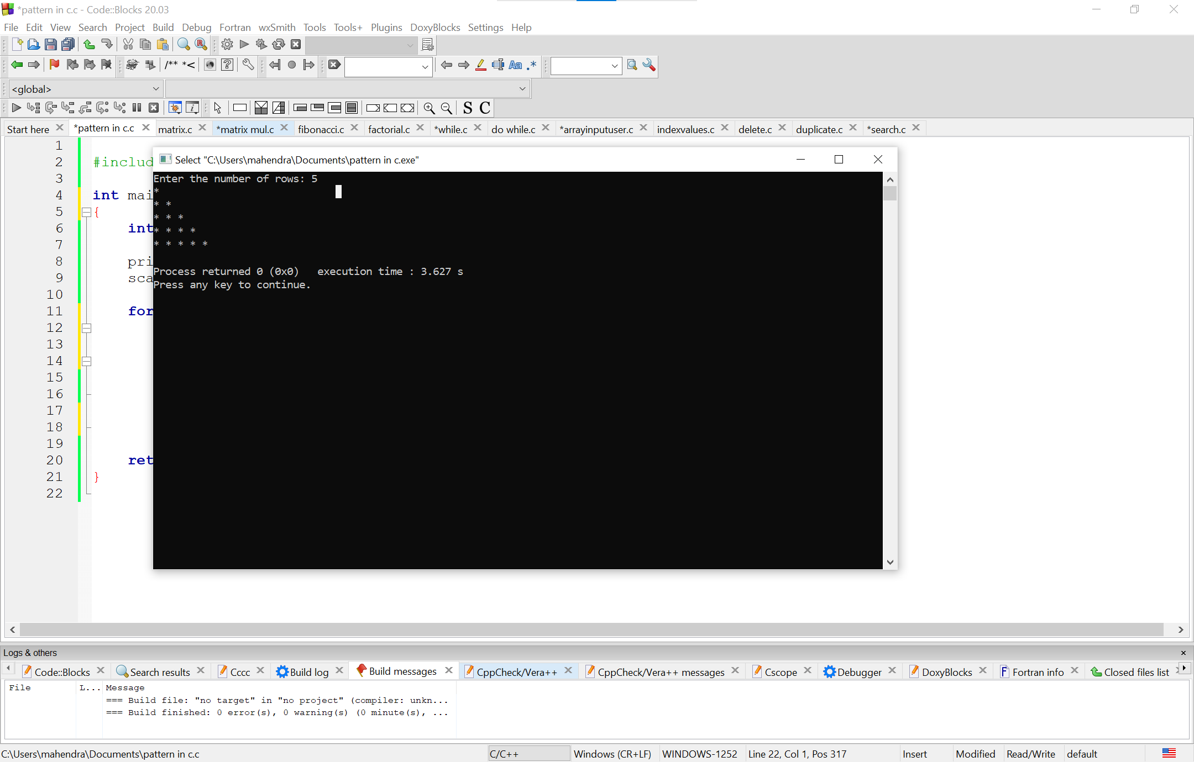

1. **Write program to print matrix multiplication in c**

**Program:**

#include<stdio.h>

#include<stdlib.h>

int main()

{

int a[5][5],b[5][5],mul[5][5],r,c,i,j,k;

system("cls");

printf("enter the number of row=");

scanf("%d",&r);

printf("enter the number of column=");

scanf("%d",&c);

printf("enter the first matrix element=\n");

for(i=0;i<r;i++)

{

for(j=0;j<c;j++)

{

scanf("%d",&a[i][j]);

}

}

printf("enter the second matrix element=\n");

for(i=0;i<r;i++)

{

for(j=0;j<c;j++)

{

scanf("%d",&b[i][j]);

}

}

printf("multiply of the matrix=\n");

for(i=0;i<r;i++)

{

for(j=0;j<c;j++)

{

mul[i][j]=0;

for(k=0;k<c;k++)

{

mul[i][j]+=a[i][k]*b[k][j];

}

}

}

for(i=0;i<r;i++)

{

for(j=0;j<c;j++)

{

printf("%d\t",mul[i][j]);

}

printf("\n");

}

return 0;

}

**Output:**

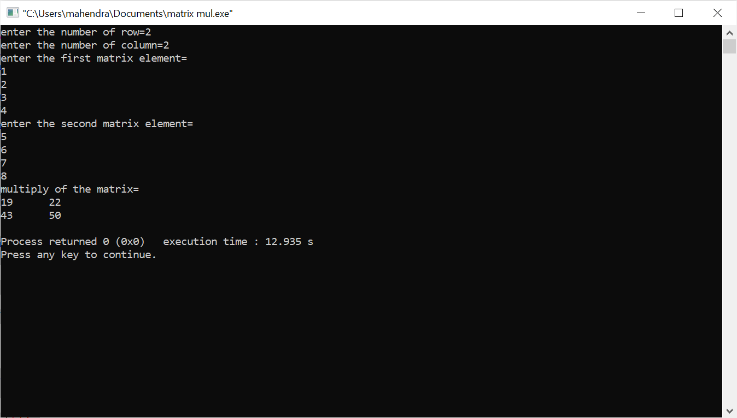

1. **write a program to print fibonacci series of a number.**

**Program:**

#include<stdio.h>

int main()

{

int n1=0,n2=1,n3,i,number;

printf("Enter the number of elements:");

scanf("%d",&number);

printf("\n%d %d",n1,n2);

for(i=2;i<number;++i)

{

n3=n1+n2;

printf(" %d",n3);

n1=n2;

n2=n3;

}

return 0;

}

**Output:**

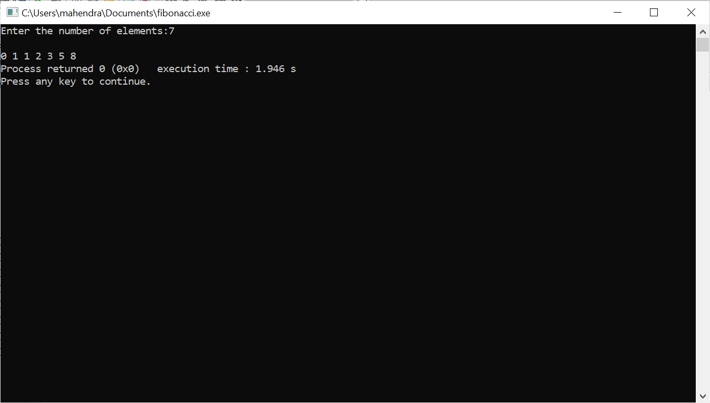

**4.write a program to print factorial of a number.**

**Program:**

#include<stdio.h>

int main()

{

int i,fact=1,number;

printf("Enter a number: ");

scanf("%d",&number);

for(i=1;i<=number;i++)

{

fact=fact*i;

if(i==1)

printf("%d",i);

else

printf("*%d\n",i);

}

printf("\n Factorial of %d is: %d\n",number,fact);

return 0;

}

**Output:**

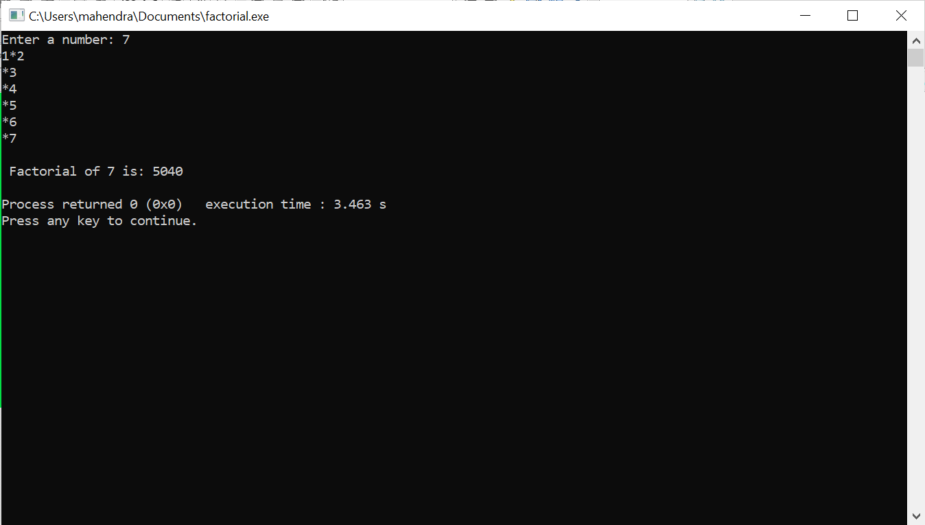

**5.Do while loop example:**

**Program:**

#include <stdio.h>

int main() {

int num, sum = 0;

do {

printf("Enter a number (enter a negative number to exit): ");

scanf("%d", &num);

if (num >= 0) {

sum += num;

}

} while (num >= 0);

printf("Sum of positive numbers entered: %d\n", sum);

return 0;

}

**Output:**

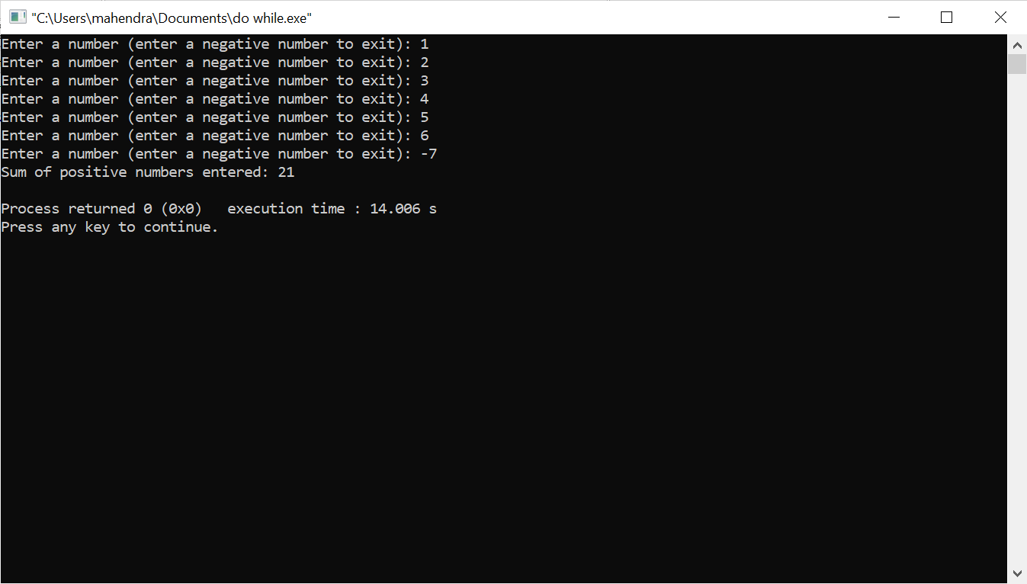

**6.write a program to print a[20] , take the input from user.**

**Program:**

#include <stdio.h>

int main() {

int a[20];

printf("Enter 20 integer values:\n");

for (int i = 0; i < 20; i++) {

printf("Enter element %d: ", i + 1);

scanf("%d", &a[i]);

}

printf("You entered:\n");

for (int i = 0; i < 20; i++) {

printf("%d ", a[i]);

}

printf("\n");

return 0;

}

**Output:**

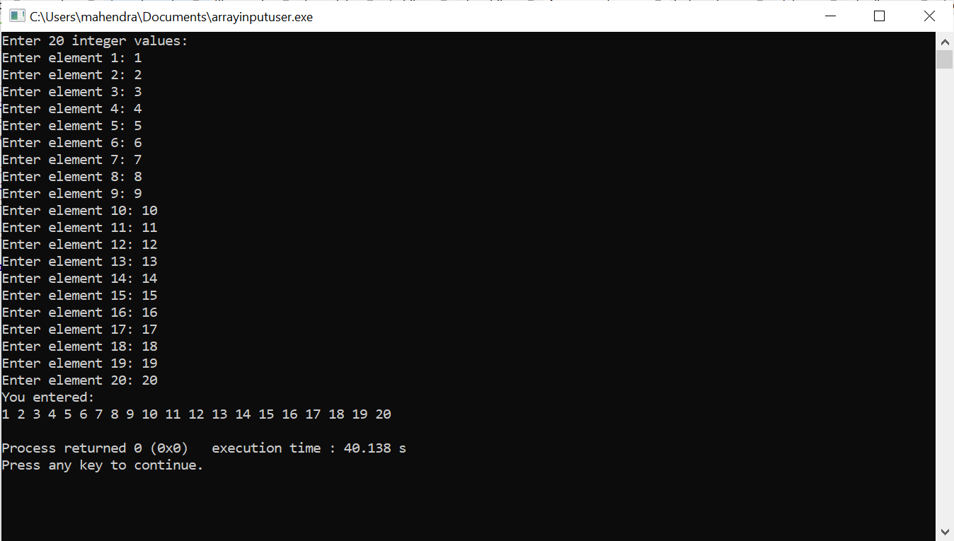

**7.write a program to print all the elements pf a[20] with their Index values**

**Program:**

#include <stdio.h>

int main() {

int a[20];

printf("Enter 20 integer values:\n");

for (int i = 0; i < 20; i++) {

printf("Enter element %d: ", i + 1);

scanf("%d", &a[i]);

}

printf("Index\tValue\n");

for (int i = 0; i < 20; i++) {

printf("%d\t%d\n", i, a[i]);

}

return 0;

}

**Output:**

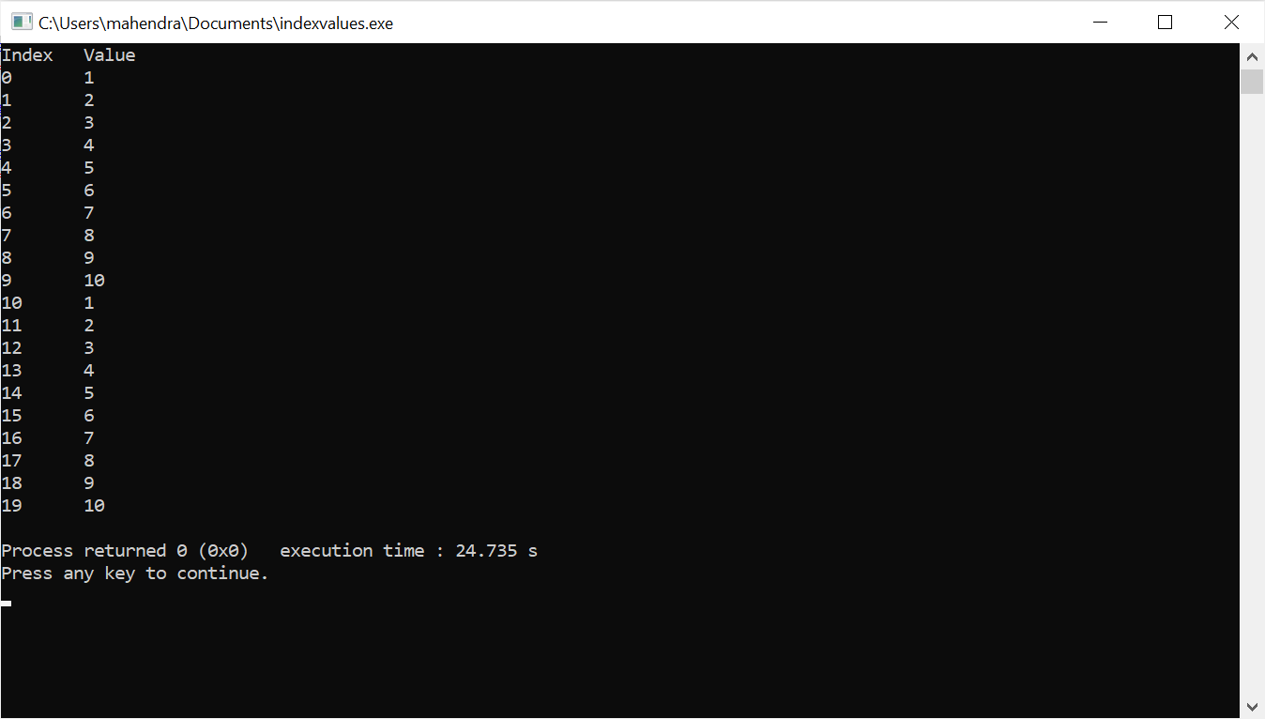

**8.write a program to print Delete a particular elemenet from an array, a[15]**

**Program:**

#include <stdio.h>

int main() {

int a[15] = {1, 2, 3, 4, 5, 6, 7, 8, 9, 10, 11, 12, 13, 14, 15};

int delete_index;

int i, j;

printf("Enter the index of the element you want to delete (0 to 14): ");

scanf("%d", &delete_index);

if (delete_index < 0 || delete_index >= 15) {

printf("Invalid index!\n");

return 1;

}

for (i = delete_index; i < 14; i++) {

a[i] = a[i + 1];

}

a[14] = 0;

printf("Array after deleting element at index %d:\n", delete_index);

for (i = 0; i < 15; i++) {

printf("%d ", a[i]);

}

return 0;

}

**Output:**

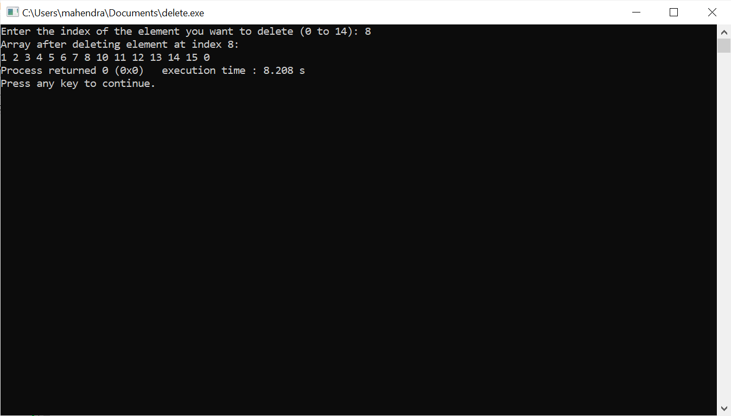

**9.write a program to print Find if there s any duplicates in a[20]**

**Program:**

#include <stdio.h>

int main() {

int a[20];

int i, j;

int found = 0;

printf("Enter 20 elements for the array:\n");

for (i = 0; i < 20; i++) {

scanf("%d", &a[i]);

}

for (i = 0; i < 20; i++) {

for (j = i + 1; j < 20; j++) {

if (a[i] == a[j]) {

found = 1;

printf("Duplicate found: %d\n", a[i]);

}

}

}

if (!found) {

printf("No duplicates found.\n");

}

return 0;

}

**Output:**

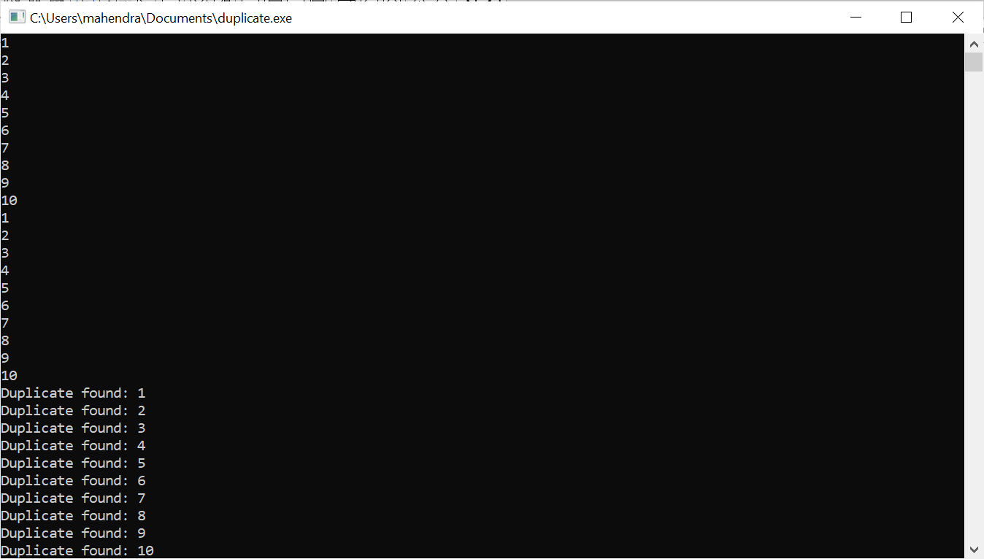

**10.write a program to print search [10] from a[20].**

**Program:**

#include <stdio.h>

}

for (i = 0; i < 20; i++) {

if (a[i] == search_value) {

found = 1;

printf("Value %d found at index %d.\n", search_value, i);

break;

}

}

if (!found) {

printf("Value %d not found in the array.\n", search_value);

}

return 0;

}

**Output:**

