Report (Reactive Web flux - FlightApp)

Static Code Analysis (SonarQube):
SonarQube issues: (BEFORE)
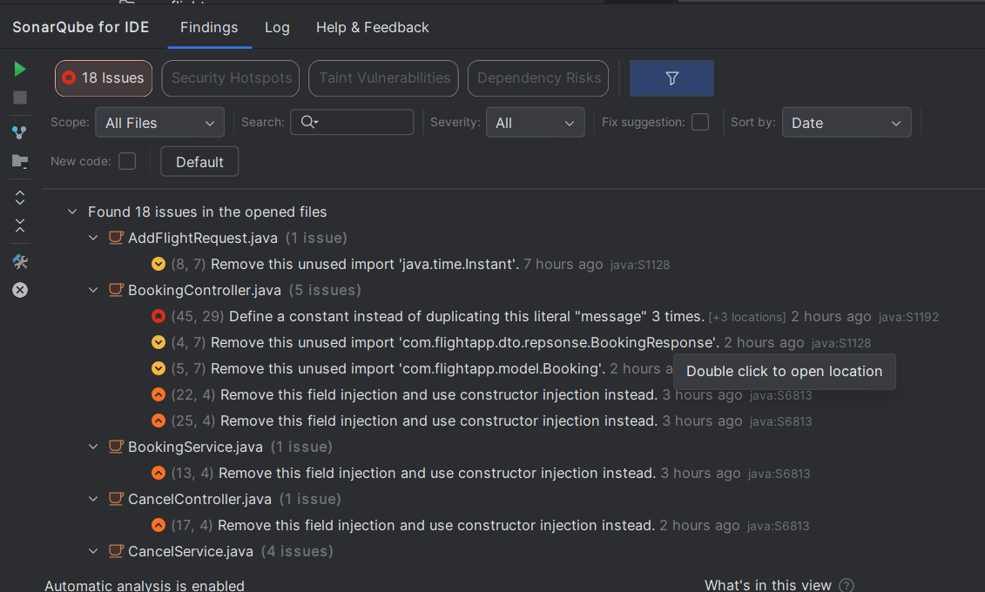

After solving:

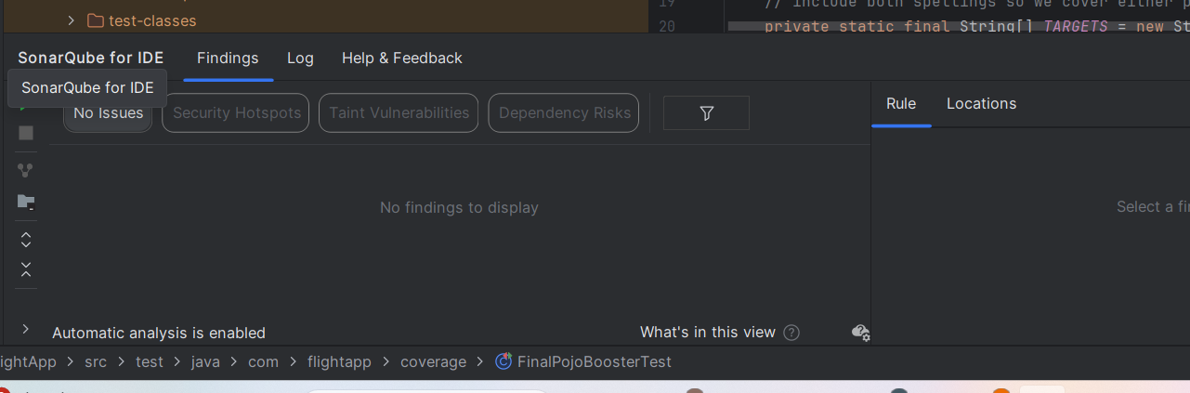
Code coverage (Jacoco): Approximately 80%

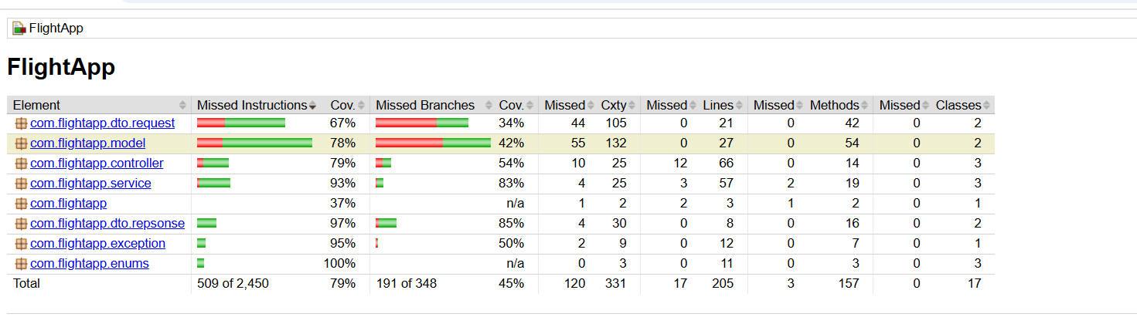

Sonar Cloud Report:

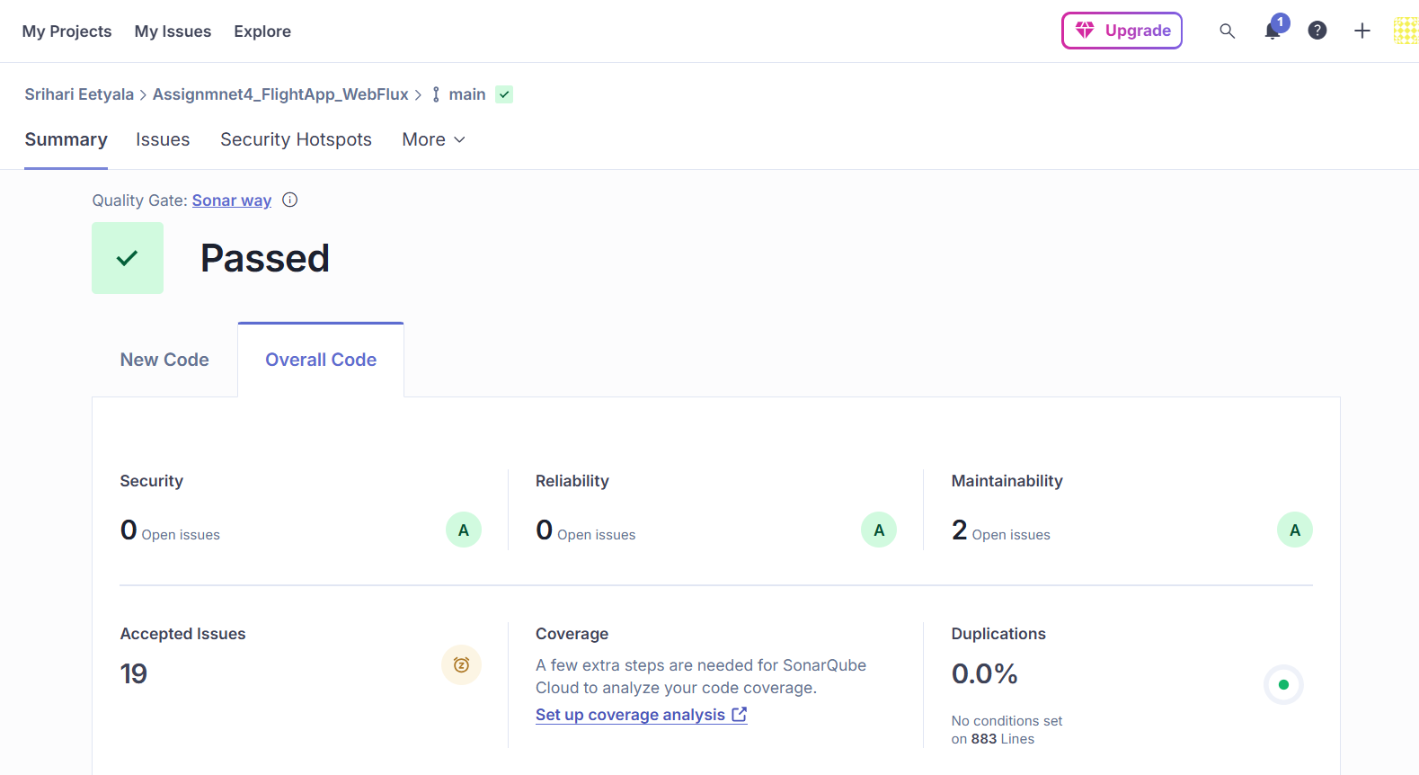

JMeter Report:
1 thread
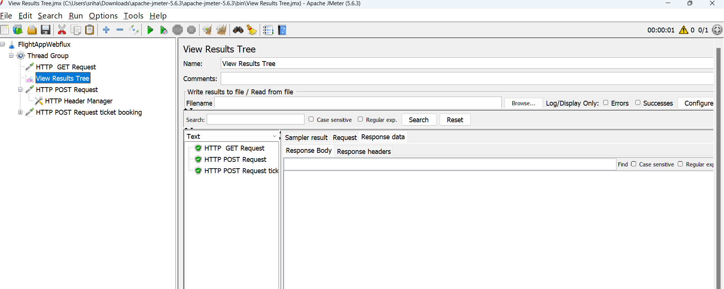

10 threads
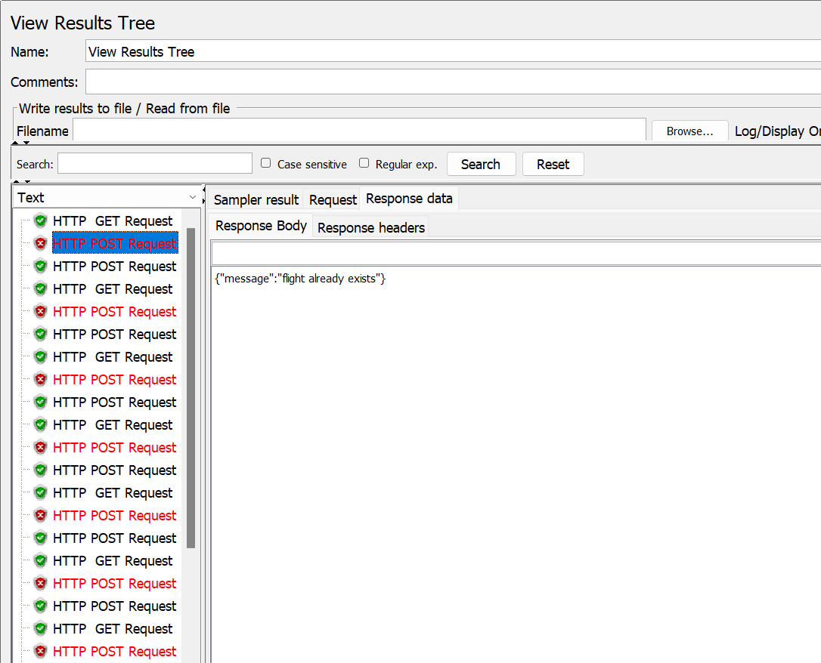
The POST request for adding a flight to the inventory is failing because we are sending only a single data object in the request body. As a result, the system returns an error with the message ‘Flight already exists.

Summaries (10 threads)
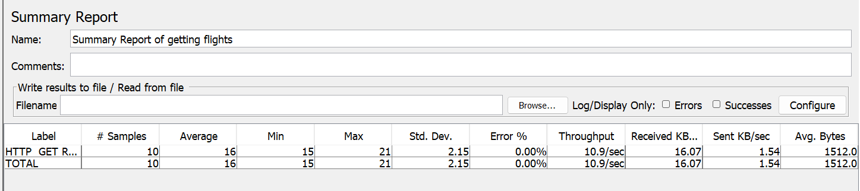

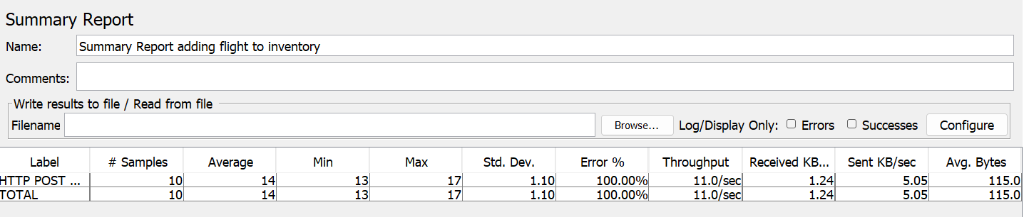
*errors because of the test case we have put for duplicate flights.

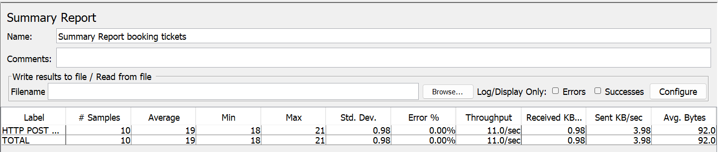

50 threads:
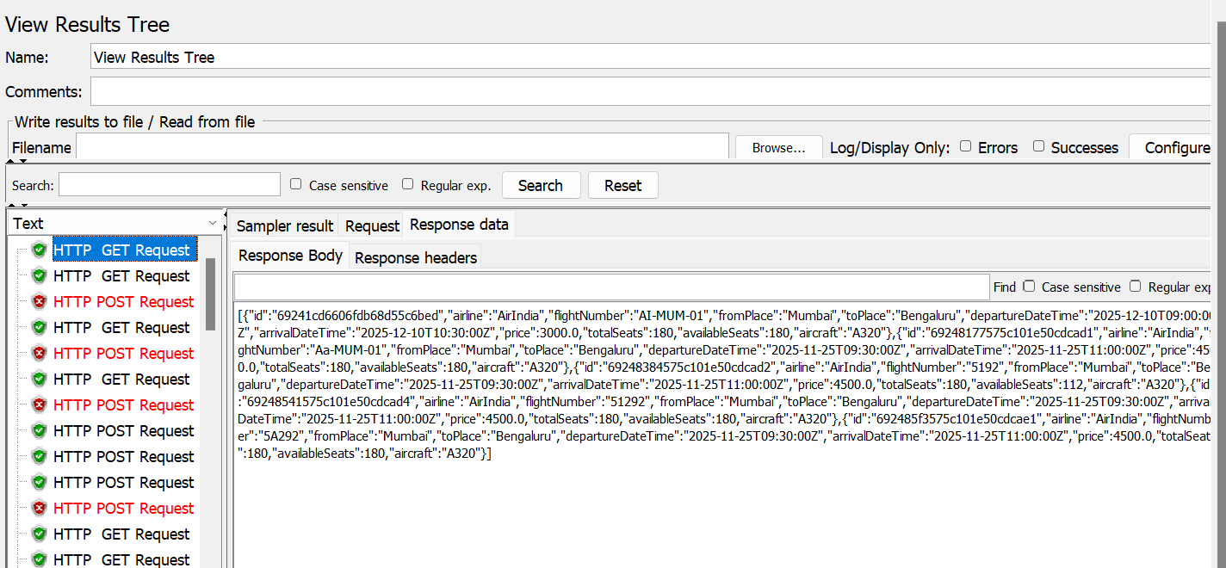
Post error because of the duplicity test case
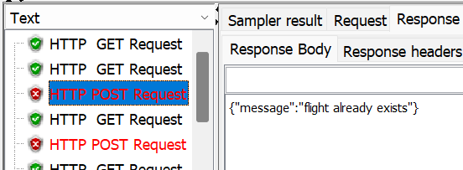

Post generating PNR after booking
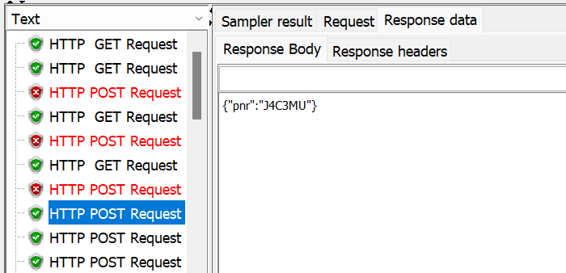
Summaries:
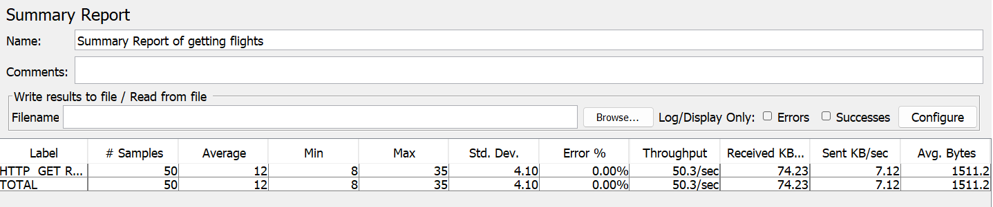

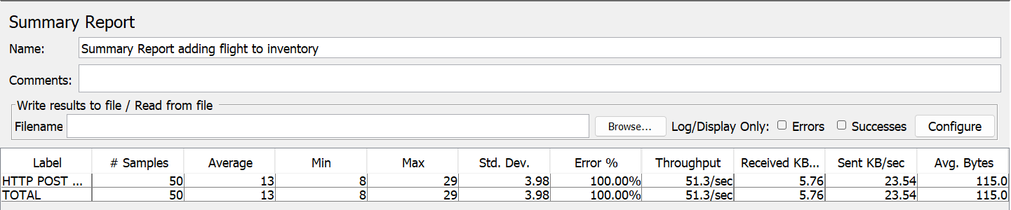
*errors because of the test case we have put for duplicate flights.

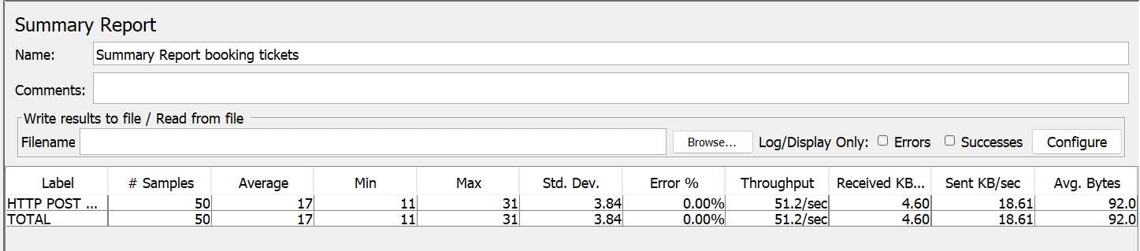

100 threads:
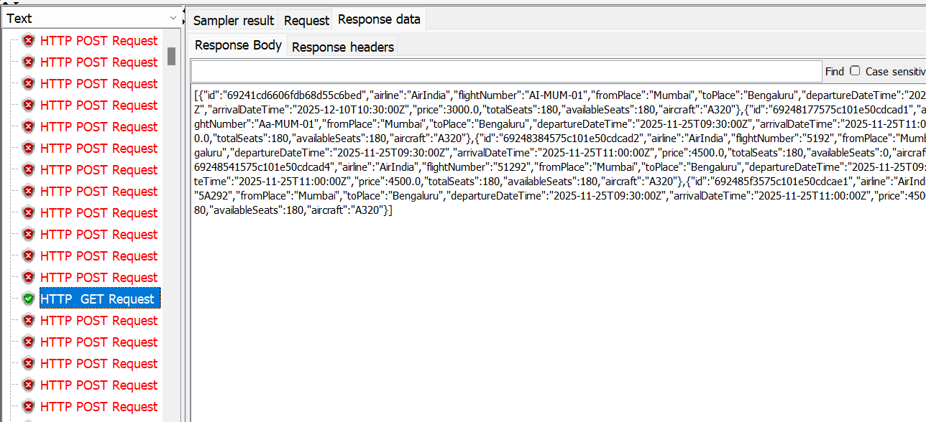
Post error because of the duplicity test case
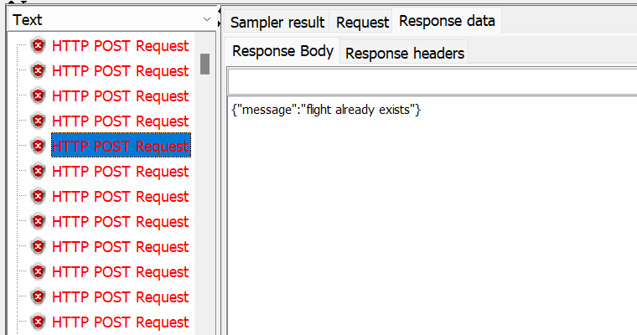

Post error because of the “not enough seats” test case
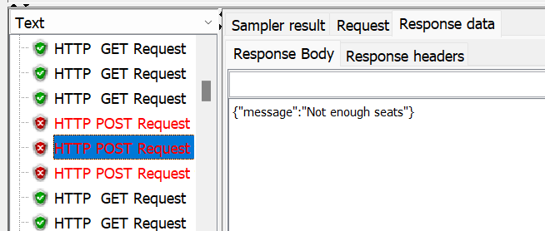

Summaries:
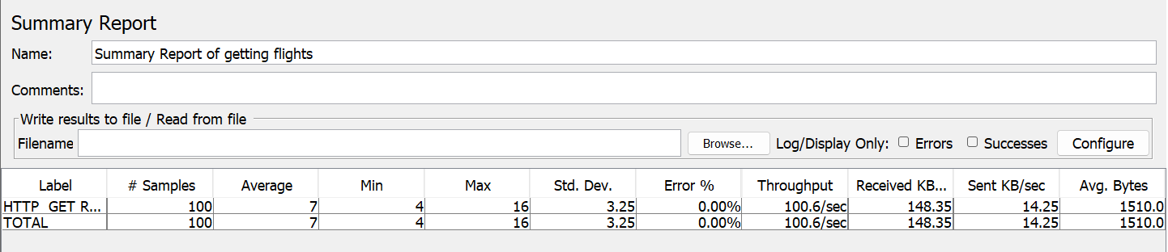

*errors because of the test case we have put for duplicate flights.
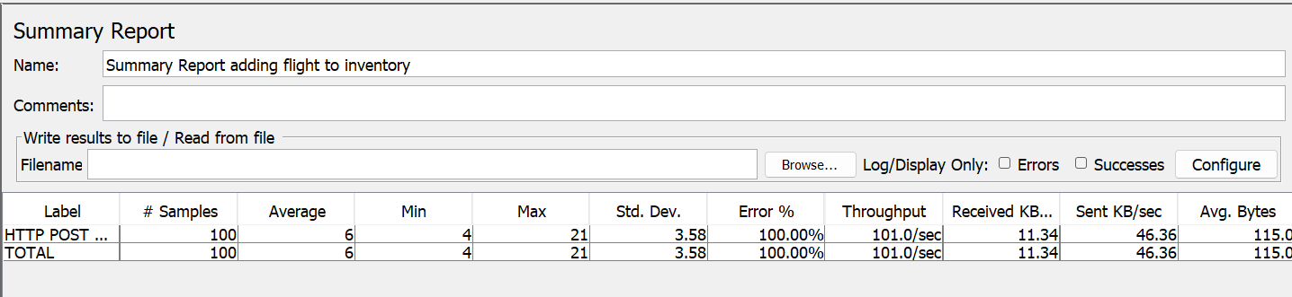

*errors because of the test case we have put for seats Availability.
