Assignment 8
(RBAC-Role Based Access Control)
1. RBAC (Role-Based Access Control)
- Only ADMIN role can add flights
- Frontend hides Add Flight button for regular users
- Backend checks user role before adding flight
- USER role can only view and book flights
ADMIN-SIGNUP:
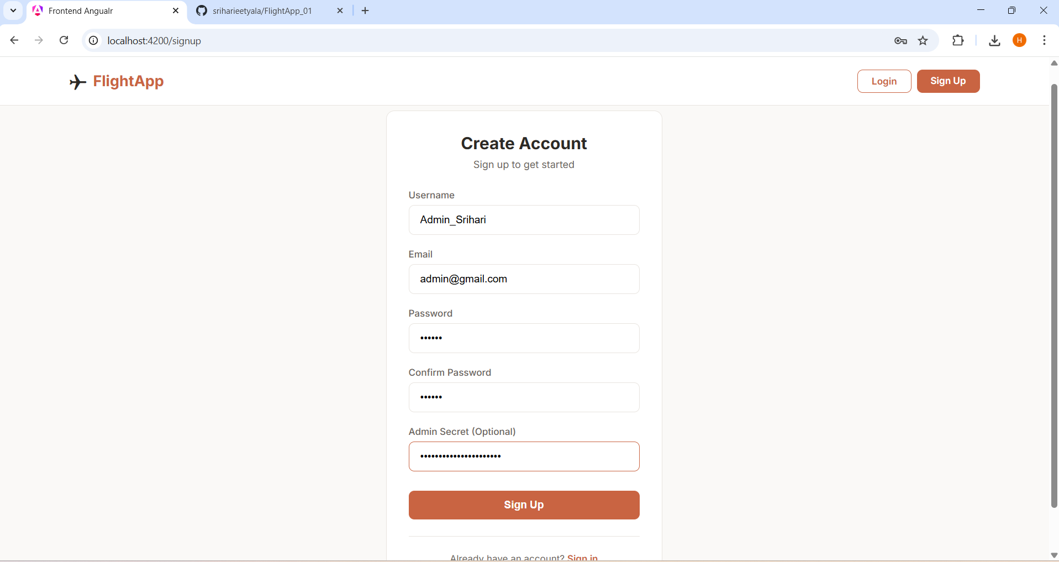

- During signup, user can provide an admin secret
- If admin secret is correct → role is set as ADMIN in database
- If admin secret is missing or wrong → role is set as USER (default)

INSIDE DATABASE:
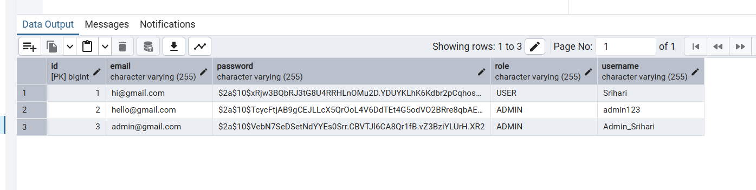

AFTER LOGIN AS AN ADMIN:
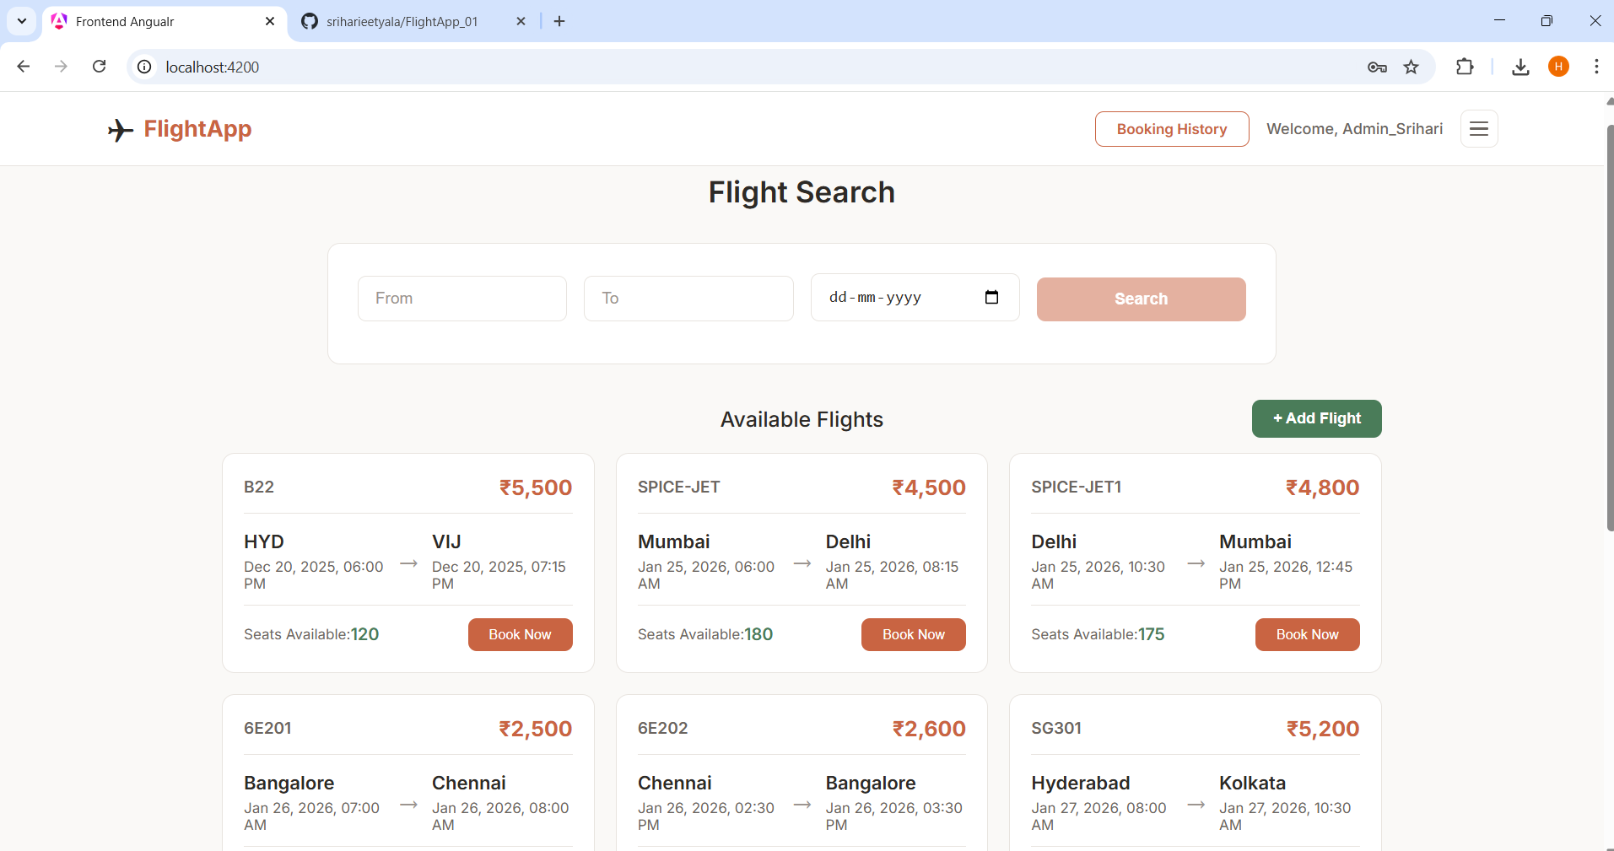

USER:
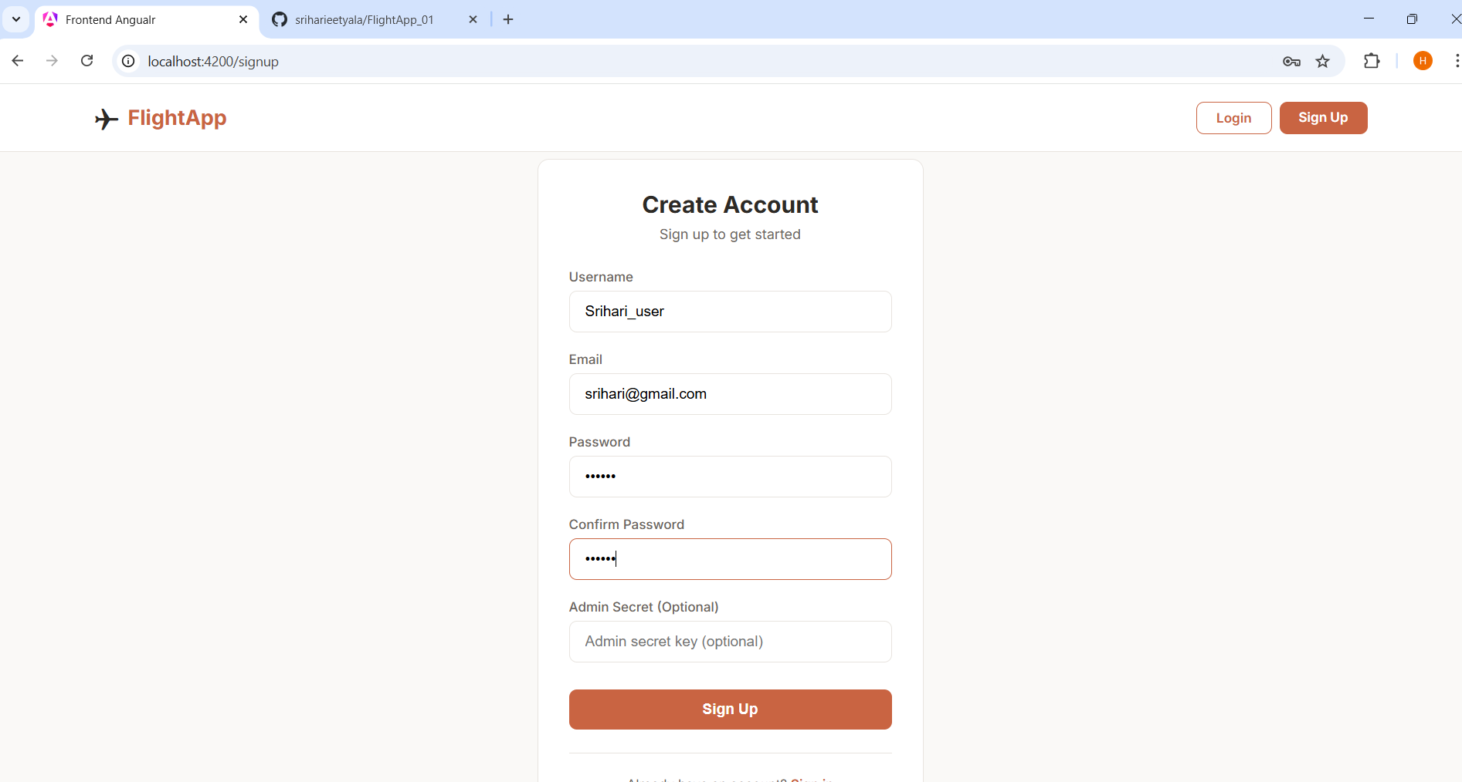

- If missing/wrong → USER role (default)

INSIDE DATABASE:
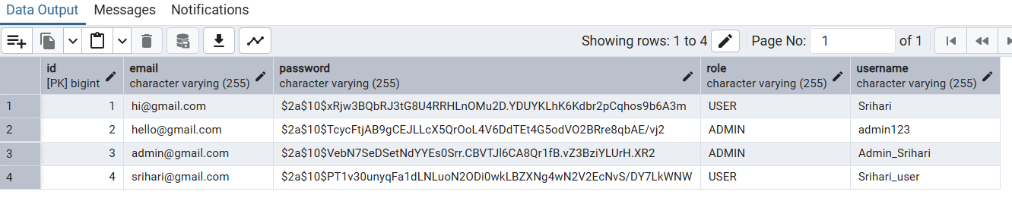

AFTER LOGIN AS AN USER:

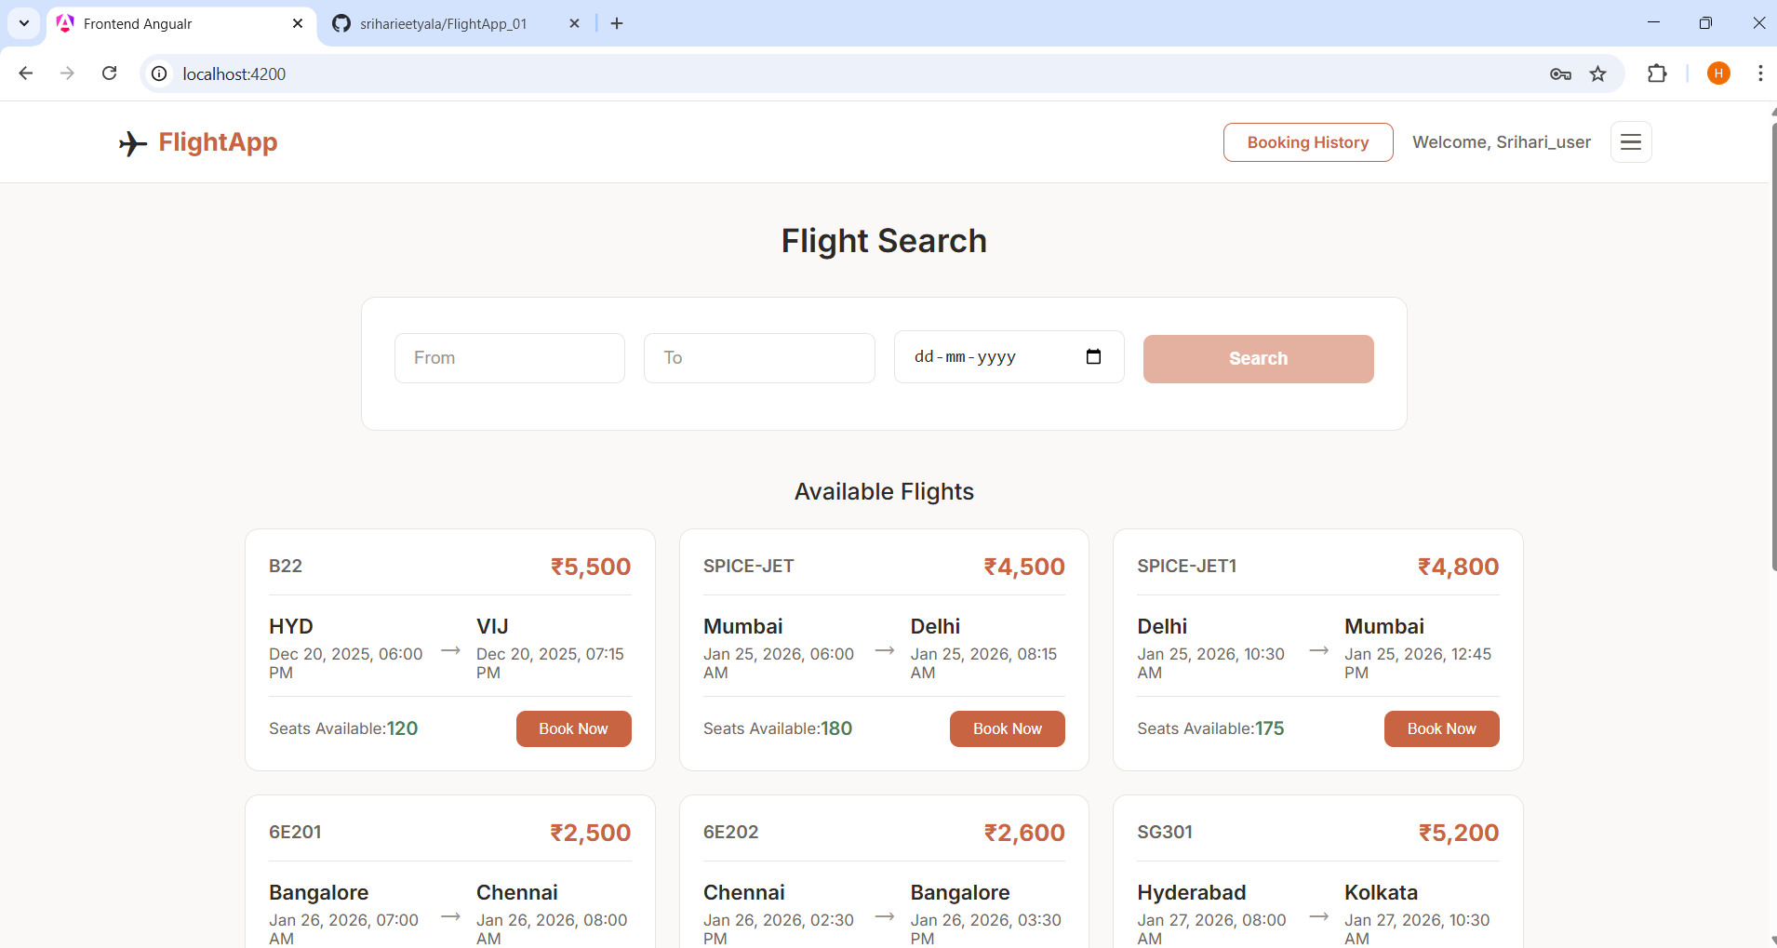

- Only ADMIN role can add flights
- Frontend hides Add Flight button for regular users
- Backend checks user role before adding flight
- USER role can only view and book flights

ADDING FLIGHTS (Only possible if the role is ADMIN)

  - Created Add Flight page for admins
  - Form to enter flight details (source, destination, date, price, seats)
  - Submits to POST /flights API
  - Redirects to dashboard on success

- Add flight button is only visible if the role is ADMIN
- Frontend hides Add Flight button for regular

Form to fill the details to add flights:
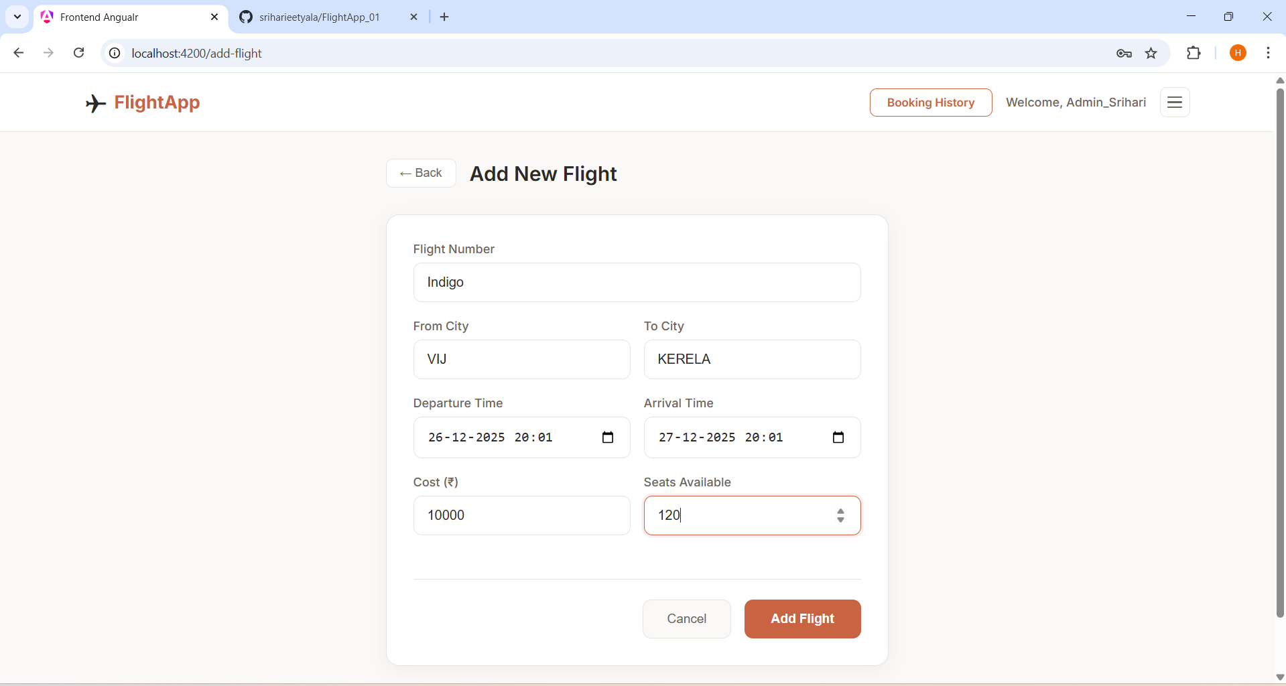

Successfully added into the dashboard:

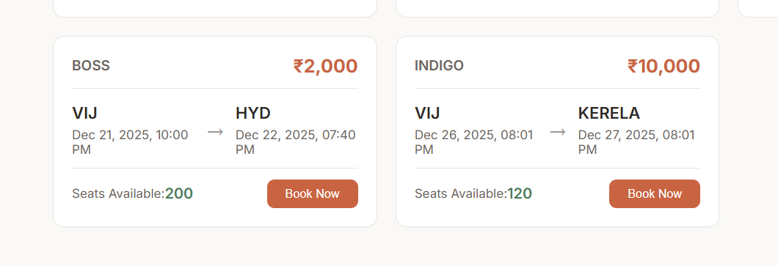

Validations implemented:
Field / Validation Type | Rule
Flight Number | Cannot be empty
From City | Cannot be empty
To City | Cannot be empty
Departure Time | Must be selected (minimum = current time)
Arrival Time | Must be selected
Cost | Must be greater than 0
Seats Available | Must be greater than 0
From City & To City | Cannot be the same city
Flight Number (on submit) | Converted to UPPERCASE
City Names (on submit) | Converted to UPPERCASE
Duplicate Flight Number | Show error: "Flight number already exists"

THIS IS AN EXAMPLE VALIDATION WHERE I DID NOT PROVIDE THE PRICE AND THE ADD BUTTON IS DISABLED.

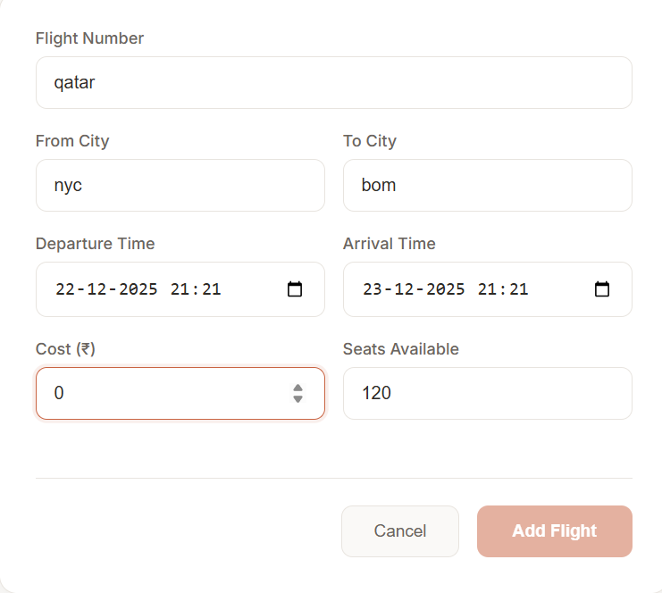
Change Password Feature:
Backend (API)
  - New API endpoint: PUT /auth/change-password
  - Request body: { currentPassword, newPassword }
  - Username received via X-User-Name header
  - Created ChangePasswordRequest DTO

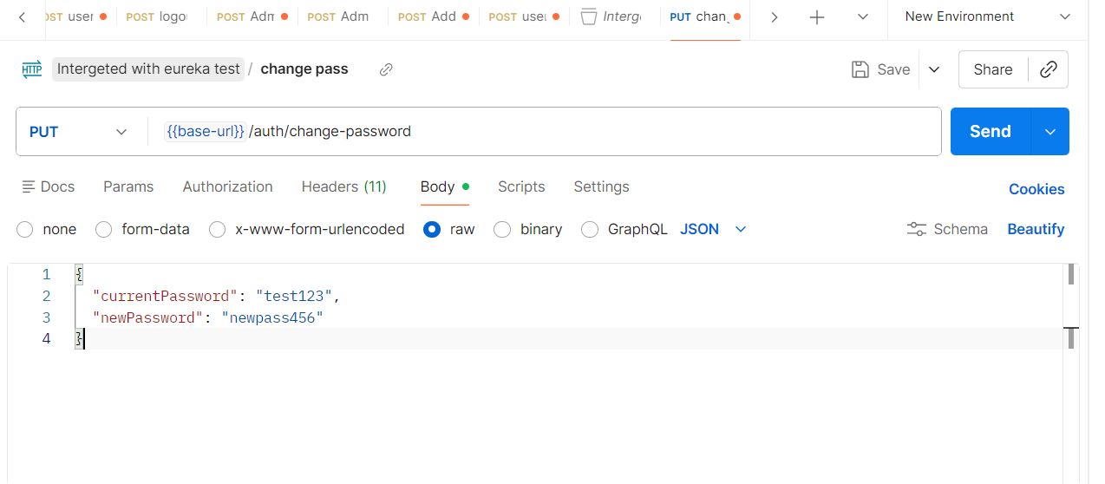

Frontend (UI)
  - New page at /change-password route
  - Form with 3 fields: current password, new password, confirm password
  - Real-time validation errors shown below fields
  - Redirects to home page after success

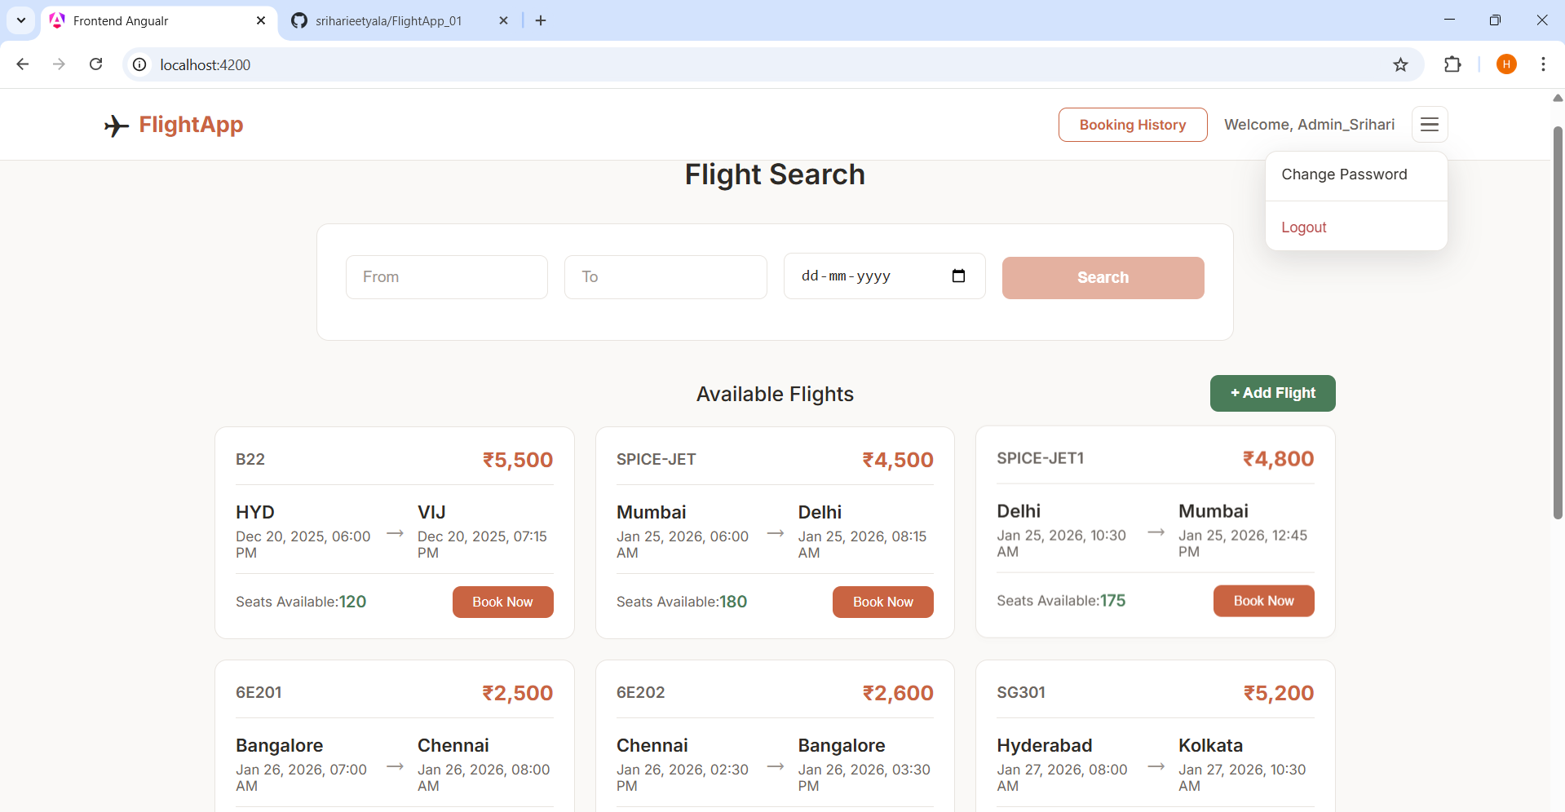

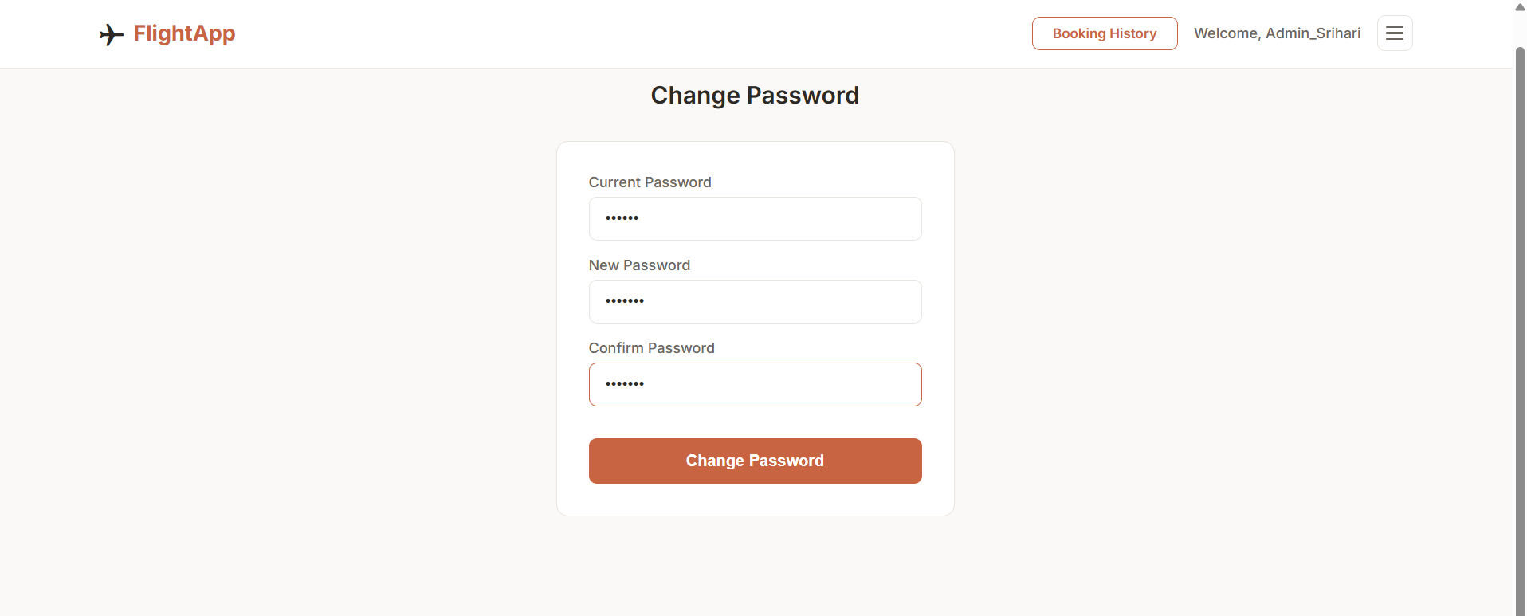

Spring Profiles (Two Properties Files):
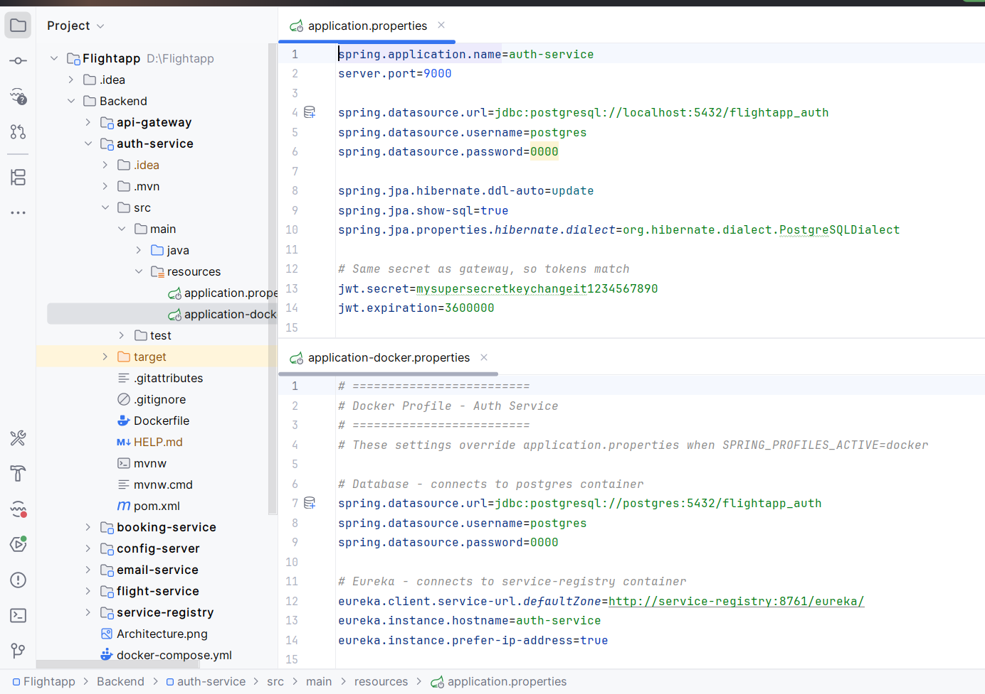
Note: Profile configuration is applied to all microservices. Screenshot shown is for auth-service as reference

Files
- application.properties → default profile (local)
- application-docker.properties → docker profile
How It Works
- Docker Compose sets SPRING_PROFILES_ACTIVE=docker
- Spring Boot loads application-docker.properties
- Overrides values from application.properties
- Container names used instead of localhost

Dockerfile Optimization:
Before (Two-Stage Build):
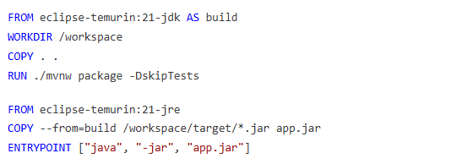

After (Single-Stage with Pre-built JAR):
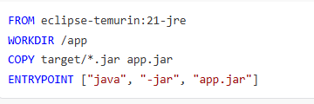

Benefits I found using this approach:
- Faster build time (JAR built locally, not inside container)
- Smaller image size (no JDK, only JRE)
- Simpler Dockerfile (7 lines vs 17 lines)

SWOT Analysis of my FlightApp
Strengths
- Built with microservices so each part can be updated separately
- Role-based access keeps admin features secure
- Passwords are encrypted, not stored in plain text
- Docker makes it easy to run anywhere
- Spring profiles let us switch between local and production easily
Weaknesses
- No forgot password or email reset option yet
- Flight search could be more advanced (filters, sorting)
- No payment integration for bookings
- Frontend has limited error handling in some places
Opportunities
- Advanced search with filters like price range, airlines, stops
- Forgot password feature using email verification
- Add seat selection during booking

Threats
- No rate limiting means possible spam or brute force attacks
- Hardcoded secrets (JWT secret, admin secret) in properties files
- No logging for failed login attempts (can't detect attacks)
- No seat locking during booking could cause double booking

