FlightApp – Full Stack Flight Booking Application

1. Project Overview
FlightApp is a full-stack flight booking application developed with an Angular frontend and a Spring Boot microservices backend.

2. Backend Usage
The backend used in this project is reused from the previous assignment.
No changes were made to the existing backend logic or microservice functionality.

3. Docker Port Reconfiguration
Service Name | Container Port | Host Port
PostgreSQL | 5432 | 5433
Config Server | 8888 | 9888
Eureka Server | 8761 | 9761
API Gateway | 8080 | 8080
Auth Service | 9000 | 9900
Flight Service | 8081 | 9081
Booking Service | 8082 | 9082
Email Service | 8085 | 9085

4. APIs Used by Frontend (via API Gateway)
All frontend requests are routed through:
http://localhost:8080

Authentication APIs
Frontend Feature | API Endpoint | Method
Signup | /auth/signup | POST
Login | /auth/login | POST

- USER role assigned by default
- ADMIN role requires a valid admin secret key

Flight APIs
Frontend Feature | API Endpoint | Method
Dashboard (All Flights) | /flight-service/flights | GET
Search Flights | /flight-service/flights/search | POST

5. Frontend Implementation
Technologies Used
- Angular 20
- TypeScript
- HTML
- CSS
- Angular HttpClient
- HTTP Interceptors

6. Frontend Pages & Flow

Dashboard
- URL: http://localhost:4200/dashboard
- API Call: GET /flight-service/flights
- Displays all available flights
- Accessible without login

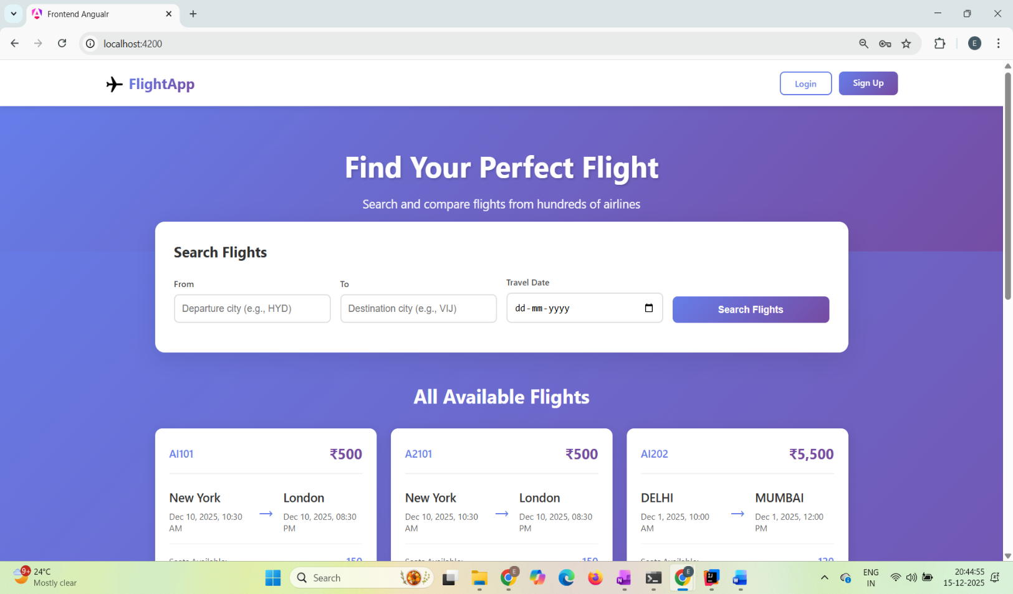

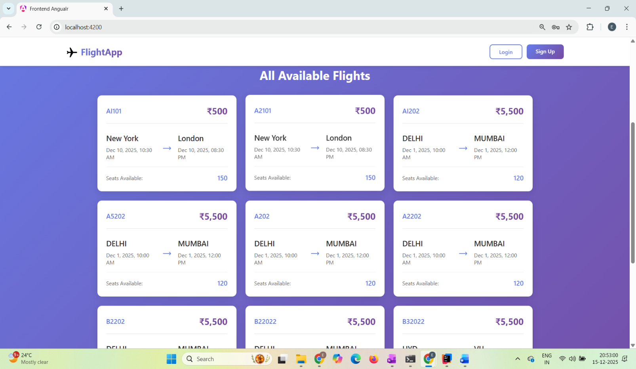

Fghx

Flight Search

- Search by source, destination, and date
- URL: http://localhost:4200/dashboard
- API Call: POST /flight-service/flights/search
- Displays matching results dynamically
- Shows “No flights found” if no data exists

Displaying flights that are requested:
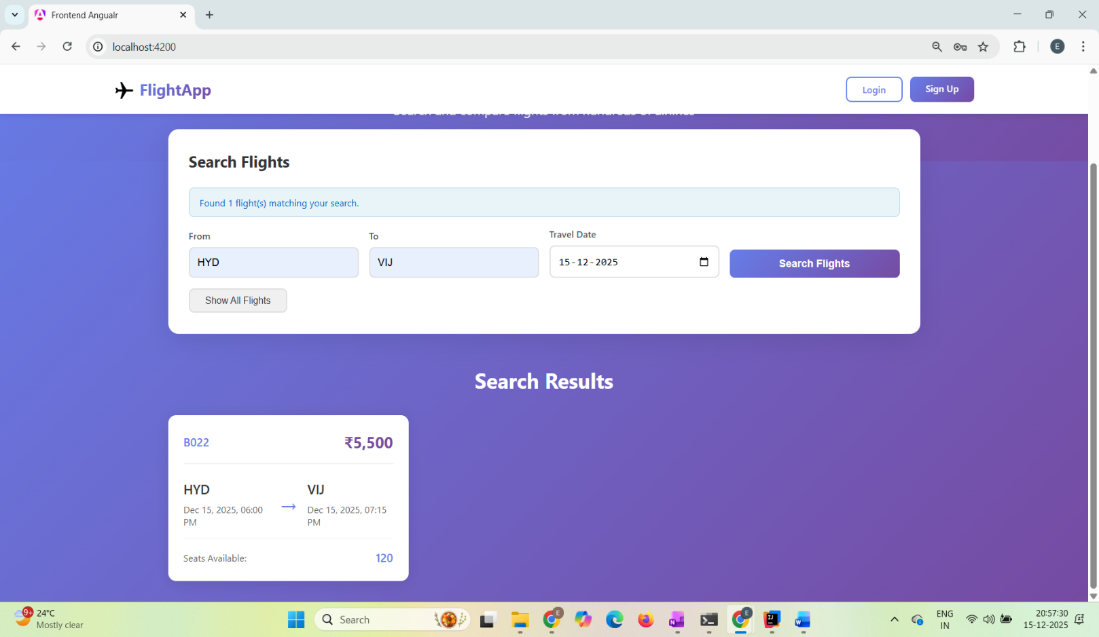

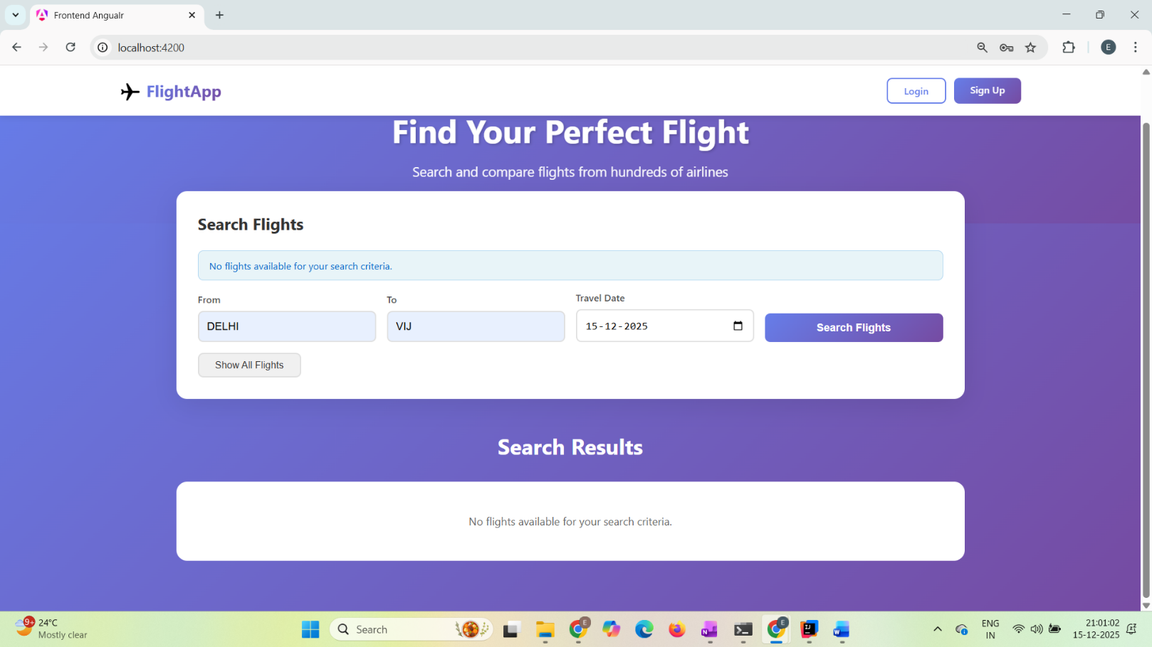
If there is no flights that matches the search conditions:

Signup
- URL: http://localhost:4200/signup
- API Call: POST /auth/signup
- Validated registration form
- Redirects to login on success

If the signup form does not receive valid inputs, the user is prompted to fill in the required details.

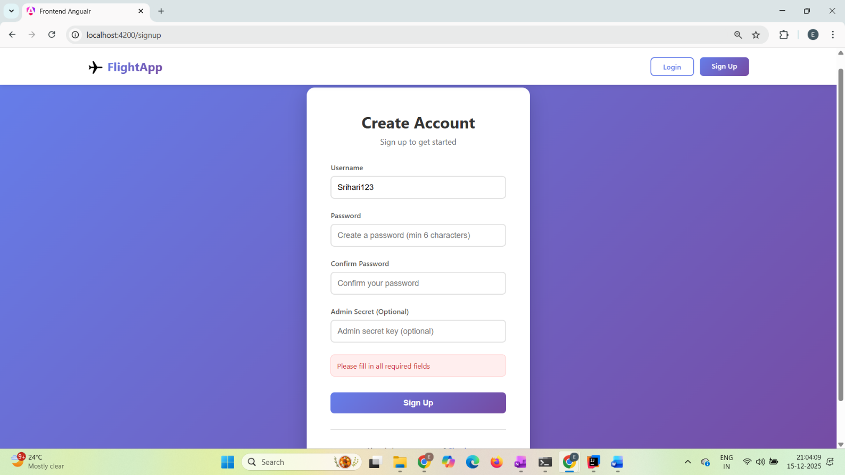

On successful registration, a success message is displayed and the user is redirected to the login page.

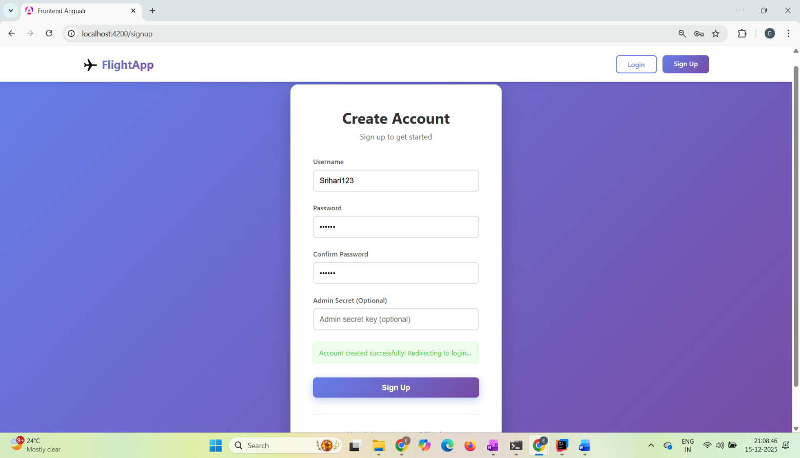

Login
- URL: http://localhost:4200/login
- API Call: POST /auth/login
- On success:
  - JWT token received
  - Redirects to dashboard
  - Username displayed in header

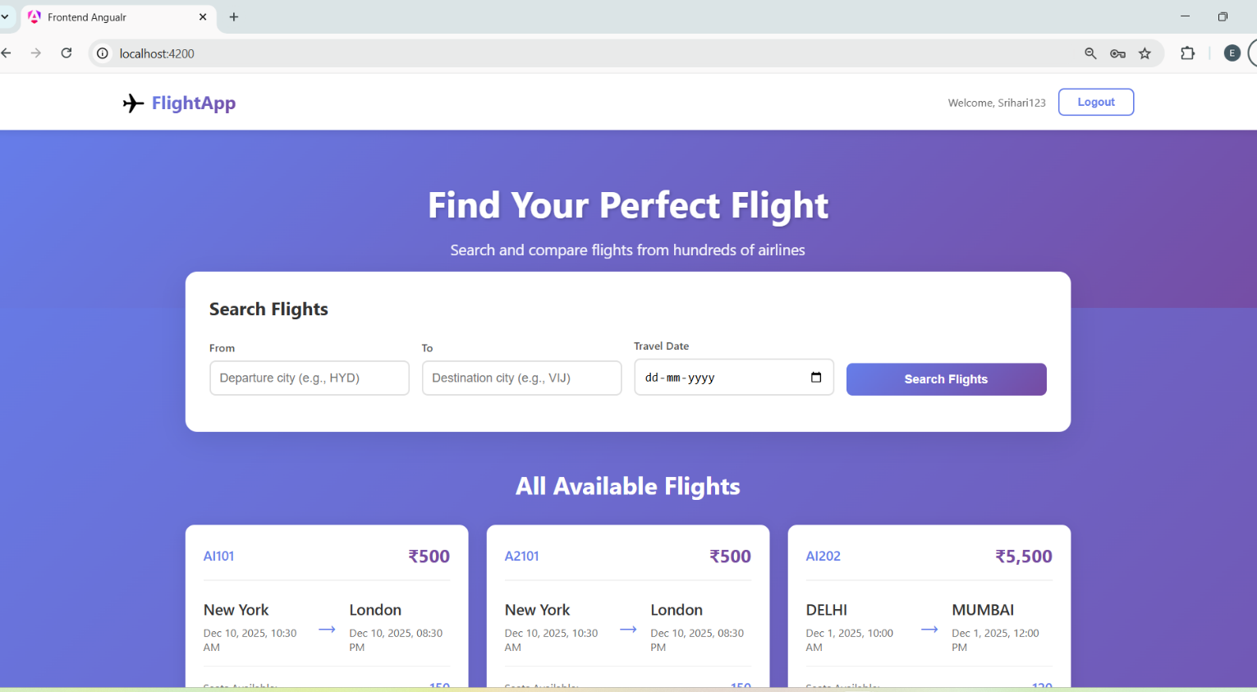
Successful login:

Unsuccessful login:
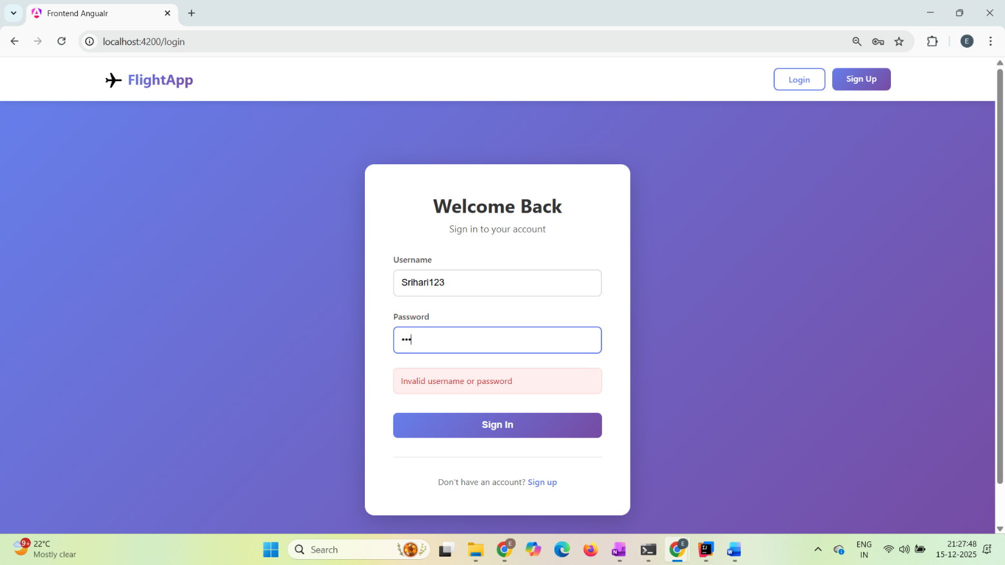

Logout
- Clears JWT and user data from localStorage
- Returns application to public state

7. JWT Handling (Frontend)
- JWT token stored in localStorage
- HTTP Interceptor automatically attaches:
- Authorization: Bearer <token>
- Public APIs remain unaffected
- Token expiry handled by re-login

8. Conclusion
- Backend reused from previous assignment
- Docker ports reconfigured using Docker Compose
- Angular frontend fully implemented
- Secure JWT-based communication via API Gateway
- Clear frontend-to-backend integration

