Newman cli testing and JMeter Testing :

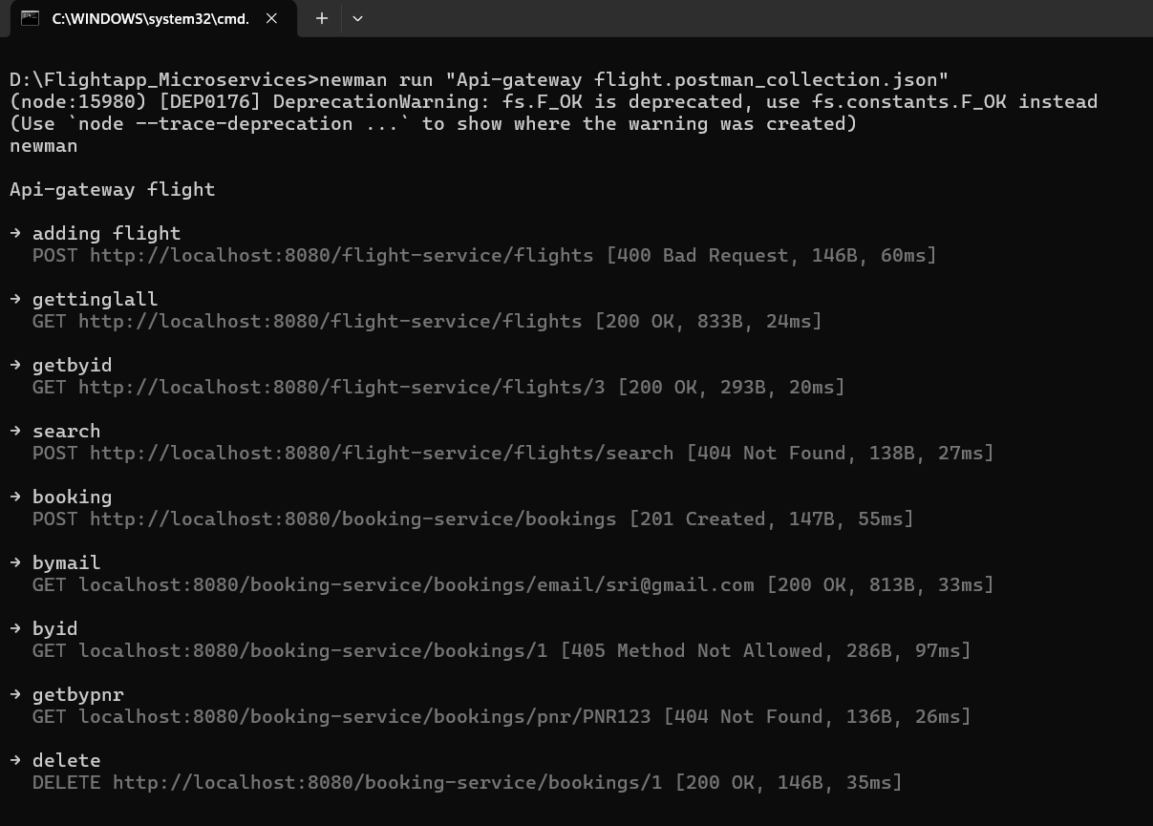
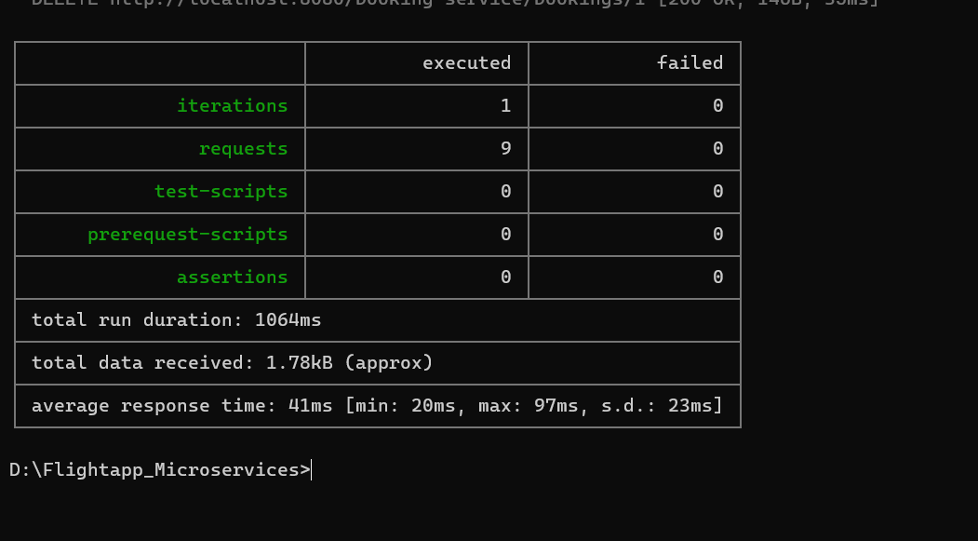
*Every request mapping executed and none failed.
Jmeter testing :
5 threads:

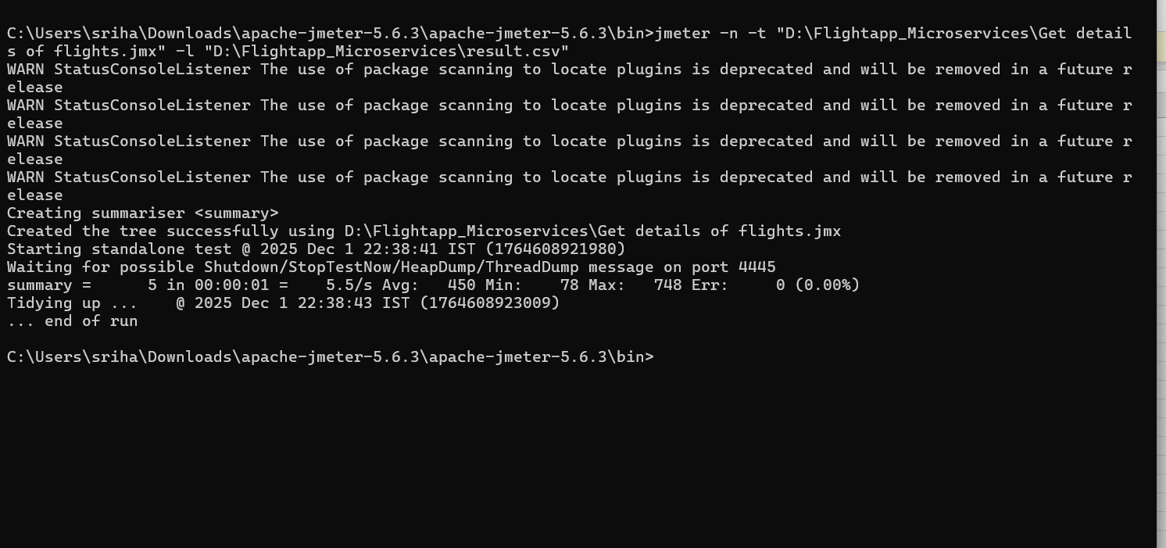

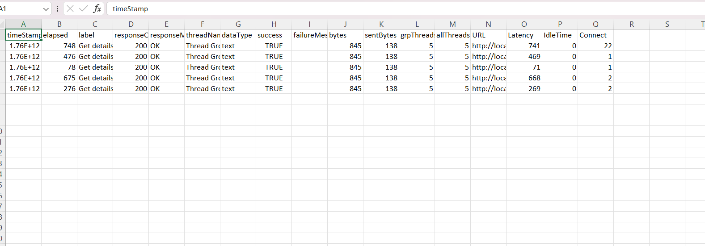

*Everything is success since it’s a get service

50 threads:
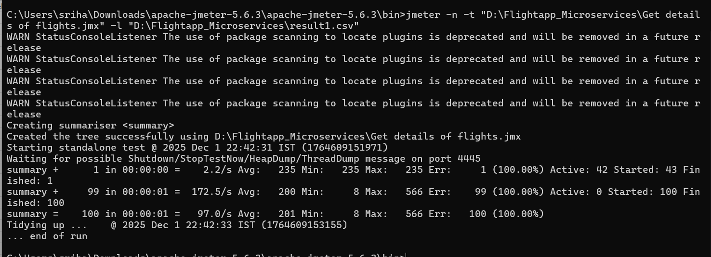

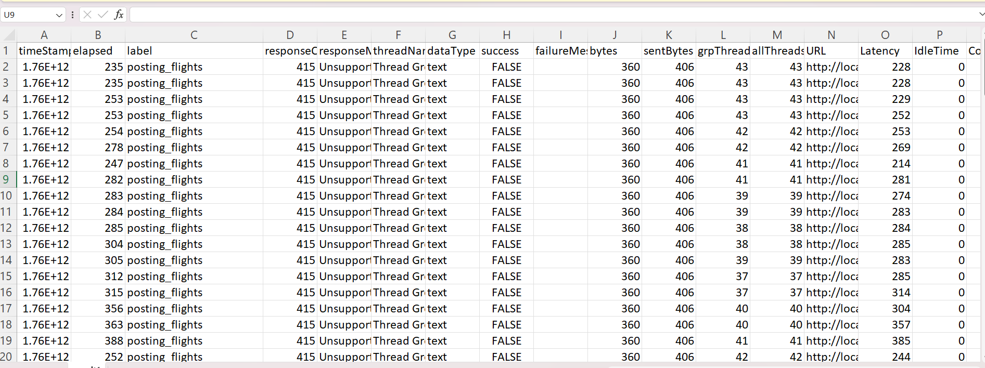

*The success flag shows false because the POST request is being sent repeatedly with the same request body across 50 threads.

