FlightApp – Microservices
The architecture:
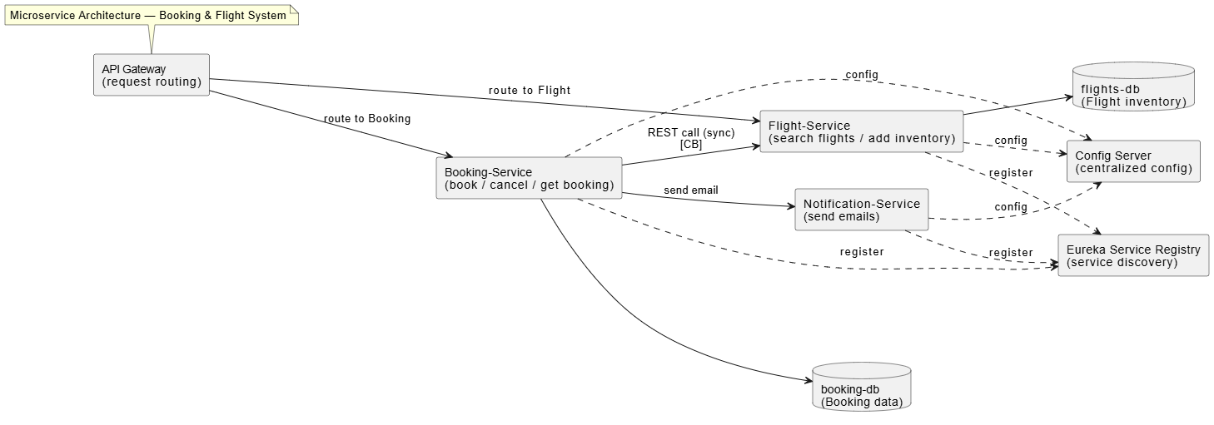

I have worked with RabbitMQ as the message broker in my application.

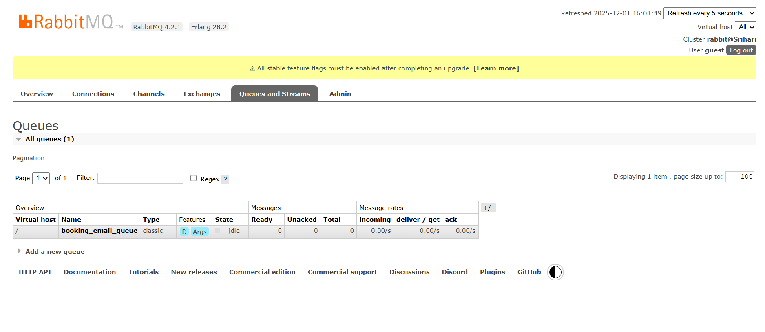
- I used Mailtrap as the email service since committing my code to Git would expose the application password. This third-party tool helps avoid any risk of credential leakage.

Here is the mail that I sent after successful submission:
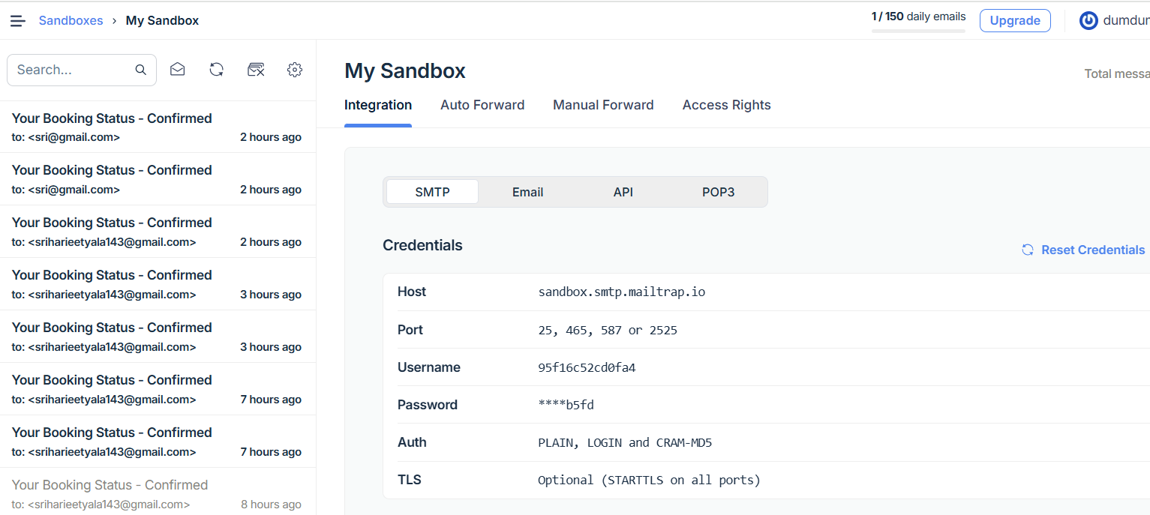

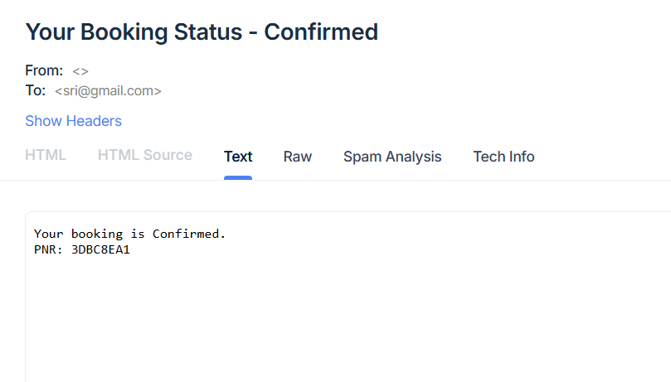

NEWMAN CLI API TESTING:

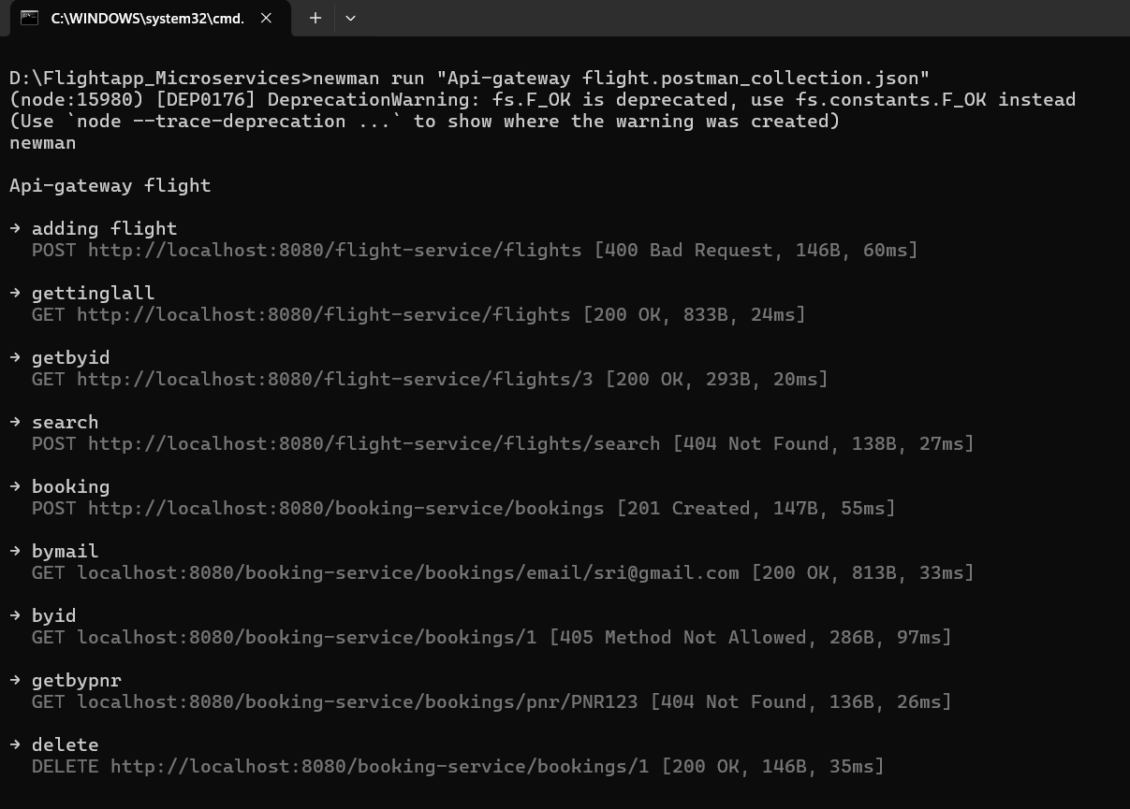
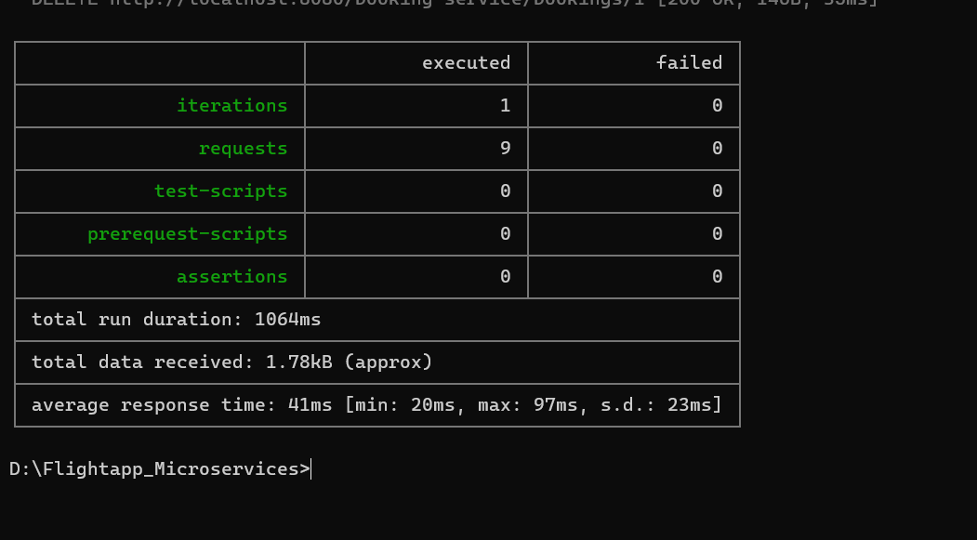

*Every request generated the a valid response given valid json

These are the components I have implemented in the application:

SERVICE-REGISTRY(EUREKA):

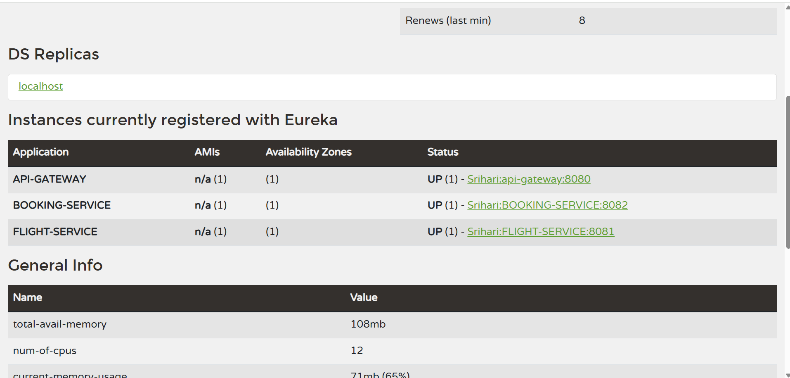
All the services are registered with Eureka, including multiple instances.

Multiple instance:

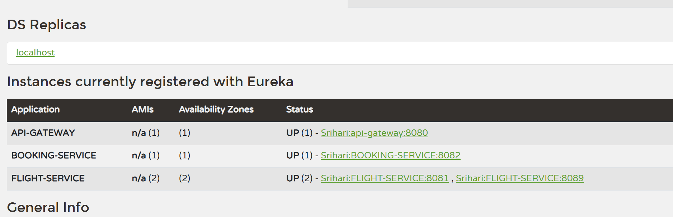

The API Gateway:
The API Gateway is configured to route all service requests through port 8080.
Localhost:8080 for all the services with a new mapping variable
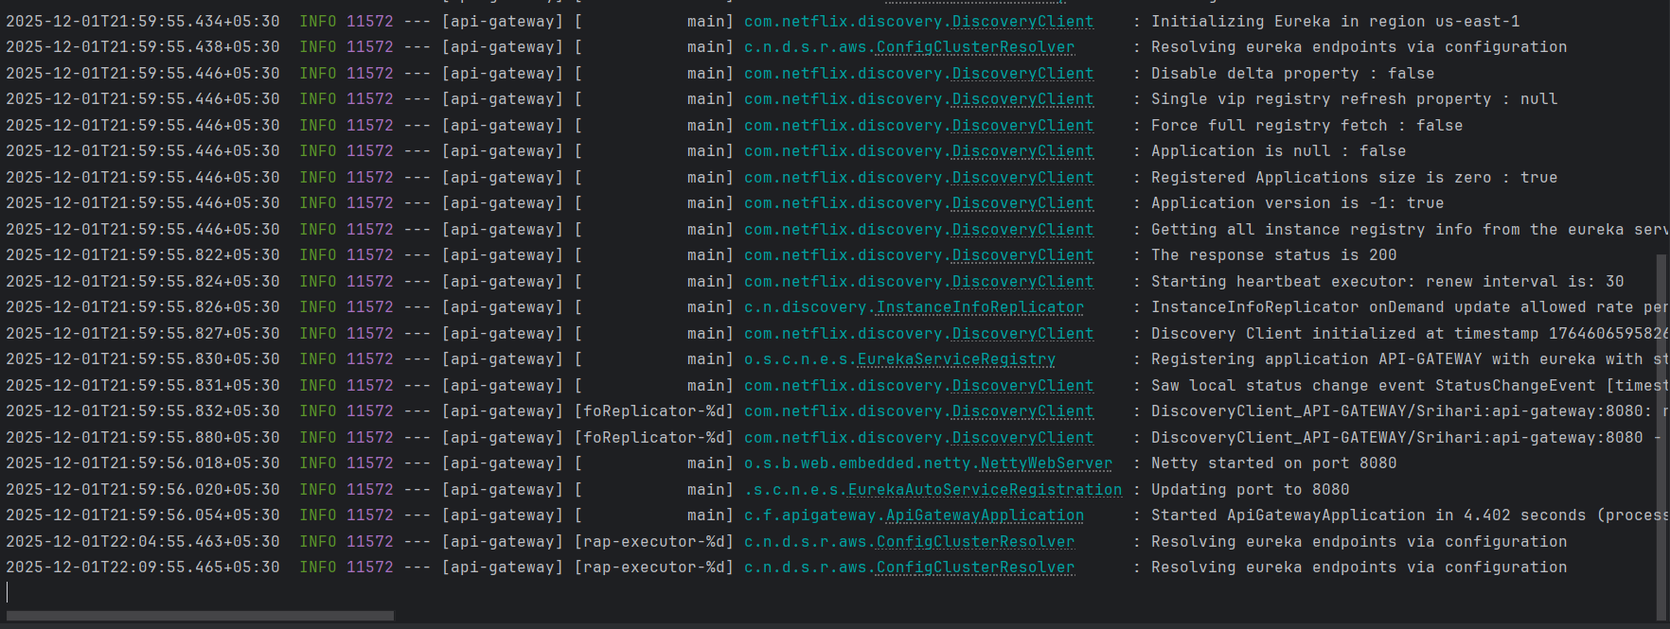
Design patterns: Circuit Breaker and Fallback:

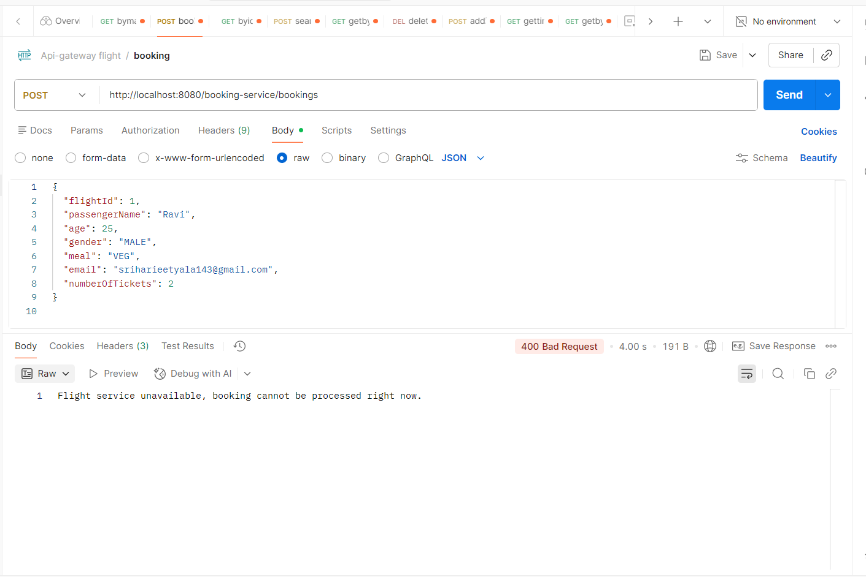
- Instead of returning an internal server error, the circuit breaker and fallback return a proper message with a 400 Bad Request.

Jmeter load testing:

5 threads:

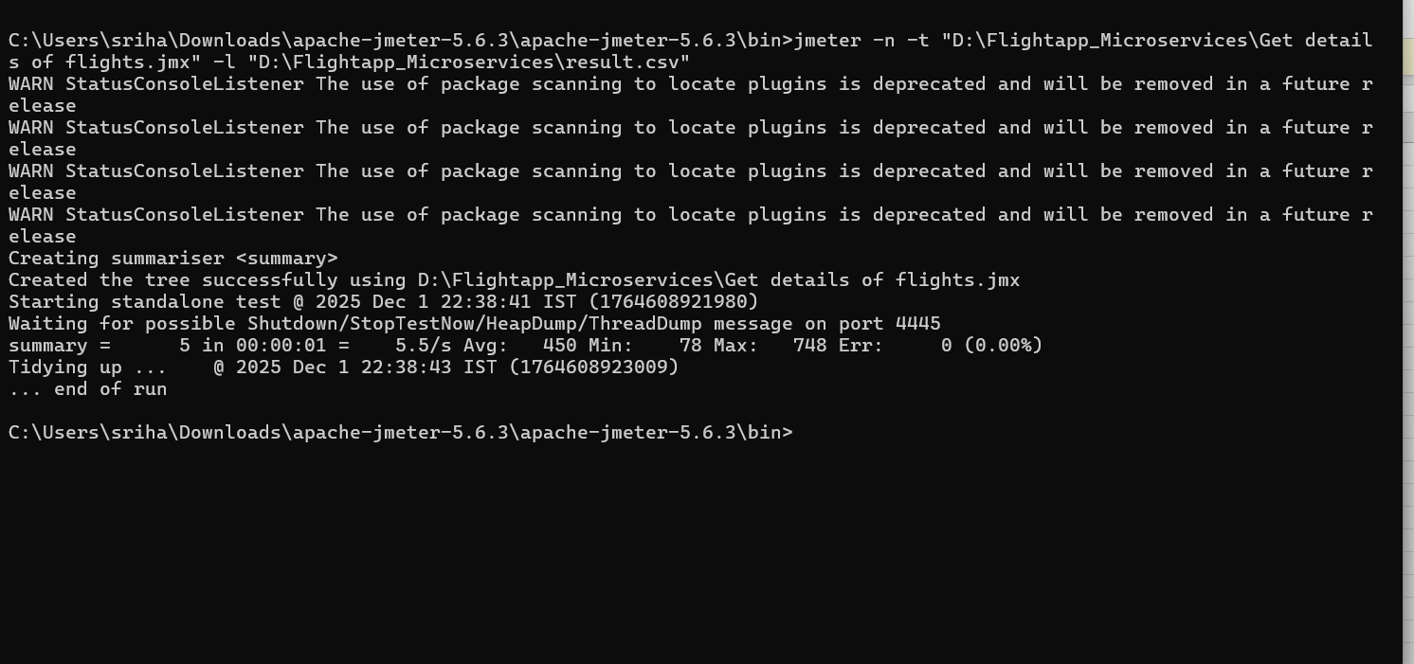

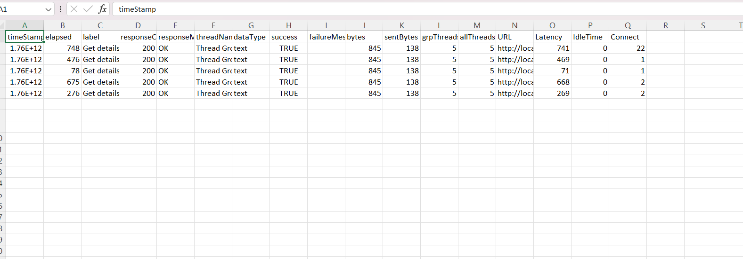

*Everything is success since it’s a get service

50 threads:

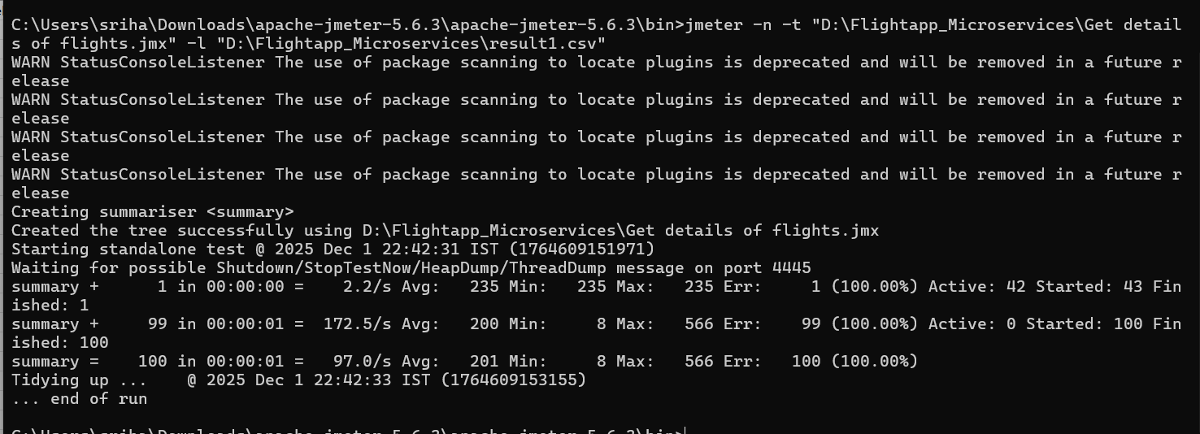

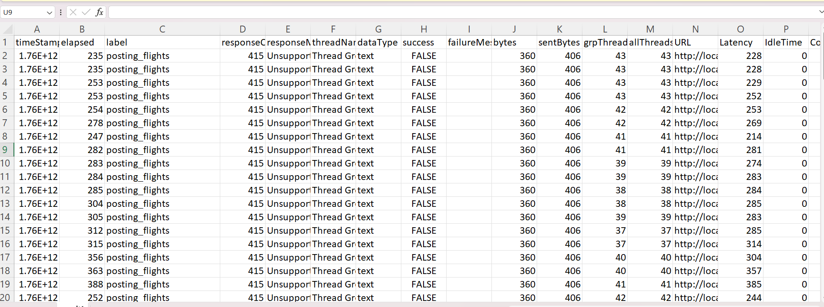

*The success flag shows false because the POST request is being sent repeatedly with the same request body across 50 threads.

CODE-COVERAGE:

JaCoCo report: (97%)
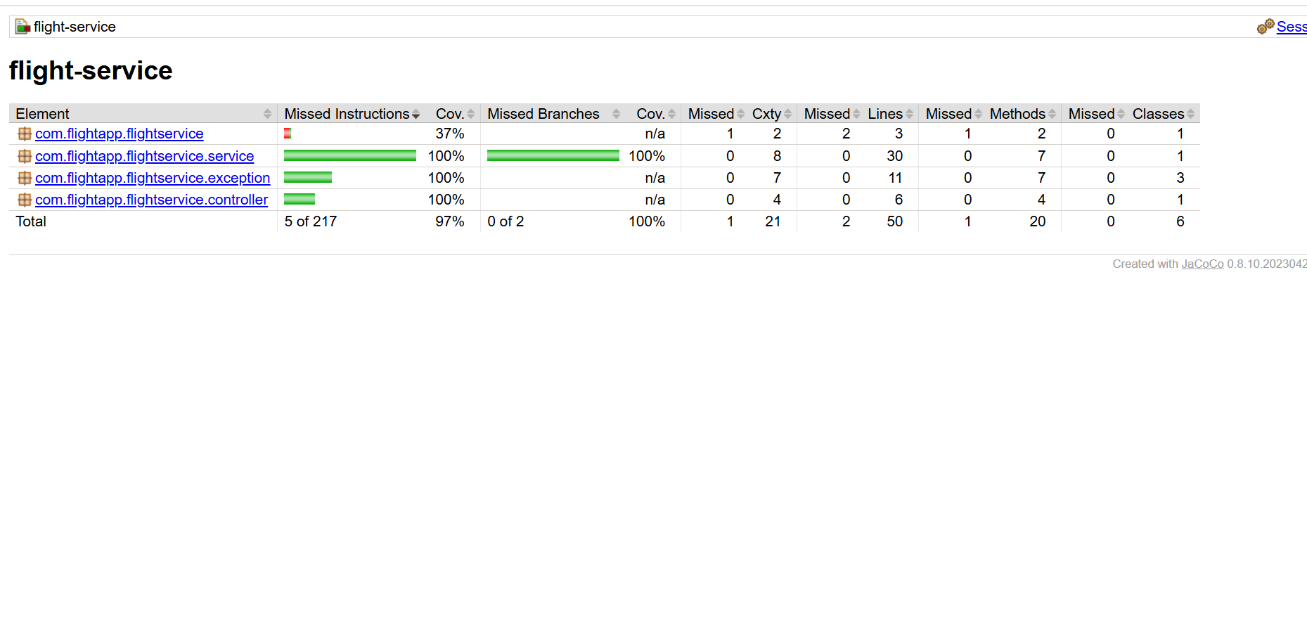

Sonarcloud report:
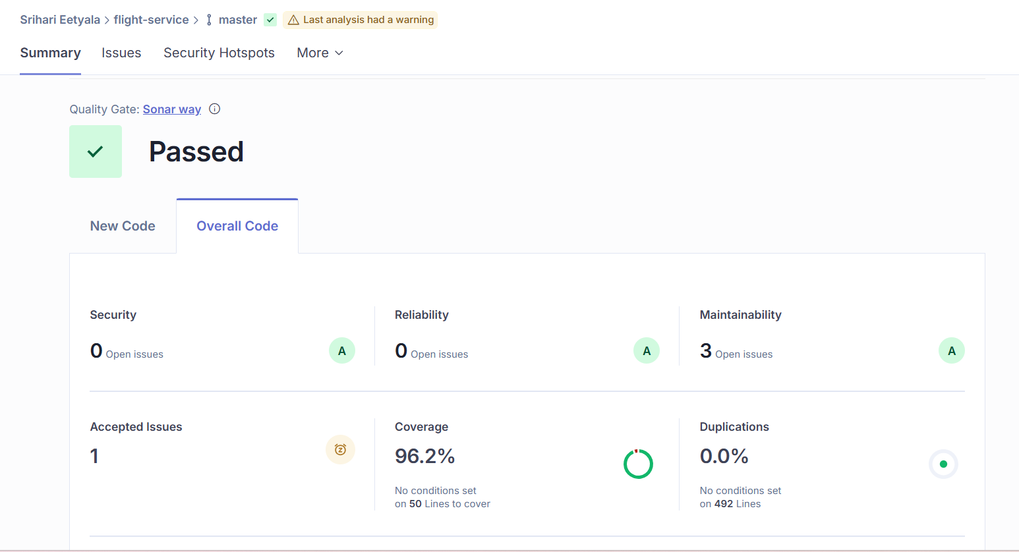

JaCoCo report: (92%)

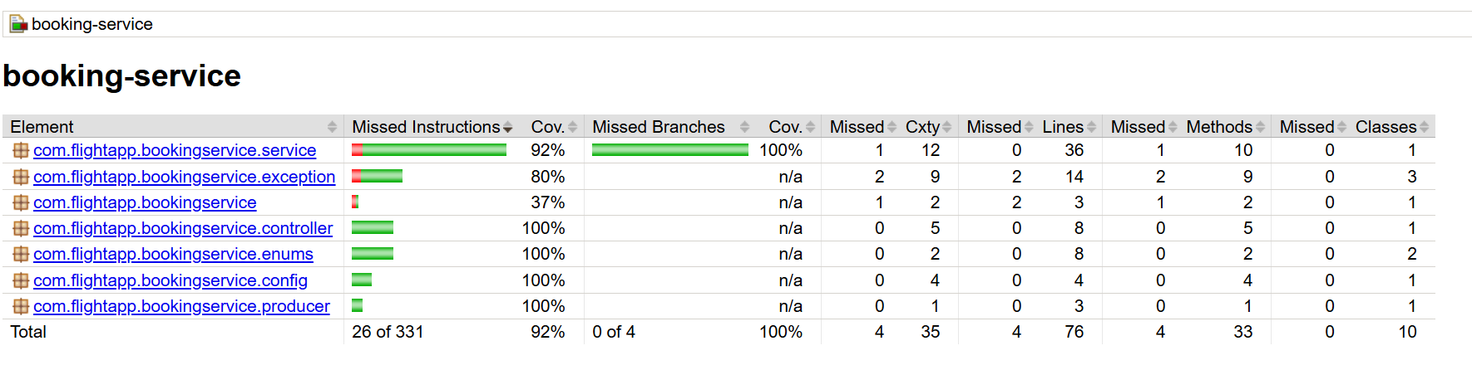

SonarCloud report:

