Report: Implementation of security and Docker deployment
ACCESS RULES MATRIX (Current Setup):

Service | Endpoint | Method | Role
Auth-Service | /auth/signup | POST | Anyone
Auth-Service | /auth/login | POST | Anyone
Auth-Service | /auth/logout | POST | Anyone
Flight-Service | /flights | GET | Anyone
Flight-Service | /flights/{id} | GET | Anyone
Flight-Service | /flights/search (Given to and fro) | POST | Anyone

User Protected (Requires USER token)
Service | Endpoint | Method | Role Required
Booking-Service | /bookings | POST | USER
Booking-Service | /bookings/email/{email} | GET | USER
Booking-Service | /bookings/id/{id} | GET | USER
Booking-Service | /bookings/pnr/{pnr} | GET | USER
Booking-Service | /bookings/{id} | DELETE | USER

Admin Protected (Requires ADMIN token):
Service | Endpoint | Method | Role Required
Flight-Service | /flights | POST | ADMIN

What Happens When Roles Incorrect?:

Case | Response
No token sent on protected API | 401 Unauthorized
Token sent but wrong role | 403 Forbidden
Token expired or bad signature | 401 Unauthorized

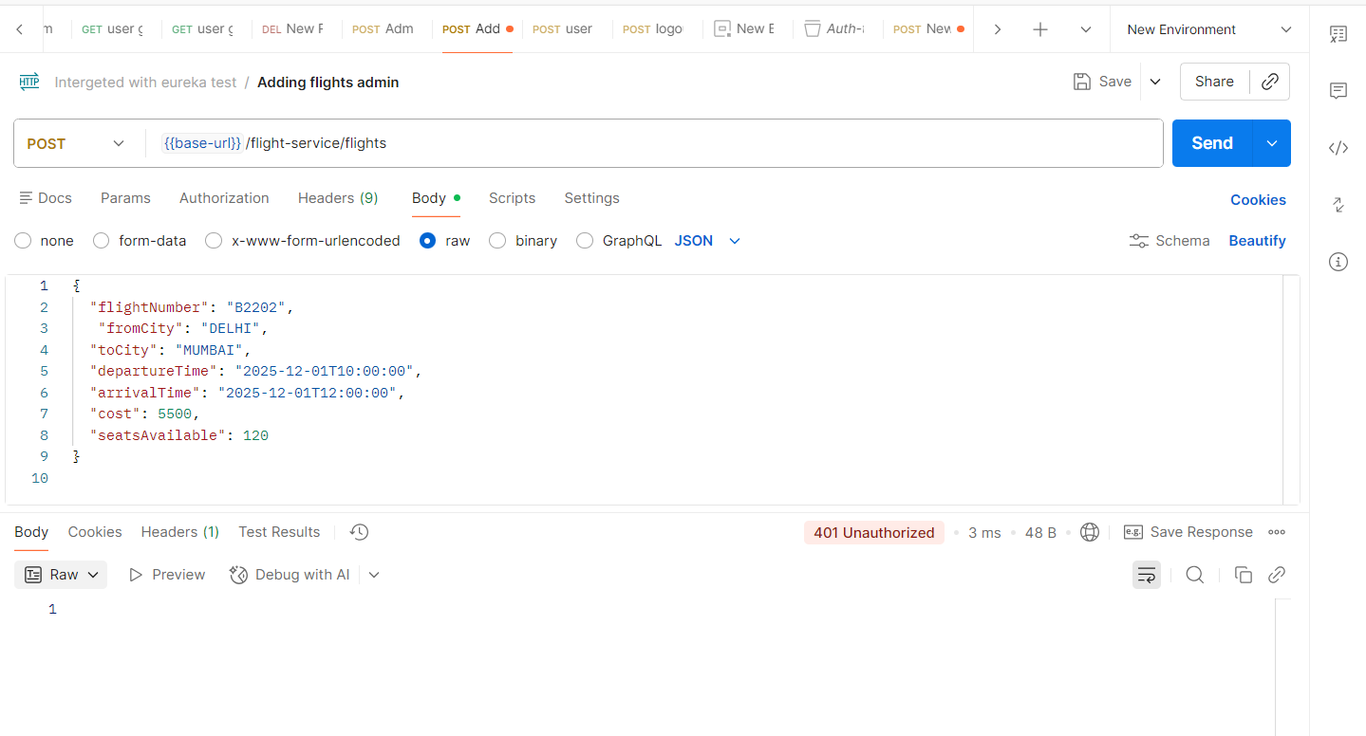
- Here I did not send any token (usually admin token has to be sent for successful access) so we are getting 401 Unauthorized.

- 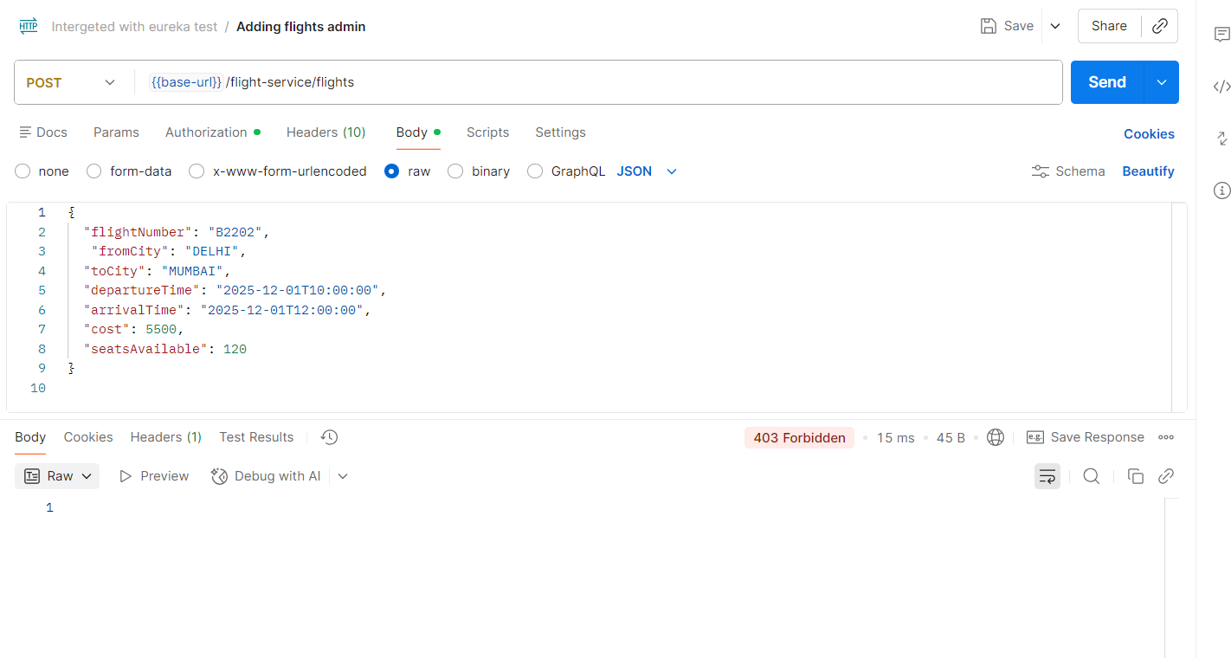I had provided the token, but it is a user-role token. Because users are not authorized to access this endpoint, the request returns a 403 Forbidden response.

- I had passed an expired token, which is causing the request to return a 401 Unauthorized response.

User Sign-In / Sign-Out Workflow:
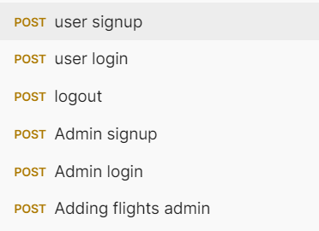

User Signup:
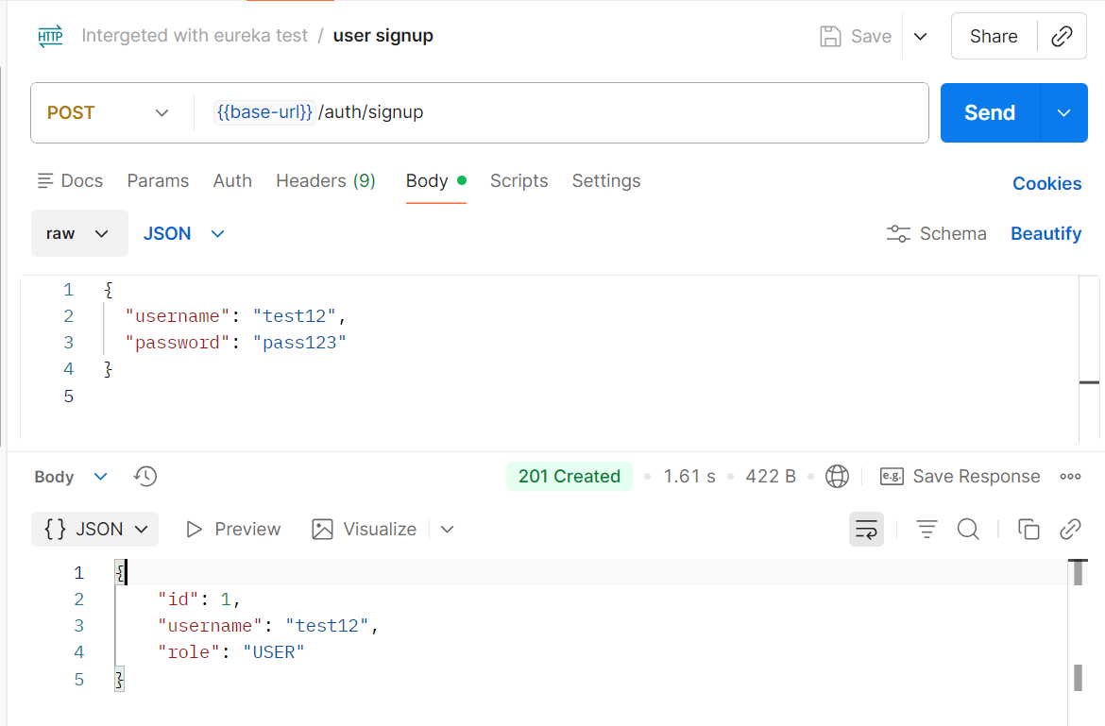

User login:
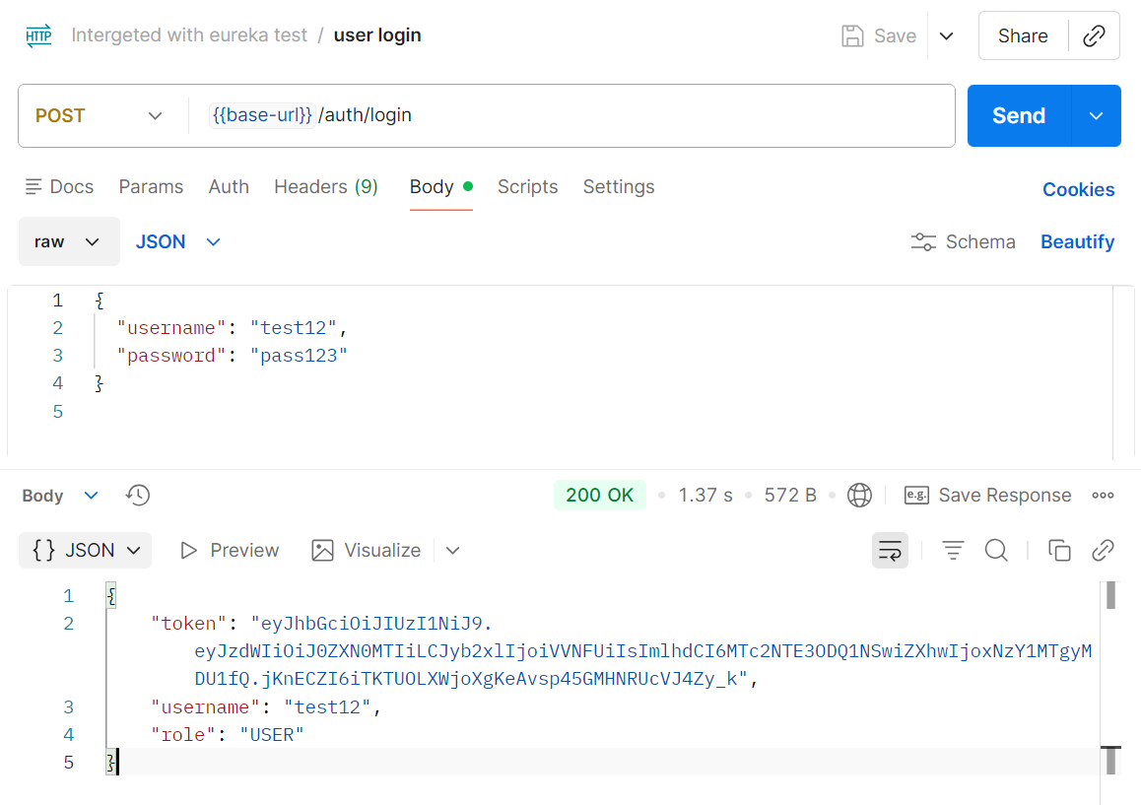
Generating token for authentication of the access to the endpoints.

Admin signup:
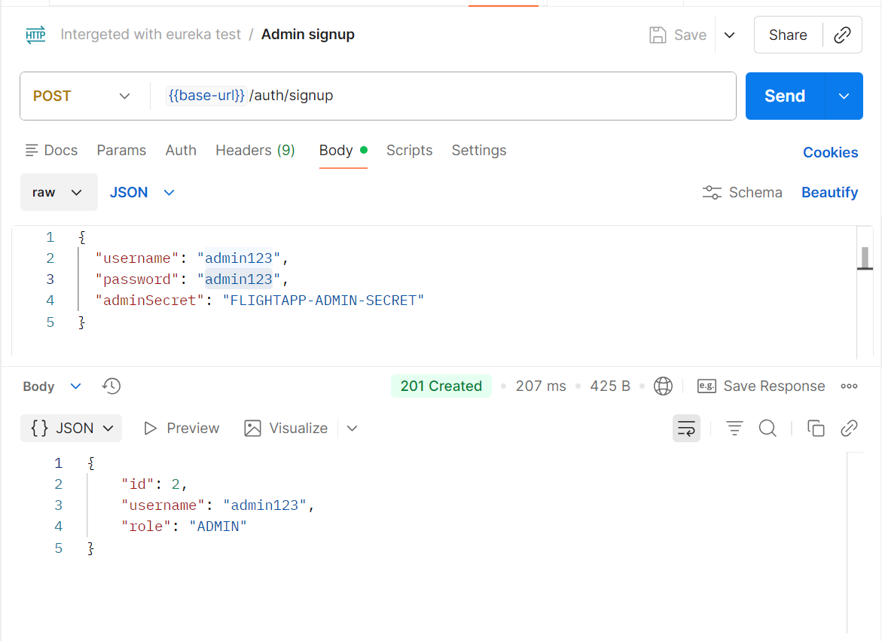
Admin Login:
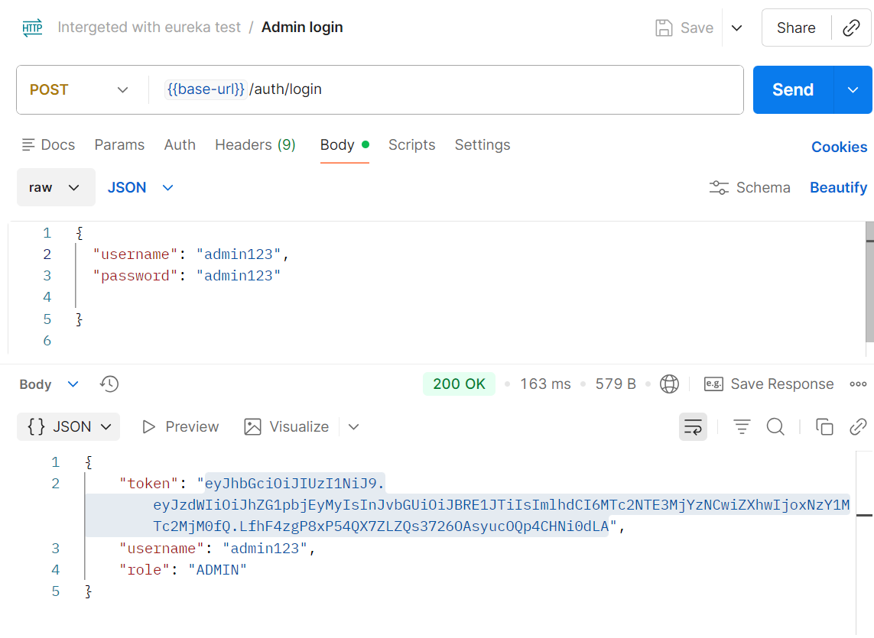
Generating token for authentication of the access to the endpoints.
Logout:
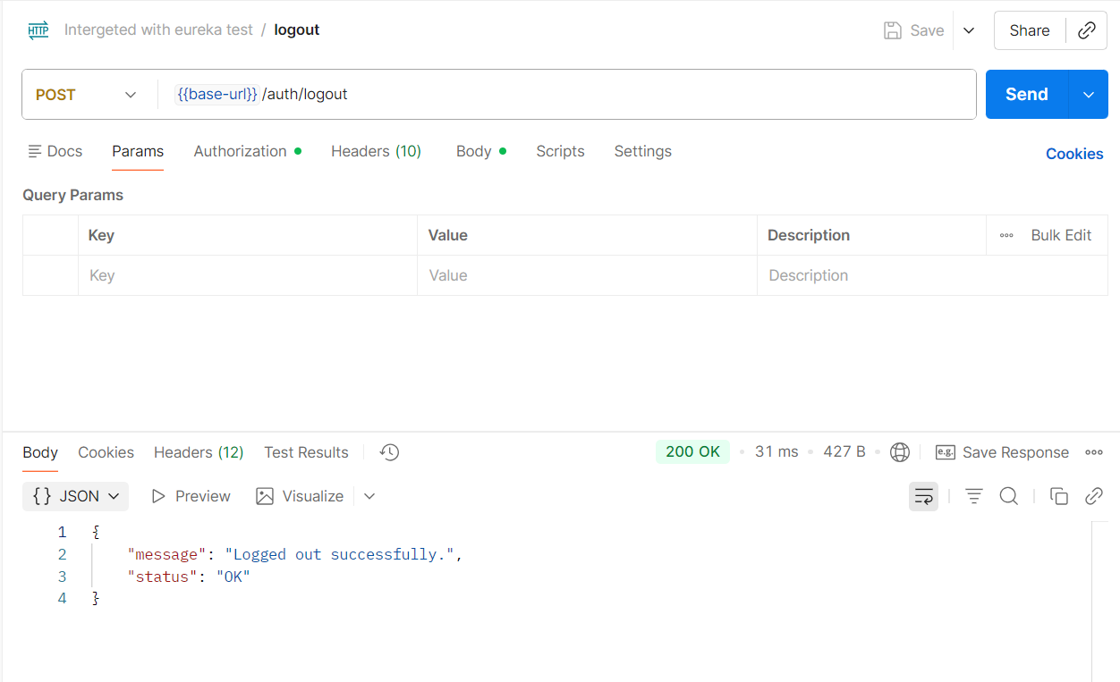
Docker part of the assignment:

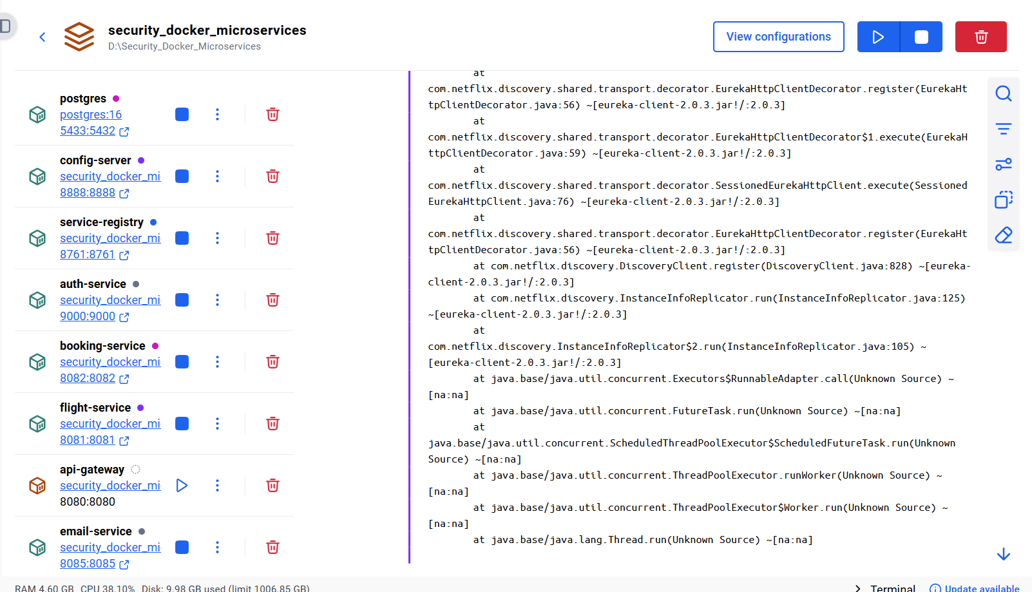

Eureka Registered Services:

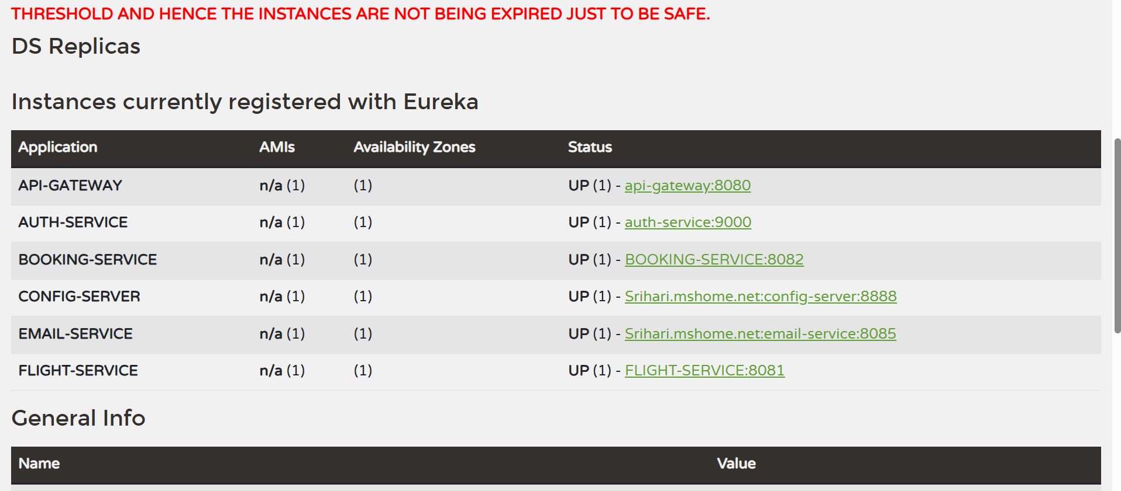

Docker Logs:

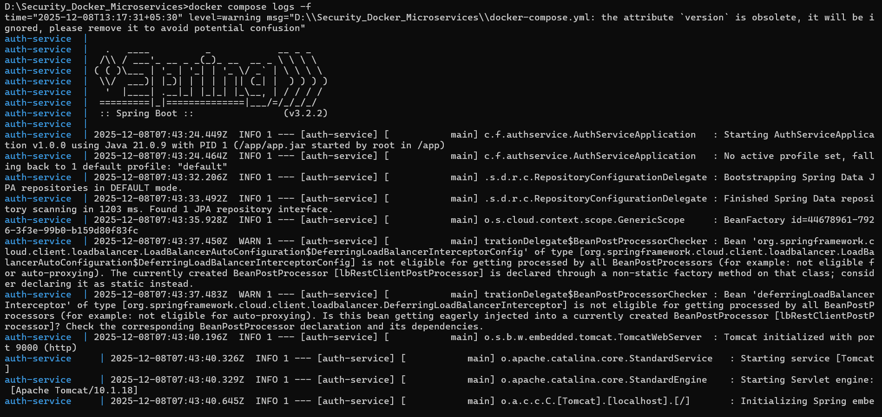
Used docker compose logs -f

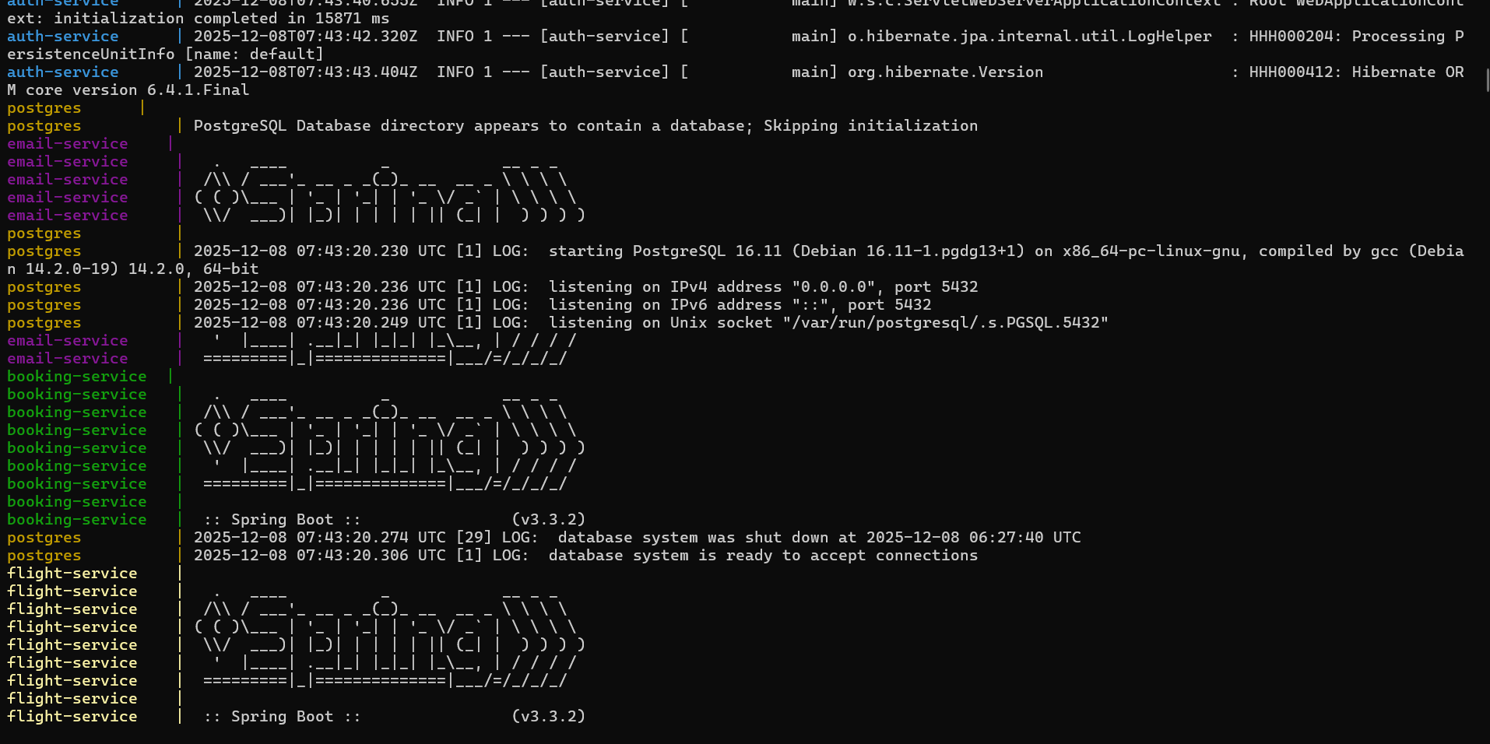

Performance and Profiling Analysis Using JMeter and Java Mission Control (JMC):
I have used 100 requests for the analysis using Jmeter.

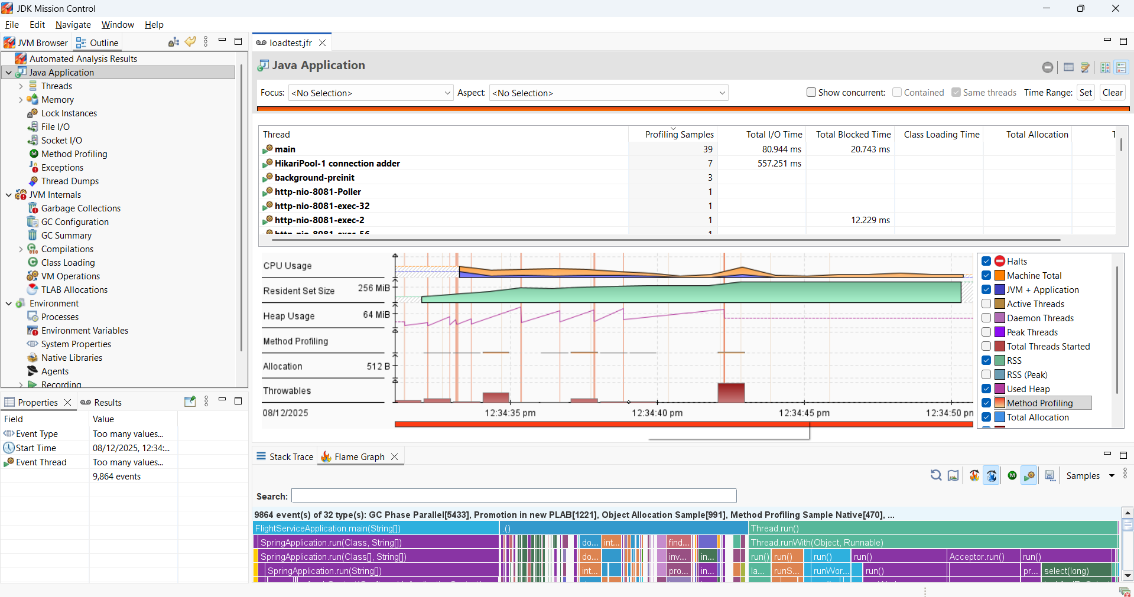

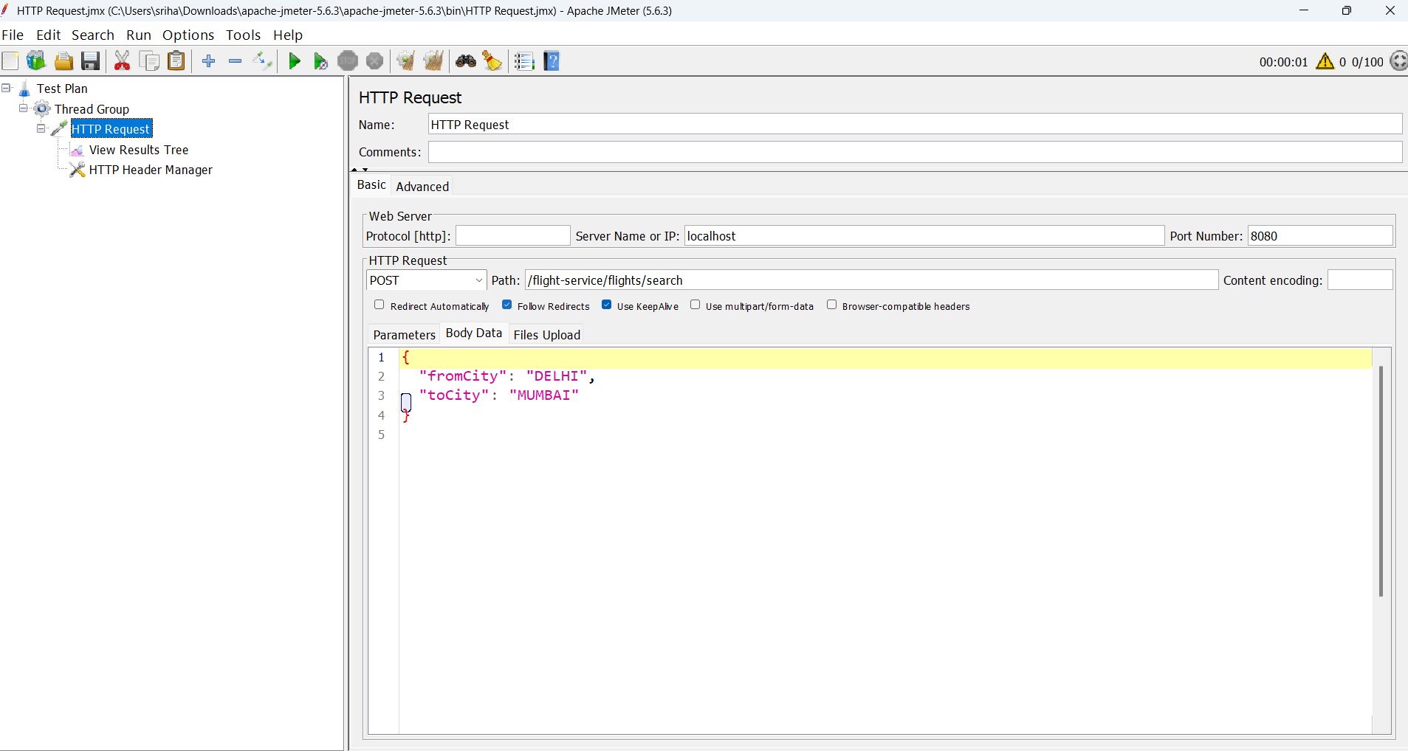

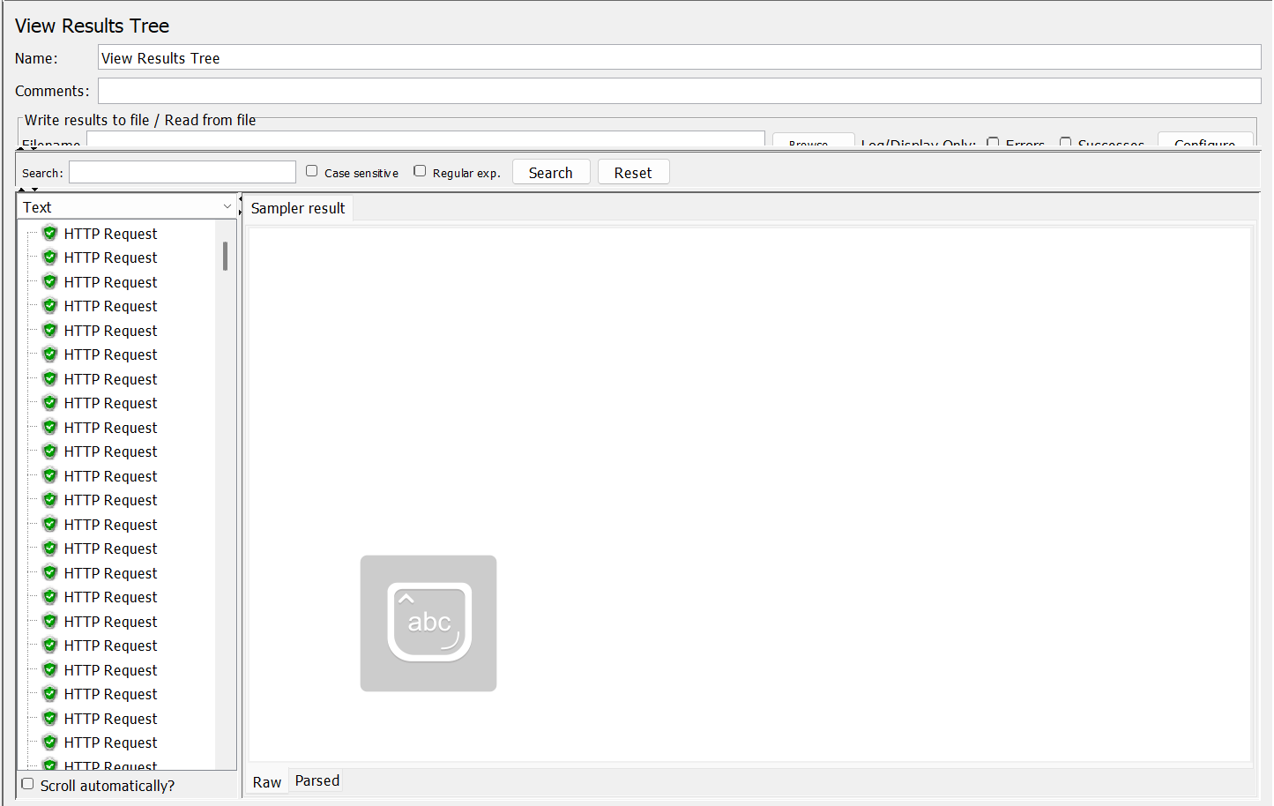

Code Coverage:
JaCoCo report: (97%)

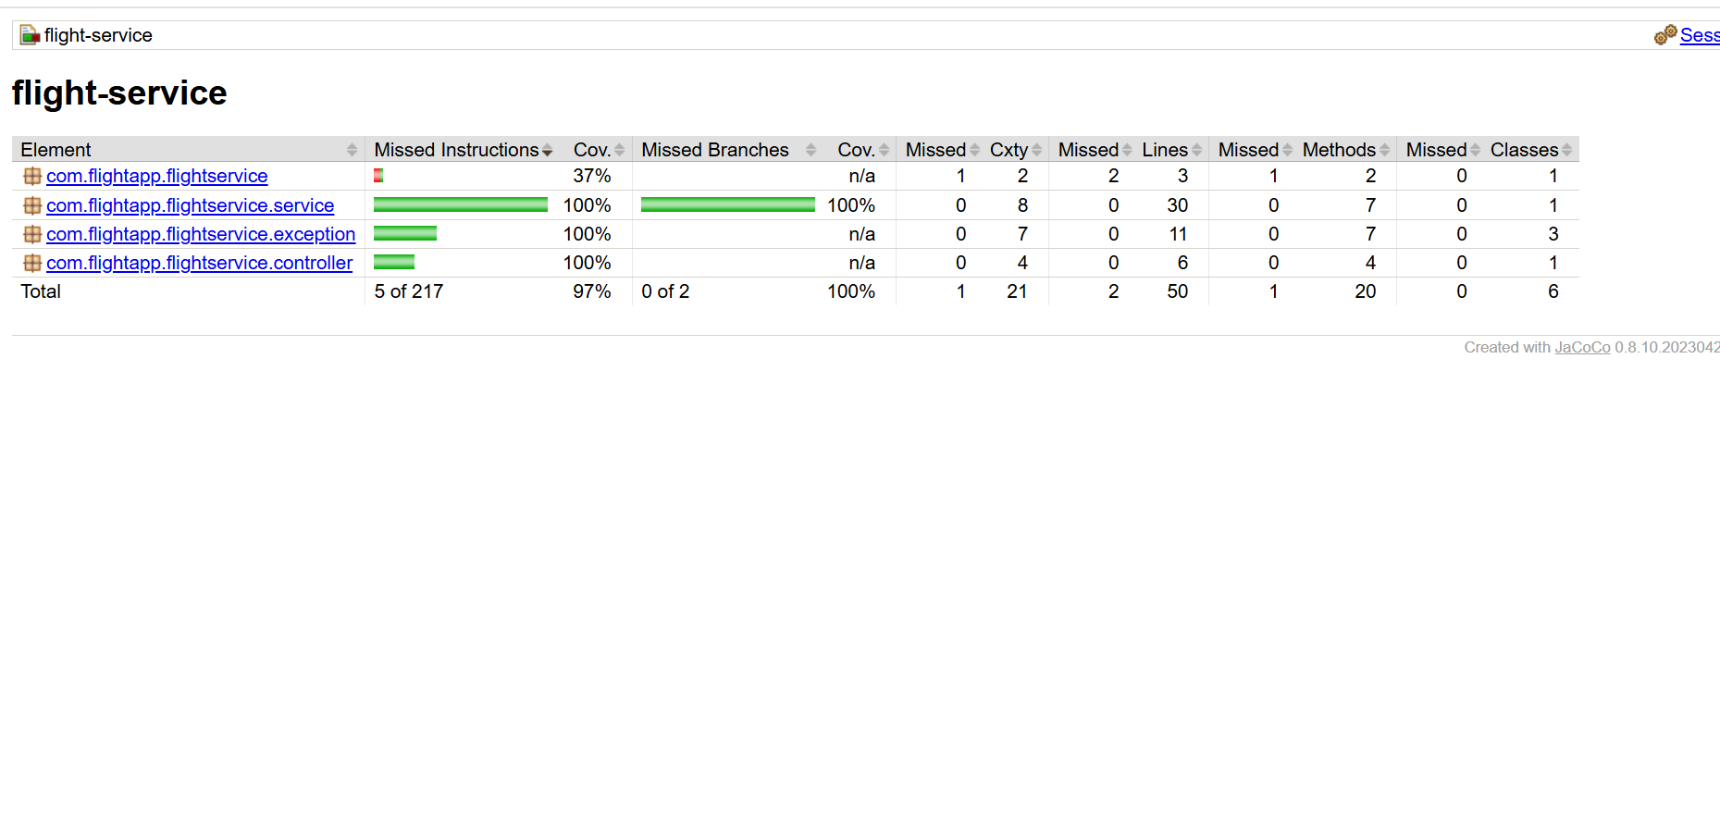

Sonarcloud report:
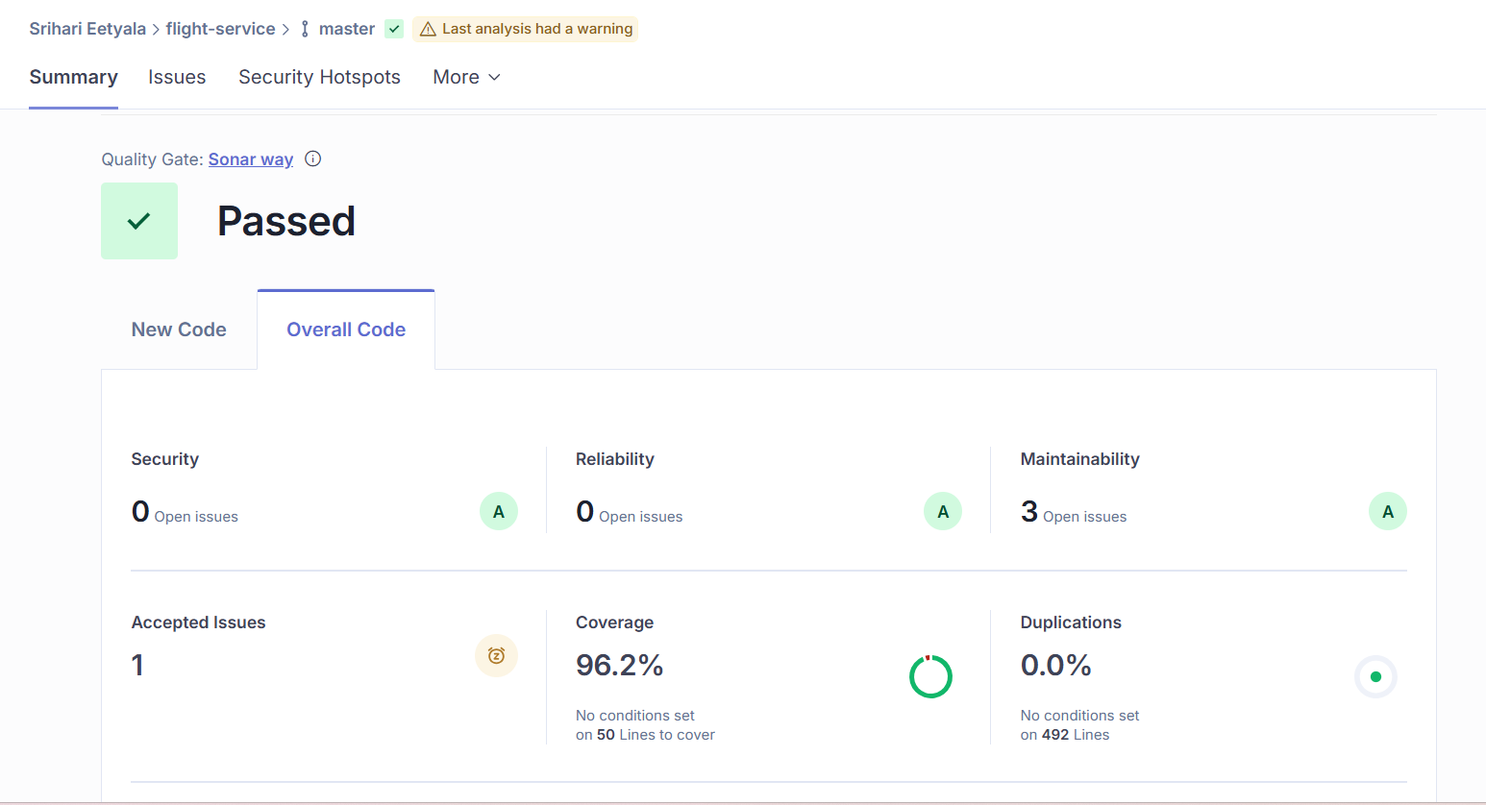

JaCoCo report: (92%)

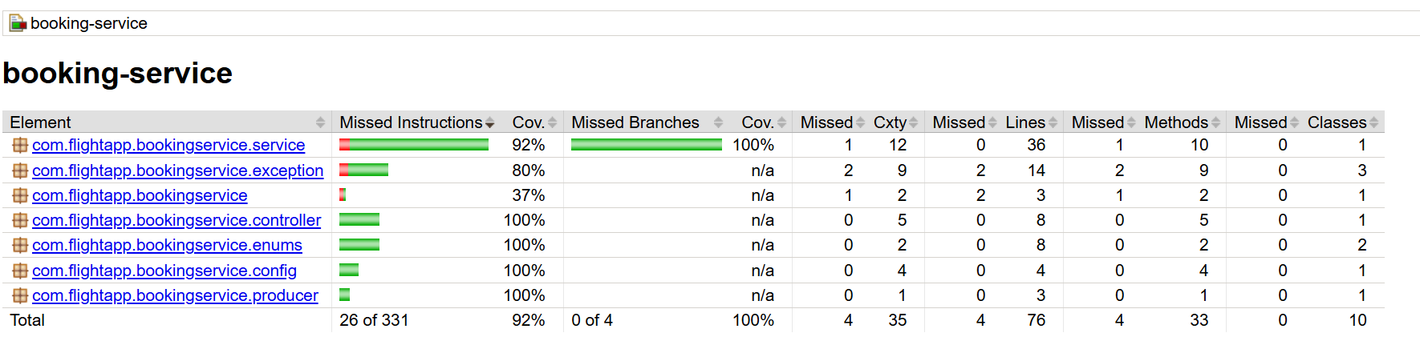

SonarCloud report:
