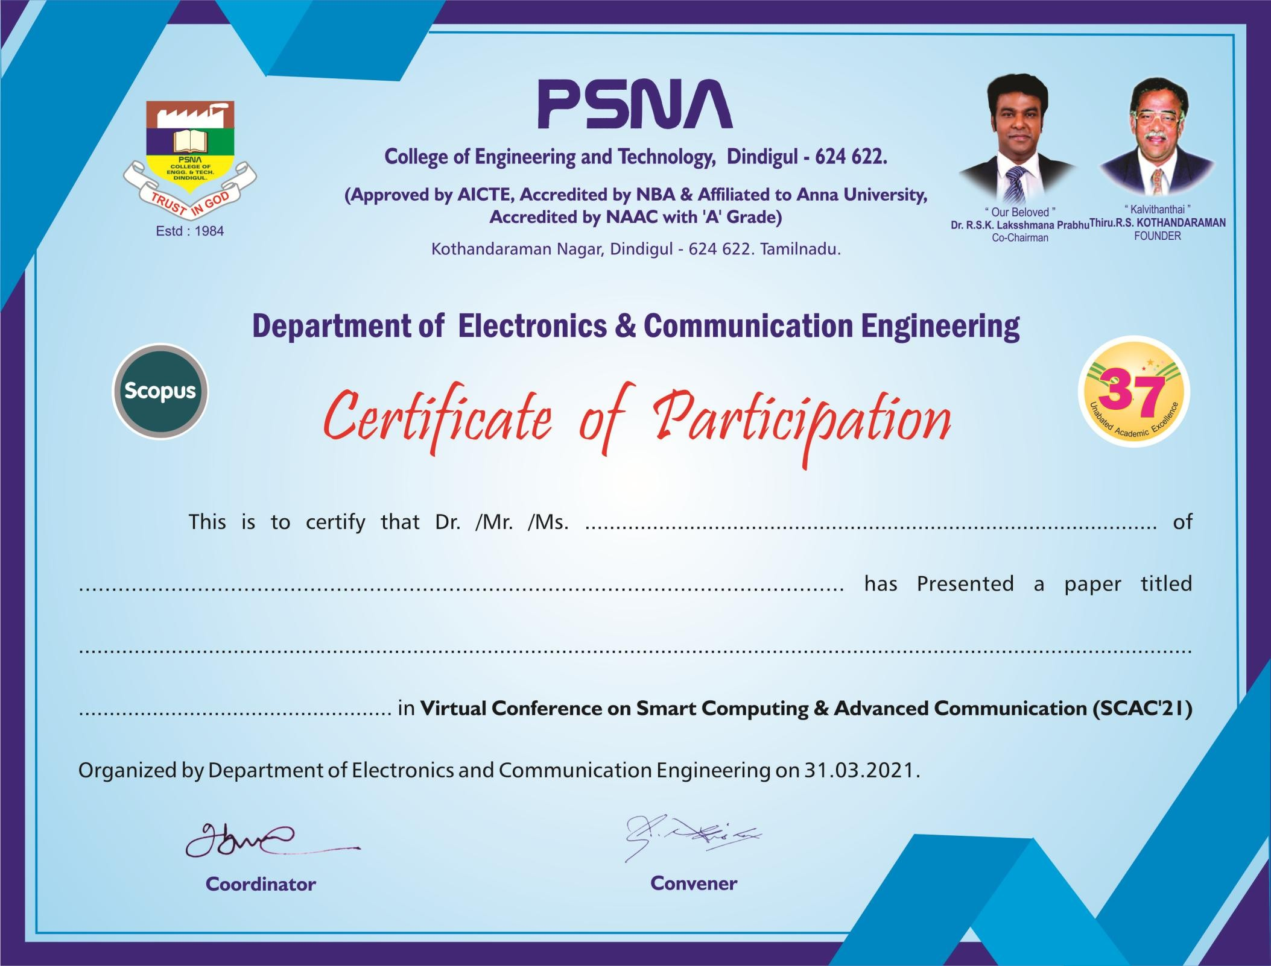

T. SRIHARIHARAN

K.S. RANGASAMY COLLEGE OF TECHNOLOGY

SPAMMER DETECTION AND FAKE USER IDENTIFICATION ON SOCIAL MEDIA