TRAVELLING SALES PERSON

PROBLEM

**AI Lab Assignment 3**

**7/2/2023**

**(Tejas Mhaiskar 210030039 , Srihari KG 210030035)**

1. **Abstract:**

In this problem we are asked to find the shortest tour length of given number of cities. And this problem belongs to a class of NP Complete problem . For such problem there is no Polynomial time reduction as such. To find the least cost to travel all cities and reach the first city back , by brute force we may have to run our search for (number of cities ) factorial times ,which is impractical. So to solve this problem , to find a sub optimal path, we have used ANT COLONY optimization for this assignment.

1. **Ant Colony Optimization:**

In this model , we try and find a sub-optimal or optimal solution using the system which ants use . Ants secrete a chemical named pheromone and trace their path by its sense for that chemical . Near the path , faster will be the return of the ant and higher will be the pheromone concentration attracting more and more ants and creating a solid path eliminating all other possibilites . Here we create a graph for costs between cities and deploy a number of ants to find a way to goal state and return to start i.e create a hamiltonian cycyle . With time the chemical evaporates by a certain rate and the less cost path remains dominant and eventually gives a good solution in most of the cases .

1. **Pseudo Code:**

We have implemented the same and here is the pseudocode for the same.And we have used 290 seconds as time limit:

**ACO:**

**Repeat under a time constraint**

**For all ants**

**Pick a random city**

**Path = None**

**Add city to the path**

**Until all cities are added to the path :**

**Pick the next city having highest probability considering pheromone concentration**

**Add city to the path**

**Update pheromone concentration using the formula**

**For the best Tour found so far, reward corresponding edges by adding more pheromone**

**After the tour is formed, Evaporate the pheromone across all paths**

**Return best tour**

**Formula used:**

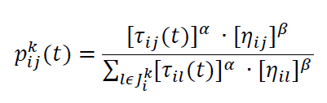

Is used to calculate the city having a maximum chance of visiting depending on tau (pheromone concentration) and eta(distance factor)

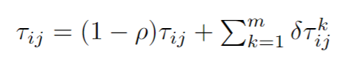

This formula is used to update the pheromone concentration by adding and evaporating.

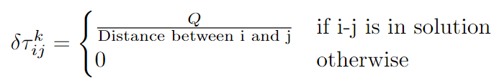

And Delta is updated as shown above, Q is taken some large constant and m is number of cities in formula.

1. **Results of the Experiment**

For the constants defined below in the table

|  |  |
| --- | --- |
| ALPHA | 0.3 |
| BETA | 20 |
| RHO | 0.5 |
| Q | num_of_cites ^ 3 |

The best results obtained during the execution are :

|  |  |
| --- | --- |
| Input File | Cost of Tour |
| euc_100 | 1628 |
| noneuc_100 | 5329 |

**Best Path found for euc 100:**

34 92 96 74 27 60 19 4 57 85 10 18 13 52 86 33 84 15 64 55 9 30 61 70 50 79 87 43 77 71 62 80 45 53 7 56 91 51 14 23 49 31 68 83 69 95 47 5 76 6 24 39 21 81 38 0 65 82 3 94 40 67 89 90 42 44 78 35 58 37 59 17 99 2 93 12 32 66 46 8 73 75 88 20 25 36 29 98 41 63 48 1 54 97 22 16 26 72 11 28

**Best path found for noneuc 100 :**

18 63 82 46 3 91 90 9 68 12 86 32 28 74 62 61 20 87 59 36 7 11 78 73 57 10 98 19 42 49 95 5 88 35 89 99 39 33 77 53 14 50 29 75 21 1 23 66 54 45 22 64 15 84 8 38 16 83 31 44 92 52 13 79 76 58 17 55 71 60 93 26 47 56 48 97 85 96 37 41 81 24 30 67 70 94 0 6 65 43 27 69 51 34 25 2 40 80 72 4

**Inference and Improvements**

The above results may not be optimal, we can consider them as sub- solution solutions is an interference of randomness and Probability. Ant colony optimization thus gives us a probabilistic approach for solving TSP. Thus ACO helps in finding approximate solutions to complex optimization problem.

By learning from the previous results of the execution, code is improved by rewarding the best solution so far found by increasing its pheromone concentration in every iteration.This gave the improvement by decreasing the cost of tour obtained before.