

**Attendance Management System using Face Recognition**

A Project Report

submitted in partial fulfillment of the requirements of

AICTE Internship on AI: Transformative Learning with

TechSaksham – A joint CSR initiative of Microsoft & SAP

by

**Abhishek,** [**abhishekgangwar2108@gmail.com**](mailto:abhishekgangwar2108@gmail.com)

Under the Guidance of

**Aditya Prashant Ardak**



### ACKNOWLEDGEMENT

I am immensely grateful for the guidance, encouragement, and unwavering support that I have received throughout the course of this project. This accomplishment would not have been possible without the contributions of several individuals and organizations, to whom I owe my deepest gratitude.

First and foremost, I wish to express my heartfelt thanks to my esteemed guide, **Aditya Prashant Ardak** for their exceptional mentorship and dedicated guidance. Their insightful advice and constructive feedback have been invaluable throughout every stage of this project. The patience and expertise demonstrated by my guide in addressing challenges, providing innovative solutions, and steering me in the right direction have been the cornerstone of this successful endeavor. Their belief in my abilities and continuous motivation inspired me to push the boundaries of my potential and achieve excellence in this work.

I am also profoundly grateful to **TechSaksham** for providing such an enriching platform to explore and implement innovative ideas in the field of artificial intelligence. The transformative learning experience and access to invaluable resources provided through this initiative have significantly enhanced my technical knowledge and professional development. The internship offered me a unique opportunity to translate theoretical concepts into practical applications, and I deeply appreciate the vision of TechSaksham in empowering young minds like me.



### ABSTRACT

This report presents the development of an **AI-driven Face Recognition-Based Attendance Management System** designed to automate attendance tracking. Traditional attendance methods, such as manual roll calls and sign-ins, are inefficient and prone to errors, especially in scenarios involving large-scale participation. To address these challenges, the proposed system employs real-time face detection and recognition using the face recognition library and provides an intuitive, user-friendly interface built with Tkinter.

The system offers key functionalities, including real-time attendance marking with color- coded feedback, student registration, and attendance logs with timestamps for auditing. The solution emphasizes accuracy and efficiency by leveraging advanced facial encoding techniques, ensuring robust performance under moderate lighting and angle variations.

The project also addresses key limitations of existing systems, such as scalability issues, environmental sensitivity, and privacy concerns. Experimental evaluations demonstrate the system's reliability and suitability for small- to medium-scale setups, such as classrooms and small offices. Future enhancements will focus on integrating cloud-based storage, improving recognition in challenging conditions, and ensuring compliance with privacy standards.

This report outlines the methodology, implementation, and potential impact of the system, showcasing its ability to streamline the attendance process and reduce administrative burdens while enhancing accuracy and transparency.

.



**TABLE OF CONTENT**

Abstract I

Chapter 1. Introduction 1

* 1. Problem Statement 1
  2. Motivation 1
  3. Objectives 2
  4. Scope of the Project 2

Chapter 2. Literature Survey 3

* 1. Review relevant literature 3
  2. Existing Models, Techniques, and Methodologies 4
  3. Limitations in Existing Systems 4

Chapter 3. Proposed Methodology 6

* 1. System Design 6
  2. Requirement Specification 8

Chapter 4. Implementation and Results 9

* 1. Snap Shots of Result 9
  2. GitHub Link for Code 13

Chapter 5. Discussion and Conclusion 14

* 1. Future Work 14
  2. Conclusion 16

References 17



**LIST OF FIGURES**

|  |  |  |
| --- | --- | --- |
| **Figure No.** | **Figure Caption** | **Page No.** |
| **Figure 1** | System Workflow for Face Recognition-Based Attendance Management System. | **7** |
| **Figure 2** | Snapshot of the Home Page Interface for the Face Recognition-Based Attendance System. | **9** |
| **Figure 3** | Snapshot of the Interface for Registering a New Student's Face in the Attendance System. | **10** |
| **Figure 4** | Registration Successful: The new face has been successfully registered in the system. | **11** |
| **Figure 5** | Camera Feed Display Before Attendance Registration. | **11** |
| **Figure 6** | Camera Feed After Face is Registered and Logged for Attendance. | **12** |
| **Figure 7** | Interface for Checking Attendance Logs and Viewing Recorded Entries. | **13** |

# CHAPTER 1



## Introduction

#### Problem Statement:

Traditional methods of recording attendance, such as manual roll calls or signing attendance sheets, are time-consuming and error-prone. Inaccuracies arise due to human errors, proxy attendance, or lost records, leading to inefficiencies in tracking and managing attendance. These challenges become more significant in large-scale setups like educational institutions, corporate offices, and events where monitoring hundreds or thousands of attendees can be overwhelming[1].

An automated attendance system based on face recognition offers a seamless, accurate, and tamper-proof solution. By leveraging the unique biometric features of individuals, this system ensures attendance is recorded efficiently, eliminating issues [2]

##### Why is this significant?

**Efficiency**: Saves time compared to manual methods.[3] **Accuracy**: Reduces human error in attendance marking. **Security**: Prevents proxy attendance.

**Scalability:** Suitable for large-scale implementations.

#### Motivation:

This project was chosen due to the increasing need for automated solutions in attendance management across various domains. As the use of artificial intelligence (AI) and biometrics grows, leveraging these technologies for attendance systems can provide a reliable and innovative solution to a common yet critical problem.[4]

##### Potential Applications and Impact:

1. **Educational Institutions:** Automates attendance in classrooms or exams, ensuring fairness and reducing workload on staff. [1]
2. **Corporate Offices:** Monitors employee attendance accurately without requiring additional hardware like fingerprint scanners.[4]
3. **Events and Conferences:** Provides efficient attendee verification and reduces registration delays.[5]
4. **Healthcare and Public Sector:** Tracks attendance in critical fields requiring precise monitoring for compliance and accountability.[5]

p g . 1

#### Objective:



The goal of this project is to design and implement a Face Detection Attendance System to automate attendance processes..[6]

##### Specific Objectives:[5]

1. Utilize facial recognition technology for real-time attendance marking.
2. Develop a user-friendly interface for interaction and management of attendance records.[7]
3. Provide functionalities such as logging attendance, displaying registered faces, and maintaining timestamped logs for auditing.[3]
4. Ensure the system is scalable, secure, and reliable.[6]
5. Minimize errors and eliminate the possibility of proxy attendance.

#### Scope of the Project:

##### Scope:

The system targets small- to medium-scale setups such as classrooms, small offices, or events. It provides real-time attendance tracking, face registration, and log management.

* + 1. Users can take attendance, view logs, and add new students using a simple interface.[7]
    2. Logs include timestamps for auditing purposes.[6]
    3. A webcam or external camera serves as the only hardware requirement, making it cost-effective.[3]

##### Limitations:

1. **Environment Dependency:** Requires well-lit conditions for accurate face recognition.[6]
2. **Database Scalability:** Limited by local storage; cloud integration may be needed for larger setups. [8]
3. **Privacy Concerns:** Proper security measures are necessary to prevent misuse of biometric data.[4]
4. **Hardware Dependence:** Requires a functioning camera and a compatible system for smooth operation.[5]

p g . 2

# CHAPTER 2



## Literature Survey

##### Review relevant literature

The integration of **face recognition technology** in attendance management systems has been an area of active research, with several studies investigating the application of machine learning and computer vision techniques for automating and enhancing the attendance process.

##### Real-Time Face Recognition for Attendance Tracking:

One of the most influential works in this domain is the study by Gupta et al., which employs deep learning techniques such as Convolutional Neural Networks (CNNs) for real-time face recognition and attendance management. Their system, developed for educational institutions, showed improvements in both efficiency and accuracy compared to traditional attendance methods [1]. The study also highlighted scalability concerns, especially when handling large datasets, which can affect the recognition speed and accuracy under varying conditions.

##### FaceNet for Attendance:

The work by Singh et al. discusses the application of **FaceNet** for embedding face vectors and using them to match faces for attendance. The study emphasizes the advantages of using a deep learning approach, achieving high accuracy in face recognition, but also discusses the computational overhead involved when implementing the system in real-time scenarios, particularly on resource-constrained devices [2].

##### Combination of Face Recognition and IoT:

Some studies combine face recognition with Internet of Things (IoT) devices for smarter attendance systems. An example is the research by Sharma et al., where facial recognition is integrated with smart systems to not only track attendance but also enable seamless data storage in cloud databases, making the system more scalable and easier to access remotely [3]. However, their approach faces challenges with data security and privacy concerns, which are common in biometric systems.

p g . 3



##### Haar Cascade and Local Binary Patterns (LBP):

Several systems, including the one by Kumar et al., use traditional methods like **Haar Cascades** for face detection and **Local Binary Patterns (LBP)** for feature extraction. While these models are lightweight and faster for real-time applications, they are less robust under poor lighting or when faces are partially occluded, as noted by the authors. Despite this, they offer a solution for small-scale systems requiring low computational power [4].

##### Challenges with Traditional Models:

A major limitation noted in the literature is the challenge of handling **complex backgrounds** and **occlusions** in real-world scenarios. For example, models based on **Support Vector Machines (SVM)**, as discussed in research by Hati et al., can produce false positives when deployed in fixed or controlled environments, highlighting the need for more adaptive, neural network-based models for robust performance [5].

##### Existing Models, Techniques, and Methodologies

* **Haar Cascade Classifiers**: Traditional face detection method offering lightweight operation but limited robustness under varying lighting and angles[1].
* **Deep Learning Models (e.g., FaceNet, OpenFace)**: Provide high accuracy through deep embeddings but are resource-intensive and require significant computational power for real-time performance [3].
* **YOLO-Based Detection**: Faster models like YOLO have been used for real-time applications but need optimized preprocessing pipelines for small-scale attendance systems.[1]

##### Limitations in Existing Systems

* + 1. **Scalability Issues:** Current systems face performance degradation as the database grows, impacting recognition speed.

p g . 4

* + 1. **Environmental Sensitivity:** Accuracy reduces significantly under poor lighting, extreme facial angles, or partial occlusions.



* + 1. **Privacy Concerns:** Some implementations inadequately address data security and consent, leading to ethical challenges.

##### How This Project Addresses the Gaps

* + - * **Real-Time Performance:** Utilizes efficient libraries like face_recognition and lightweight UI design through Tkinter for optimized performance on standard hardware.
      * **Enhanced Accuracy:** Employs post-detection refinements, such as color-coded status for user-friendly operation.
      * **Privacy-First Design:** Data is securely stored in Firebase with minimal personal data collection.
      * **User Experience:** Simplifies operation with intuitive interface options like attendance, logs, and registration.

p g . 5

# CHAPTER 3



## Proposed Methodology

The proposed methodology outlines the system design and implementation strategy for the face-recognition-based attendance management system. It ensures real-time operation, user-friendly interaction, and secure data handling.

#### System Design

The system design integrates several interconnected modules to ensure smooth functionality:

##### Face Detection Module:

* Uses the face_recognition library powered by dlib to detect human faces in real-time.
* Ensures high accuracy in identifying faces under standard lighting and moderate angle variations [1],[5].

##### Recognition and Verification Module:

* Matches detected faces with a pre-registered database of face encodings.
* Displays the recognition status in a color-coded format:
  + **Red:** Face detected but not recognized.
  + **Green:** Face successfully recognized [5].

##### Attendance Marking Module:

* Updates the attendance database upon successful recognition.
* Associates the recognized name with a timestamp for logging purposes.

##### Log Management Module:

* Maintains a history of recognized faces with timestamps for record-keeping and validation [9].

##### User Interface (UI) Module:

* Built using Tkinter for simplicity and accessibility.
* Features intuitive options:
  + Taking Attendance
  + Viewing Registered Faces

p g . 6

* + Checking Logs



* + Registering New Students [4]

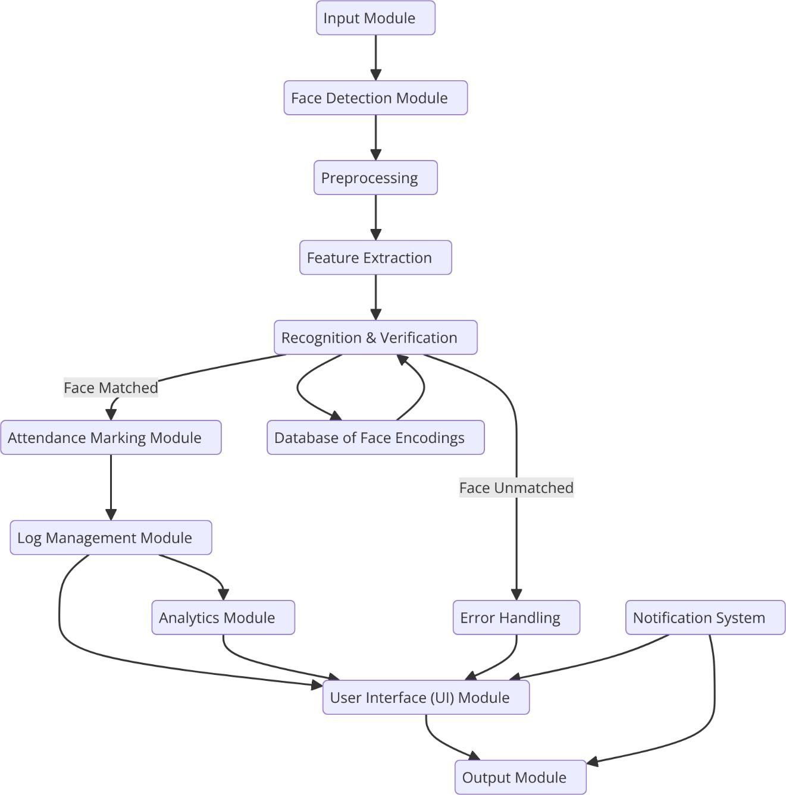

**Figure 1**: System Workflow for Face Recognition-Based Attendance Management System

p g . 7

#### Requirement Specification



##### Hardware Requirements:

* + - * **Camera/Webcam:** For capturing real-time images.[2]
      * **Processing Unit:** Dual-core processor or higher for smooth computation.
      * **RAM:** Minimum 4GB to handle real-time processing efficiently.
      * **Storage:** Adequate space for storing logs and face encodings.

##### Software Requirements:

* + - * **Operating System:** Windows/Linux/MacOS.
      * **Programming Language:** Python 3.x. [10]

##### Libraries/Frameworks:

* + - * + face_recognition for detection and recognition.
        + OpenCV for image processing.
        + Tkinter for building the user interface . [10]
        + pandas for managing logs and attendance data.

p g . 8

# CHAPTER 4



## Implementation and Result

#### Snap Shots of Result:

**Option :** Register New Face

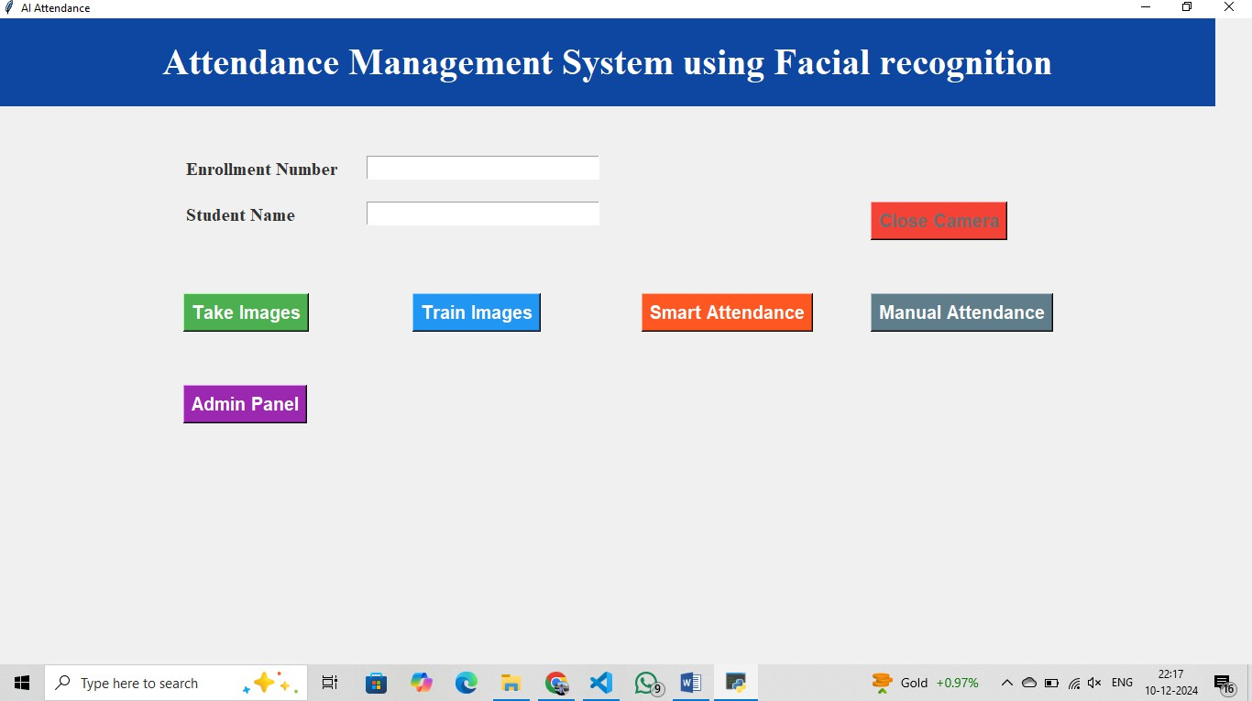

**Figure 2**: Snapshot of the Home Page Interface for the Face Recognition-Based Attendance System

p g . 9



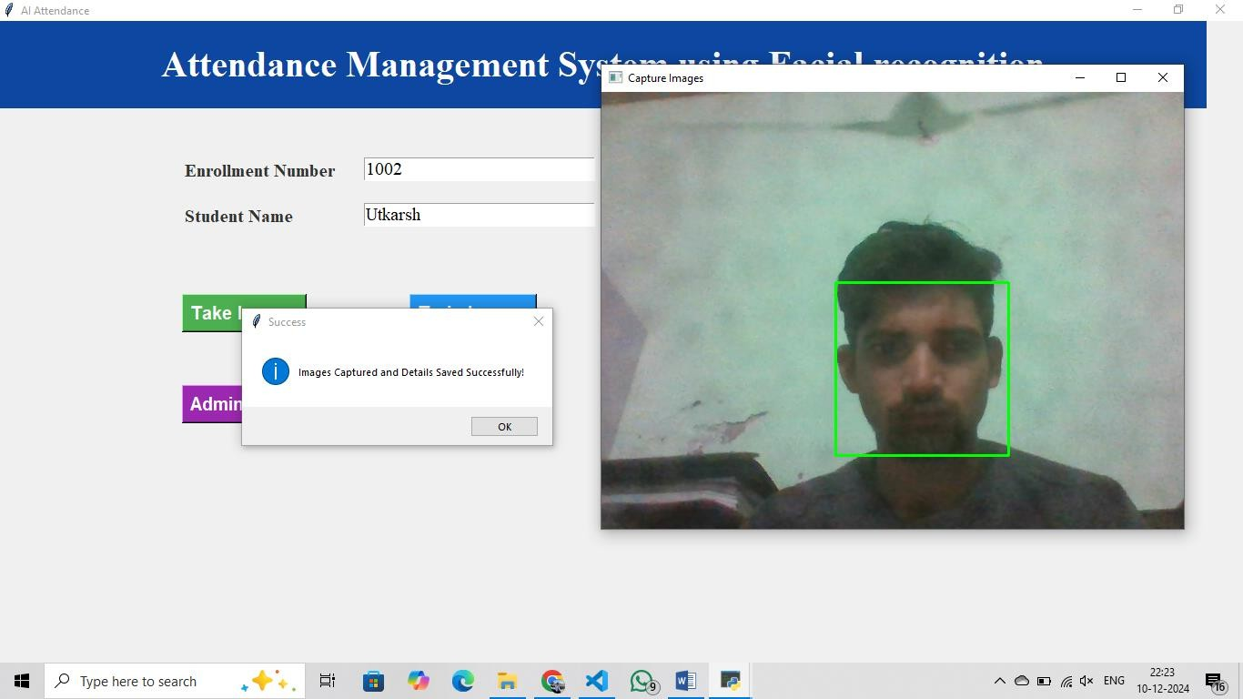

**Figure 3**: Snapshot of the Interface for Registering a New Student's Face in the Attendance System

p g . 10

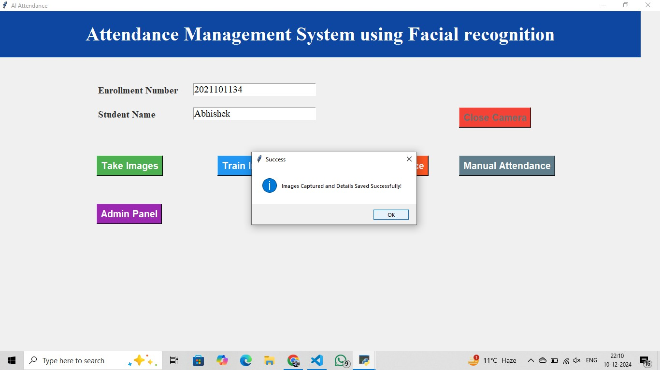



**Figure 4:** Registration Successful: The new face has been successfully registered in the system.

**Option :** Take Attendance

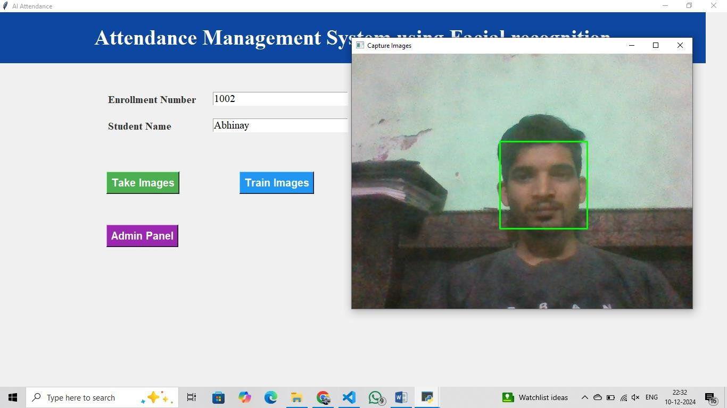

**Figure 5:** Camera Feed Display Before Attendance Registration

p g . 1 1

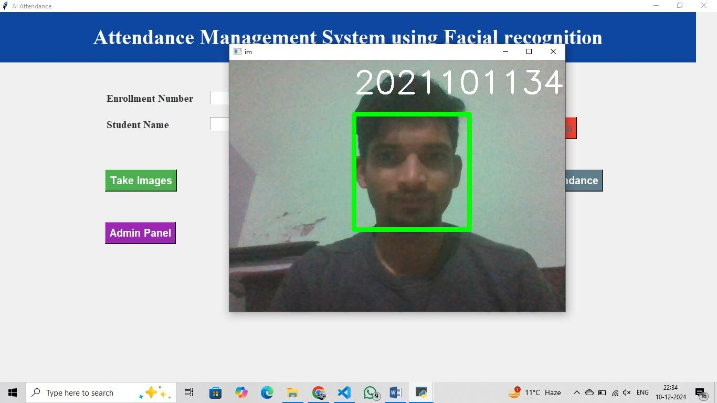



**Figure 6:** Camera Feed After Face is Registered and Logged for Attendance

##### Red and Green Color Feedback:

The camera feed in the system uses color codes to visually indicate the status of attendance. When the face is detected but not yet recognized, the feed appears in red, signaling that the system is processing the face but has not yet confirmed the identity. Once the face is successfully recognized and matched with a registered student, the feed turns green, confirming that attendance has been successfully registered for that individual. This color- coding system provides a clear and immediate visual cue to the user, ensuring efficient operation and accurate tracking.

p g . 1 2

|  |  |
| --- | --- |
| **Option :** Check the Logs    **Figure 8:** Interface for Checking Attendance Logs and Viewing Recorded Entries  **4.2 GitHub Link for Code:**  https://github.com/abhishekgangwar2108/Attendance-Management-  System-using-Face-Recognition  p g . 1 3 |  |
|  | |

# CHAPTER 5



## Discussion and Conclusion

#### Future Work:

##### Large-Scale Face Recognition for More Than 100 Faces Simultaneously

* + 1. **Efficient Preprocessing:**
       - Utilize **multi-threading** or **parallel processing** to handle video frames concurrently for high throughput.
       - Apply **batch face encoding** rather than processing faces one by one, significantly improving computational efficiency.

##### Optimized Algorithms:

* + - * Switch to lightweight, scalable models like **MobileFaceNet** or **YOLOv8**

for faster detection without compromising accuracy.

* + - * Use **approximate nearest neighbor (ANN)** algorithms like FAISS for matching face encodings rapidly, ideal for large datasets.

##### Hardware Scaling:

* + - * Deploy the system on a **GPU-enabled server** to handle simultaneous detections and encodings.
      * Integrate multiple cameras with **distributed processing** to expand coverage in larger environments.

##### Cloud-Based Deployment:

* + - * Store face encodings in a cloud database (e.g., Firebase, AWS DynamoDB) to ensure scalability.
      * Use cloud computing services for real-time data analysis and recognition, reducing local computational overhead.

##### Enhancing Efficiency and Robustness

1. **Advanced Techniques:**
   * Implement **active learning** to continually improve the recognition model by retraining on difficult-to-classify faces.
   * Integrate **pose estimation** to handle varying angles, enhancing recognition accuracy under real-world conditions.

##### Dynamic Adaptation:

* + Introduce **adaptive frame skipping** during continuous recognition, reducing redundant computations while maintaining accuracy.

##### Error Handling:

p g . 1 4

* + Develop robust mechanisms to detect and flag errors, such as duplicate recognition or lighting-induced misclassification.



##### User Interface (UI) Enhancements

1. **Modernized Design:**
   * Replace Tkinter with a more flexible and visually appealing framework like **PyQt5** or **Flutter**.
   * Introduce **drag-and-drop features** for uploading face images and managing data intuitively.

##### Accessibility Features:

* + Add **multilingual support** for diverse user bases.
  + Incorporate **voice-guided navigation** for hands-free operation.

##### Interactive Logs and Reporting:

* + Allow real-time visualization of attendance trends with interactive graphs and filters.
  + Enable bulk export of logs in multiple formats (CSV, Excel).

##### Future Work

1. **Integration with IoT Devices:**
   * Link with IoT-enabled attendance gates or turnstiles for seamless entry and exit management.
   * Use smart lighting or signaling systems to indicate attendance status visually in large halls.

##### Face Recognition in Challenging Conditions:

* + Deploy **infrared cameras** for better detection in low-light environments.
  + Develop occlusion-resilient models to recognize partially visible faces.

##### Data Privacy and Security:

* + Encrypt stored face encodings using secure algorithms like AES.
  + Implement GDPR-compliant policies to ensure user data safety and anonymity.

p g . 1 5

#### Conclusion:



The **Face Recognition-Based Attendance Management System** is a powerful solution that leverages advanced computer vision and machine learning techniques to streamline the traditional attendance process. This project highlights the intersection of technology and practicality, demonstrating its potential to improve efficiency, accuracy, and ease of use in educational institutions, workplaces, and event management scenarios.

The system's core features—real-time face detection, accurate recognition, color-coded feedback, and robust attendance logging—are designed for simplicity and effectiveness. The intuitive user interface, built using Tkinter, ensures accessibility for a wide range of users, from administrators to end-users.

This project lays a strong foundation for future improvements, including:

* + 1. **Scalability:** Enhancing the system to handle hundreds of faces simultaneously with cloud-based storage and processing.
    2. **Advanced Recognition:** Overcoming challenges like poor lighting, occlusion, and facial variations using advanced algorithms and hardware.
    3. **Improved User Experience:** Upgrading the interface for a more modern, dynamic, and user-friendly experience.
    4. **Data Privacy and Security:** Ensuring the system adheres to strict privacy standards with robust encryption and secure storage mechanisms.

The successful implementation of this project demonstrates how AI and face recognition technologies can automate and improve mundane tasks while paving the way for broader applications such as security systems, personalized services, and smart environments.

By addressing limitations and expanding functionalities, this project has the potential to evolve into a comprehensive attendance management platform with multi-domain applications, embodying a forward-thinking approach to real-world problems.

p g . 1 6

# REFERENCES



1. C. Anilkumar, B. Venkatesh, and S. Annapoorna, “Smart Attendance System with Face Recognition using OpenCV,” in *2023 Second International Conference on Augmented Intelligence and Sustainable Systems (ICAISS)*, IEEE, Aug. 2023, pp. 1149–1155. doi: 10.1109/ICAISS58487.2023.10250715.
2. J. P. Jeong, M. Kim, Y. Lee, and P. Lingga, “IAAS: IoT-Based Automatic Attendance System with Photo Face Recognition in Smart Campus,” in *2020 International Conference on Information and Communication Technology Convergence (ICTC)*, IEEE, Oct. 2020, pp. 363–

366. doi: 10.1109/ICTC49870.2020.9289276.

1. S. Kakarla, P. Gangula, M. S. Rahul, C. S. C. Singh, and T. H. Sarma, “Smart Attendance Management System Based on Face Recognition Using CNN,” in *2020 IEEE-HYDCON*, IEEE, Sep. 2020, pp. 1–5. doi: 10.1109/HYDCON48903.2020.9242847.
2. A. Raghuwanshi and P. D. Swami, “An automated classroom attendance system using video based face recognition,” in *2017 2nd IEEE International Conference on Recent Trends in Electronics, Information & Communication Technology (RTEICT)*, IEEE, May 2017, pp. 719–724. doi: 10.1109/RTEICT.2017.8256691.
3. S. Sawhney, K. Kacker, S. Jain, S. N. Singh, and R. Garg, “Real-Time Smart Attendance

System using Face Recognition Techniques,” in *2019 9th International Conference on Cloud Computing, Data Science & Engineering (Confluence)*, IEEE, Jan. 2019, pp. 522–525. doi: 10.1109/CONFLUENCE.2019.8776934.

1. K. Painuly, Y. Bisht, H. Vaidya, A. Kapruwan, and R. Gupta, “Efficient Real-Time Face Recognition-Based Attendance System with Deep Learning Algorithms,” in *2024 International Conference on Intelligent and Innovative Technologies in Computing, Electrical and Electronics (IITCEE)*, IEEE, Jan. 2024, pp. 1–5. doi: 10.1109/IITCEE59897.2024.10467743.
2. Z. Yu, Y. Qin, X. Li, C. Zhao, Z. Lei, and G. Zhao, “Deep Learning for Face Anti-Spoofing: A Survey,” *IEEE Trans Pattern Anal Mach Intell*, pp. 1–22, 2022, doi: 10.1109/TPAMI.2022.3215850.
3. K. M. M. Uddin, A. Chakraborty, Md. A. Hadi, M. A. Uddin, and S. K. Dey, “Artificial Intelligence Based Real-Time Attendance System Using Face Recognition,” in *2021 5th International Conference on Electrical Engineering and Information Communication Technology (ICEEICT)*, IEEE, Nov. 2021, pp. 1–6. doi: 10.1109/ICEEICT53905.2021.9667836.
4. H. Sultan, M. H. Zafar, S. Anwer, A. Waris, H. Ijaz, and M. Sarwar, “Real Time Face Recognition Based Attendance System For University Classroom,” in *2022 2nd International Conference on Artificial Intelligence (ICAI)*, IEEE, Mar. 2022, pp. 165–168. doi: 10.1109/ICAI55435.2022.9773650.

p g . 1 7

1. A. M. Tripathi, A. K. Rai, and D. Pandey, “Face Recognition-Based Automated Attendance System,” in *2024 IEEE International Conference on Computing, Power and Communication Technologies (IC2PCT)*, IEEE, Feb. 2024, pp. 563–565. doi: 10.1109/IC2PCT60090.2024.10486785.



p g . 1 8