Databricks

<https://community.cloud.databricks.com/?o=2274764229456135#>

[srihariprasad@yahoo.com](mailto:srihariprasad@yahoo.com) (login id)

where practice exercise and material is saved ….. see below

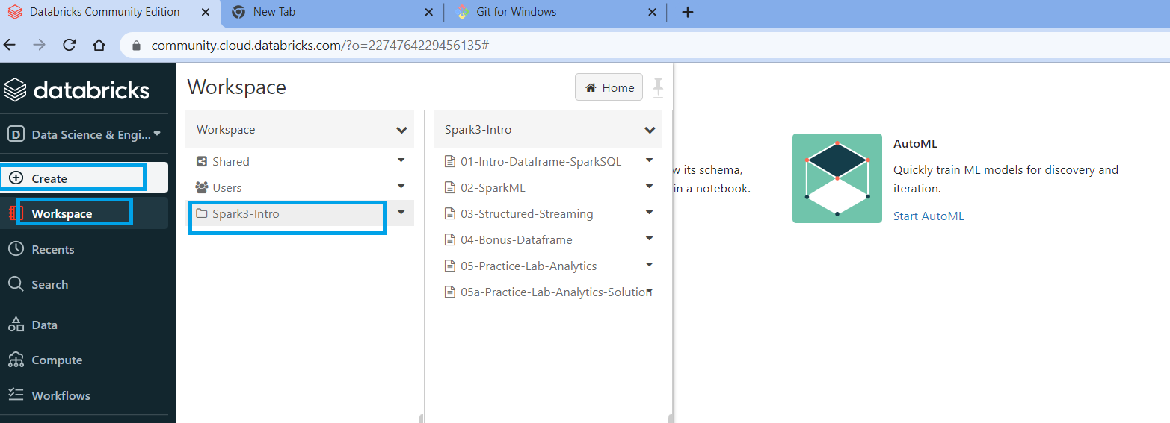

<https://community.cloud.databricks.com/?o=2274764229456135#folder/3487119796185052>

how to create a spinout a cluster for practice

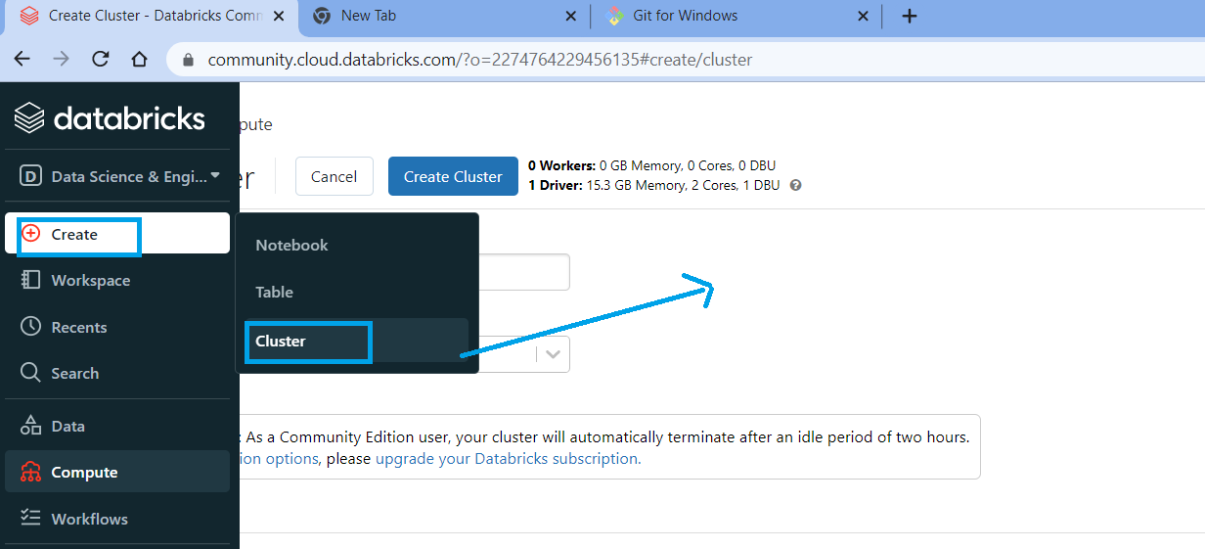

How to create a notebook to practice spark

