About Us

Taksha Engineering Pte Ltd is a Singapore-based company specializing in repair and redecoration works, renovation services and comprehensive painting services for commercial, industrial, and residential properties.

With over 10 years of industry experience, we have established ourselves as a trusted contractor known for delivering quality workmanship and reliable service. Our portfolio includes a wide range of successfully completed projects across both private and public sectors, including residential units, industrial buildings, hospitals, and landed properties.

At Taksha Engineering, we are committed to meeting our clients’ needs with professionalism, efficiency, and attention to detail—ensuring every project is completed to the highest standards.
Established in 2017, Taksha Engineering has grown into a strong multi-disciplinary company with expertise across a wide range of construction trade works and projects.
We operate our own fabrication facility located at Blk 12, Lorong Bakar Batu, enabling us to maintain strict quality control, efficient production, and timely project delivery.
Our team comprises experienced technical personnel and a highly skilled workforce who are well-equipped to manage complex designs and technical challenges. We work both independently and collaboratively with our clients to deliver practical, cost-effective, and high-quality solutions.
Taksha Engineering is committed to maintaining high industry standards and safety compliance:
- BCA Registered Contractor
CR09 – Repairs & Redecoration - L4
CR13- Waterproofing Installation - L1
- BizSAFE Star Certified
- ISO 45000:2018
- ISO 90001:2015
With professionalism, integrity, and a strong focus on workmanship, we continue to build long-term partnerships with our clients and stakeholders.

OUR VISION
- To strive to deliver our services with the highest quality, executing efficiently and in a timely manner to ensure maximum customer satisfaction.
- To be a value-added partner to our suppliers, contractors, and customers.
- To become a world-leading manufacturer and fabricator of stainless steel, brass, metal, and glass products.

OUR MISSION
- To provide excellent products and services with prompt delivery and competitive pricing.
- To achieve customer satisfaction through a “zero-defect” mindset, driven by teamwork, innovation, and continuous improvement.
- To maintain the highest levels of professionalism and integrity in our relationships with suppliers, contractors, and customers.

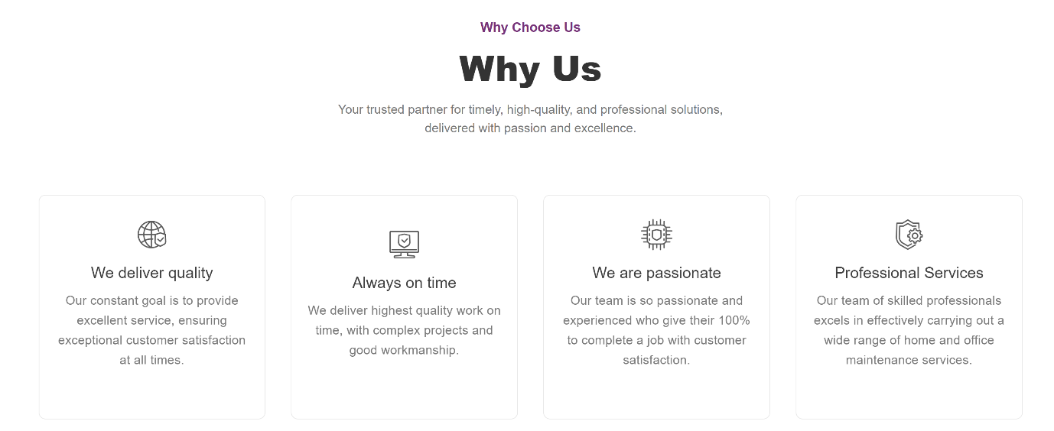
Change the format:
Painting Service:
Reliable Painting is your trusted partner for high-quality, professional painting services in Singapore. Backed by a skilled team and a proven track record, we are known for delivering outstanding results that not only meet expectations—but exceed them.
With extensive experience in the painting and repainting industry, we understand what it takes to transform your space. Whether it’s interior (in-house) or exterior painting, we provide tailored solutions designed to suit your needs, style, and budget. From helping you choose the right products to executing every detail with precision, our experienced painters ensure a flawless, long-lasting finish every time.
What sets us apart is our commitment to excellence and value. We combine premium workmanship with competitive pricing, so you get exceptional results without overspending. No shortcuts, no compromises—just reliable service you can count on.

Residential (HDB) Private Residential Landed property

Private Residential Hospital

Bird Netting Services
Our bird netting provides a durable and humane solution to keep birds out while remaining visually discreet. Easy to install on buildings, balconies, and roof areas, it blends seamlessly without affecting aesthetics.
It also protects your property from damage caused by bird droppings and nesting debris, keeping your space clean and well-maintained.

FIRE REDEDNT BIRD NETTING BIRD SPIKES GMS PVC COATED NETTING

Facade Maintenance Services
Regular facade maintenance helps extend a building’s lifespan and prevent costly damage. Taksha Engineering offers services including glass replacement and installation, cleaning, re-sealant application, and gasket replacement to keep your building in top condition.

Tension Membrane Installation & Repair
We provide professional tension membrane installation and repair services, delivering durable, weather-resistant, and visually striking structures for both residential and commercial projects. Our solutions are ideal for canopies, walkways, facades, and outdoor coverings.
From new installations to repair and maintenance works, our experienced team ensures precise fitting, high-quality materials, and long-lasting performance. We also handle inspections, re-tensioning, and replacements to maintain structural integrity and appearance over time.
With a focus on safety, functionality, and design, we offer reliable and cost-effective solutions tailored to your project needs.

Fire-Rated Ceiling & Partition Works
We provide professional fire-rated ceiling and partition solutions designed to enhance building safety and meet regulatory requirements. Our systems are built to effectively compartmentalize spaces, helping to slow the spread of fire and protect critical escape routes.
Using high-quality materials such as fire-rated plasterboards (15mm), steel framing systems, and rockwool insulation, we deliver installations that achieve 1-hour to 2-hour fire ratings. Our services are suitable for both residential and commercial projects.
With a focus on safety, compliance, and workmanship, we ensure reliable and durable fire protection solutions tailored to your building needs.

Aluminium Works
We provide high-quality aluminium works for residential and commercial projects, offering durable, lightweight, and corrosion-resistant solutions. Our services include fabrication and installation of aluminium doors, windows, partitions, frames, and custom structures.
With skilled workmanship and attention to detail, we ensure precise fitting, modern aesthetics, and long-lasting performance tailored to your project requirements.

Metal Roofing Works
We specialize in metal roofing services, offering durable, weather-resistant, and low-maintenance solutions for residential and commercial projects. Our services include installation, repair, and maintenance of metal roofs, ensuring long-lasting protection and structural integrity.
With high-quality materials and expert workmanship, we deliver efficient and reliable metal roofing systems that combine strength, functionality, and aesthetic appeal.

Canopy Works
We provide professional canopy solutions for residential and commercial properties, combining functionality with aesthetic appeal. Our services include design, fabrication, installation, and maintenance of canopies using durable materials such as steel, aluminum, and tension membranes.
With precision workmanship and high-quality materials, we deliver canopies that offer weather protection, enhance outdoor spaces, and complement the overall building design.
Fire-Rated & Non-Fire-Rated Glass Works
We specialize in both fire-rated and non-fire-rated glass solutions for residential and commercial projects. Our fire-rated glass systems provide enhanced safety by helping to contain fire and smoke, while our non-fire-rated glass options focus on aesthetics, natural light, and modern design.
Our services include installation, replacement, partitions, curtain walls, and custom glass features, using high-quality materials for durability, precision, and a sleek finish tailored to your project needs.
General Construction Works
We provide a wide range of general construction services, including drain installation, apron construction, and boundary wall building. Our team delivers durable and high-quality structures that meet functional requirements and enhance the overall safety and aesthetics of your property.
With skilled workmanship and attention to detail, we ensure timely and efficient project completion for both residential and commercial sites.

Demolition & Reinstatement Works
We offer professional demolition and reinstatement services for residential and commercial projects. Our team safely and efficiently handles the removal of structures, walls, or fixtures, followed by precise reinstatement to restore the area to its original or improved condition.
With a focus on safety, compliance, and quality workmanship, we ensure minimal disruption and durable results tailored to your project requirements.

Waterproofing Works
We provide professional waterproofing services to protect residential and commercial buildings from water damage. Our solutions include roof, terrace, basement, and bathroom waterproofing using high-quality membranes, coatings, and sealants.
With expert application and durable materials, we ensure long-lasting protection, prevent leaks, and maintain the structural integrity of your property.

