**Introduction to Ajax:**

Ajax is not a programming language, it’s the script.  Ajax means, Asynchronous java script and xml, and this is the type of programming made popular in 2005 by Google suggest [Google search, while we are typing something in Google search box it will show you some suggestions automatically right that is Ajax]

With Ajax we can move the data from our web page to the server, and we can update the part of our web page without refreshing the entire page.  We can able to make background server calls for fetching addition data, Updating some portion in web page without refreshing the whole page.

JavaScript and CSS, XML a little before we start Ajax programs.

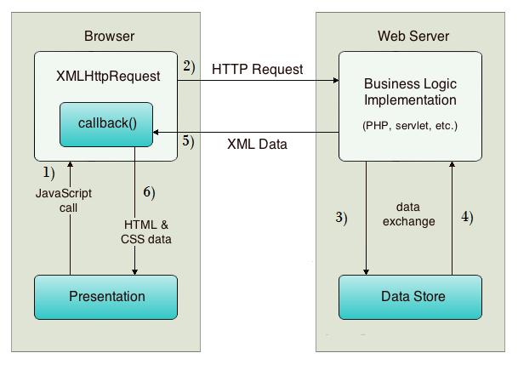

XMLHttpRequest object plays a important role.

1. User sends a request from the UI and a javascript call goes to XMLHttpRequest object.
2. HTTP Request is sent to the server by XMLHttpRequest object.
3. Server interacts with the database using JSP, PHP, Servlet, ASP.net etc.
4. Data is retrieved.
5. Server sends XML data or JSON data to the XMLHttpRequest callback function.
6. HTML and CSS data is displayed on the browser.

Actually, Synchronous means at a time we can send single request and we need to wait for the response before send the second request, and Asynchronous means we can send the second request before we get the response of first request, Ajax is the example of this Asynchronous type.

<html>

<head>

<script>

function fun1()

{

var a;

if (window.XMLHttpRequest)

{// If the browser if IE7+[or]Firefox[or]Chrome[or]Opera[or]Safari

a=new XMLHttpRequest();

}

else

{//If browser is IE6, IE5

a=new ActiveXObject("Microsoft.XMLHTTP");

}

a.onreadystatechange=function()

{

if (a.readyState==4 && a.status==200)

{

document.getElementById("myDiv").innerHTML=a.responseText;

}

}

a.open("POST","first.txt",true);

a.send();

} // fun1() close

</script>

</head>

<body>

<div id="myDiv" style="width: 300px; height: 30px;">Click on the button below</div>

<button type="button" onclick="fun1()">Change Content</button>

</body>

</html>

<!-- Explanation

Once the document loaded then immediately we will be able to see one button Change Content , and see i have been given onclick=”fun1()” [ line number 33 ] means once we click on this button controller will go to line number 4 and will starts execute that fun1()

At line number 6, i have taken one variable with name a

For any ajax program, we must create one request object to send our ajax request to the server, that ajax object is nothing but XMLHttpRequest object

See line number 8, i have written window.XMLHttpRequest means am checking whether my browser supports XMLHttpRequest object or not, if yes assigning XMLHttpRequest object into a [ a=new XMLHttpRequest(); ] else i mean if our web browser doesnt supports XMLHttpRequest object then we can assign ActiveXObject [ which supports old web browsers ] into our variable a [ a=new ActiveXObject(“Microsoft.XMLHTTP”); ]

So from line numbers 8 -15 request object creation work been done

Now controller directly jumps to line number 25, and opens the connection and send the request to first.txt (this is my notepad file), see actually the 3rd parameter i have given as true means Asynchronous data transfer will be activated

Finally request will be sent in line number 26, that’s it.

If server sends the response back to our application then controller will automatically execute from line number 17 – 23, you may get one doubt like why its not executed initially… ? there is a reason actually this a.onreadystatechange=function() executes only when we get the response from the server, hope you are clear ;)

**Ajax Request, open () and send () methods**

In Ajax if we want to send the request to the server, we have 2 methods in XMLHttpRequest object to do this work, those are open () and send ().

Actually open () method will opens the connection with the server and send will sends our request object to the server.

Let we took the XMLHttpRequest object into one variable called obj then

obj.open(” POST “, ” destination URL “,true);

obj.send();

open() method has 3 parameters, first parameter having the values POST/GET this is depends on our requirement, my choice is always POST, because its having security than GET

Second parameter is the destination, to where we need to send the request. It may be any file path or url or url patterns [ in java ] or what ever

Third parameter having the values true/false, actually true means we are opening Asynchronous data transfer, and false means Synchronous.

Finally send() method will send the request object to the server.

# Ajax Server Response, responseText and responseXML

Once we send the request to the destination [ server ], we will get the response from the server in two formats either in Text or XML, i mean we can get the response from the server by using responseText and responseXML propertys of our XMLHttpRequest object

responseText — for getting the response in the format of text

responseXML — for getting the response in the format of XML

# Ajax onreadystatechange Event Of XMLHttpRequest Object

Once the request been sent to the server, changes will happen in the current webpage based on the response only. The onreadystatechange event will be triggered every time the readyState changes.

onreadystatechange

A function will be stored and will be called automatically each time readyState property changes

readyState

0 – request not initialized

1 – connection been established with the server

2 – request received from the server

3 – request being processing

4 – request finished and response is ready

status

200 : ok

404 : page not found, it’s normal 404 error

So, readyState = 4 & status = 200 then everything will be perfect, i mean we got the response from the server, and our webpage will be modified with the response text/xml.