
Performance Qualification Document
for
Clinevo OnePV Intake System 1.1
(Manual Case Registration – Adverse Event Case)

Environment: Production

PRE-APPROVAL
Author(s)
Name | Designation / Department | Signature and Date
Harikrishna S | Senior Consultant / Consulting and Support
Reviewer(s)
Name | Designation / Department | Signature and Date
Siva Sai Kanipakam | Associate Validation Manager / Testing
Abdul Hameed | Product Manager / Development
Aarti Singh | QA Lead / QA
Approver(s)
Name | Designation / Department | Signature and Date
Ashish B | Vice President/ Product Development
Prasanna Gurumoorthy | Senior Vice President/ Product Development

TABLE OF CONTENT

1.0 Introduction 6
1.1 Purpose 6
1.2 Scope 6
1.2.1 In Scope 6
1.2.2 Out of Scope 6
2.0 System Overview 6
3.0 Acceptance Criteria 6
4.0 Pass / Fail Criteria 7
5.0 Individual Identification Log 7
6.0 Performance Qualification Test Scripts 8
6.1 Test Set# 1: Manual Case Registration Adverse Event Case 8
7.0 Performance Qualification Summary 30
8.0 Revision History 30

Term and Expansion
Term | Expansion
CLIN | Clinevo
CR | Change Request
DB | Database
FRS | Functional Requirements Specifications
SRS | System Requirements Specifications
HTTPS | Hypertext Transfer Protocol Secure
ID | Identification
NA | Not Applicable
PQ | Performance Qualification
QA | Quality Assurance
PROD | Production
OPV | One Pharmacovigilance
EU | European Union

Introduction

Purpose
The purpose of this Performance Qualification (PQ) document is to verify the Clinevo OnePV Intake System 1.1 operates and performs to meet all the requirements specified in the System Requirements specification and Functional Requirements specification (SRS and FRS).

Scope

In Scope
The scope of this Performance Qualification (PQ) document is limited to OnePV Intake System 1.1 to ensure better quality management, completeness and timeliness.

Out of Scope
Not applicable (NA).

System Overview
The OnePV Intake Application supports pharmacovigilance case intake and processing activities by allowing authorized users to receive, review, and manage safety information from various intake channels. The system enables case registration, classification, and workflow management through a centralized interface. It also provides search and dashboard functionalities to help users track and manage intake cases efficiently. The application operates within a validated environment and uses role-based access control to ensure secure and compliant processing of pharmacovigilance data.

Acceptance Criteria
Expected result shall be identified for each step of the document and the actual results shall be evaluated against the acceptance criteria. Based on the evaluation, a determination shall be made by the executor as to whether the script meets the criterion (pass) or results to discrepancy (fail).

The results of the protocol execution shall be accepted, and the system shall be considered qualified under the following conditions:
- All required scripts have been successfully executed, the objectives have been met and all corresponding evidences are attached.
- All the discrepancies observed (if any) during the execution have been adequately resolved or addressed and approved.
- Appropriate documentation has been gathered, referenced, and stored.

Pass / Fail Criteria
Pass or Fail determinations shall be made upon evaluating the following:
- The Actual Result matches the Expected Result.
- The documentation associated with the execution is available.
- Pass or Fail is written in full at appropriate places.

Individual Identification Log
Description: This Log will ensure that all individuals involved in execution within the document can be readily identified.

Procedure: All individuals who participate in the execution, review, and / or any approach of this document must complete the information listed in the table below.

Name and Department | Role / Designation | Initials
Siva Sai Kanipakam and Testing | Reviewer /Associate Validation Manager | S.S.K
Abdul Hameed and Development | Reviewer / Product Manager | A.H
Aarti Singh and QA | Reviewer / QA Lead | A.S

Performance Qualification Test Scripts

Test Set# 1: Manual Case Registration Adverse Event Case
Test Case #: |  | Test Case Name: | Manual Case Registration - Adverse Event Case | Run #: | 01
Test Objective |  | To verify Manual Case Registration for Adverse Event Case Functionality.
Pre-Requisites: |  | The user accounts used in this test set has been provisioned with appropriate permissions within the Clinevo OnePV Intake System to perform this test set.

Test Case #: |  | Test Case Name: | Manual Case Registration – Adverse Event Case
Step # | Procedure |  | Expected Results | Does Observed Result Match Expected Result? Pass/ Fail (if Fail give details) | Initials / Date
1 | Scenario:  Accessing into Clinevo OnePV Intake Production Environment.  Steps to be followed:  - Open Browser.  - Enter the Production URL  URL: https://prod.one-aipv.com/login  - Click on the Enter (Keyboard operation).  (Refer expected result)  µ |  | Clinevo OnePV Intake Production login page shall display. | Pass  Login page displayed successfully. | S.B. / 15-Oct-2026  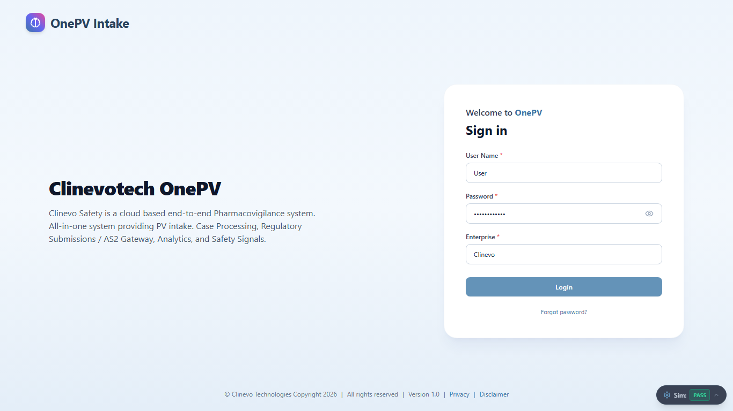
2 | Scenario:  Login to Clinevo OnePV system  Steps to be followed:  - Enter the following details in Login Page  - User Name:  (Enter user name in text field)  - Password:  (Enter the password)  Note: Enter the valid password for the user account at the runtime. User entered password at the runtime will be masked for security reasons  - Enterprise: Clinevo  (Enter the enterprise in the text field)  - Click on Login button.  (Refer expected result)  µ |  | On clicking Login button, user shall login into Clinevo OnePV Intake system and in the homepage, top right side logged-in username and logged on date and timestamp shall display. | Pass  Logged in as sirihari.banda. Header username and timestamp verified. | S.B. / 15-Oct-2026  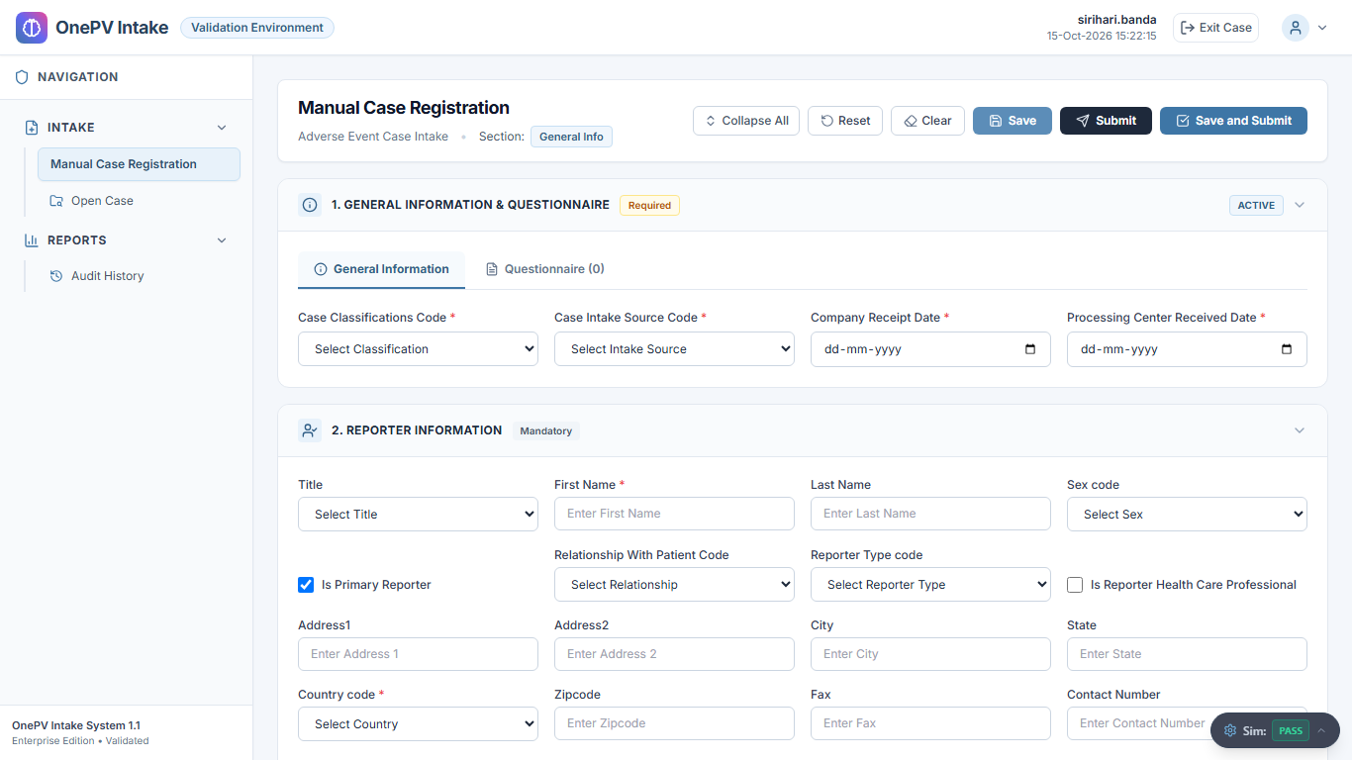
3 | Scenario:  System shall allow to navigate Manual Case Registration page.  Steps to be followed:  From left menu under Intake, Click on Manual Case Registration.  (Refer expected result)  µ |  | Manual Case Registration shall display. | Pass  Step TS1-S03 executed and verified successfully. | S.B. / 15-Oct-2026
4 | Scenario:  System shall allow to Register Case.  Steps to be followed:  - In Manual Case Registry Page, under general info section enter the data in below fields,  - Case Classifications Code: Adverse Event  (Select case classification from dropdown)  - Case Intake Source Code:  (Select from the dropdown)  - Company Receipt Date:  (Select the date from the calendar)  - Processing Center Received Date:  (Select the date from the calendar)  - Click on the Save button.  (Refer expected result)  µ  - Click on OK button from the confirmation message. |  | System shall register case successfully with confirmation message and temporary case Id shall create. | Pass  Verified: System registered case successfully. Case ID TMP-CASE-7214 generated. | S.B. / 15-Oct-2026  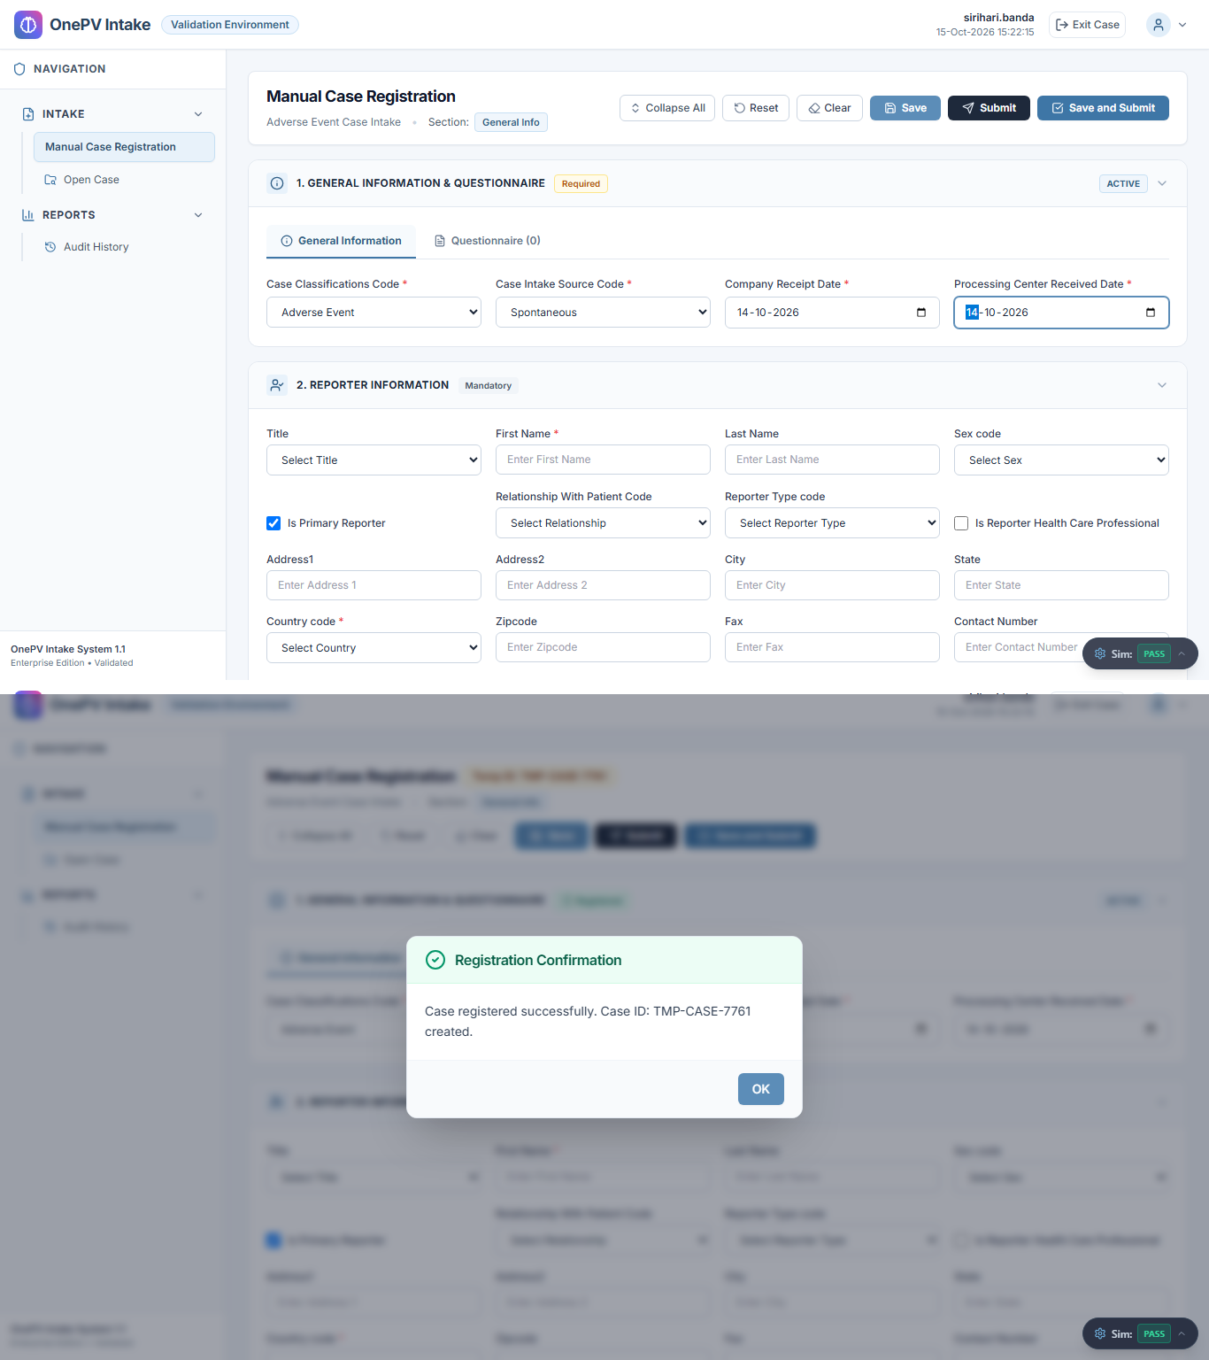
5 | Scenario:  System shall allow to add Questionnaire manually.  Steps to be followed:  - Under General Info, from Questionnaire tab click on add questions button.  (Refer expected result 1)  - In Additional Question message, click on Add Questions Manually radio button and enter data in below fields,  - Field Type:  (Select from the dropdown)  - Question:  (Enter question in the text field)  - Click on the Save button.  (Refer expected result 2)  µ  - Click on OK button from the confirmation message. |  | - System shall display Additional Questions message  - System shall manually add questions with confirmation message and display under Questionnaire tab. | Pass  Step TS1-S05 executed and verified successfully. | S.B. / 15-Oct-2026  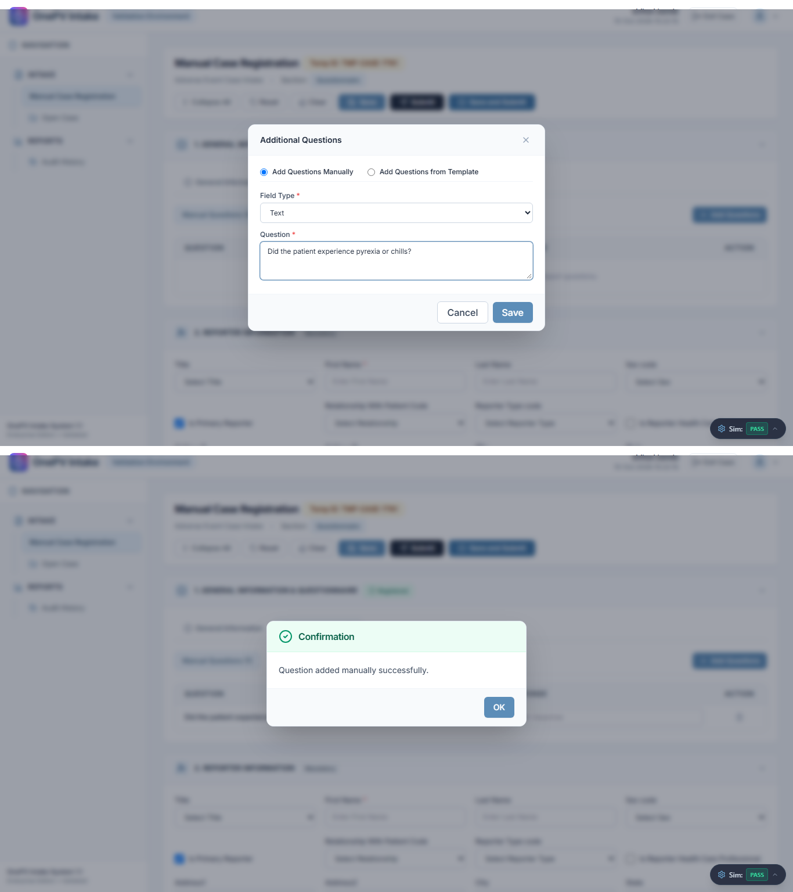
6 | Scenario:  System shall allow to provide response for manually created question.  Steps to be followed:  - Under response column, enter the response for the added questions.  - Under Questionnaire tab, click on the Save button.  (Refer expected result)  µ  - Click on OK button from the confirmation message. |  | Data shall save successfully with confirmation message. | Pass  Step TS1-S06 executed and verified successfully. | S.B. / 15-Oct-2026  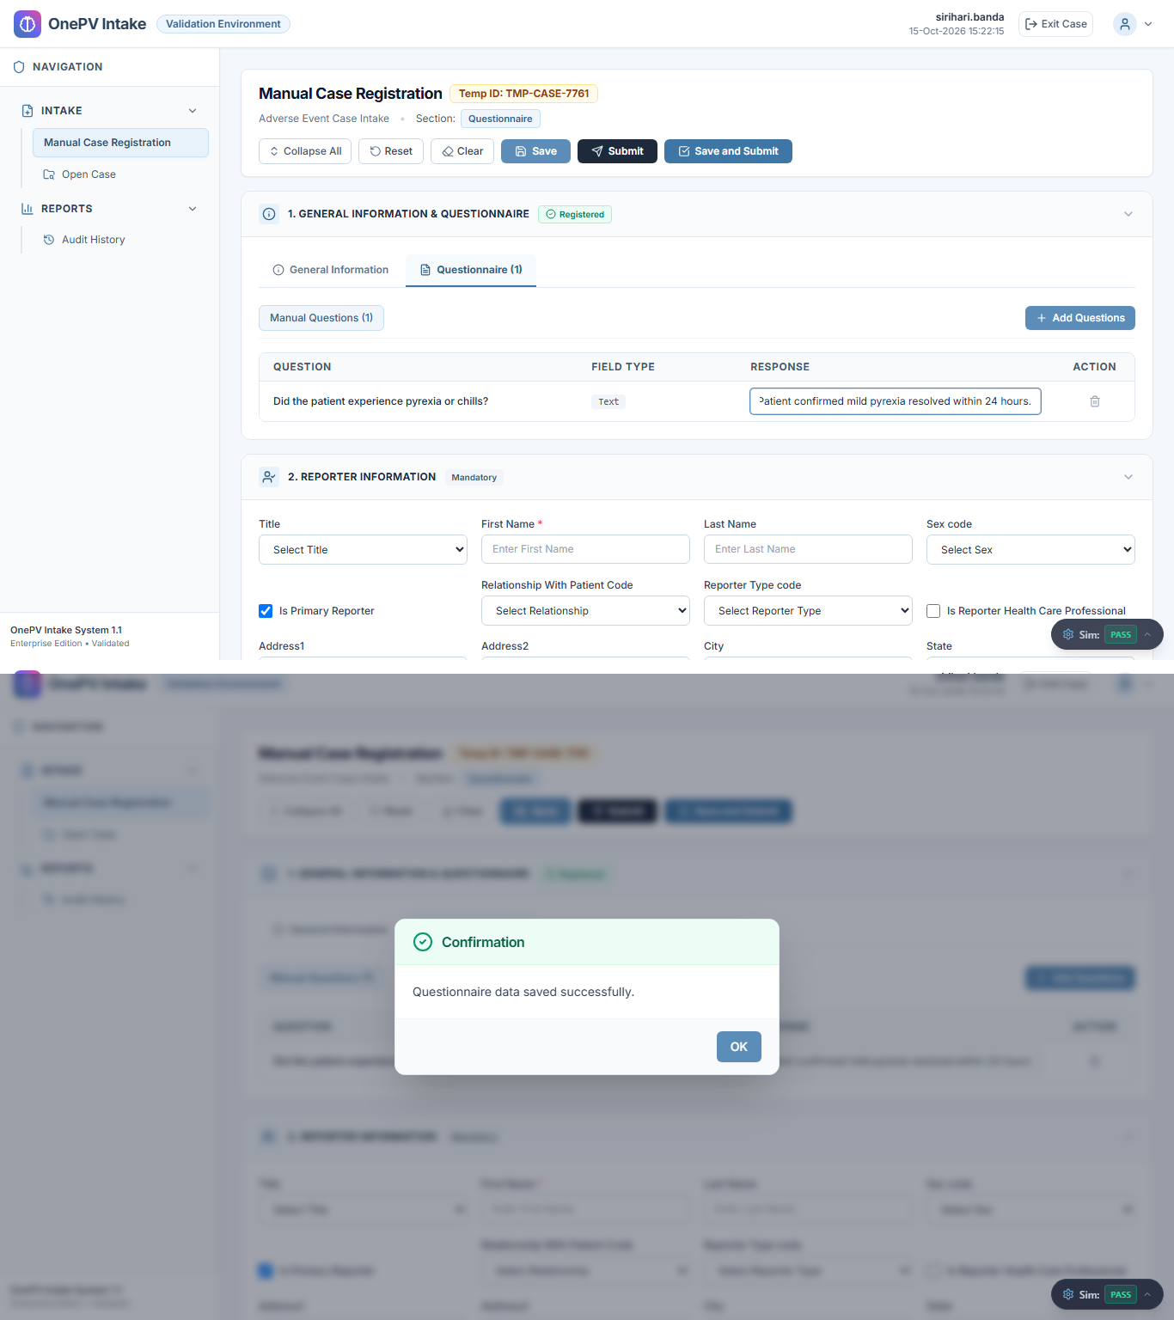
7 | Scenario:  System shall allow to add Questionnaire from template.  Steps to be followed:  - Under General Info, from Questionnaire tab click on add questions button.  - In the Additional Question message, click on Add Questions from Template radio button and select template.  - Click on Select button.  (Refer expected result)  µ  - Click on OK button from confirmation message. |  | Template shall add successfully with confirmation message. | Pass  Step TS1-S07 executed and verified successfully. | S.B. / 15-Oct-2026  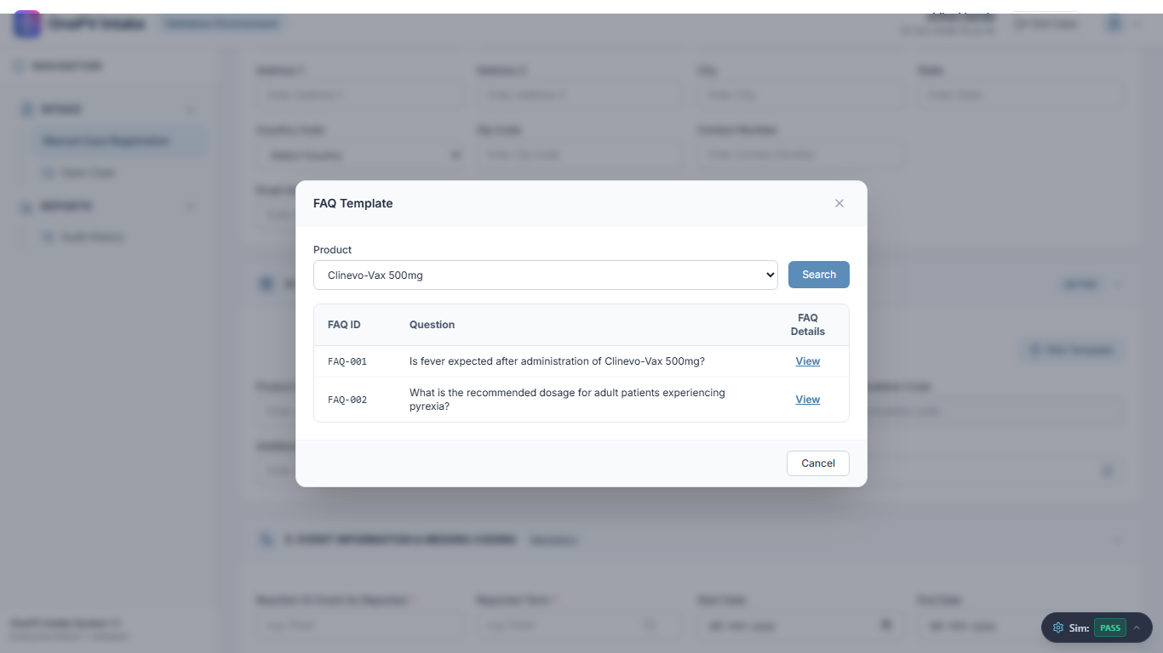
8 | Scenario:  System shall allow to provide response for created question from template under Questionnaire tab.  Steps to be followed:  - Under Questionnaire section, click on imported template tab.  - Under response column, Enter the data for the provided question.  - Under Questionnaire tab, click on the Save button.  (Refer expected result)  µ  - Click on OK button from confirmation message. |  | Data shall save successfully with confirmation message. | Pass  Step TS1-S08 executed and verified successfully. | S.B. / 15-Oct-2026  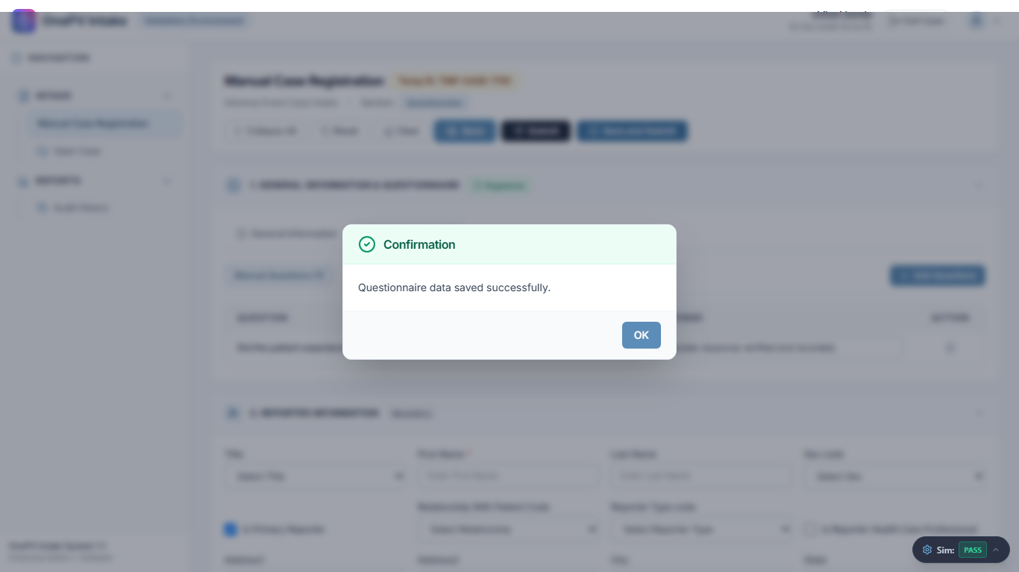
9 | Scenario:  System shall allow to add reporter.  Steps to be followed:  - Under Reporter section, enter data in below details:  - Title:  (Choose the value from dropdown)  - First Name:  (enter the data)  - Last Name:  (enter the data)  - Sex code:  (Select from dropdown)  - Relationship With Patient Code:  (Select from dropdown)  - Reporter Type code:  (Select from dropdown)  - Is Reporter Health Care Professional:  (Enable toggle button)  - Address1:  (enter the data)  - Address2:  (enter the data)  - City:  (enter the data)  - State:  (enter the data)  - Country code:  (Choose Country from the dropdown)  - Zipcode:  (enter the data)  - Fax:  (enter the data)  - Contact Number:  (enter the data)  - Email Address:  (enter the data)  - Click on the Save button.  (Refer expected result)  µ  - Click on OK button from confirmation message. |  | System shall add Reporter information successfully with Confirmation message. | Pass  Reporter information (16/16 fields) saved successfully with confirmation message. | S.B. / 15-Oct-2026  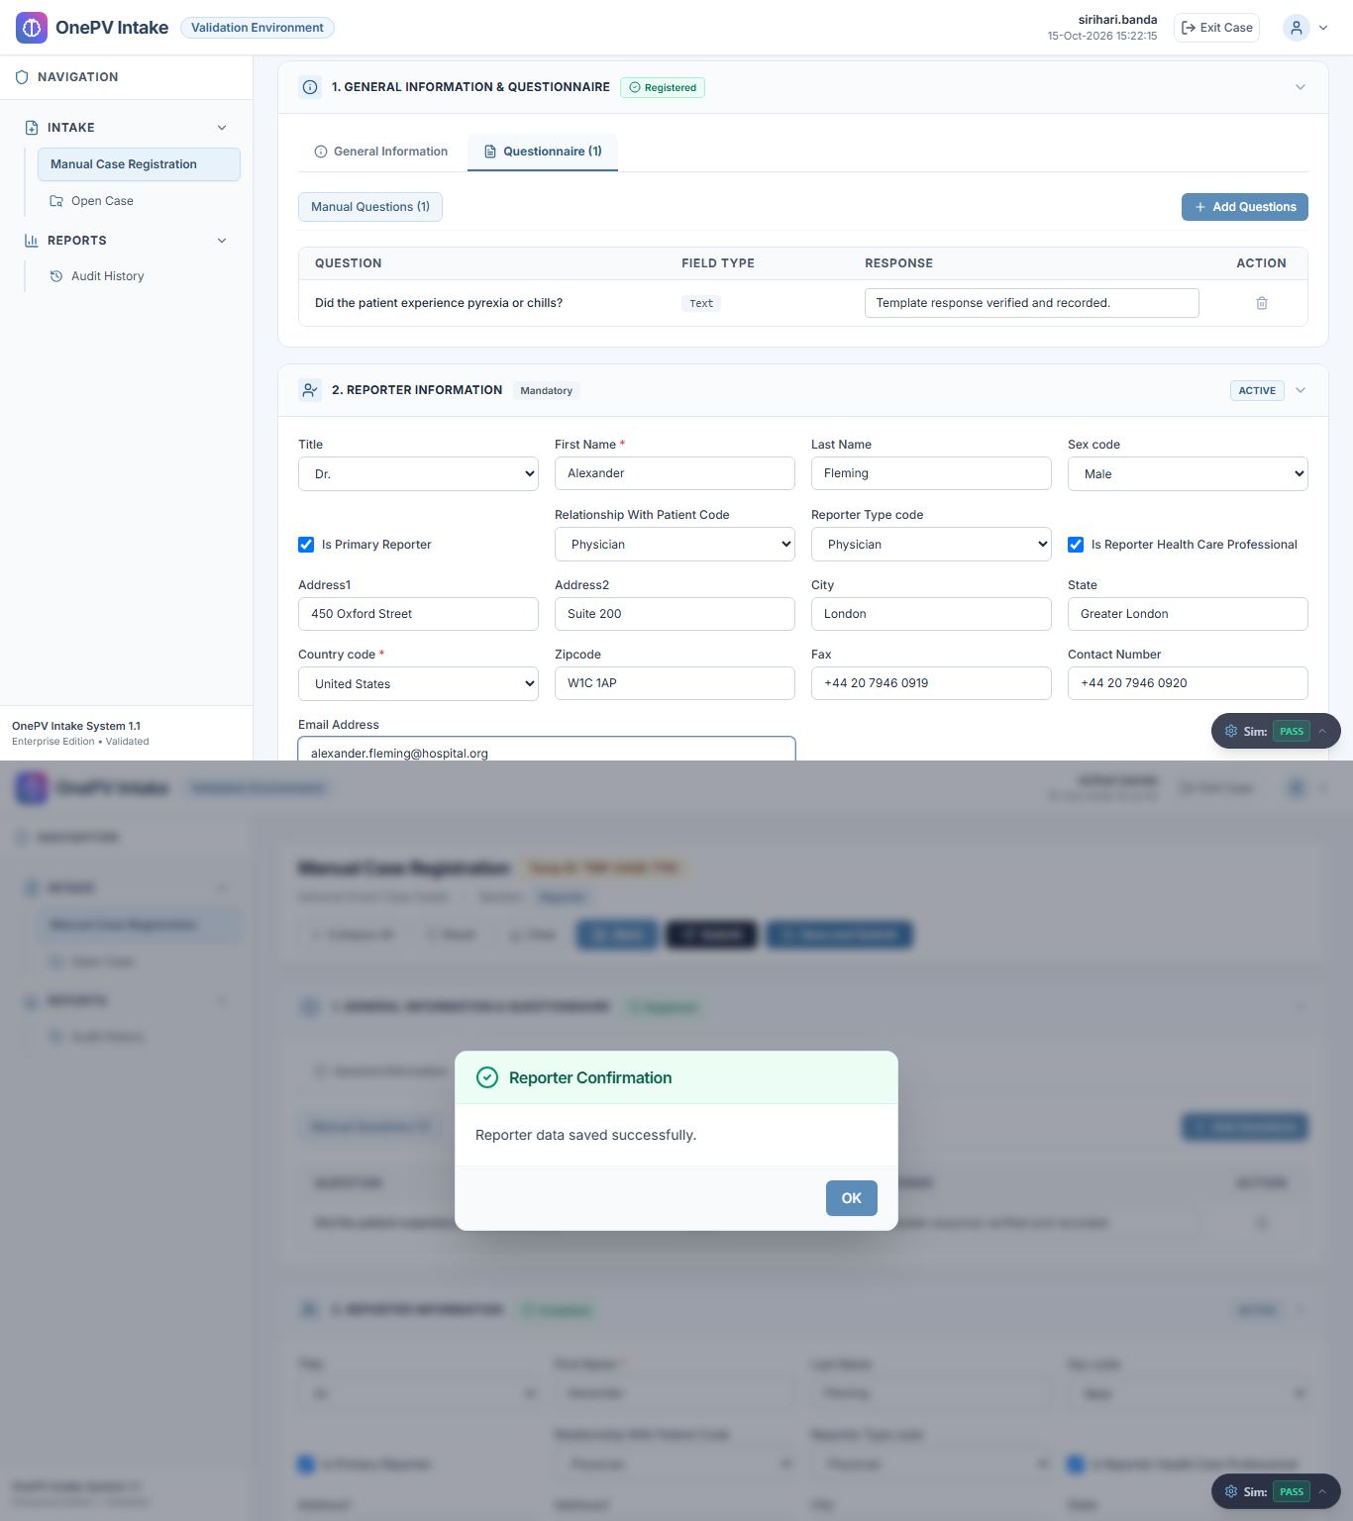
10 | Scenario:  System shall allow to Add Patient information.  Steps to be followed:  - Under Patient Information section, enter the data in below details:  - Initials:  (Enter the data)  - Is Reporter As Patient: No  (Select from the dropdown)  - Title:  (Select from dropdown)  - First Name:  (Enter the data)  - Last Name:  (Enter the data)  - Occupation:  (Enter the data)  - Date of Birth:  (Select date)  - Sex Code:  (Enter the value from dropdown)  - Address 1:  (Enter the data)  - Address 2:  (Enter the data)  - State:  (Enter the state)  - Country Code:  (Enter the value from dropdown)  - Zip Code:  (Enter the data)  - Contact Number:  (Enter the data)  - Email Address:  (Enter the data)  - Click on Save button.  (Refer expected result)  µ  - Click on OK button from confirmation message. |  | System shall add Patient information successfully with Confirmation message. | Pass  Patient information (15/15 fields) saved successfully with confirmation message. | S.B. / 15-Oct-2026  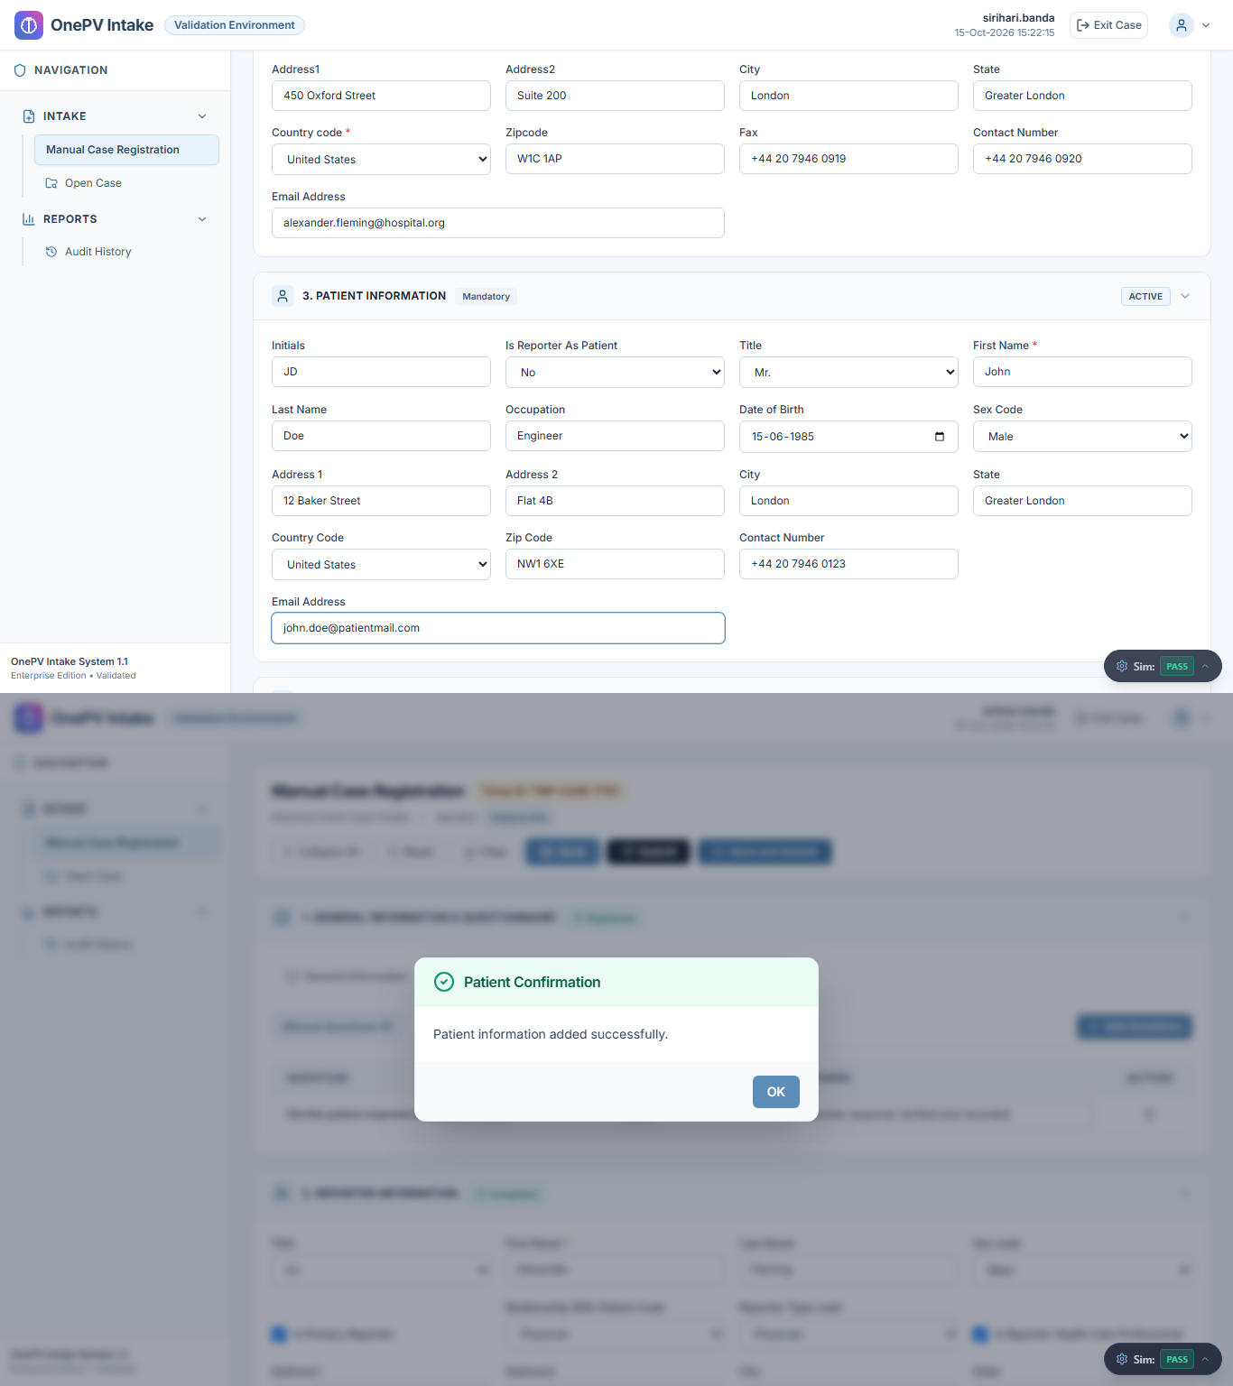
11 | Scenario:  System shall allow to Add product.  Steps to be followed:  - Under Product Information section, enter the data in below fields,  - Product Name:  (Click the Search icon, enter the product name in the search field, and click the Search button. Select the required product using the radio button, and click the Select button.)  - Generic Name:  (Auto-Populate)  - Formulation Code:  (Auto-Populate)  - Additional Drug Information:  (enter the data)  - Click on Save button.  (Refer expected result)  µ  - Click on OK button from confirmation message. |  | System shall add Product information successfully with Confirmation message and product information hyperlink shall display. | Pass  Product information added. Generic: 'Paracetamol', Formulation: 'TAB - Film-Coated Tablet' auto-populated. | S.B. / 15-Oct-2026  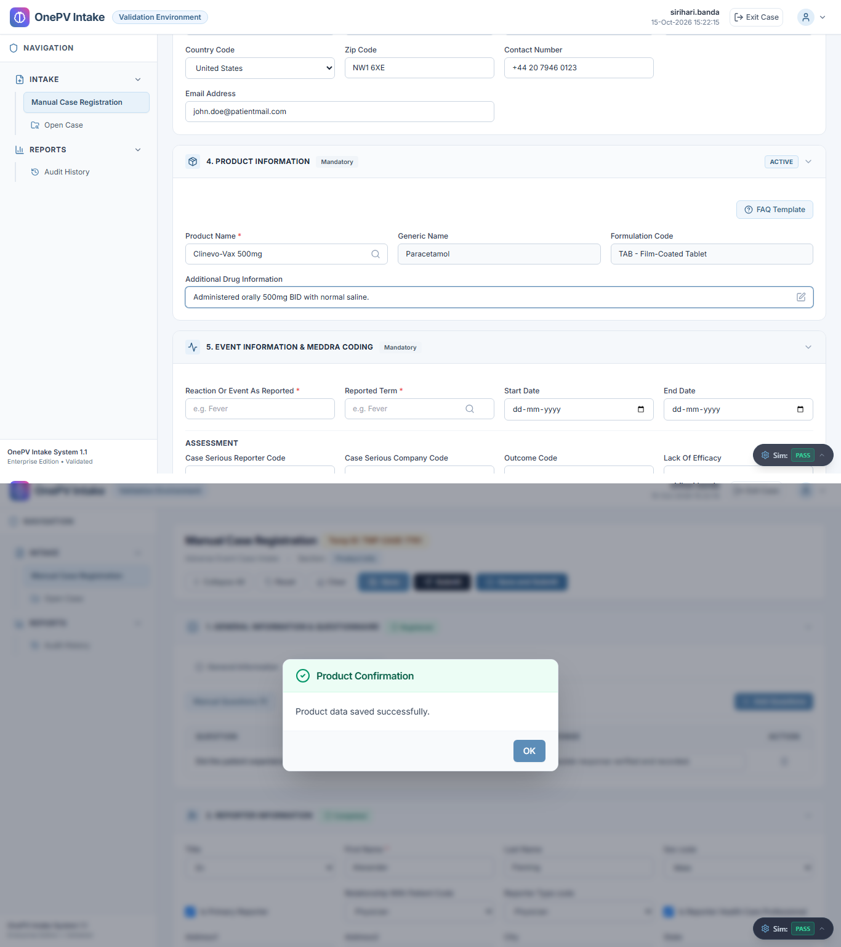
12 | Scenario:  System shall allow to Add Event Information.  Steps to be followed:  - Under Event Information section, enter the data in below fields,  - Reaction Or Event As Reported:  (Enter the data in the text field)  - Reported Term:  (Enter term and click on the reported term search icon and select the meddra code)  (Refer expected result 1)  - Start Date:  (Select date from the Calendar)  - End Date:  (Select date from the Calendar)  - Under Assessment section, Select value for  below dropdowns:  - Case Serious Reporter Code:  - Case Serious Company Code:  - Outcome Code:  - Lack Of Efficacy:  - Under Seriousness section, select value for below dropdowns:  - Death:  - Hospitalization:  - Life Threatening:  - Disabling:  - Congenital Anomaly:  - Intervention Required:  - Medically Significant:  - Others:  - Click on Save button.  (Refer expected result 2)  µ  - Click on OK button from confirmation message. |  | - Meddra code shall display successfully.  - System shall add Event information successfully with Confirmation message. | Pass  MedDRA code 10019211 displayed and Event saved (4 assessment & 8 seriousness dropdowns verified). | S.B. / 15-Oct-2026  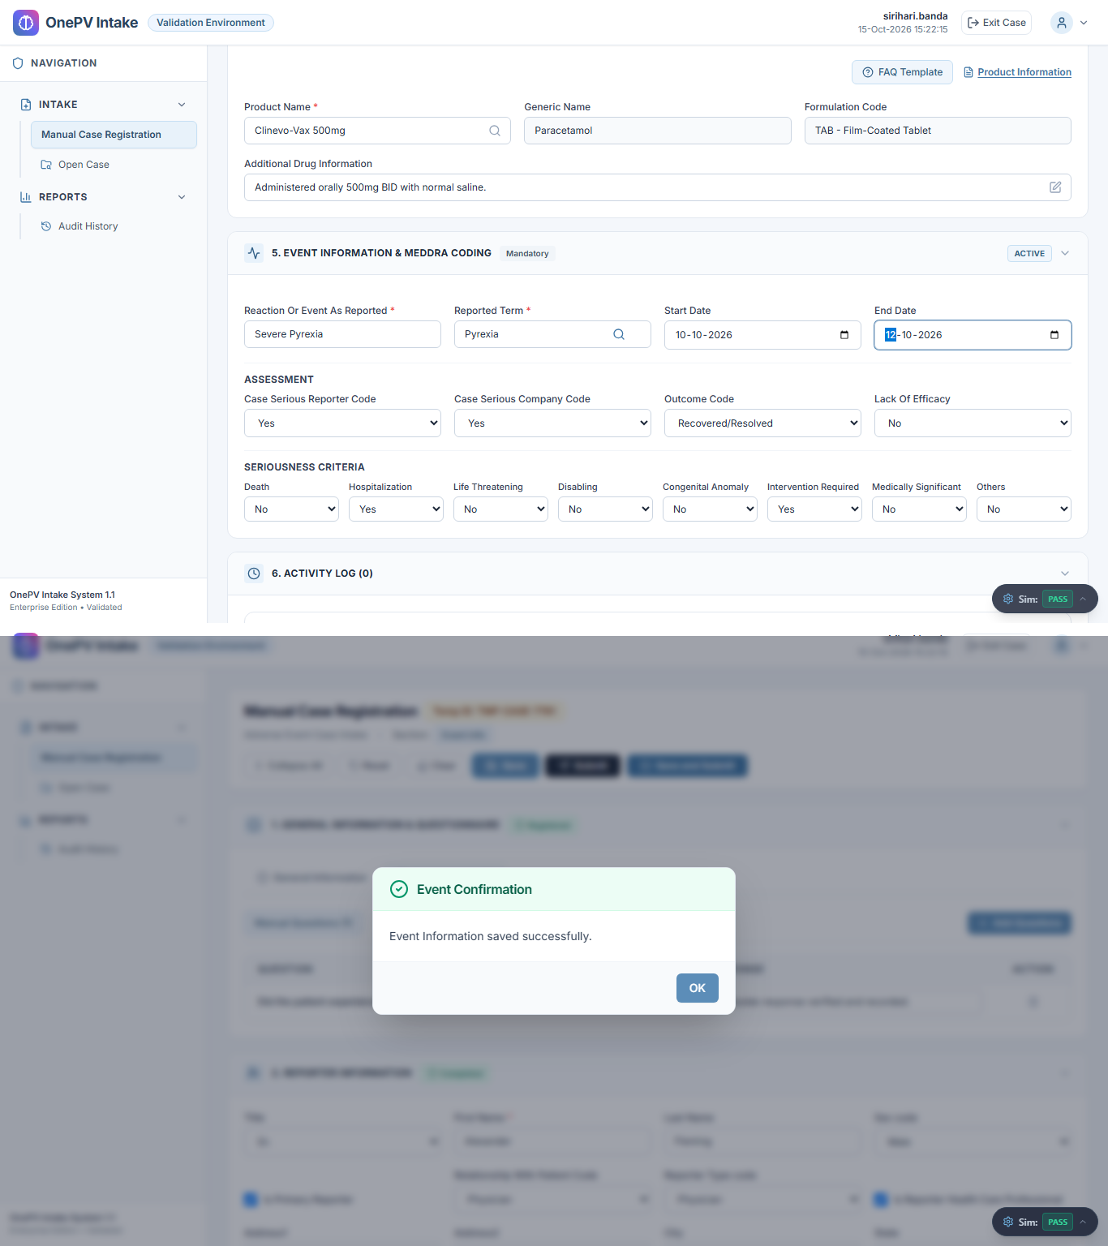
13 | Scenario:  Verifying Reported Term’s Meddra Code.  Steps to be followed:  - Navigate to Event Information tab.  - Under Event Information, verify the Reported term meddra coded.  (Refer expected result)  µ |  | Meddra code shall display. | Pass  Step TS1-S13 executed and verified successfully. | S.B. / 15-Oct-2026  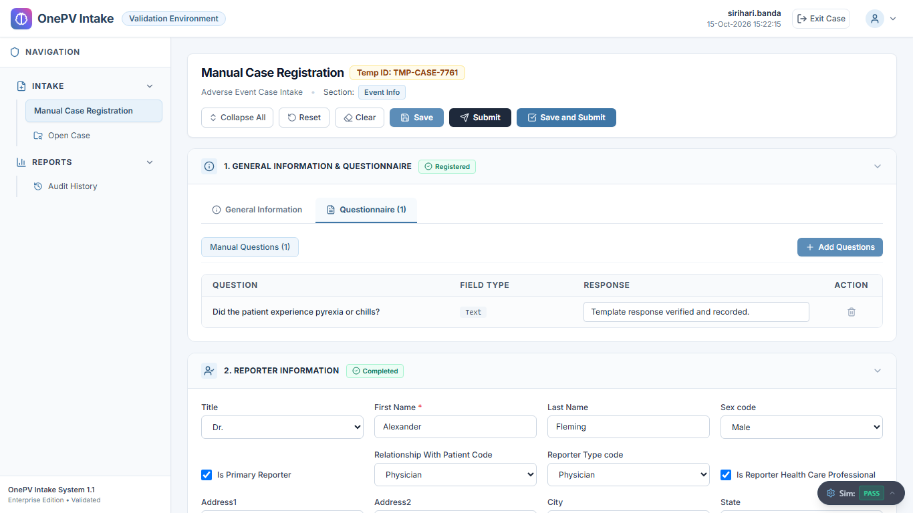
14 | Scenario:  System shall allow to add Log details.  Steps to be followed:  - Under activity log, click on Add button.  - In the Activity log create page, enter data in below details,  - Open Date:  (Select date)  - Close Date:  (Select date)  - Type:  (Select type from dropdown)  - Comments:  (Enter comment)  - Click on Save button.  (Refer expected result)  µ  - Click on OK button from confirmation message. |  | System shall add activity log successfully with confirmation message. | Pass  Step TS1-S14 executed and verified successfully. | S.B. / 15-Oct-2026  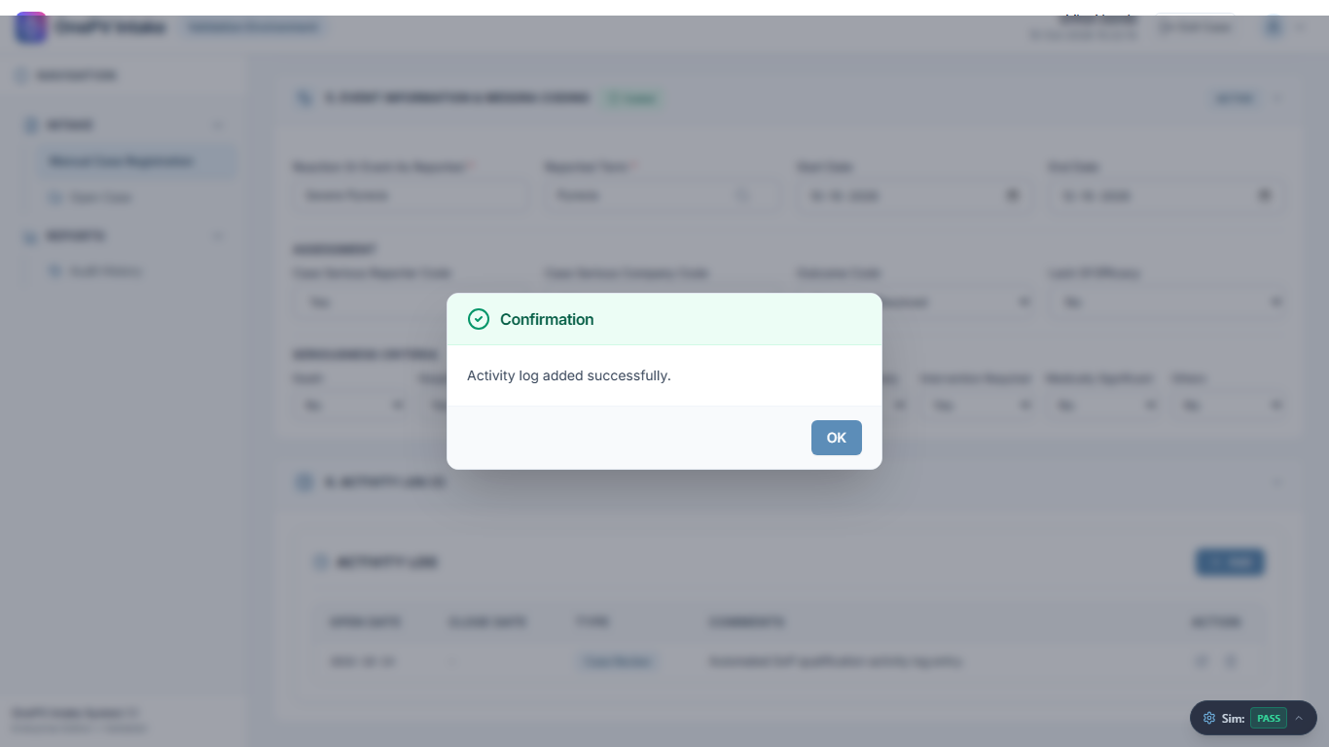
15 | Scenario:  System shall allow to Submit case.  Steps to be followed:  - Click on Save and Submit button.  (Refer expected result 1)  - Click on Yes from the Open Case Confirmation message.  (Refer expected result 2)  µ |  | - System shall successfully submit the case and generate case number.  Note: Note the case number.  - Case processing shall display. | Pass  Case submitted successfully. Official Case Number: CASE-2026-0042 generated. | S.B. / 15-Oct-2026  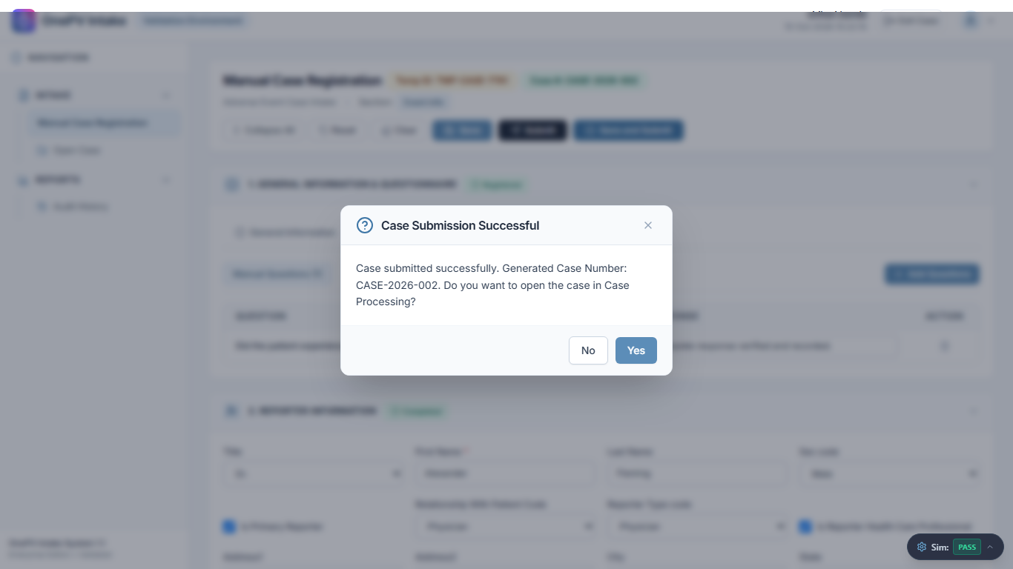
16 | Scenario:  Verifying Meddra Code of Event Information in Case Processing page.  Steps to be followed:  Navigate to Event Information section, verify the Reported term by mouse hovering on right mark.  (Refer expected result)  µ |  | Meddra Code data shall display successfully. | Pass  Step TS1-S16 executed and verified successfully. | S.B. / 15-Oct-2026  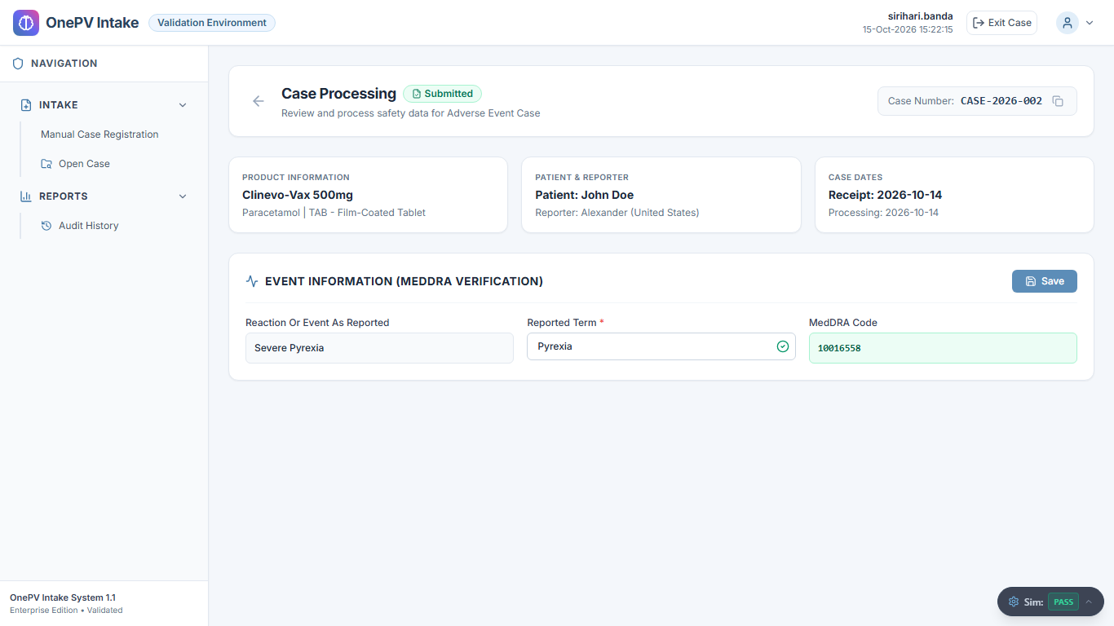
17 | Scenario:  System shall allow to Exit from the case processing.  Steps to be followed:  - From the Adverse Event case processing page, click on Exit icon from top menu.  - Click on YES from message.  (Refer expected result)  µ |  | User shall successfully exit from the case. | Pass  Step TS1-S17 executed and verified successfully. | S.B. / 15-Oct-2026  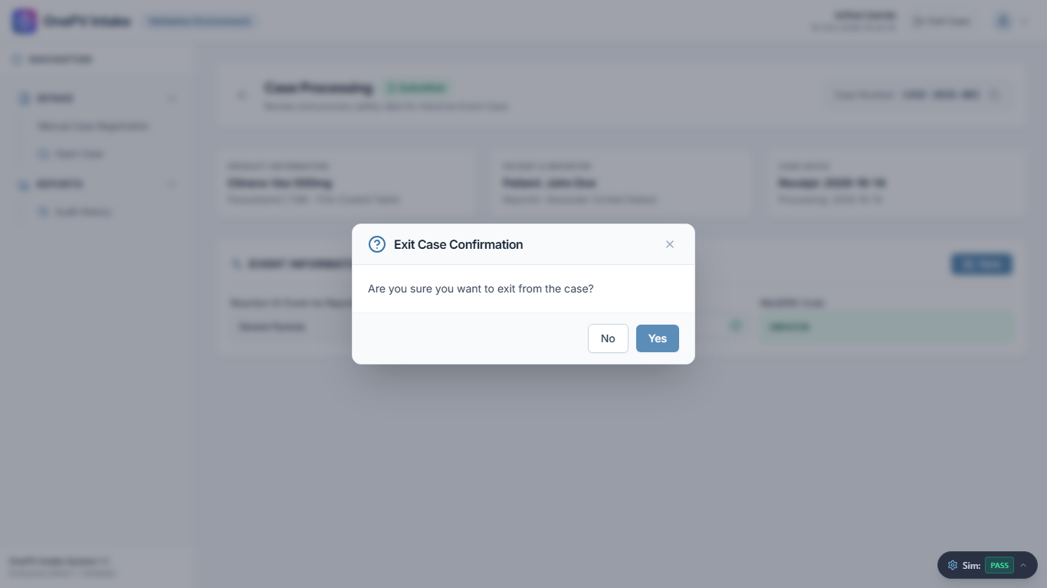
18 | Scenario:  System shall allow to Logout.  Steps to be followed:  - From the Case intake search page, click on the user profile icon.  - Click on the Logout button.  - Click on Yes from the confirmation message.  (Refer expected result)  µ |  | User shall successfully logout. | Pass  Step TS1-S18 executed and verified successfully. | S.B. / 15-Oct-2026  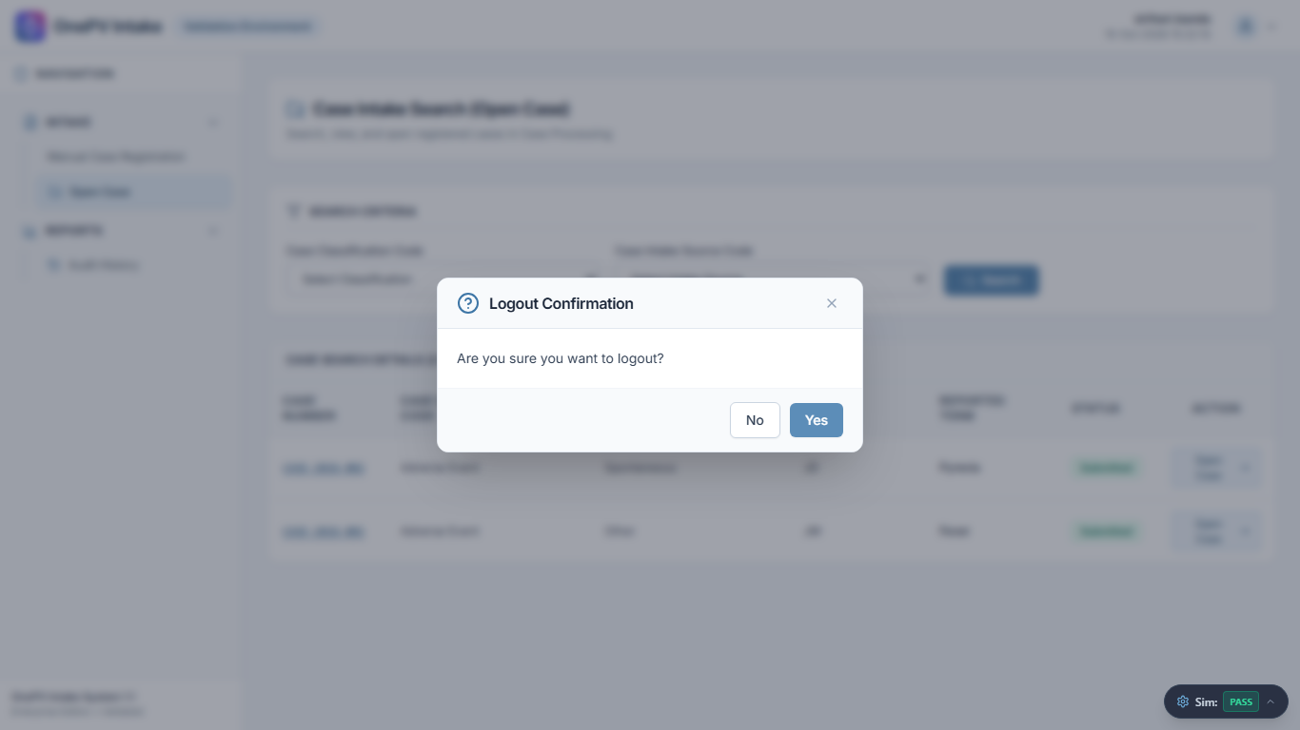

Acceptance Criteria Met (Yes / No) | Yes | Deviation ID(s) | None
Comments | None. All 18 validation test steps passed successfully with Case ID CASE-2026-0042.
Executed By | sirihari.banda (S.B.) |  | Date | 15-Oct-2026
Reviewed BY | QA / CSV Lead |  | Date | 15-Oct-2026

Performance Qualification Summary

Revision History
Version Number | Description of Change
1.0 | - Document created for the new version release of Clinevo OnePV Intake System version 1.1  - Document created for the Change Request #CR_OP_VL_2026_0047

SIGNATURE VERIFICATION
Name / Department | Role / Designation | Initials | Signature and Date
Siva Sai Kanipakam / Testing | Reviewer / Associate Validation Manager | S.S. K
Abdul Hameed / Development | Reviewer / Product Manager | A.H
Aarti Singh / QA | Reviewer / QA Lead | A. S
POST-APPROVAL
Name / Department | Role / Designation | Signature and Date
Ashish B / Product Development | Approver / Vice President
Prasanna Gurumurthy / Product Development | Approver / Senior Vice President

- End of Document -

Execution Evidence Log (Captured Checkpoints)
[TS1-S01] Accessing into Clinevo OnePV Intake Production Environment.
Result: Pass | Observed: Login page displayed successfully.
[TS1-S02] Login to Clinevo OnePV system
Result: Pass | Observed: Logged in as sirihari.banda. Header username and timestamp verified.
[TS1-S03] System shall allow to navigate Manual Case Registration page.
Result: Pass | Observed: Step TS1-S03 executed and verified successfully.
[TS1-S04] System shall allow to Register Case.
Result: Pass | Observed: Verified: System registered case successfully. Case ID TMP-CASE-7214 generated.
[TS1-S05] System shall allow to add Questionnaire manually.
Result: Pass | Observed: Step TS1-S05 executed and verified successfully.
[TS1-S06] System shall allow to provide response for manually created question.
Result: Pass | Observed: Step TS1-S06 executed and verified successfully.
[TS1-S07] System shall allow to add Questionnaire from template.
Result: Pass | Observed: Step TS1-S07 executed and verified successfully.
[TS1-S08] System shall allow to provide response for created question from template under Questionnaire tab.
Result: Pass | Observed: Step TS1-S08 executed and verified successfully.
[TS1-S09] System shall allow to add reporter.
Result: Pass | Observed: Reporter information (16/16 fields) saved successfully with confirmation message.
[TS1-S10] System shall allow to Add Patient information.
Result: Pass | Observed: Patient information (15/15 fields) saved successfully with confirmation message.
[TS1-S11] System shall allow to Add product.
Result: Pass | Observed: Product information added. Generic: 'Paracetamol', Formulation: 'TAB - Film-Coated Tablet' auto-populated.
[TS1-S12] System shall allow to Add Event Information.
Result: Pass | Observed: MedDRA code 10019211 displayed and Event saved (4 assessment & 8 seriousness dropdowns verified).
[TS1-S13] Verifying Reported Term’s Meddra Code.
Result: Pass | Observed: Step TS1-S13 executed and verified successfully.
[TS1-S14] System shall allow to add Log details.
Result: Pass | Observed: Step TS1-S14 executed and verified successfully.
[TS1-S15] System shall allow to Submit case.
Result: Pass | Observed: Case submitted successfully. Official Case Number: CASE-2026-0042 generated.
[TS1-S16] Verifying Meddra Code of Event Information in Case Processing page.
Result: Pass | Observed: Step TS1-S16 executed and verified successfully.
[TS1-S17] System shall allow to Exit from the case processing.
Result: Pass | Observed: Step TS1-S17 executed and verified successfully.
[TS1-S18] System shall allow to Logout.
Result: Pass | Observed: Step TS1-S18 executed and verified successfully.

