Linear combination and span

V1, V2, V3, V4, V5, … in Rn

Then C1 V1 + C2 V2 + C3 V3 + C4 V4 +…+ CnVn  is linear combination

Span

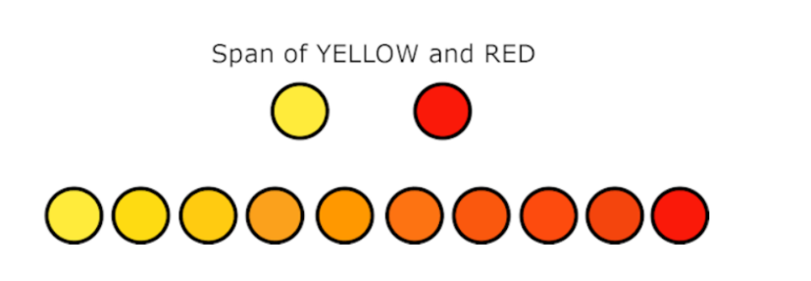

It is like possible combinations from the given vectors

When done with vectors the example can be represented as

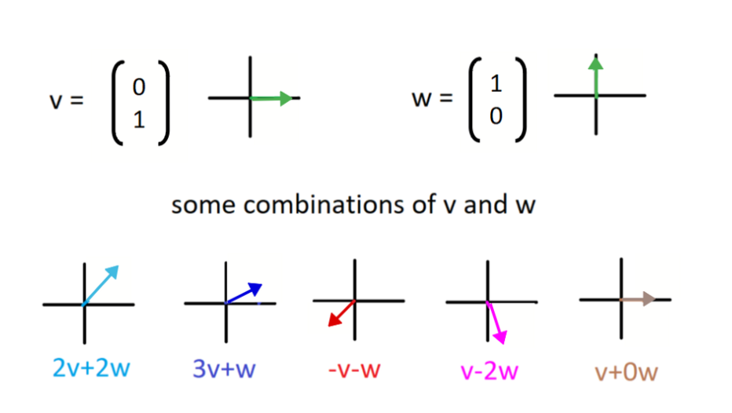

[source](https://mikebeneschan.medium.com/how-to-understand-span-linear-algebra-cf3baa12edda)

Introduction to linear independence

The span of the vectors can be simplified in some cases to be linearly dependent… giving the existing dimension(in the same plane)

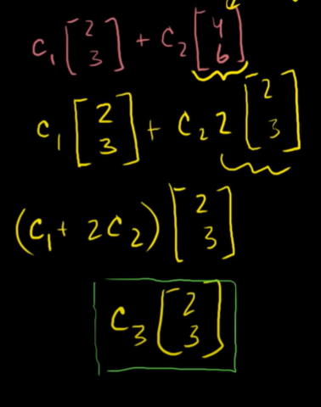

Linear dependence

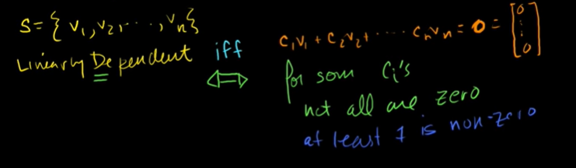

Finding c1, c2, c3 when linearly dependent

Linearly dependent -> one of the constants is non-zero

Linearly independent -> all constants should be zeroes

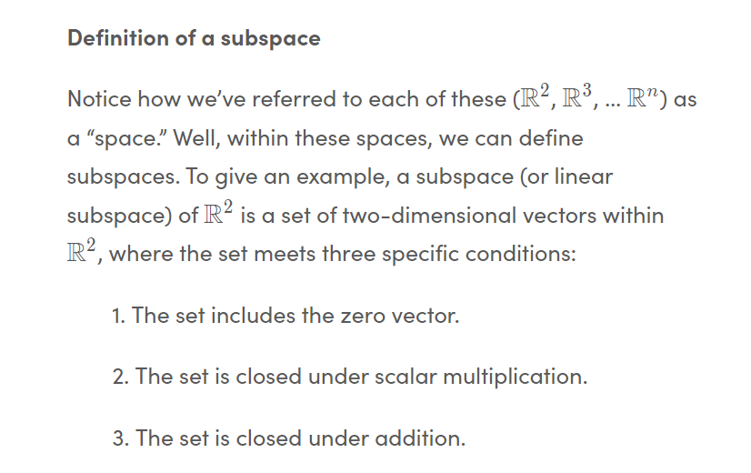Linear subspaces

The below is point 2,3 of above definition.

