QUESTION 1
Write a simple poem and represent it as a web page. Give a title for the poem.
Make rhyming words in the poem as bold.

CODE:
<!DOCTYPE html>
<html>
<body>
<h1 style="text-align:center;">POEM</h1>
<p style="text-align:center;">Beneath the sky so wide and <b>blue</b>,</P>
<p style="text-align:center;">The world whispers secrets old and <b>true</b>.</p>
<p style="text-align:center;">With every breeze, a story <b>told</b>,</p>
<p style="text-align:center;">In nature’s arms, we’re young, not <b>old</b>.</p>
</body>
</html>
OUTPUT:
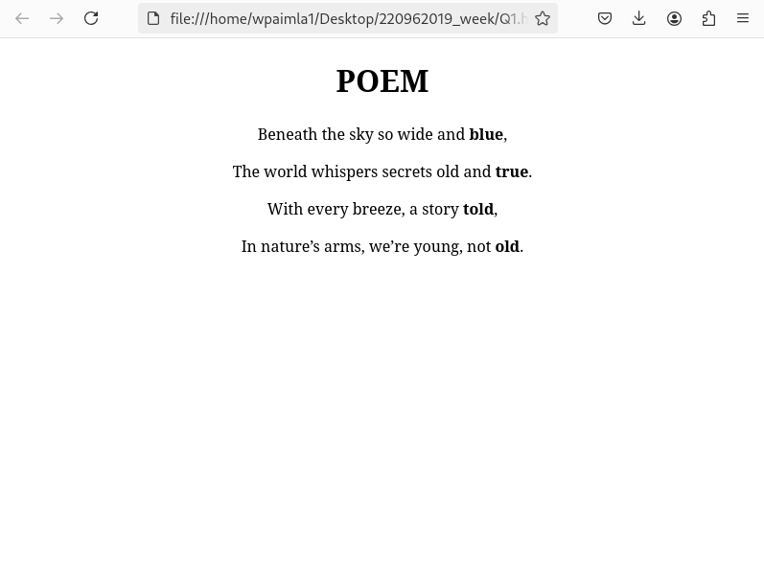

QUESTION 2
Assume you have brought a new car. Write down the list of additional
accessories you need for the car as an unordered list in HTML. Also, list the
travel plans on the car as an ordered list.

CODE:
<body>
<h1>CAR ACCESORIES</h1>
<ul>
<li>Seat Covers</li>
<li>Floor Mats</li>
<li>Chargers</li>
<li>Phone Mounts</li>
</ul>
<h1>TRAVEL PLANS</h1>
<ol>
<li>golden temple
<ul>
<li>Destinations: Delhi → Agra → Jaipur</li>
<li>Duration: 7-10 days</li>
<li>Highlights: Taj Mahal, Jaipur's forts, and Delhi's historical sites.</li>
</ul>
</li>

<li>Manali to Leh
<ul>
<li>Destinations: Manali → Rohtang Pass → Keylong → Leh</li>
<li>Duration: 10-12 days</li>
<li>Highlights: Breathtaking mountain views, Pangong Lake, Nubra Valley.</li>
</ul>
</li>
</ol>
</body>
</html>

OUTPUT:
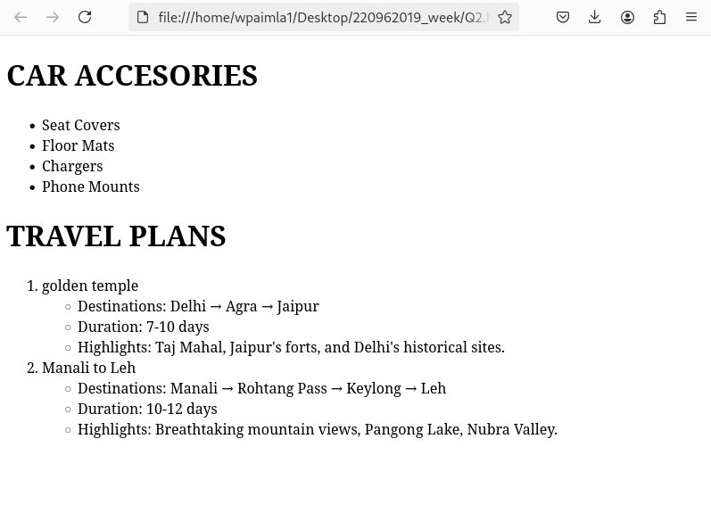
QUESTION 3
Complete the following website name “Share your Winter Vacation Videos”.
The required video files are located inside the compressed folder “Week 1
Assignment Files/Media/”.Hint: Add a <video> element to a <figure> element that will either play
paris.mp4, paris.webm or paris.ogv in the element. Test in different browsers

CODE:
<!DOCTYPE html>
<html lang="en">
<head>
<title>Share Your Winter Vacation Videos</title>
</head>
<body>
<h1>Share Your Winter Vacation Videos</h1>
<figure>
<video controls>
<source src="/home/wpaimla1/Desktop/220962019_week/v1.mp4" type="video/mp4">
Your browser does not support the video tag.
</video>
<figcaption>Enjoy the beautiful sights of Paris during winter!</figcaption>
</figure>
</body>
</html>
OUTPUT:
