Week 6
Name:Sri harsha
class:Ai & ML sec ‘a’
Regno:220962019
rollno :09

Q1.Develop a simple web page to perform basic arithmetic operations. Take two
integer inputs from the user, select the operation to be performed using a
dropdown. Include a button “Calculate” to perform the selected operation, and
then display the result in the same web page.

Views.py
# calcapp/views.py
from django.shortcuts import render

def calculate(request):
result = None
error = None
if request.method == 'POST':
try:
num1 = int(request.POST.get('num1'))
num2 = int(request.POST.get('num2'))
operation = request.POST.get('operation')

if operation == 'add':
result = num1 + num2
elif operation == 'subtract':
result = num1 - num2
elif operation == 'multiply':
result = num1 * num2
elif operation == 'divide':
if num2 == 0:
error = "Cannot divide by zero."
else:
result = num1 / num2
except ValueError:
error = "Please enter valid integers."

return render(request, 'calculate.html', {'result': result, 'error': error})
===================================
html file
<!-- calcapp/templates/calculate.html -->
<!DOCTYPE html>
<html>
<head>
<title>Simple Calculator</title>
</head>
<body>
<h1>Basic Arithmetic Operations</h1>

<form method="POST">
{% csrf_token %}
<label for="num1">First Number:</label>
<input type="number" name="num1" required>
<br>

<label for="num2">Second Number:</label>
<input type="number" name="num2" required>
<br>

<label for="operation">Operation:</label>
<select name="operation" required>
<option value="add">Add</option>
<option value="subtract">Subtract</option>
<option value="multiply">Multiply</option>
<option value="divide">Divide</option>
</select>
<br>

<button type="submit">Calculate</button>
</form>

{% if result %}
<h2>Result: {{ result }}</h2>
{% elif error %}
<h2 style="color: red;">Error: {{ error }}</h2>
{% endif %}
</body>
</html>
===========================================
output:
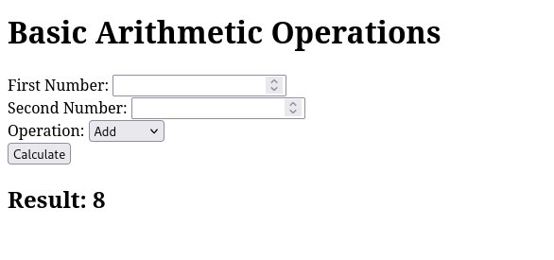
Q2.Develop a simple web form that generates the front cover for a magazine. The
form should provide the options for selecting the image, background color,
changing font size, color etc. Input messages must be taken from the user so
as to display it on the front cover with legible font family and font size. The
front cover developed should be proportionate to the web page size. Place the
css files inside static folder.

Views.py
# magcover/views.py

from django.shortcuts import render
from django.core.files.storage import FileSystemStorage

def generate_cover(request):
cover_image = None
title = None
subtitle = None
background_color = '#FFFFFF' # default white background
font_size = '20px' # default font size
font_color = '#000000' # default font color (black)

if request.method == 'POST':
# Get the background color, font size, and font color
background_color = request.POST.get('background_color', '#FFFFFF')
font_size = request.POST.get('font_size', '20px')
font_color = request.POST.get('font_color', '#000000')
title = request.POST.get('title', 'Magazine Title')
subtitle = request.POST.get('subtitle', 'Subtitle Here')

# Handle image upload
if 'cover_image' in request.FILES:
uploaded_image = request.FILES['cover_image']
fs = FileSystemStorage()
cover_image = fs.save(uploaded_image.name, uploaded_image)

return render(request, 'magcover/generate_cover.html', {
'cover_image': cover_image,
'title': title,
'subtitle': subtitle,
'background_color': background_color,
'font_size': font_size,
'font_color': font_color
})
===================================
html file
<!-- magcover/templates/magcover/generate_cover.html -->
<!DOCTYPE html>
<html lang="en">
<head>
<meta charset="UTF-8">
<meta name="viewport" content="width=device-width, initial-scale=1.0">
<title>Magazine Cover Generator</title>
<link rel="stylesheet" href="{% static 'magcover/styles.css' %}">
</head>
<body>

<h1>Create Your Magazine Cover</h1>

<form method="POST" enctype="multipart/form-data">
{% csrf_token %}

<label for="cover_image">Upload Cover Image:</label>
<input type="file" name="cover_image" accept="image/*">
<br><br>

<label for="title">Title:</label>
<input type="text" name="title" placeholder="Enter magazine title" required>
<br><br>

<label for="subtitle">Subtitle:</label>
<input type="text" name="subtitle" placeholder="Enter subtitle" required>
<br><br>

<label for="background_color">Background Color:</label>
<input type="color" name="background_color" value="#FFFFFF">
<br><br>

<label for="font_size">Font Size (px):</label>
<input type="number" name="font_size" value="20">
<br><br>

<label for="font_color">Font Color:</label>
<input type="color" name="font_color" value="#000000">
<br><br>

<button type="submit">Generate Cover</button>
</form>

{% if cover_image %}
<div class="cover-preview" style="background-color: {{ background_color }}; font-size: {{ font_size }}px; color: {{ font_color }};">
<img src="{{ cover_image.url }}" alt="Cover Image" style="max-width: 100%; height: auto;">
<h2>{{ title }}</h2>
<p>{{ subtitle }}</p>
</div>
{% endif %}

</body>
</html>
===========================================
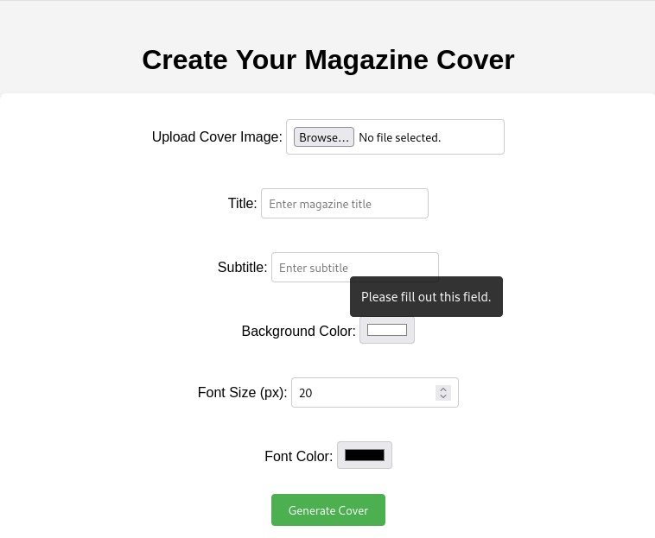
output:
Q1Design a simple web application to provide information about a book. The
home page of the application should display the cover page of the book along
with three hyperlinks: Metadata, Reviews, Publisher info. Give provision to
revert to home page from any other page..

Views.py
from django.shortcuts import render

def home(request):
return render(request, 'home.html')

def metadata(request):
return render(request, 'metadata.html')

def reviews(request):
return render(request, 'reviews.html')

def publisher_info(request):
return render(request, 'publisher_info.html')
===================================
html file
{% load static %}
<!DOCTYPE html>
<html lang="en">
<head>
<meta charset="UTF-8">
<meta name="viewport" content="width=device-width, initial-scale=1.0">
<title>Book Information</title>
</head>
<body>
<h1>Book Title</h1>
<img src="{% static 'book_cover.jpg' %}" alt="Book Cover" width="300">
<p>
<a href="{% url 'metadata' %}">Metadata</a> |
<a href="{% url 'reviews' %}">Reviews</a> |
<a href="{% url 'publisher_info' %}">Publisher Info</a>
</p>
</body>
</html>
{% load static %}
<!DOCTYPE html>
<html lang="en">
<head>
<meta charset="UTF-8">
<meta name="viewport" content="width=device-width, initial-scale=1.0">
<title>Metadata</title>
</head>
<body>
<h1>Book Metadata</h1>
<p>Author: John Doe</p>
<p>Genre: Fiction</p>
<p>Published Year: 2021</p>
<p><a href="{% url 'home' %}">Back to Home</a></p>
</body>
</html>
{% load static %}
<!DOCTYPE html>
<html lang="en">
<head>
<meta charset="UTF-8">
<meta name="viewport" content="width=device-width, initial-scale=1.0">
<title>Publisher Info</title>
</head>
<body>
<h1>Publisher Information</h1>
<p>Publisher: ABC Publishing</p>
<p>Location: New York, USA</p>
<p><a href="{% url 'home' %}">Back to Home</a></p>
</body>
</html>
{% load static %}
<!DOCTYPE html>
<html lang="en">
<head>
<meta charset="UTF-8">
<meta name="viewport" content="width=device-width, initial-scale=1.0">
<title>Reviews</title>
</head>
<body>
<h1>Book Reviews</h1>
<p>"This book was a thrilling read!" - Reviewer 1</p>
<p>"Highly recommend for fans of suspense." - Reviewer 2</p>
<p><a href="{% url 'home' %}">Back to Home</a></p>
</body>
</html>
===========================================
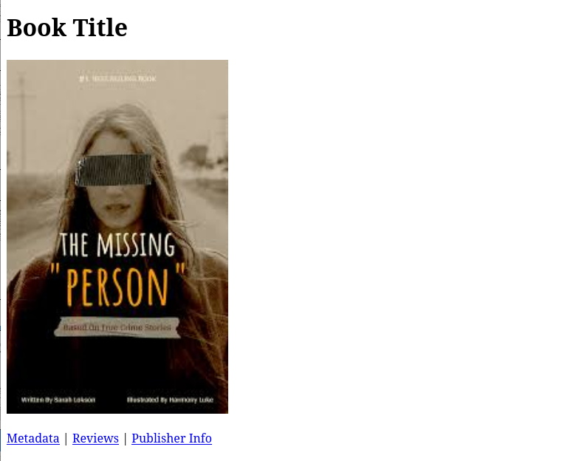
output:

